201 Final Project Report



Boba 4 U: Yilin Sun, Alish Kartik, Winston Chen, Yongxin Li

**Introduction**

Efficient selling and employee data management are crucial for the operational and analytical success of our starting business. This report details the design and functionality of a comprehensive system that leverages MySQL, Python, Qt Designer, and PyQt5 to streamline operations and generate actionable insights. The system utilizes a dataset containing selling and employee information, including customer orders, employee details, and sales analytics. Combining operational and analytical models is better for our inventory management, employee tracking, and data-driven decision-making.

**Data Source**

The primary data source for this project are generated manually from Mockaroo <https://www.mockaroo.com/schemas/667973>

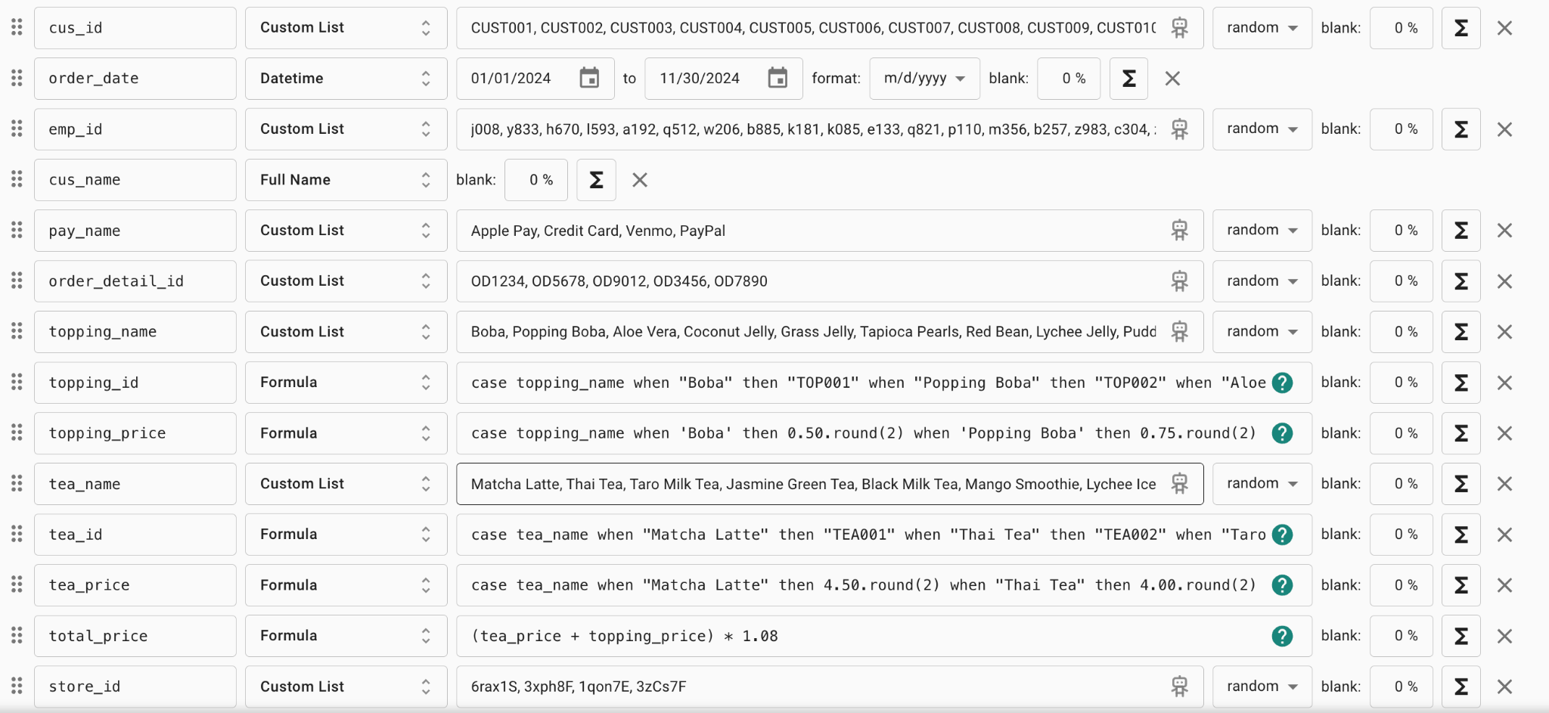

Our menu has about 17 drinks and 10 toppings. This synthetic data reflects diverse customer preferences and purchasing behaviors.

**Application Design:**

The application contains 2 main models

**Operational Modle**: supports day-to-day activities such as order processing, and customer information.

* Order processing:
  + Employees order drinks and toppings for customers using an intuitive interface.
  + The system calculates the subtotal, applies about 8% sales tax, and displays the total price.
  + Orders can be added to a cart, and the preferred payment method(e.g. Apple Pay, Credit Card, Venmo, Paypal) is recorded.
* Order Details and customer information:
  + Captures order specifics, including data time of purchase, and the order id.
  + Stores customer details such as name and payment preferences to enhance analytical modeling.

**Analytical Modle:** provides insights into sales trends, inventory needs, and employee data, supports strategic planning and operational efficiency through advanced reporting and data visualization:

* Top-Selling Products:
  + Displays the top 10 drinks and toppings based on sales volume.
  + Guides inventory preparation, ensuring popular items like boba are adequately stocked while implementing conditional preparation for sensitive items(e.g. chess foam is prepared only if fewer than 10 orders)
* Sales Reporting:
  + Generates daily, weekly, and monthly sales reports within a user-defined time range.
  + For example, selecting a time range from 06/24/2024 to 07/07/2024 allows the user to:
    - View daily sales totals for each day in the range.
    - Analyze weekly sales for two periods: the week of 06/24 and the week of 07/01.
    - Generate monthly bar charts for June and July.
* Employee Data Management:
  + Facilitates viewing employee details by selecting their name, and displays comprehensive information such as address, vehicle details, date of birth, etc.