搭建nsq消息系统

1. **安装gvm**
2. cd /var/local
3. bash < <(curl -s -S -L

<https://raw.githubusercontent.com/moovweb/gvm/master/binscripts/gvm-installer>)

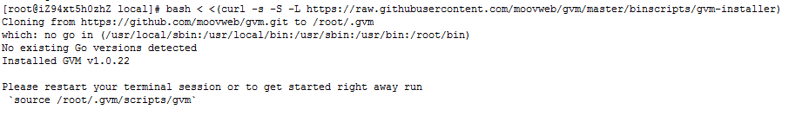

1. source /root/.gvm/scripts/gvm
2. gvm list

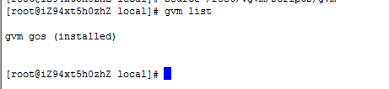

1. **安装Go**
2. cd /var/local
3. wget https://raw.githubusercontent.com/wcccode/collection/master/go/repo/go1.4.2.linux-amd64.tar.gz
4. tar –xzvf go1.4.2.linux-amd64.tar.gz
5. 配置环境变量

export GOROOT=/var/local/go1.4.2.linux-amd64

export GOPATH=/var/local/goworkspace

export PATH=$PATH: $GOROOT/bin

1. go version
2. **安装nsq**
3. cd /var/local
4. wget <https://raw.githubusercontent.com/wcccode/collection/master/go/repo/nsq-0.3.5.linux-amd64.go1.4.2.tar.gz>
5. tar –xzvf nsq-0.3.5.linux-amd64.go1.4.2.tar.gz
6. 创建启动脚本
7. startup-1-nsqlookup.sh

nohup ./nsqlookupd 2>&1 | /usr/sbin/cronolog "./log/nsqlookupd-%Y-%m-%d.log" &

1. startup-2-nsqd.sh

nohup ./nsqd --lookupd-tcp-address=127.0.0.1:4160 --msg-timeout=120s 2>&1 | /usr/sbin/cronolog "./log/nsqd-%Y-%m-%d.log" &

1. startup-3-nsqadmin.sh

nohup ./nsqadmin --lookupd-http-address=127.0.0.1:4161 2>&1 | /usr/sbin/cronolog "./log/nsqadmin-%Y-%m-%d.log" &

1. startup-4-nsqtofile.sh

./nsq_to_file --topic-pattern=.* --output-dir=/tmp --lookupd-http-address=127.0.0.1:4161;

1. shutdown.sh

ps -ef|grep "./nsq"|awk '{print $2}'|xargs kill

1. **安装****cronolog**
2. yum install -y cronolog httpd
3. 查看安装目录 which cronolog
4. **启动nsq**
5. sh startup-1-nsqlookup.sh
6. sh startup-2-nsqd.sh
7. sh startup-3-nsqadmin.sh
8. sh startup-4-nsqtofile.sh
9. **关闭nsq**

sh shutdown.sh

1. **访问nsq**

打开http://127.0.0.1:4171/