Basic

1. Show the execution result (snapshot) of UDP server



1. Show the execution result (snapshot) of UDP client



1. Show the execution result (snapshot) of TCP server



1. Show the execution result (snapshot) of TCP client



Advanced

1. How do you measure the latency?

本作業的latency是一個封包從client端送出後到server再response回client的時間，因此我認為這一來一往的過程就是整個latency所花的時間，所以我在client端的send前和receive後加入gettimeofday()這個function來計算client send到server和server response到client端的這段時間。

1. Show the latency result
2. Latency of TCP:

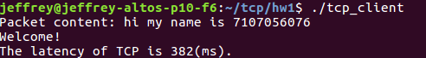

1. Latency of UDP:

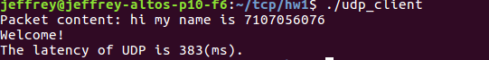

1. How do you measure the throughput?
2. Show the throughput result