Basic

1. Show the execution result (snapshot) of server

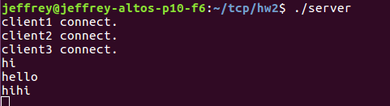

1. Show the execution result (snapshot) of client

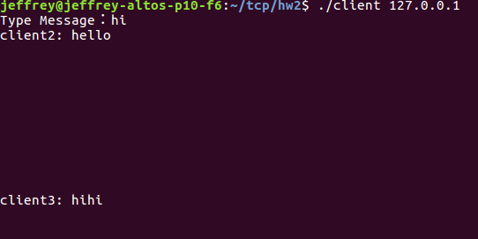

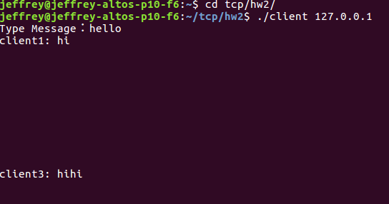

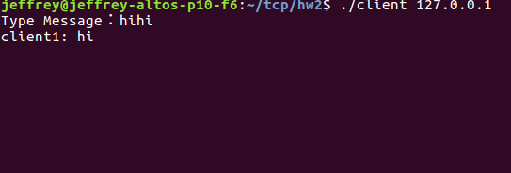

Advanced

1. Show the execution result(snapshot) of server
2. Show the execution result(sanpshot) of client