Basic

1. Show the execution result (snapshot) of HW3-1

因為使用loctl()需使用root權限更改網卡設定，才能成功更改。

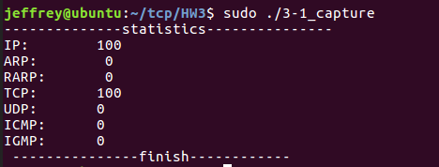

1. Show the execution result (snapshot) of HW3-2

和3-1類似，但需先篩選過protocol=UDP和dest. Addr為自己的。

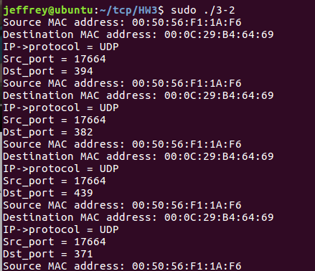

1. Show the execution result (snapshot) of HW3-3

和3-2類似，只是protocol是TCP，另外dest.addr和src.addr不能是自己的。

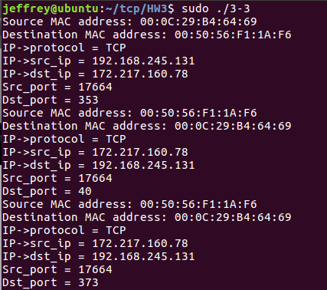

Advanced

1. Please describe that how do you fake ip address ?
2. Show the execution result (snapshot) of HW3-4
3. Please describe that how do you modify payload?
4. Show the execution result (snapshot) of HW3-5, please show the original payload and fake payload.