Name: Virendra Patil

Class: Final Year Mechanical

Contact: 7082405601

Mail ID: [virendrapatil.24vp@gmail.com](mailto:virendrapatil.24vp@gmail.com)

GitHub ID: virendrapatil24

Attachment: python and notepad file of the code

**Challenge 1 Solution**

Initial Assumptions:

* Number of colors limited to maximum 3 colors.

Thought Process:

* Solved puzzles by hand on paper & tried different variations in shape and color.
* Looked upon repeating pattern.
* Then found out the pattern related to number of colors.( i.e. for 2 and 3 )
* Applied some constraints which helped my code to run exactly as per the solution required.

Explanation:

* Created a platform using python where user have to give the input regarding number of colors and number of blocks.
* Then computer will follow the steps for the corresponding input and will guide the user to solve the puzzle until the solution is reached.
* User must have knowledge about the number of colors and number of blocks.

For e.g.:

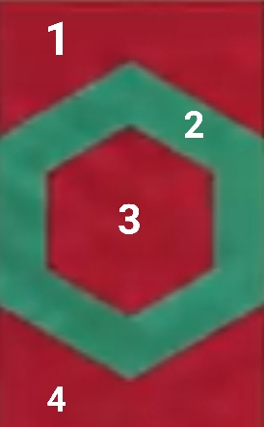

In above image Number of colors = 2;

Number of blocks = 4;

For e.g.:

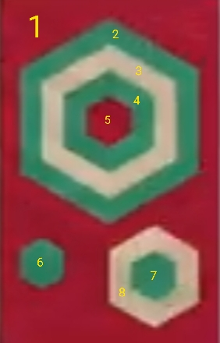

In above image Number of colors = 3;

Number of blocks = 8;

* User must have knowledge about the following statement:

*“Find the block (say B1) which is between 2 blocks having same color (say C1), then select C1 and tap B1.”*

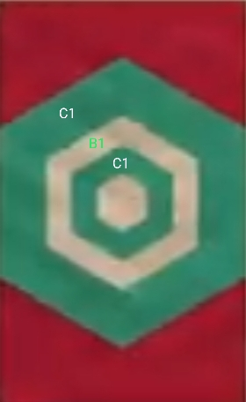 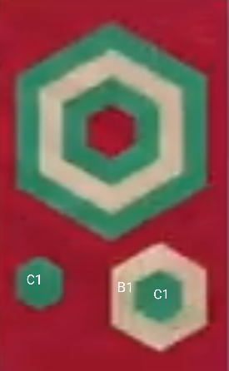

Above are the possibilities for the corresponding statement.

* If a user reaches at a point where he/she gets 2 or more ways for this statement:

*“Find the block (say B1) which is between 2 blocks having same color (say C1), then select C1 and tap B1”* then he/she may repeat the steps for different ways and conclude the solution with minimum number of steps.

Algorithm:

* Computer will take input for number of colors from the user.
* If/elif statement will be called for corresponding input.
* Computer will call the function for the corresponding input (Either 2/3).
* Then computer will ask for number of blocks and then corresponding to that input the if/elif statement will be called.
* Process will be continued until the solution is reached.