About Me

Chris Funk

Table of Contents

# Who I am and where I came from

I grew up in Oregon where I was lucky enough to live on a forested hill, which allowed me to spend countless hours playing in the woods.

I studied Biology at two colleges, first [Reed College](https://www.reed.edu/) and then [Wesleyan University](https://www.wesleyan.edu/). I ended up gaining expertise in evolutionary genetics from Dr. Fred Cohan at Wesleyan, and then Dr. Ron Burton at the Scripps Institute of Oceanography.

My top four things to do when I’m not doing science are:

1. Trail running
2. Snorkeling streams
3. Backpacking
4. Kayaking and just about anything else outdoors!

Here’s a picture of me holding CGP3 at La Hacienda Águila.

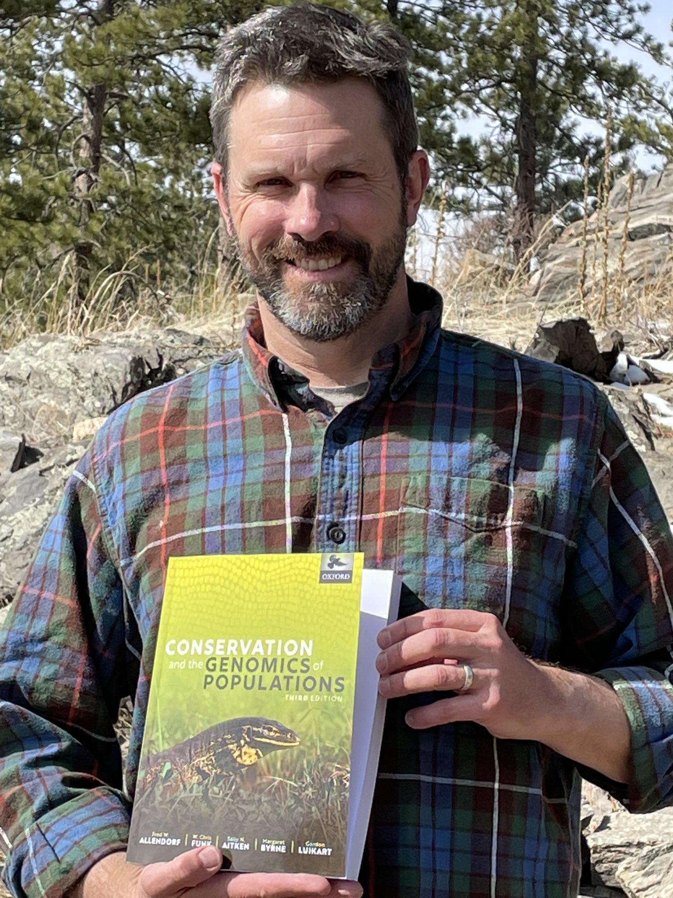

Chris snorkeling for stream amphibs in Cook Cr, OR

# Research Interests

We strive to understand the evolutionary and ecological mechanisms that generate and maintain biological diversity using population genomics, experimental manipulations, and field studies. Our goal is to not only test basic evolutionary and ecological theory, but also directly inform policy and management decisions that will ultimately determine the fate of biodiversity.

## Influential papers

A couple of papers that have shown me the power of genetics and genomics in conservation are Allendorf, Hohenlohe, and Luikart (2010) and Slatkin (1981).

## The mathematics behind my research

Two equations relevant to my research:

$$ΔH=−\frac{1}{2N_{e}}$$

$$F_{ST}=\frac{1}{4N_{e}m−1}$$

## My computing experience

My experience with programming:

* 8th grade: Learned how to program in LOGO in Mr. Delegan’s class! LOGO was a teaching language that allowed students to write code for graphics. For my project, I wrote a program for a short video of a Seattle Seahawk NFL football player catching a football and then spiking it in the endzone!
* First year of graduate school at the University of Montana: I wrote simulations in Turbopascal vs. 7.0 to estimate Ne using the temporal method from simulated populations of known Ne. These simulations were published in my first first-authored paper Funk, Tallmon, and Allendorf (1999).
* Rest of graduate school: I wrote lots of Matlab code for Population Viability Analyses as part of my dissertation research on the effects of dispersal on population dynamics.
* Island fox project: I ran STACKS and custom scripts written by the Hohenlohe lab for a project on the evolutionary processes driving patterns of genetic variation in Channel Islands foxes.
* I have always enjoyed the coding I have done, but have never had systematic training in computing or bioinformatics. It totally enjoyed this class two years ago, and got a lot out of it, but now need a refresher since I’m going to start doing a lot of WGS bioinformatics soon.

Some snippets of non-evaluated code:

Unix

ls *.Rmd

R

# read in data  
pca.data <- read.csv("by_island_PCA_in_loci2001to2243_transposed.csv", header=FALSE)  
  
# take a look  
dim(pca.data)  
pca.data[1:10,1:10]  
  
# run the pca  
pcaout <- prcomp(pca.data, center=T, scale.=F)  
summary(pcaout)  
  
# view a quick biplot of PC1 and PC2  
plot(pcaout$x[,1],pcaout$x[,2], xlab = "PC 1", ylab = "PC 2")

## What I hope to get out of this class

My goal in taking this class is to:

* Learn a framework for conducting bioinformatic analyses. Although I have a solid grasp of pop gen theory, I didn’t have any formal bioinformatics training before I took this class two years ago, as this field was not taught to us when I was a grad student.
* I want to have a solid foundation in bioinformatics and computational biology so that I can provide my students and postdocs with better guidance in their research.
* And, I would like to be able to lead my own genomics papers now and then too! This course will provide with the skills I need to be able to do this. I’m planning to lead a monarch butterfly WGS over the next couple/few years.
* Although it will likely take well into this year for my lab to collect WGS data (still have to hire the lab manager to do this), for now, I can play with the monarch reference genome and WGS data from this paper Talla et al. (2020).

# Evaluating some R code

Here’s some R code stolen from the WWW to output an exponential plot:

A <- structure(list(Time = c(0, 1, 2, 4, 6, 8, 9, 10, 11, 12, 13,   
14, 15, 16, 18, 19, 20, 21, 22, 24, 25, 26, 27, 28, 29, 30),   
Counts = c(126.6, 101.8, 71.6, 101.6, 68.1, 62.9, 45.5, 41.9,   
46.3, 34.1, 38.2, 41.7, 24.7, 41.5, 36.6, 19.6,   
22.8, 29.6, 23.5, 15.3, 13.4, 26.8, 9.8, 18.8, 25.9, 19.3)), .Names = c("Time", "Counts"), row.names = c(1L, 2L,  
3L, 5L, 7L, 9L, 10L, 11L, 12L, 13L, 14L, 15L, 16L, 17L, 19L, 20L, 21L, 22L, 23L, 25L, 26L, 27L, 28L, 29L, 30L,  
31L), class = "data.frame")  
  
attach(A)  
  
names(A)

## [1] "Time" "Counts"

exponential.model <- lm(log(Counts)~ Time)  
  
summary(exponential.model)

##   
## Call:  
## lm(formula = log(Counts) ~ Time)  
##   
## Residuals:  
## Min 1Q Median 3Q Max   
## -0.54715 -0.17618 0.02855 0.18850 0.55254   
##   
## Coefficients:  
## Estimate Std. Error t value Pr(>|t|)   
## (Intercept) 4.555249 0.111690 40.78 < 2e-16 ***  
## Time -0.063915 0.006158 -10.38 2.36e-10 ***  
## ---  
## Signif. codes: 0 '***' 0.001 '**' 0.01 '*' 0.05 '.' 0.1 ' ' 1  
##   
## Residual standard error: 0.2814 on 24 degrees of freedom  
## Multiple R-squared: 0.8178, Adjusted R-squared: 0.8102   
## F-statistic: 107.7 on 1 and 24 DF, p-value: 2.362e-10

timevalues <- seq(0, 30, 0.1)  
  
Counts.exponential2 <- exp(predict(exponential.model,list(Time = timevalues)))  
  
plot(Time, Counts,pch = 16)  
  
lines(timevalues, Counts.exponential2,lwd = 2, col = "red", xlab = "Time (s)", ylab = "Counts")

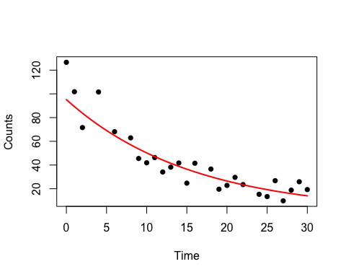

# Citations

Allendorf, Fred W, Paul A Hohenlohe, and Gordon Luikart. 2010. “Genomics and the Future of Conservation Genetics.” *Nature Reviews Genetics* 11 (10): 697–709.

Funk, W Chris, David A Tallmon, and Fred W Allendorf. 1999. “Small Effective Population Size in the Long-Toed Salamander.” *Molecular Ecology* 8 (10): 1633–40.

Slatkin, Montgomery. 1981. “Estimating Levels of Gene Flow in Natural Populations.” *Genetics* 99 (2): 323–35.

Talla, Venkat, Amanda A. Pierce, Kandis L. Adams, Tom J. B. de Man, Sumitha Nallu, Francis X. Villablanca, Marcus R. Kronforst, and Jacobus C. de Roode. 2020. “Genomic Evidence for Gene Flow Between Monarchs with Divergent Migratory Phenotypes and Flight Performance.” *Molecular Ecology* 29 (14): 2567–82. https://doi.org/<https://doi.org/10.1111/mec.15508>.