# Review Questions

## Week 1

1. Who are the major people involved in invention of internet, web, email?

* 1962 Licklider of MIT: proposed the idea of a network of computer that could talk to each other.
* 1971 Ray Tomlinson Develop Email: Came up with @ symbol to tell the difference between person and location in an email address.
* 1972 Vincent Cerf unifies lots of mini networks like ARPANet: Developed transmission control protocol to help computers talk to each other.
* 1991 Tim Berners-Lee (working at CERN) introduced the World Wide Web.
  + Helped solve the difficulties scientists were having sharing information
  + Created HTML
  + Created URLS
  + Developed HTTP the protocol
  + Director of the World Wide Web Consortium(W3C), which oversees the continued development of the Web.

1. What is an HTTP request?

HTTP= The Hypertext Transfer Protocol is designed to enable communications between clients and servers. HTTP works as a request-response protocol between a client and server.

1. How does a web page get routed to a user?

From the browser, a user enters the URL, then it goes into the DNS server (translates domain to IP), then it goes into the Server (stores or generates info) and sends it back to the user.

* Client 🡪 HTTP🡪Server🡪Response🡪back to Client

1. Explain what a DNS server does?

DNS servers are responsible for translating those domain names to numeric IP addresses, leading them to the correct website.

1. What is an IP address and what is it used for?

IP address stands for Internet Protocol address. It is a label which is used to identify one or more devices on a computer network, such as the internet. It can be compared to a postal address. An IP address is a long number written in binary.

1. What is a protocol? Why are the different protocols and what is the difference?

The protocol property sets or returns the protocol part of the href attribute value. The href attribute specifies the destination of a link in an area. The protocol is a standard that specifies how data are transmitted between computers.

https: means that it is secure

http: means that it is not secure

1. What's the difference between a top level domain and a sub-domain?

Top level domain: .com, .net,.edu,.co

Sub-domain: the portion before the top level domain: http://its.syr.edu

1. Explain the difference between the internet and the web.

The web is the service while the internet is the infrastructure/platform for that service

1. What web languages are we learning in this class?

HTML5, CSS, and JavaScript

1. What is the significance of W3C and what purpose does it serve?

W3C= Wold Wide Web Consortium, it is an international community that develops the web with relevant protocols and guidelines.

1. What is the syntax to show that a tag is a closing tag?

</>

## Week 2

1. What must be declared in the first line of all HTML documents?

<!DOCTYPE html>

1. What is metadata? Give an example of a tag that uses metadata.

<meta charset="utf-8"> #this means that type of character we are using

Metadata is the data about the data

1. What is the difference between a HEAD and BODY tag?

HEAD is for the title of the tab

BODY is where the page content goes

1. What is the difference between a tag and an element?

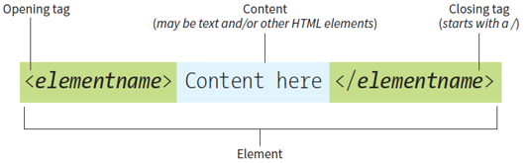

1. What is the purpose of DOCTYPE?

DOCTYPE is to show that you were currently coding in HTML

1. List one of the recommended use case of the H1 tag?

<h1>Page Title</h1>

1. Give an example of a nested tag.
2. What is the difference between block and inline?

|  |  |
| --- | --- |
| Block | 1. Block-level element always starts on a new line 2. Always takes up the full width available (stretched out to the left and right as far as it can) 3. Has a top and a bottom margin, whereas an inline element does not |
| Inline | 1. Does not start on a new line 2. Only takes up as much width as necessary |

1. What is a void tag? What are some examples of void tags?

Void tag: HTML tags that are self-closing

Examples: line break has no closing tag <br>

1. What is a character escape?

An HTML character escape is a piece of text ("string") that begins with an ampersand(&) and ends with a semicolon ( ; ) . Entities are frequently used to display reserved characters like: ∞ © ® ™ Ω α

Here’s the character code for the infinity symbol: &infin;

1. What are the different types of lists and how can you tell the difference by looking at the code?

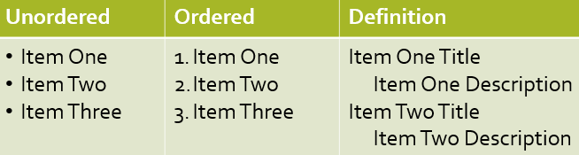

<ol> <!-- This is an ordered list-->

            <li>First Item</li>

            <li>Second Item</li>

           </ol>

           <ul> <!-- This is an unordered list-->

            <li>First Item</li>

            <li>Second Item</li>

           </ul>

## Week 3

1. What is fair use?

To allow for limited and reasonable uses as long as the use does not interfere with owners’ rights or impede their right to do with the work as they wish.

1. What are some examples of text that cannot be copywritten?

You cannot copywrite recipes ingredient lists as well as the directions

1. What is transformation? What is an example of changing intellectual property that doesn't satisfy the transformation definition?

Taking someone else’s work and change it in someway so that contributes to fair use.

Photographer who took a picture of a sculpture and then sued a sculpturer who made a sculpture from it.

A parody is an example of transformation.

If you want to write a review of something, you can write some quotes from the book as long as it’s not too long. But you have to cite it.

1. What is an HTML attribute and what is an example of an attribute?

HTML attributes provide additional information about elements

Usually come in name/value pairs like: name=”value”

Attributes are always specified in the start tag

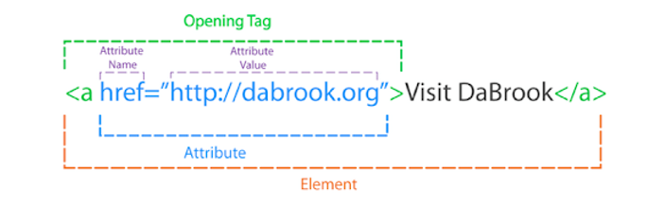

1. What is the difference between a relative link and an external link?

External link: full url including http

Example: <a href= “<http://www.google.com>”> Google</a>

Relative link: Refer to page based on the current page’s relative location

Example: <a href= “about.html”>Page in Same Folder<a/>

1. Why is the 'alt' attribute important in an image tag?

Describes image as text

1. What is the attribute href used for?

used to link to local files or files on the internet.

1. What does the notations ../ do? Give an example of how it should be used.

Every time you go up to a parent folder you add a ../

Every time you go down to a sub folder you add a /folder_name where folder_name is the actual name of your folder

1. What does the src attribute do? What element is it associated with?

Specifies image location

1. What does the iframe tag do?

Iframe is used to embed a link or media onto your own web page.

## Week 4

1. What are tables used for?

Tables are used to display information in an organized fashion

1. What is the difference between the td and th tags?

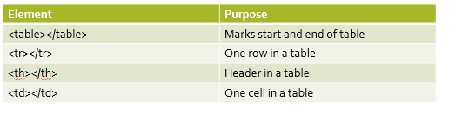

1. What does the method attribute do? What does the action attribute do?

Method: defines how form is processed and what method is used to send data

Action: Will contain elements with form control elements (checkboxes, dropdowns, text boxes)

1. What is the difference between get and post?

Get: sends the form data across the url

Post: sends the form data on a special header with the http request

1. Why do we need the label element? What does the for attribute do inside the label element?

Label element is to create a label and the for attribute assigns the label value is a codename/value (backend)

1. What form element would you use to allow someone to type paragraphs of text?

Text area

1. What form element would you use if you wanted to force someone to type one of three options? Is there another form element that works just as well?

Input with type radio and select box

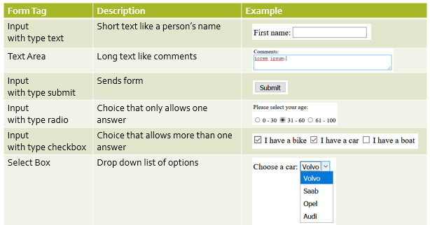

## Kahoot

1. What does HTML stand for?

Hypertext Markup Language

1. Which of the following HTML elements is sued for making any text bold?

strong

1. Which of the following HTML element is used for creating an unordered list?

ul

1. Which of the following characters indicate closing of a tag?

/

1. Which of the following attributes is used to add link to any element?

href

1. Which of the following is the correct way of creating a hyperlink in HTML?

<a href= <http://www.google.com>>google</a>

1. Which of the following tags is used to add a line-break in HTML?

<br>

1. Who is making the Web standards?

World Wide Web Consortium

1. Choose the correct HTML element for the largest heading:

h1

1. How can you open a link in a new tab/browser window?

<a href= “page.html” target=”_blank”>page</a>