William Chen IST 323 – M002

Professor Christopher Croad 10/23/2020

Lab #3 - Encrypting and Decrypting Web Traffic with HTTPS

1. **Part One, Step #10: Certificate in my name**
2. **Part One, Step #17: Site biding configuration**

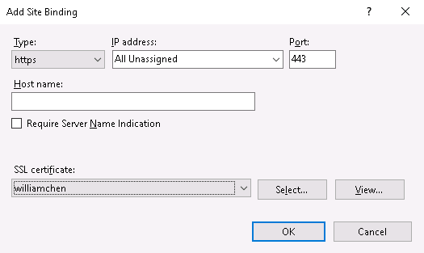

1. **Part Two, Step #8: Certificate dialog box**

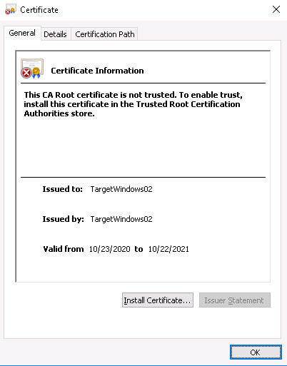

1. **Part Two, Step #10: Certificate expiration date**

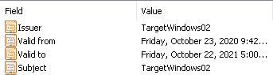

**Lessons learned**

I learned how to encrypt traffic with HTTPS. This was the first time I’ve seen a certificate problem when accessing a website, and I learned that you could look into the certificate details of that website. Knowing who the certificate is registered to allows me to research that certificate owner to see if I want to continue to the site. Also, seeing the validity dates tells me when the certificate was created. For some reason, I also thought that certificates lasted for years, rather than one year, and having to renew it every year. I also learned that anyone could make self-registered certificates, but to have it approved or trusted, you have to pay for it.