Course_Project_Week2

Chien-Hua Wang

January 16, 2019

## download zip file containing data if it hasn’t already been downloaded

zipUrl <- "https://d396qusza40orc.cloudfront.net/repdata%2Fdata%2Factivity.zip"  
zipFile <- "Activity Monitoring Data.zip"  
if (!file.exists(zipFile)) {  
 download.file(zipUrl, zipFile, mode = "wb")  
}

## unzip zip file containing data if data directory doesn’t already exist

dataPath <- "Activity Monitoring Data"  
if (!file.exists(dataPath)) {  
 unzip(zipFile)  
}

## Import data

activitydf <- read.csv("activity.csv")  
# Format steps and date   
activitydf$date = as.Date(activitydf$date)

### 1. Calculate the total number of steps taken per day

Total_Steps = activitydf %>%  
 select(date, steps) %>%  
 group_by(date) %>%  
 summarize(steps = sum(steps))  
head(Total_Steps,10)

## # A tibble: 10 x 2  
## date steps  
## <date> <int>  
## 1 2012-10-01 NA  
## 2 2012-10-02 126  
## 3 2012-10-03 11352  
## 4 2012-10-04 12116  
## 5 2012-10-05 13294  
## 6 2012-10-06 15420  
## 7 2012-10-07 11015  
## 8 2012-10-08 NA  
## 9 2012-10-09 12811  
## 10 2012-10-10 9900

### 2. Histogram of the total number of steps taken each day

ggplot(Total_Steps, aes(x = steps)) +  
 geom_histogram(fill = "blue", binwidth = 900) +  
 labs(title = "Daily Steps", x = "Steps", y = "Frequency")

## Warning: Removed 8 rows containing non-finite values (stat_bin).

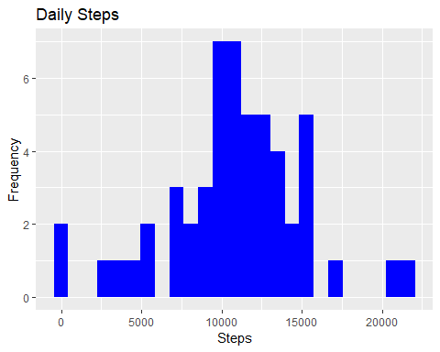

### 3. Mean and median number of steps taken each day

Total_Steps %>%  
 select(steps) %>%  
 summarise(Mean_Steps = mean(steps,na.rm=T),  
 Media_Steps = median(steps, na.rm=T))

## # A tibble: 1 x 2  
## Mean_Steps Media_Steps  
## <dbl> <int>  
## 1 10766. 10765

### 4. Time series plot of the average number of steps taken

Intervaldf = activitydf %>%  
 select(steps, interval) %>%  
 group_by(interval) %>%  
 summarise(steps = mean(steps, na.rm=T))  
ggplot(Intervaldf, aes(x = interval , y = steps)) + geom_line(color="blue", size=1) + labs(title = "Avg. Daily Steps", x = "Interval", y = "Avg. Steps per day")

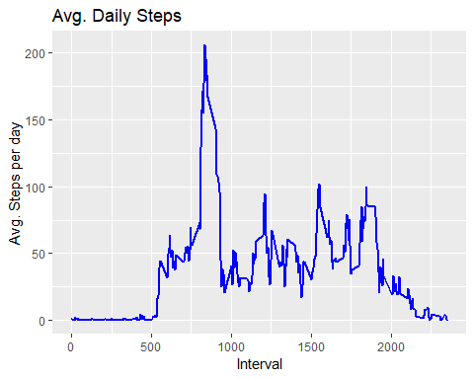

### 5. The 5-minute interval that, on average, contains the maximum number of steps

Intervaldf %>%  
 filter(steps == max(steps)) %>%  
 select(interval) %>%  
 summarize(max_interval = interval)

## # A tibble: 1 x 1  
## max_interval  
## <int>  
## 1 835

### 6. Code to describe and show a strategy for imputing missing data

#### Using the mean value to fill NA

sapply(activitydf,function(x) sum(is.na(x)))

## steps date interval   
## 2304 0 0

newactivitydf = activitydf %>%  
 mutate(steps = replace_na(steps,mean(steps,na.rm=T)))  
  
sapply(newactivitydf,function(x) sum(is.na(x)))

## steps date interval   
## 0 0 0

# Create a new dataset that is equal to the original dataset but with the missing data filled in.  
# write.csv(newactivitydf,file='tidyData_activity.csv')

### 7. Histogram of the total number of steps taken each day after missing values are imputed

Total_Steps = newactivitydf %>%  
 select(date, steps) %>%  
 group_by(date) %>%  
 summarize(steps = sum(steps))  
  
ggplot(Total_Steps, aes(x = steps)) +  
 geom_histogram(fill = "blue", binwidth = 900) +  
 labs(title = "Daily Steps", x = "Steps", y = "Frequency")

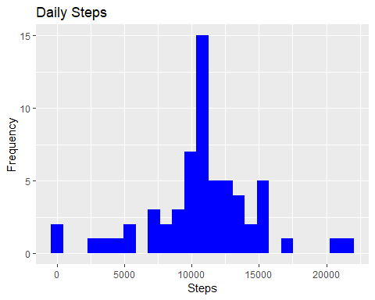

Total_Steps %>%  
 select(steps) %>%  
 summarise(Mean_Steps = mean(steps,na.rm=T),  
 Media_Steps = median(steps, na.rm=T))

## # A tibble: 1 x 2  
## Mean_Steps Media_Steps  
## <dbl> <dbl>  
## 1 10766. 10766.

### 8.Panel plot comparing the average number of steps taken per 5-minute interval across weekdays and weekends

activitydf <- read.csv("activity.csv")  
activitydf = activitydf %>%  
 mutate(steps = replace_na(steps,mean(steps,na.rm=T)),  
 date = as.Date(date),  
 `Day of week` = weekdays(date),  
 `weekday or weekend` = ifelse(grepl(pattern = "Monday|Tuesday|Wednesday|Thursday|Friday",`Day of week`),"weekday", "weekend"),  
 `weekday or weekend` = as.factor(`weekday or weekend`)) %>%  
 select(everything()) %>%  
 group_by(interval, `weekday or weekend`) %>%  
 summarise(steps = mean(steps))  
  
ggplot(activitydf , aes(x = interval , y = steps, color=`weekday or weekend`)) + geom_line() + labs(title = "Avg. Daily Steps by Weektype", x = "Interval", y = "No. of Steps") + facet_wrap(~`weekday or weekend` , ncol = 1, nrow=2)

