Model 0 LSTM 50 nodes, 50 epochs

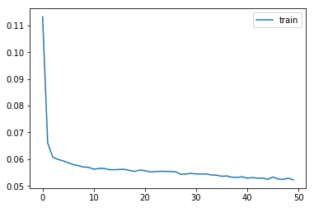

Model 1 LSTM 50 nodes, LSTM 50 nodes, 50 epochs

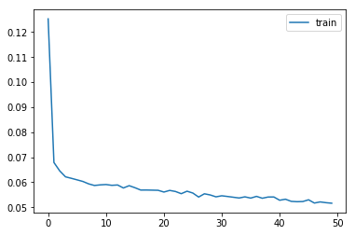

Model 2 LSTM 100 nodes 50 epochs

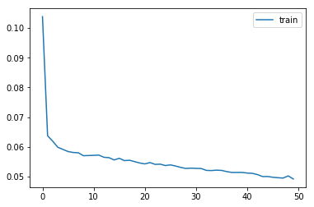

Model 3 : LSTM 100 nodes, 150 epochs

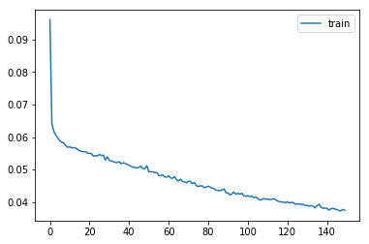

Model 7 : GRU 100 nodes, dropout = 0.2

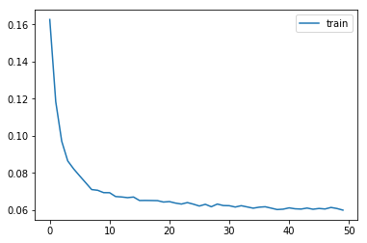

Model 8: LSTM (50) + LSTM(100)

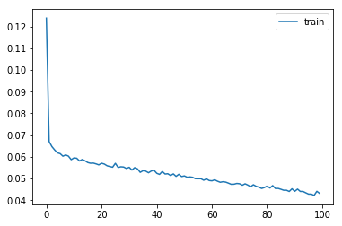

Model 9: LSTM (50, dropout 0.3) + LSTM(100, dropout 0.2)

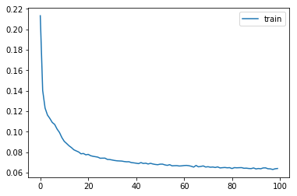

Model 10: SimpleRNN (50), 100 epochs

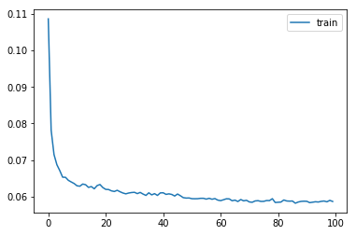

Model 11: Simple RNN 100 nodes

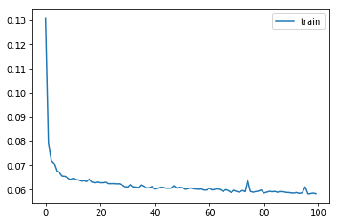

Model 12: Simple RNN 50 nodes 500 epochs

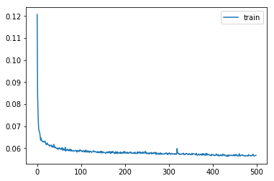

Model 13: Simple RNN (50, activation ReLU)

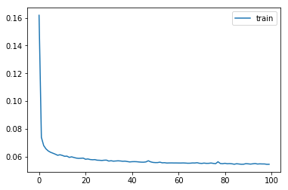

Model 14: LSTM (200)

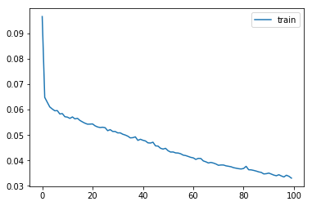

Model 15: LSTM(100), LSTM(50), LSTM(25)

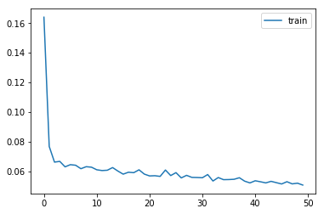

Model 16: LSTM (100), LSTM(100), LSTM(50)

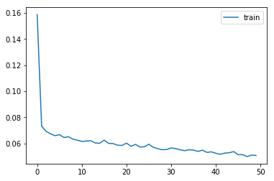

Model 17 : Conv1D(28,4,relu), LSTM(100)

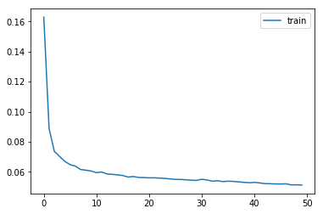

Model 18: Bidirectional LSTM(50)

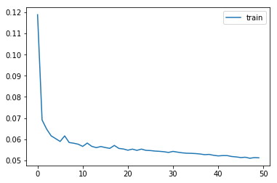

Model 19: Bidirectional LSTM(50, dropout = 0.3)

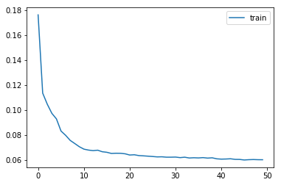

Model 20: LSTM(100, stateful, batch size = 378)

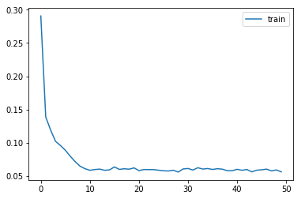

Model 21: GRU(100, stateful, batch size = 378)

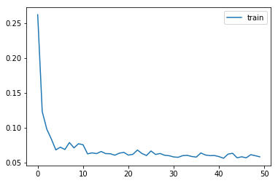

Model 22: GRU(200, stateful, batch size = 378)

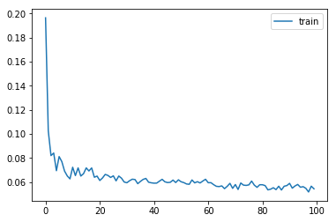

Model 23: GRU(50, stateful, batch size = 378)

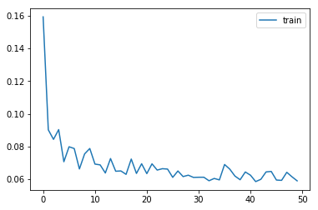

Model 24: LSTM(50, stateful, batch size = 378)

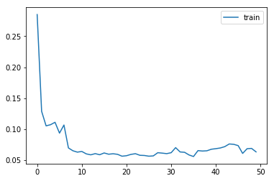

Model 25: LSTM(50, stateful, batch size = 189)

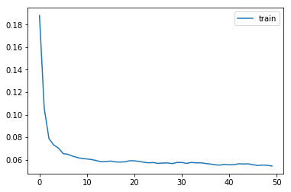

Model 26: LSTM(50, stateful, batch size = 837)

