RCFS – The REDCap “File Server” Plugin.

Introduction
RCFS is a REDCap plugin that’s designed to distribute simple html and text based output within the context of a REDCap project. It does this while respecting REDCap authorization, project user roles and Data Access Groups.
The plugin requires ad-hoc reports to be generated outside of REDCap using tools such as R and SAS. The resulting files are placed in a location that is assessable from the REDCap server (i.e. on the server or a shared drive). From here the files are exposed through the REDCap user interface based on project ID and Data Access Group (DAG). The mechanism by which the files arrive in this location is beyond the scope of this plugin. However the files could, for example, be written directly by the data processing application (SAS, R, etc.) or they could be copied by a utility such as Rsync, SCP or SFTP. Additionally the jobs that create these files could be scheduled to run at intervals, for example to create weekly project management metrics for the study.

Installation
No database configuration is required.

Application Files
The application consists of two separate php files:
- rcfs.php and
- rcfs_serve.php
Place the two files in the same folder, either the main plugins folder or a sub-folder. In our installation we have the two files placed in the main plugins folder (/var/www/redcap/plugins). Under these circumstances the URL for the plugin will look something like https://mydomain.com/plugins/rcfs.php.
The files must be readable and executable by your web server/php process. The permissions required for this will vary depending on your operating system configuration.

Bookmarks
In each project where you want to use the plugin you should create a project bookmark, similar to the example below. Make sure that Append Project ID to URL is checked. Users will access the plugin via the bookmark.

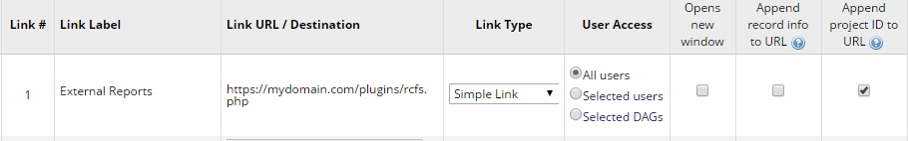

Report Files
Modify both the rcfs.php and rcfs_serve.php files so that the $file_root variable reflects the location where your report files are going to be placed. Make sure that both these files use the same location.
Organize sub-folders beneath the file root as follows:
Root ($file_root)
Project Folders (Named after project ID)
DAG Folders (Named after REDCap’s Unique Group Name)
For example:
/home/reports
/home/reports/114
/home/reports/114/Edmonton
/home/reports/114/Calgary
Place your report files in the appropriate folder. Files in the project level folder will be available to users who have access to the project, but who do not belong to a Data Access Group. Files placed in a DAG folder will be available to users who:
- have access to the project
- are not in a DAG, or
- are assigned to a DAG with the same Unique Group Name as the folder.

Operation
A REDCap user accesses the RCFS plugin by clicking the bookmark in the project menu to the left of a REDCap project page.
If the user has Data Export rights within the project then the plugin displays files as follows:
- If the user belongs to a Data Access Group then the plugin displays all available files based on the user’s DAG.
- If the user does not belong to a DAG then the plugin displays all files that are not for a DAG, followed by the name and files for each DAG, in alphabetical order, by DAG.
For each supported file (currently html, pdf, txt, jpg, png and log files) the plugin lists the filename, date of modification and a title.
- In the case of html files the title displayed is retrieved directly from the page title in the files html metadata. If the page title does not exist then “Untitled HTML File” will be displayed instead.
- For log files the plugin displays “Log file”
- For txt files the plugin displays “Text File”.

