CHAPTER ONE
INTRODUCTION
1.1 General Introduction
The healthcare sector is a critical component of any society, and the effective management of hospital information is essential for delivering quality healthcare services. Traditionally, hospitals have relied on manual record-keeping and paper-based systems, which are prone to errors, inefficiencies, and data loss. In recent years, the adoption of computerized Hospital Information Management Systems (HIMS) has become increasingly important to address these challenges.
This project focuses on the design and implementation of a Hospital Information Management System aimed at streamlining hospital operations, improving patient care, and enhancing data security. The system was developed using PHP, MySQL, HTML, CSS, and JavaScript, providing a robust and user-friendly platform for managing patient records, staff information, appointments, and billing. The development process involved requirements gathering, system design, implementation, and testing to ensure the system meets the needs of hospital administrators and healthcare professionals.

1.2 Statement of the Problem
Hospitals often face significant challenges in managing large volumes of patient data, staff records, and administrative processes. Manual systems are time-consuming, susceptible to human error, and make it difficult to retrieve or update information efficiently. These issues can lead to delays in patient care, loss of critical data, and overall inefficiency in hospital operations. There is a clear need for an automated system that can securely store, manage, and retrieve hospital information, thereby improving service delivery and operational efficiency.
1.3 Aim and Objectives of the Study
Aim:
The aim of this study is to design and implement a Hospital Information Management System.

Objectives:
The specific objectives of the study are:
i. To analyze the requirements for an effective hospital information management system.
ii. To design a user-friendly and secure system for managing hospital data.
iii. To develop and implement the system using appropriate technologies.
iv. To test and evaluate the system’s performance and usability.
v. To provide recommendations for future enhancements.

1.4 Significance of the Study
This study is significant as it addresses the pressing need for efficient information management in hospitals. The proposed system will benefit hospital administrators, healthcare professionals, and patients by providing quick access to accurate information, reducing paperwork, and improving overall service delivery. It will also serve as a reference for future research and development in healthcare information systems.

1.5 Scope of the Study
The scope of this study is limited to the design and implementation of a Hospital Information Management System for a typical hospital setting. The system covers patient registration, staff management, appointment scheduling, and billing. It does not include advanced features such as telemedicine, integration with external laboratories, or mobile application support. The study is geographically limited to a selected hospital and covers data collected within the 2024/2025 academic session.

1.6 Limitation of the Study
The study faced several limitations, including limited access to real hospital data due to privacy concerns, time constraints, and resource limitations. Additionally, the system was tested in a simulated environment rather than a live hospital setting, which may affect the generalisability of the results.

1.7 Definition of Terms
- Hospital Information Management System (HIMS): A computerized system designed to manage hospital operations and information.
- Patient Record: Digital documentation of a patient’s medical history and treatment.
- Database: An organized collection of structured information or data, typically stored electronically.
- User Interface: The means by which users interact with a computer system.
- Automation: The use of technology to perform tasks with minimal human intervention.

CHAPTER TWO
LITERATURE REVIEW
2.1 Theoretical Concept
Hospital Information Management Systems (HIMS) are specialized information systems designed to manage the administrative, financial, and clinical aspects of a hospital. The theoretical foundation of HIMS is rooted in information systems theory, which emphasizes the collection, storage, processing, and dissemination of information to support decision-making and improve organizational efficiency (Laudon & Laudon, 2020).

The evolution of HIMS has been influenced by advancements in database management, software engineering, and health informatics. Early systems were primarily focused on billing and scheduling, but modern HIMS now integrate electronic health records (EHR), laboratory information, pharmacy management, and more. The adoption of HIMS is driven by the need for accuracy, data security, and timely access to patient information, which are critical for effective healthcare delivery.

2.2 Review of Related Work
Several studies have explored the development and implementation of hospital information systems. For instance, Olatunji and Adebayo (2019) developed a web-based hospital management system that improved patient data retrieval and reduced administrative workload. Their methodology involved the use of PHP and MySQL, similar to the technologies adopted in this study. However, their system lacked advanced security features, which this project aims to address.

Another study by Chukwu et al. (2021) focused on the integration of electronic health records in Nigerian hospitals. The authors highlighted challenges such as user resistance and inadequate infrastructure, suggesting that user training and system customization are essential for successful implementation.

Despite these advancements, gaps remain in the areas of data security, user experience, and scalability. Many existing systems are not tailored to the specific needs of local hospitals, leading to underutilization. This project seeks to bridge these gaps by designing a customizable and secure HIMS that addresses the unique requirements of the target hospital.

CHAPTER THREE
METHODOLOGY
3.1 Data Collection
To ensure the system meets the needs of its users, I ensure accurate and reliable data were collected. Secondary data collection method was employed. The secondary data was obtained from textbooks, academic journals, and reputable online sources to review best practices and existing solutions in hospital information management.

3.2 Description of the Proposed System
The proposed Hospital Information Management System is a web-based application designed to automate and streamline hospital operations. The system architecture follows a client-server model, with the front-end developed using HTML, CSS, and JavaScript, and the back-end powered by PHP and MySQL.

A Data Flow Diagram (DFD) was used to illustrate the flow of information within the system, while an Entity Relationship Diagram (ERD) was created to model the database structure. The system is designed to handle patient registration, staff management, appointment scheduling, and billing.

3.3 Analysis of the Proposed System
The system analysis was conducted in the following phases:

- Input: Data is entered into the system through user-friendly forms for patient registration, staff details, and appointment scheduling.
- Output: The system generates reports such as patient lists, appointment schedules, and billing summaries, which can be viewed or printed by authorized users.
- Database: All data is stored in a MySQL database, ensuring data integrity and security. The database is structured to minimize redundancy and support efficient data retrieval.

3.4 System Design
The system was designed using the Unified Modelling Language (UML) methodology. Use case diagrams were developed to capture user interactions, while activity diagrams illustrated the workflow of key processes such as patient registration and billing. The design was validated through peer review and iterative prototyping to ensure technical feasibility and alignment with user requirements.

CHAPTER FOUR
IMPLEMENTATION AND RESULTS PRESENTATION
4.1 System Requirements
The successful implementation of the Hospital Information Management System required both hardware and software resources.

Hardware Requirements:
- A computer system with at least 4GB RAM and 250GB hard disk
- Intel Core i3 processor or higher
- Stable internet connection (for web-based access)

Software Requirements:
- Windows 10 or higher
- XAMPP (for Apache, PHP, and MySQL)
- Web browser (e.g., Google Chrome, Mozilla Firefox)
- Code editor (e.g., Visual Studio Code)

4.2 System Implementation
The system was implemented using a modular approach, with each module handling a specific aspect of hospital management.

- Input Interface:
User-friendly forms were developed for patient registration, staff management, and appointment scheduling. Validation was implemented to ensure data accuracy.

- Output Interface:
The system provides dashboards and printable reports for patient lists, appointment schedules, and billing summaries.

- Database Interface:
The MySQL database was designed with tables for patients, staff, appointments, and billing. PHP scripts handle all database interactions, ensuring data security and integrity.

4.3 Results Presentation
After implementation, the system was tested using sample data. The following screenshots shows the accuracy of results:

Figure 1: Login Page
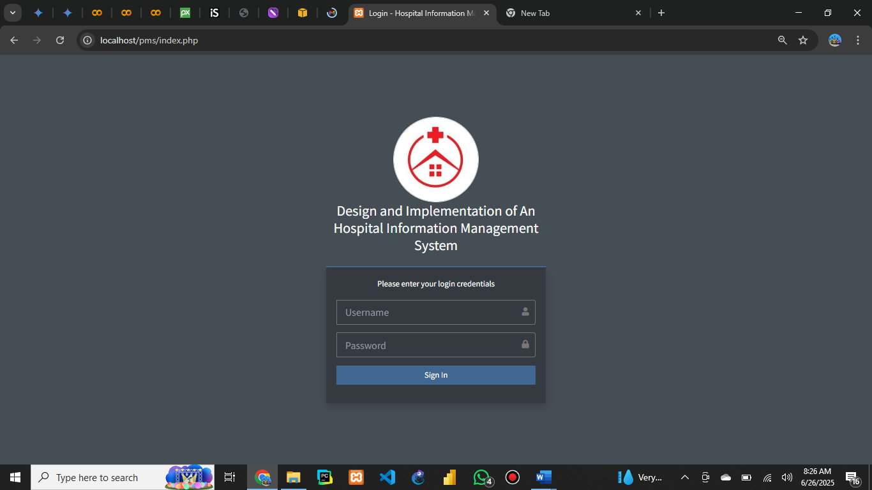

Figure 2: Dashboard
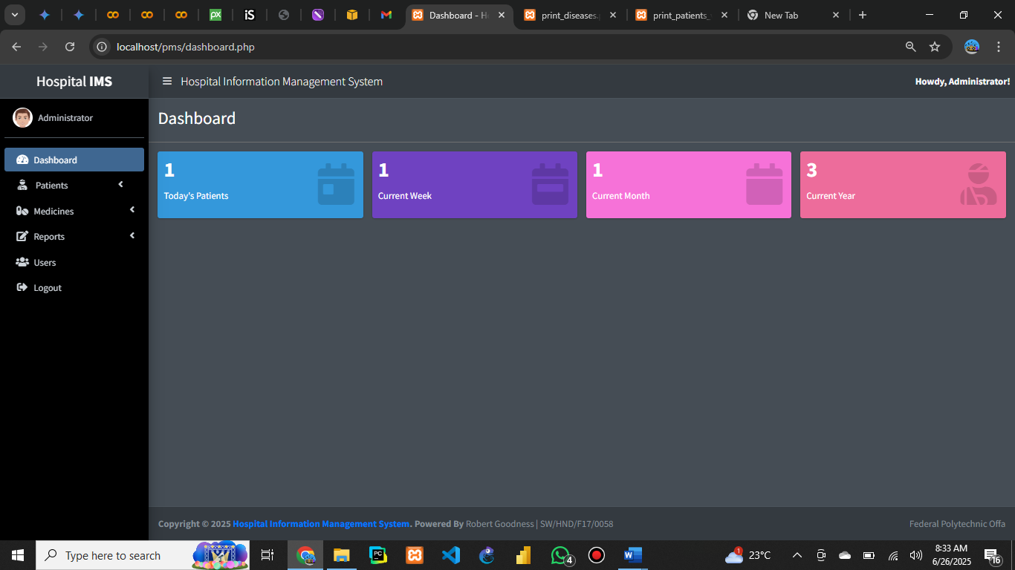
Figure 3: Add Drug Prescription
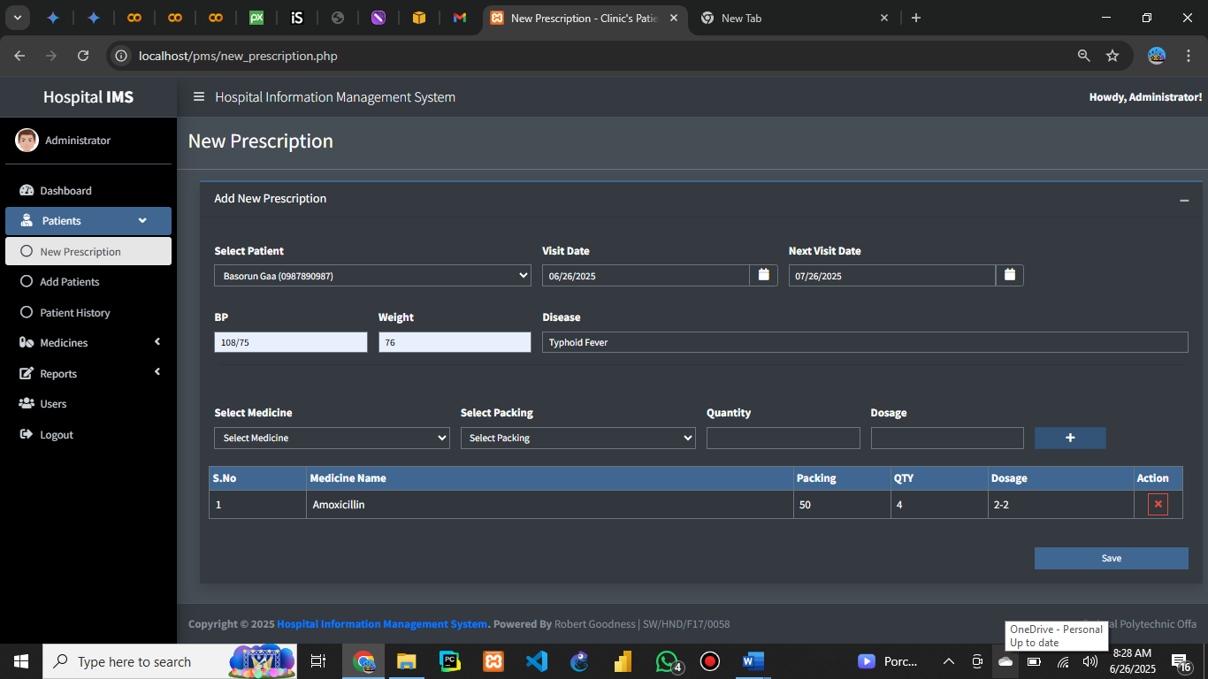

Figure 4: View Patients History with Appointment Details
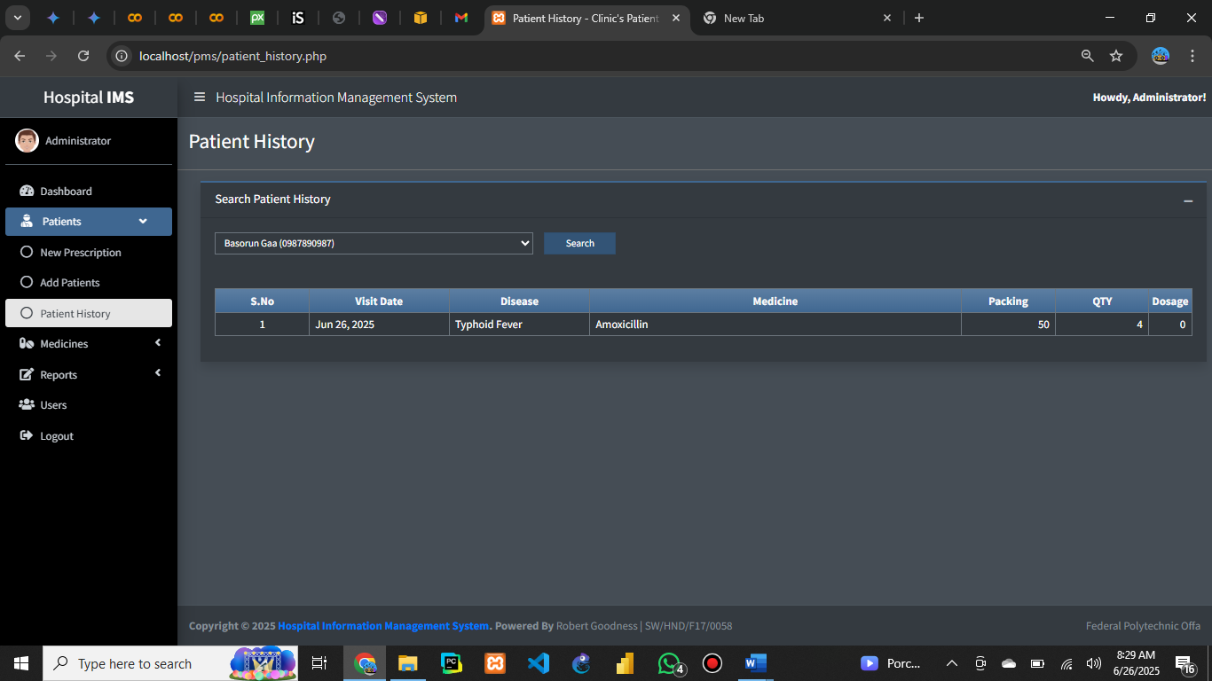
Figure 5: Add New Patient
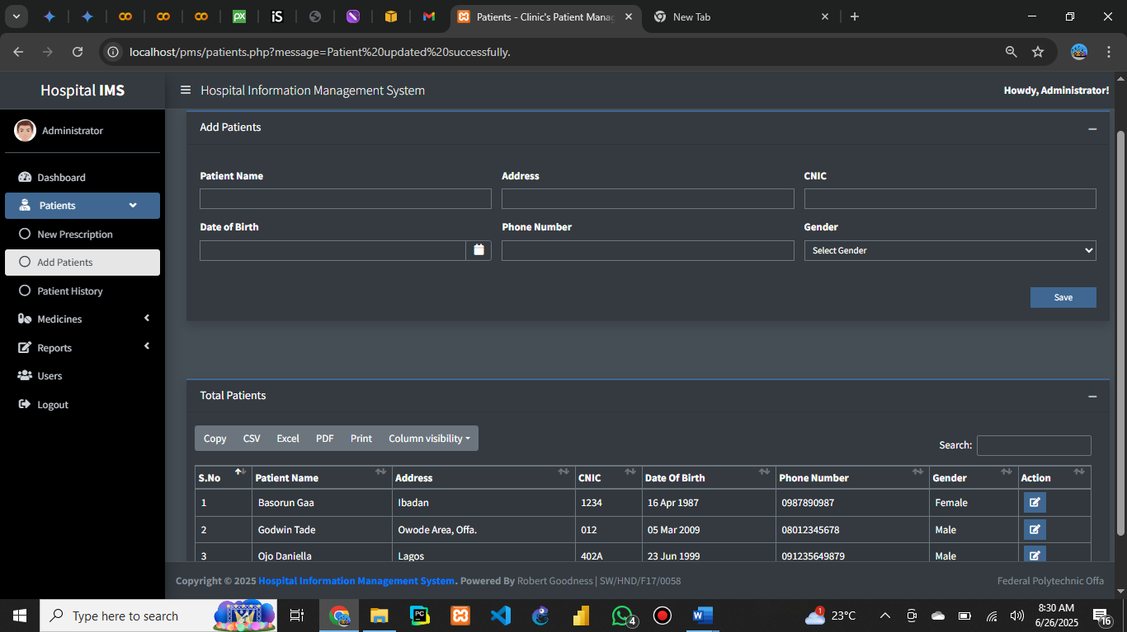

Figure 6: Add Medicine
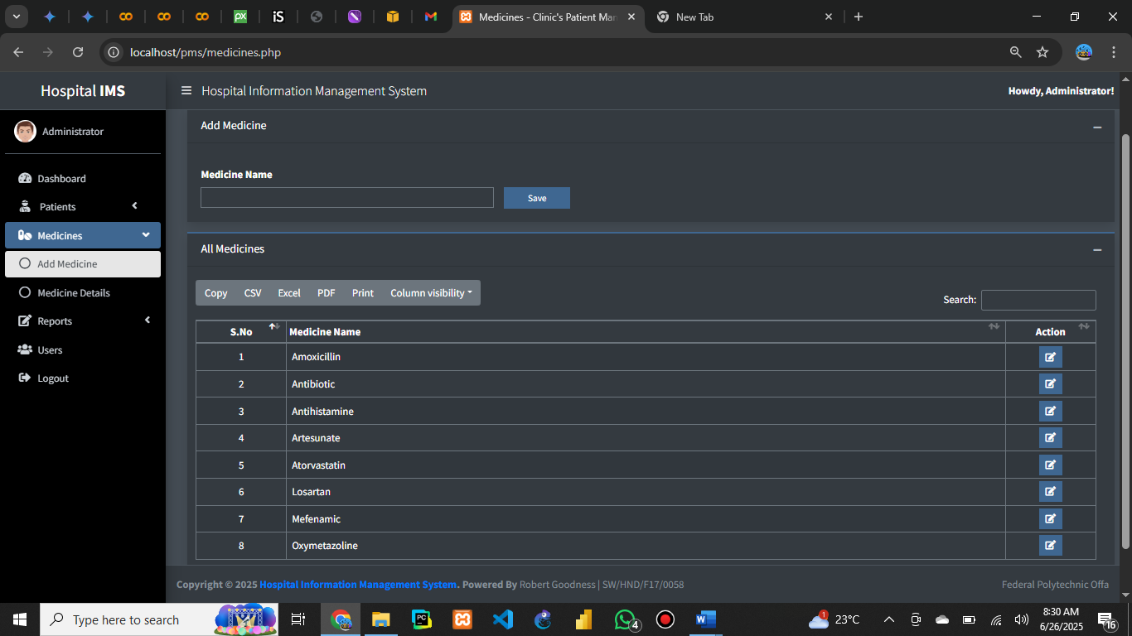
Figure 7: Add Medicine Details
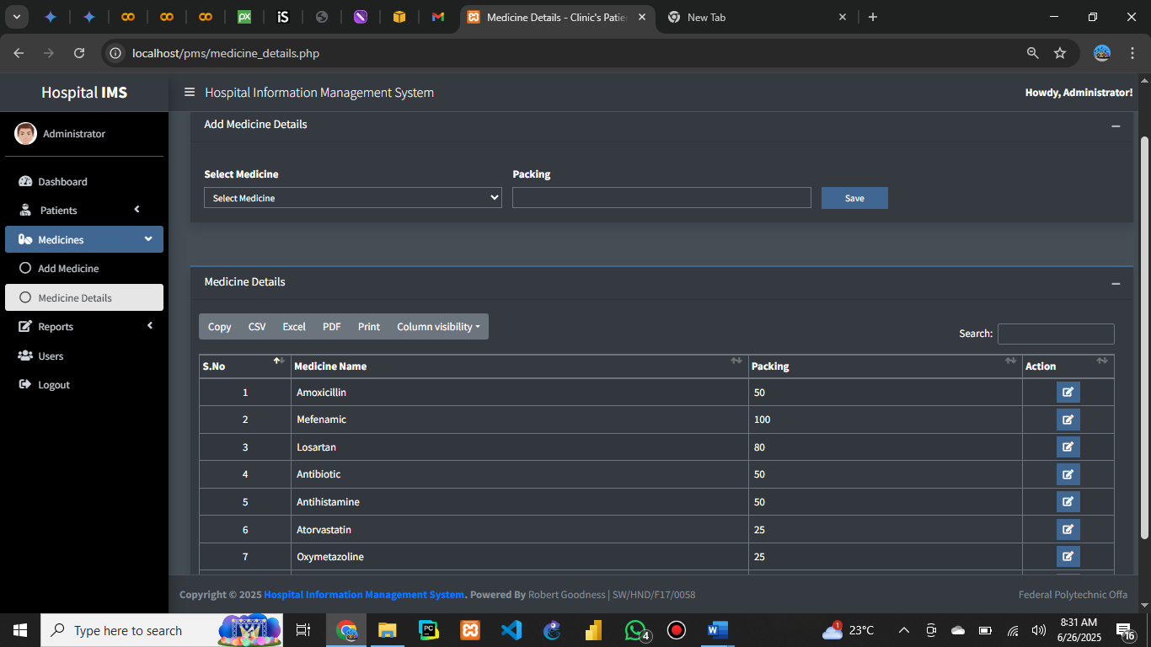

Figure 8: Create Reports
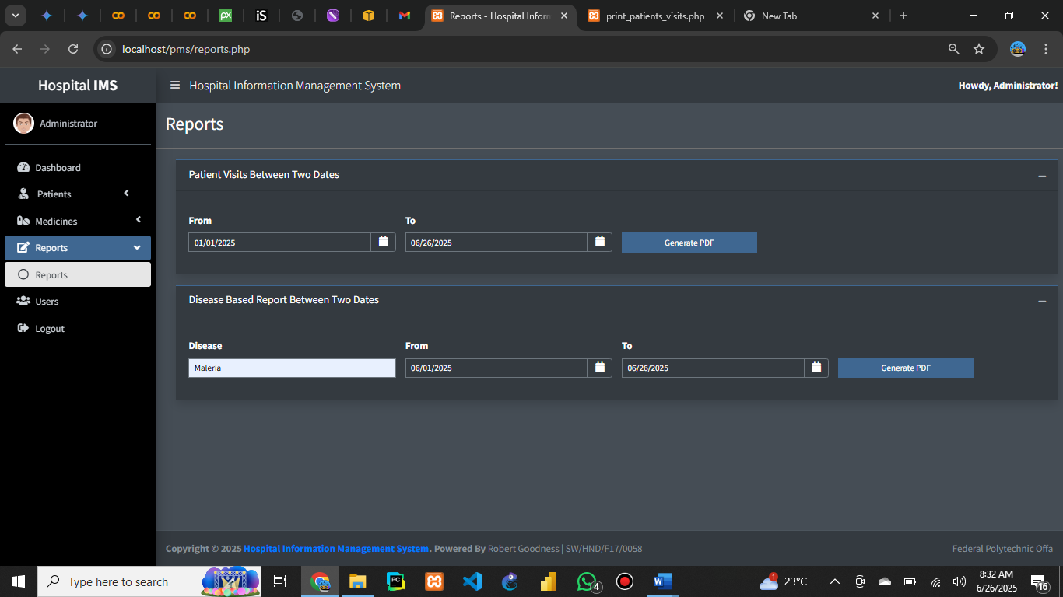
Figure 9: Patients Report
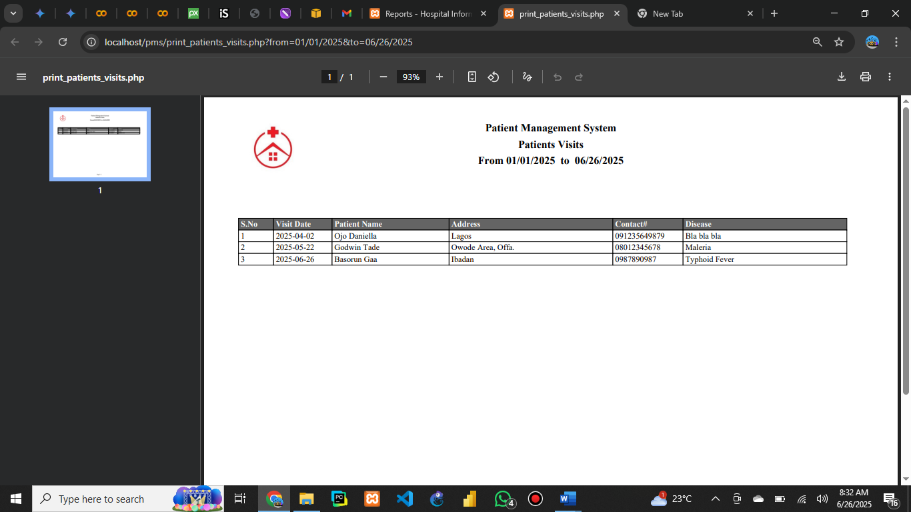

Figure 10: Disease’ Report
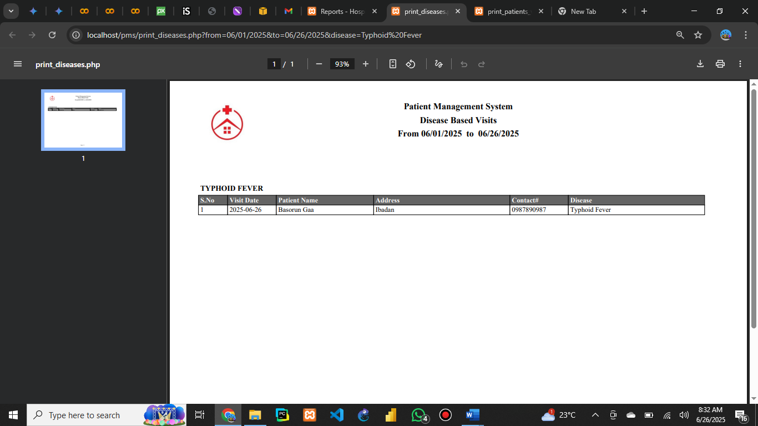
Figure 11: Users
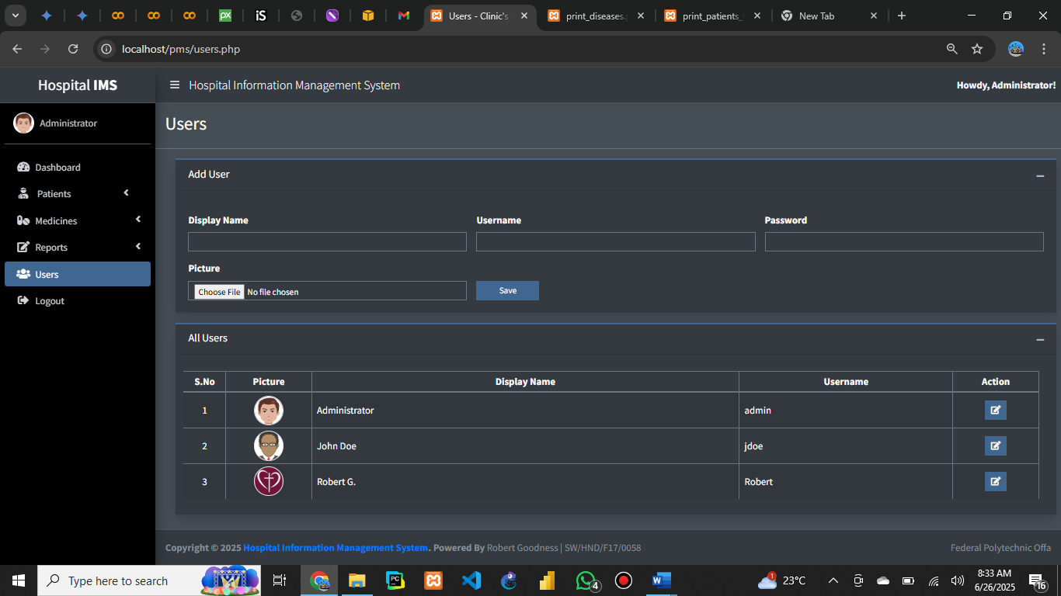

Patient records, staff lists, and appointment schedules were accurately stored and retrieved from the database, hence making this research work a success.

4.4 System Evaluation/Testing
The system was evaluated based on functionality, usability, and performance.

- Validation:
The system met the requirements identified during the analysis phase, providing accurate and timely information.
- Verification:
Test cases were executed to ensure correct data processing and output generation. Peer review and user feedback were incorporated to improve usability.

- Evaluation:
The system demonstrated improved efficiency compared to manual processes, with faster data retrieval and reduced errors.

  - System Documentation and Maintenance
- Program Documentation:
Each module was documented, detailing input fields, processing logic, and expected outputs.

- System Documentation:
Technical specifications, including database schema and system architecture, were compiled for future reference.
- Operational Documentation:
Instructions for system setup, backup, and maintenance were provided.
- User Documentation:
A README file was developed to guide users in using the system effectively.

4.6 Benefits of the System
- The implemented Hospital Information Management System offers several benefits:
- Streamlined hospital operations and reduced paperwork
- Improved data accuracy and security
- Faster access to patient and staff information
- Enhanced decision-making through timely reports
- Scalability for future enhancements

CHAPTER FIVE
SUMMARY, CONCLUSION AND RECOMMENDATION
5.1 Summary
This project focused on the design and implementation of a Hospital Information Management System to address the inefficiencies and challenges associated with manual hospital record-keeping. The study began by identifying the need for an automated system to improve data accuracy, security, and accessibility. A thorough literature review highlighted existing solutions and gaps in current practices. The methodology involved gathering requirements through interviews and questionnaires, designing the system architecture using UML diagrams, and implementing the solution with PHP, MySQL, HTML, CSS, and JavaScript. The system was tested with sample data, and results showed significant improvements in operational efficiency and data management.

5.2 Conclusion
The Hospital Information Management System developed in this project successfully achieved its objectives. It provides a secure, user-friendly platform for managing patient records, staff information, appointments, and billing. The system reduces paperwork, minimizes errors, and enhances the speed and accuracy of information retrieval. By addressing the problems identified in the manual system, the project demonstrates the value of automation in healthcare management and sets a foundation for further enhancements.

5.3 Recommendation
Based on the findings and results of this study, the following recommendations are made:
- Hospitals should adopt computerized information management systems to improve efficiency and service delivery.
- Regular training should be provided to staff to ensure effective use of the system.
- Future enhancements could include integration with laboratory and pharmacy modules, support for mobile devices, and implementation of advanced security features such as two-factor authentication.
- Further research should be conducted to assess the system’s performance in a live hospital environment and to gather feedback from a wider range of users.

References
Chukwu, E., Eze, G., & Okafor, C. (2021). Integration of Electronic Health Records in Nigerian
Hospitals: Challenges and Prospects. African Journal of Health Informatics, 12(2), 45-
53.
Laudon, K. C., & Laudon, J. P. (2020). Management Information Systems: Managing the Digital
Firm (16th ed.). Pearson.
Olatunji, A., & Adebayo, S. (2019). Development of a Web-Based Hospital Management System.
International Journal of Computer Applications, 178(7), 15-22.

APPENDICES
Appendix i: Program Flowchart

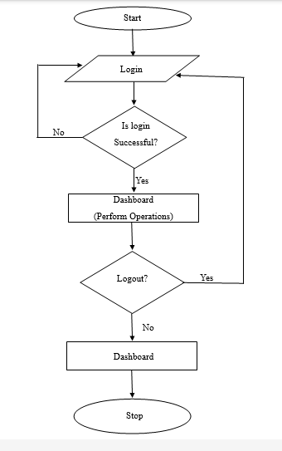

Appendix ii: Program Source Code
Login Page
<?php
include './config/connection.php';

$message = '';

if(isset($_POST['login'])) {
$userName = $_POST['user_name'];
$password = $_POST['password'];

$encryptedPassword = md5($password);

$query = "select `id`, `display_name`, `user_name`,
`profile_picture` from `users`
where `user_name` = '$userName' and
`password` = '$encryptedPassword';";

try {
$stmtLogin = $con->prepare($query);
$stmtLogin->execute();

$count = $stmtLogin->rowCount();
if($count == 1) {
$row = $stmtLogin->fetch(PDO::FETCH_ASSOC);

$_SESSION['user_id'] = $row['id'];
$_SESSION['display_name'] = $row['display_name'];
$_SESSION['user_name'] = $row['user_name'];
$_SESSION['profile_picture'] = $row['profile_picture'];

header("location:dashboard.php");
exit;

} else {
$message = 'Incorrect username or password.';
}
} catch(PDOException $ex) {
echo $ex->getTraceAsString();
echo $ex->getMessage();
exit;
}

}
?>
<!DOCTYPE html>
<html lang="en">
<head>
<meta charset="utf-8">
<meta name="viewport" content="width=device-width, initial-scale=1">
<title>Login - Hospital Information Management System</title>

<!-- Google Font: Source Sans Pro -->
<link rel="stylesheet" href="https://fonts.googleapis.com/css?family=Source+Sans+Pro:300,400,400i,700&display=fallback">
<!-- Font Awesome -->
<link rel="stylesheet" href="plugins/fontawesome-free/css/all.min.css">
<!-- icheck bootstrap -->
<link rel="stylesheet" href="plugins/icheck-bootstrap/icheck-bootstrap.min.css">
<!-- Theme style -->
<link rel="stylesheet" href="dist/css/adminlte.min.css">

<style>

.login-box {
width: 430px;
}

#system-logo {
width: 5em !important;
height: 5em !important;
object-fit: cover;
object-position: center center;
}
</style>
</head>
<body class="hold-transition login-page dark-mode">
<div class="login-box">
<div class="login-logo mb-4">
<img src="dist/img/logo.jpg" class="img-thumbnail p-0 border rounded-circle" id="system-logo">
<div class="text-center h3 mb-0">Design and Implementation of An Hospital Information Management System</div>
</div>
<!-- /.login-logo -->
<div class="card card-outline card-primary rounded-0 shadow">
<div class="card-body login-card-body">
<p class="login-box-msg">Please enter your login credentials</p>
<form method="post">
<div class="input-group mb-3">
<input type="text" class="form-control form-control-lg rounded-0 autofocus"
placeholder="Username" id="user_name" name="user_name">
<div class="input-group-append">
<div class="input-group-text">
<span class="fas fa-user"></span>
</div>
</div>
</div>
<div class="input-group mb-3">
<input type="password" class="form-control form-control-lg rounded-0"
placeholder="Password" id="password" name="password">
<div class="input-group-append">
<div class="input-group-text">
<span class="fas fa-lock"></span>
</div>
</div>
</div>
<div class="row">
<div class="col-12">
<button name="login" type="submit" class="btn btn-primary rounded-0 btn-block">Sign In</button>
</div>
<!-- /.col -->
</div>

<div class="row">
<div class="col-md-12">
<p class="text-danger">
<?php
if($message != '') {
echo $message;
}
?>
</p>
</div>
</div>
</form>

</div>
<!-- /.login-card-body -->
</div>
</div>
<!-- /.login-box -->

<!-- jQuery -->

</body>
</html>s
Dashboard
<?php
include './config/connection.php';

$date = date('Y-m-d');

$year = date('Y');
$month = date('m');

$queryToday = "SELECT count(*) as `today`
from `patient_visits`
where `visit_date` = '$date';";

$queryWeek = "SELECT count(*) as `week`
from `patient_visits`
where YEARWEEK(`visit_date`) = YEARWEEK('$date');";

$queryYear = "SELECT count(*) as `year`
from `patient_visits`
where YEAR(`visit_date`) = YEAR('$date');";

$queryMonth = "SELECT count(*) as `month`
from `patient_visits`
where YEAR(`visit_date`) = $year and
MONTH(`visit_date`) = $month;";

$todaysCount = 0;
$currentWeekCount = 0;
$currentMonthCount = 0;
$currentYearCount = 0;

try {

$stmtToday = $con->prepare($queryToday);
$stmtToday->execute();
$r = $stmtToday->fetch(PDO::FETCH_ASSOC);
$todaysCount = $r['today'];

$stmtWeek = $con->prepare($queryWeek);
$stmtWeek->execute();
$r = $stmtWeek->fetch(PDO::FETCH_ASSOC);
$currentWeekCount = $r['week'];
$stmtYear = $con->prepare($queryYear);
$stmtYear->execute();
$r = $stmtYear->fetch(PDO::FETCH_ASSOC);
$currentYearCount = $r['year'];

$stmtMonth = $con->prepare($queryMonth);
$stmtMonth->execute();
$r = $stmtMonth->fetch(PDO::FETCH_ASSOC);
$currentMonthCount = $r['month'];

} catch(PDOException $ex) {
echo $ex->getMessage();
echo $ex->getTraceAsString();
exit;
}

?>
<!DOCTYPE html>
<html lang="en">
<head>
<?php include './config/site_css_links.php';?>
<title>Dashboard - Hospital Information Management System</title>
<style>
.dark-mode .bg-fuchsia, .dark-mode .bg-maroon {
color: #fff!important;
}
</style>
</head>
<body class="hold-transition sidebar-mini dark-mode layout-fixed layout-navbar-fixed">
<!-- Site wrapper -->
<div class="wrapper">
<!-- Navbar -->

<?php

include './config/header.php';
include './config/sidebar.php';
?>
<!-- Content Wrapper. Contains page content -->
<div class="content-wrapper">
<!-- Content Header (Page header) -->
<section class="content-header">
<div class="container-fluid">
<div class="row mb-2">
<div class="col-sm-6">
<h1>Dashboard</h1>
</div>
</div>
</div><!-- /.container-fluid -->
</section>

<!-- Main content -->
<section class="content">
<div class="container-fluid">
<!-- Small boxes (Stat box) -->
<div class="row">
<div class="col-lg-3 col-6">
<!-- small box -->
<div class="small-box bg-info">
<div class="inner">
<h3><?php echo $todaysCount;?></h3>

<p>Today's Patients</p>
</div>
<div class="icon">
<i class="fa fa-calendar-day"></i>
</div>

</div>
</div>
<!-- ./col -->
<div class="col-lg-3 col-6">
<!-- small box -->
<div class="small-box bg-purple">
<div class="inner">
<h3><?php echo $currentWeekCount;?></h3>

<p>Current Week</p>
</div>
<div class="icon">
<i class="fa fa-calendar-week"></i>
</div>

</div>
</div>
<!-- ./col -->
<div class="col-lg-3 col-6">
<!-- small box -->
<div class="small-box bg-fuchsia text-reset">
<div class="inner">
<h3><?php echo $currentMonthCount;?></h3>

<p>Current Month</p>
</div>
<div class="icon">
<i class="fa fa-calendar"></i>
</div>

</div>
</div>
<!-- ./col -->
<div class="col-lg-3 col-6">
<!-- small box -->
<div class="small-box bg-maroon text-reset">
<div class="inner">
<h3><?php echo $currentYearCount;?></h3>

<p>Current Year</p>
</div>
<div class="icon">
<i class="fa fa-user-injured"></i>
</div>

</div>
</div>
</div>
</div>
</section>

<!-- /.content -->
</div>
<!-- /.content-wrapper -->

<?php include './config/footer.php';?>
<!-- /.control-sidebar -->
</div>
<!-- ./wrapper -->

<?php include './config/site_js_links.php';?>
<script>
$(function(){
showMenuSelected("#mnu_dashboard", "");
})
</script>

</body>
</html>

Users
<?php
include './config/connection.php';

$message = '';

if(isset($_POST['save_user'])) {
$displayName = $_POST['display_name'];
$userName = $_POST['user_name'];
$password = $_POST['password'];

$encryptedPassword = md5($password);

//$targetDir = "user_images/";
$baseName = basename($_FILES["profile_picture"]["name"]);

//time is a php function which gives unix time value.
//unix time value is all seconds from 1970

//abc.x.y.z.png

// $extArr = explode(".", $baseName);
// $extension = end($extArr);

//$targetFile = time(). '.'.$extension;

$targetFile = time().$baseName;
// 12312312312312312
//abc.jpg
//abc.jpg
//244574700_322087779604661_8207402889226768946_n

$status = move_uploaded_file($_FILES["profile_picture"]["tmp_name"],
'user_images/'.$targetFile);

if($status) {
try {
$con->beginTransaction();

$query = "INSERT INTO `users`(`display_name`,
`user_name`, `password`, `profile_picture`)
VALUES('$displayName', '$userName', '$encryptedPassword', '$targetFile');";

$stmtUser = $con->prepare($query);
$stmtUser->execute();

$con->commit();

$message = 'user registered successfully';

} catch(PDOException $ex) {
$con->rollback();
echo $ex->getTraceAsString();
echo $ex->getMessage();
exit;
}

} else {
$message = 'a problem occured in image uploading.';
}

header("location:congratulation.php?goto_page=users.php&message=$message");
exit;
}
$queryUsers = "select `id`, `display_name`, `user_name`,
`profile_picture` from `users`
order by `display_name` asc;";
$stmtUsers = '';

try {
$stmtUsers = $con->prepare($queryUsers);
$stmtUsers->execute();

} catch(PDOException $ex) {
echo $ex->getTraceAsString();
echo $ex->getMessage();
exit;
}
?>
<!DOCTYPE html>
<html lang="en">
<head>
<?php include './config/site_css_links.php';?>
<?php include './config/data_tables_css.php';?>
<title>Users - Clinic's Patient Management System in PHP</title>

<style>
.user-img{
width:3em;
width:3em;
object-fit:cover;
object-position:center center;
}
</style>
</head>
<body class="hold-transition sidebar-mini dark-mode layout-fixed layout-navbar-fixed">
<!-- Site wrapper -->
<div class="wrapper">
<!-- Navbar -->
<?php include './config/header.php';
include './config/sidebar.php';?>
<!-- Content Wrapper. Contains page content -->
<div class="content-wrapper">
<!-- Content Header (Page header) -->
<section class="content-header">
<div class="container-fluid">
<div class="row mb-2">
<div class="col-sm-6">
<h1>Users</h1>
</div>
</div>
</div><!-- /.container-fluid -->
</section>
<!-- Main content -->
<section class="content">
<!-- Default box -->
<div class="card card-outline card-primary rounded-0 shadow">
<div class="card-header">
<h3 class="card-title">Add User</h3>
<div class="card-tools">
<button type="button" class="btn btn-tool" data-card-widget="collapse" title="Collapse">
<i class="fas fa-minus"></i>
</button>
</div>
</div>
<div class="card-body">
<form method="post" enctype="multipart/form-data">
<div class="row">

<div class="col-lg-4 col-md-4 col-sm-4 col-xs-10">
<label>Display Name</label>
<input type="text" id="display_name" name="display_name" required="required"
class="form-control form-control-sm rounded-0" />
</div>

<div class="col-lg-4 col-md-4 col-sm-4 col-xs-10">
<label>Username</label>
<input type="text" id="user_name" name="user_name" required="required"
class="form-control form-control-sm rounded-0" />
</div>

<div class="col-lg-4 col-md-4 col-sm-4 col-xs-10">
<label>Password</label>
<input type="password" id="password"
name="password" required="required"
class="form-control form-control-sm rounded-0" />
</div>

<div class="col-lg-4 col-md-4 col-sm-4 col-xs-10">
<label>Picture</label>
<input type="file" id="profile_picture"
name="profile_picture" required="required"
class="form-control form-control-sm rounded-0" />
</div>

<div class="col-lg-1 col-md-2 col-sm-2 col-xs-2">
<label>&nbsp;</label>
<button type="submit" id="save_medicine"
name="save_user" class="btn btn-primary btn-sm btn-flat btn-block">Save</button>
</div>
</div>
</form>
</div>

</div>
<!-- /.card -->
</section>
<section class="content">
<!-- Default box -->

<div class="card card-outline card-primary rounded-0 shadow">
<div class="card-header">
<h3 class="card-title">All Users</h3>

<div class="card-tools">
<button type="button" class="btn btn-tool" data-card-widget="collapse" title="Collapse">
<i class="fas fa-minus"></i>
</button>

</div>
</div>
<div class="card-body">
<div class="row table-responsive">

<table id="all_users"
class="table table-striped dataTable table-bordered dtr-inline"
role="grid" aria-describedby="all_users_info">
<colgroup>
<col width="5%">
<col width="10%">
<col width="50%">
<col width="25%">
<col width="10%">
</colgroup>
<thead>
<tr>
<th class="p-1 text-center">S.No</th>
<th class="p-1 text-center">Picture</th>
<th class="p-1 text-center">Display Name</th>
<th class="p-1 text-center">Username</th>
<th class="p-1 text-center">Action</th>
</tr>
</thead>

<tbody>
<?php
$serial = 0;
while($row = $stmtUsers->fetch(PDO::FETCH_ASSOC)) {
$serial++;
?>
<tr>
<td class="px-2 py-1 align-middle text-center"><?php echo $serial;?></td>
<td class="px-2 py-1 align-middle text-center">
<img class = "img-thumbnail rounded-circle p-0 border user-img" src="user_images/<?php echo $row['profile_picture'];?>">
</td>

<td class="px-2 py-1 align-middle"><?php echo $row['display_name'];?></td>
<td class="px-2 py-1 align-middle"><?php echo $row['user_name'];?></td>

<td class="px-2 py-1 align-middle text-center">
<a href="update_user.php?user_id=<?php echo $row['id']; ?>" class="btn btn-primary btn-sm btn-flat">
<i class="fa fa-edit"></i>
</a>
</td>
</tr>
<?php } ?>
</tbody>
</table>
</div>
</div>

<!-- /.card-footer-->
</div>

<!-- /.card -->

</section>
<!-- /.content -->
</div>
<!-- /.content-wrapper -->
<?php
include './config/footer.php';

$message = '';
if(isset($_GET['message'])) {
$message = $_GET['message'];
}
?>
<!-- /.control-sidebar -->
</div>
<!-- ./wrapper -->

<?php include './config/site_js_links.php'; ?>
<?php include './config/data_tables_js.php'; ?>

<script>
showMenuSelected("#mnu_users", "");

var message = '<?php echo $message;?>';

if(message !== '') {
showCustomMessage(message);
}

$(document).ready(function() {

$("#user_name").blur(function() {
var userName = $(this).val().trim();
$(this).val(userName);

if(userName !== '') {
$.ajax({
url: "ajax/check_user_name.php",
type: 'GET',
data: {
'user_name': userName
},
cache:false,
async:false,
success: function (count, status, xhr) {
if(count > 0) {
showCustomMessage("This user name exists. Please choose another username");
$("#save_user").attr("disabled", "disabled");

} else {
$("#save_user").removeAttr("disabled");
}
},
error: function (jqXhr, textStatus, errorMessage) {
showCustomMessage(errorMessage);
}
});
}

});
});
</script>
</body>
</html>

Appendix iii: Program Output
Login

Dashboard

s

Users

