乡愁永酒诗文集第四册

【英文作品】

王超杰

# （一）学术作品

## 【Books 书籍】

* [Data Visualization with Plotly Express 数据可视化电子书](https://www.plotlybook.xyz)

## 【Book Chapters 书章】

* Wang, C. (2022). The strengths, weaknesses, opportunities, and threats analysis of big data analytics in healthcare. In M. Khosrow-Pour (Ed.), *Research anthology on big data analytics, architectures, and applications* (pp. 1703-1718). Hershey, PA: IGI Global.

## 【Dissertation 博士论文】

* 1. Beyond Technology: Design a Value-Driven Integrative Process Model for Data Analytics [(download)](https://www.wcj365.xyz/pdf/wang_dissertation.pdf)

## 【Journal Article 期刊论文】

* 1. Boeing 737 MAX: A case study of failure in a supply chain using system of systems framework, *Issues in Information Systems*, Volume 22, Issue 1. [(download)](https://www.wcj365.xyz/pdf/1_iis_2021_51-62.pdf)
  2. Explore Health Information Exchanges using Systems of Systems Framework, *International Journal of Applied Research on Public Health Management (IJARPHM)*, Volume 5, Issue 2. [(download)](https://www.wcj365.xyz/pdf/Exploring-Health-Information-Exchange.pdf)
  3. From Artificial to Emotional Intelligence: Integrating Five Types of Intelligence to Achieve Organizational Excellence, *International Journal of Management, Knowledge and Learning (IJMKL)*, Volume 8, Issue 2. [(download)](https://www.wcj365.xyz/pdf/From-Artificial-to-Emotional-Intelligence.pdf)
  4. The Yin and Yang of a Doctor of Science in Information Systems and Communications Program, *Issues in Information Systems (IIS)*, Volume 20, Issue 2. [(download)](https://www.wcj365.xyz/pdf/2_iis_2019_128-139.pdf)
  5. The Strengths, Weaknesses, Opportunities, and Threats Analysis of Big Data Analytics in Healthcare, *International Journal of Big Data and Analytics in Healthcare (IJBDAH)*, Volume 4, Issue 1. [(download)](https://www.wcj365.xyz/pdf/SWOT-Analysis-Big-Data-Healthcare.pdf)
  6. Integrating Data Analytics and Knowledge Management: A Conceptual Model, *Issues in Information Systems*, Volume 19, Issue 2. [(download)](https://www.wcj365.xyz/pdf/2_iis_2018_208-216.pdf)

# （二）系统思维

## 【Knowledge and Wisdom】

There are two approaches human beings gain understanding of the phenomenal world. One is through indirect experiments. The other is through direct experiences. The former is also known as scientific methods or simply sciences. Sciences emphasis measurement, empirical analysis, and logical reasoning. The latter relies more on intuition, imagination, and analogical reasoning.

The understanding we gain through sciences forms the body of knowledge. The understanding we gain through life experiences and intuition leads to wisdom.

The complex reality is like an iceberg. We can only see the small part that is above the water. The large part is beneath the water and beyond our sights. So we only know what we know through observation. For the vast unknown, we have to rely on our intuition, imagination and analogical reasoning.

We need both knowledge and wisdom in order to have a more comprehensive and more accurate understanding of the reality and the world.

In his 2005 book “A Whole New Mind”, author Daniel H. Pink coined the term “Conceptual Age” - a new era starting in 21st century that is different from the past Agriculture Age (18th century), Industrial Age (19th century), and Information Age (20th century).

Pink pointed out that while the Agricultural Age and Industrial Age requires physical strength and the Information Age requires knowledge, high tech, and IQ the Conceptual Age requires high concepts, high tough, and EQ.

We have passed the Information Age in which knowledge workers were in demand and had thrived. We are now in the Conceptual Age where people with both knowledge and wisdom are in high demand and will thrive.

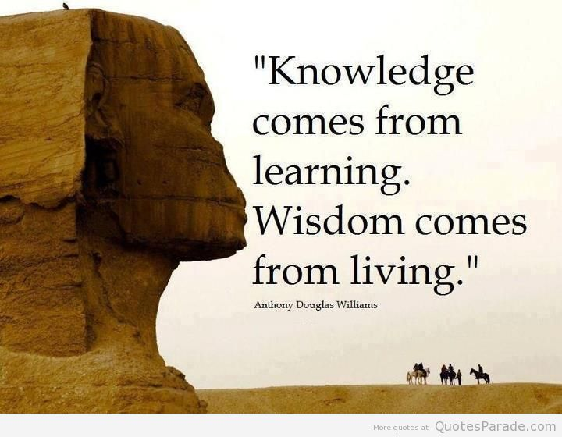

## 【East-West Harmony】

Yin-Yang balance is the most fundamental concept of the ancient Chinese philosophy. Many aspects of Chinese civilization from culture to politics, from science to medicine, and the many schools of thoughts including Taoism and Confucianism have been deeply rooted in or subtly influenced by this concept.

Yin and Yang are the basic elements or forces that make up or drive the phenomenal reality - physically and metaphysically. The interaction, interconnection, and interdependence of these two opposing but complementary elements or forces is the simplest possible but most elegant way to explain phenomena of any kind, be it cosmos, nature, human, or society.

The imbalance of Yin and Yang is the root of instability. In order for the whole which both Yin and Yang are part of to survive, sustain, and prosper, Yin and Yang have to constantly interact with each other, complement each, and reach the ever evolving dynamic balance.

Interestingly, the globe is divided geographically into two hemispheres - the East and the West. These two hemispheres also exhibit prominent differences in cultures, religions and economic standings.

The West has the characteristics of the Yang which is masculine, individualist, extrovert, analytical, and innovative. The East has the characteristics of the Yin which is feminine, collective, introvert, intuitive, and conservative. Consequently, the West is more advanced in science and technology, more economically developed and more active and aggressive in world affairs; In contrast, the East tends to focus more on humanity, arts, self-cultivation, harmony between human and nature, harmony within self, family and society.

The global problems and crisis we are facing today can be attributed to the imbalance of the East and the West. This imbalance comes in many shades of grey, but the most important is the imbalance in economic and military power. The West is much more developed in economy, more advanced in science and technology, and possesses overwhelmingly stronger economic and military power.

The differences in cultures and religions and the lack of dialog and tolerance also make it harder for the East and the West to interact and connect with each other, let alone to depend on and support each other.

To achieve balance and harmony, the West and the East should learn from each other’s strength. The West needs to put more focus and emphasis on arts, humanity, social justice, and income equality while the East needs to improve on science, technology and economic development.

But most importantly, the East and the West should learn to tolerate and respect the differences and to value and cherish the diversity.

The world peace and the future survival of our human race depend largely on the balance and harmony of the East and the West. If the current trend of imbalance persists, the world will become more and more dangerous and human survival will be at great risk.

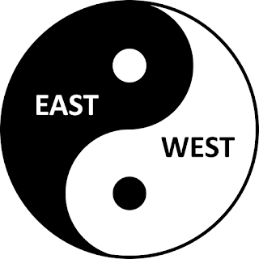

## 【H for Harmony】

As human beings, we all seek health, happiness, and harmony.

According to the ancient Chinese wisdom dated back over five thousand years ago, the balance of Yin and Yang is the key to everything. Yin and Yang represent the most fundamental forces of the Universe and are found everywhere in the Nature, human body and mind, families, communities, societies, and the world. Yin represents soft, feminine, water, earth, intuition, introvert, conservative, etc.; In contrast, Yang represents hard, masculine, fire, heaven, logic, extrovert, radical, etc.

Yin and Yang are not against or opposite to each other but are complementary and interdependent. They are two inseparable parts of the whole just like the two inseparable sides of a coin. They are also like the two movements of a pendulum which swings constantly left and right to achieve the dynamic balance.

When Yin and Yang are in the state of imbalance, say, one is overpowering the other, disorder will come. For example:

When Yin and Yang in our body lose balance, we become sick; when Yin and Yang in our mind lose balance, we suffer from our internal conflict and stress; When Yin and Yang in the society lose balance ,we see social injustice and unrest; When Yin and Yang in the world lose balance, we see conflicts between cultures, religions, and nations and large scale human suffering follows when conflicts escalate and wars erupt.

Interestingly, humanity, health, happiness, and harmony all begin with alphabet “H”. “H” is symmetric and represents balance. “H” also looks like a bridge connecting two sides. In the world, There are gaps between the rich and the poor, the power and the people, the privileged and the disadvantaged, the West and the East. Global issues and social problems are rooted in the gaps and imbalance and bridging the gaps and restoring the balance are keys to long term peace and harmony. The health and happiness of all human beings depend on the harmony and the peace of the world.



## 【Hard vs. Soft Systems】

If you live in a densely populated metropolis and have to deal with the traffic congestion in your everyday work and life, you would understand the inconvenience and the stress it brings.

Of course technology can help. For any given day and time, to get from A to B, you can always rely on GPS navigation device or App coupled with real-time live traffic data feed to find a fastest route. Although this does not solve the overall congestion problem, it helps individuals alleviate some of the trouble and stress. This is the concept of “Hard System” in which the problem is well defined (To determine a fastest route to get from A to B), sufficient data about the problem can be collected (Live traffic data are gathered), and scientific analysis or tools can be developed (Navigation software uses algorithm to find an optimal route).

But on the other hand, the problem of traffic congestion is not so easy to analyze and solve. The traffic patterns are very dynamic and unpredictable and are attributable to many interwoven factors. It involves many interconnecting highways, roads, and streets with traffics from many different sources such as schools, shopping trips, work, tourists. Weather plays a big part in influencing the traffic. On a foggy, rainy or snowy day, the traffic definitely gets worse. The day and time also matter a lot. Rush hours and weekdays see much heavier traffic. Furthermore, the overall economy, the immigration policy can also impact the traffic in a larger perspective and scale. There is no simple way to describe, model, analyze and solve the overall problem. That is why traffic congestion problems are forever unsolved and even get worse overtime in major cities. This is the concept of “Soft System” where the problem is complex and even ill-defined, facts are complicated and may not be evident or even agreed upon by all stakeholders, data are hard to collect let alone to analyze, and no optimal solutions exist or can be found.

In the late 1960’s systems researchers in the University of Lancaster, UK led by Peter Checkland developed a new approach called Soft Systems Methodology (SSM). One unique characteristic of this approach is its emphasis on the understanding of the problem before even attempting to solve it.

Thinking is only the means, not the end. The end goal is to solve problem. But to solve problems, we have to understand them first. Thinking has to begin with seeing first.



## 【Self-organization I】

Among many agile frameworks (Extreme Programming, Kan-ban, Lean, etc.), Scrum has become prevailing and dominant over the past decade. Many organizations from businesses to government agencies adopt scrum as they move away from traditional waterfall methodology to agile methodology. Some follow agile and scrum strictly and religiously, others mix it with waterfall in a hybrid attempting to reap the best of both worlds.

Ken Schwaber, one of the two co-developers of Scrum process, both among the 17 initial signatories of the Agile Manifesto, wrote in his book “Agile Project Management with Scrum”:

For Scrum to work, the team has to deeply and viscerally understand collective commitment and self-organization. Scrum’s theory, practices, and rules are easy to grasp intellectually. But until a group of individuals has made a collective commitment to deliver something tangible in a fixed amount of time, those individuals probably don’t get Scrum. When the team members stop acting as many and adopt and commit to a common purpose, the team becomes capable of self-organization and can quickly cut through complexity and produce actionable plans."

This echos one of the 12 principles behind the agile manifesto:

The best architectures, requirements, and designs emerge from self-organizing teams. The key phrase here is **“self-organization”** as a noun or **“self-organizing”** as an adjective.

Even though many agile and Scrum practitioners are preaching “self-organization” and trying hard to improve the effectiveness of the scrum teams through self-organization, the results are mixed.

From many years of practicing agile and Scrum in both small scale and large scale information technology projects ranging from private to public sector, I witnessed teams struggle to form cohesion and to deliver the outcomes promised by Scrum. Many of the projects are short-term ranging from a few months to a year or so, by the time the team has gone through the forming, storming, and norming phase and you start seeing the light at the end of the tunnel, the project deadline is approaching which leaves little time for the performing phase. Much of the fruits from the initial team learning and development effort goes underutilized or even untapped.

This leads me to think about “self-organization”: - What exactly is “self-organization”? - Can a scrum team achieve self-organization? - If yes, how can the team achieve it? - If not, what are the impediments? - Can the team achieve some level of self-organization under some circumstances?

## 【Self-organization II】

Self-organization as a concept and a phenomenon has its root in systems theory. It is a key characteristic of a complex adaptive system.

In a complex adaptive system, a large number of diverse component parts interact and form a cohesive, robust, and resilient whole that exhibits emergent properties and achieves higher order in the absence of intervention or control from external forces.

Natural scientists first discovered these phenomena in natural systems such as a colony of ants, a forest, an ocean.

Engineers attempting to create better, larger, and more complicated systems such as a satellite, a power plant, or an enterprise information system apply the lessons and principles learned from the natural systems to improve the structure, design, and functions of the engineered systems.

Social scientists also find similar phenomena in social systems such as a community, a stock market, an economy and follow the suit by applying scientific knowledge and engineering techniques to effect social changes and to improve human conditions.

Self-organization enables a complex adaptive system to evolve from an initial chaotic, dysfunctional state into a cohesive, functional state. Self-organization also makes a complex adaptive system more robust and resilient to perturbations and uncertainties from its changing environments.

Now let’s get back to our original question: Can a scrum team achieve self-organization? or phrase it in a different way: Is a scrum team a complex adaptive system?

A team consists of members who interact with each other to achieve a common goal. In traditional project management, a team is led by a team lead or a project manager and has well defined roles and responsibilities and top-down command and control hierarchy. Clearly, this type of team does not conform to the definition of a complex adaptive system which is a bottom-up grass-root organism without controlling forces imposed from the above.

A scrum team by definition consists of a scrum master which is a servant leader, a product owner which is the liaison of the end users and the champion for the end products, and a development team whose responsibility is to design, build and deliver the products to the end users in an incremental and iterative fashion.

The size of the development team within a scrum team can vary and even the guideline varies as well. Some say 5 plus or minus 2, others say 7 plus or minus 2. The rationale here is that the development team should be cross-functional in that all necessary disciplines are represented (for example, designers, developers, testers) but at the same time should have minimal number of people in order to achieve efficiency and effectiveness in communication and collaboration.

This reflects the emphasis of individuals and interactions from Agile Manifesto: “Individuals and interactions over processes and tools” This also reflects the emphasis of face to face conversation from agile principle #6: “The most efficient and effective method of conveying information to and within a development team is face-to-face conversation.” This results in a overall scrum team size of less than a dozen people. In practice, the average scrum team size is even smaller. a complex adaptive system typically have large number of component parts. In another words, critical mass is needed to generate the dynamic behavior and to allow for the resilience and robustness to develop over time. Small group may be easier to communicate and collaborate, it does not generate the critical mass.

Another aspect of scrum is the emphasis of the role of the scrum master. A scrum master is the opposite of a traditional project manager or team lead in that it does not provide management function of command and control. In contrast, it is a servant leader and its primary goal is to protect the team from external influence, to facilitate communication and collaboration, to remove impediments, and to enable the team to focus on the tasks and deliver the products. In one of the agile projects I have worked on, we call the scrum master “Super Mom” to reflect the similarity of the role and the same initials (SM). This makes the scrum team somewhat like a closed system instead of an open system which a complex adaptive system is meant to be.

From the above, we can clearly see that agile methodology and scrum process put some structure and constrain around the makeup and function of a scrum team in terms of size, roles and responsibilities, and interaction with external entities such as end users, subject matter experts, and stakeholders.

The structure and constraints find its roots in the traditional project management and make the scrum team less a complex adaptive system.

Additionally, several characteristics of a complex adaptive system are missing in a scrum team.

First, a complex adaptive system typically starts in a organic way in that component parts are not “hand picked” by an external force but rather are naturally formed together organically such as a flock of birds or a schools of fishes.

Secondly, component parts within a complex adaptive system are typically equal and diverse without supervisor-subordinate relationship and clear distinction of roles and responsibilities. They are sometimes called agents. The emergent properties of a complex adaptive system come from the free and seemingly random interactions among the parts and also with the environments.

Lastly, it takes time for a complex adaptive system to form organically and to transition from chaotic state to a harmonic state. The time boxing nature of scrum and the limited time duration of projects do not provide the time needed for a scrum team to adapt and grow naturally.

The conclusion is that a scrum team is not a complex adaptive system and cannot achieve self-organization naturally or organically.

This is why scrum teams struggle to self-organize.

## 【A Different STEM】

The world has become more complex and less safe even though the last several decades have seen rapid advancement in science and technologies and increasing global economic development and growth. We are now facing challenging threats from global warming, terrorism, identity theft, cyber attacks, racial and religious conflicts, income inequality and social injustice, and many more.

What is puzzling is that as a human race we were able to send spaceships and astronauts to the outer space and we invented Internet, mobile devices, and social media networks to instantly connect people worldwide but we are still not able to resolve our differences and conflicts. More sadly, we still resort to bloody wars and sufferings of innocents for settling disputes and achieving peace the same way it has been for thousands of years.

Apparently, the STEM as it stands for Science, Technology, Engineering, and Math alone does not solve human problems. The advancement in STEM does not directly lead to solutions of human problems and does not directly translate into the betterment of humanity. Even though people enjoy the benefits of what STEM brings to their daily lives, they continue to suffer from stress and anxiety from deteriorating environments, declining health, broken relationships, and physical and financial threats.

It may be time to look at alternatives. How about a different kind of STEM?

This one stands for Systems Thinking, Engagement, and Mindfulness.

First, system thinking is a paradigm shift. We can no longer look at problems in isolation. We are much more interconnected and interdependent at many aspects and at many levels now than ever. All problems are correlated and affect each other whether we see the relationships or not. We don’t just examine and solve one problem. We have to examine and solve all problems together in a systemic way.

In addition to treating problems as systems with a holistic and panoramic lenses, we must devise potential solutions with systemic approaches. There is no single approach or solution to problems. We have to evaluate multiple alternatives. Alternative approaches don’t necessarily compete with each other but rather they complement each other. Science and technology are not the only solutions, they are part of the more comprehensive and overarching solutions. Science and technology alone are not able to solve social problems. Humanity has to be considered as a key component in the solutions.

It is actually part of the problem that we give the traditional STEM too much attention and value. Many young talents are attracted to the STEM fields with the promise of better career and higher income. Businesses touts countless innovations to gain competitive advantage and to maximize corporate profits and shareholder returns. The subjects of humanity such as arts, music, languages, cultures, religions, and history are neglected and undervalued. The imbalance between science and humanity limits our options and our abilities to solve multi-faceted social problems.

The E in the new STEM stands for Engagement. The top down, command and control approach of problem solving from traditional management textbook no long works in the modern complex world. To solve problems, we need to engage stakeholders at all levels at all times. Engagement brings about multiple views, alternative ways of thinking, and better solutions. Engagement is really a part of system thinking. To gain system perspective, we have to engage everyone.

The M in the new STEM stands for Mindfulness. Mindfulness is a Buddhist concept and practice followed by millions of followers for thousands of years and have been adopted by the west for the past many decades for its benefits in improving both physical and mental health. Buddhism believes that human sufferings originate from ignorance which is the incorrect view of the reality and of ourselves and instructs its followers to clam and cleanse their mind by focusing on the present moment and paying close attention to ourselves and our surroundings without forcing and judging. Regular practices of mindfulness will help reduce and eventually eliminate the ignorance and hence bring us back to full awareness, enlightenment, wisdom, and happiness.

If engagement is about collective wisdom, then mindfulness is about individual wisdom. Collective wisdom relies on individual wisdom. They go hand in hand just like the parts and the whole in the systems thinking.

## 【Mindfulness for Systems Thinkers】

Systems thinking is more than thinking. It starts with seeing and ends at doing. Thinking is only the intermediate step. We don’t just think for the sake of thinking, we think in order to solve problems. But if we don’t see the problems clearly first, we will not be able to think of them critically. Poor seeing and thinking will eventually lead to undesirable actions and ineffective solutions.

Mindfulness is about seeing. It brings our mind back from distractions and disturbances and keeps it fully aware of ourselves and our surroundings at the present moment and from moment to moment. This awareness grounds us on the matters, their relationships, and the fine details here and now so that we can see with our senses and our mind the reality in a brighter light and a fuller view.

Mindfulness is also about acceptance. We observe ourselves, others around us, and our surrounding environments with full attention and unconditional empathy without prejudice and judgement. We accept what it is. Acceptance leads to better understanding and appreciation of the reality. Acceptance helps us gain more objective mental models of the reality. Mental models are foods for thoughts. While our thinking tends to be subjective, objective inputs to our thought process can help alleviate the inherent limitation of the subjectivity.

Mindfulness is rooted in Buddhism and has been practiced by its followers for thousands of years. Over the past several decades, this ancient Eastern religious practice has been adopted worldwide including the west. Many researches have documented both the physical and mental health benefits of mindfulness. The regular practices of mindfulness have been proven effective in helping people alleviate sufferings and achieve happiness.

A happier mind sees better, thinks better and acts better.

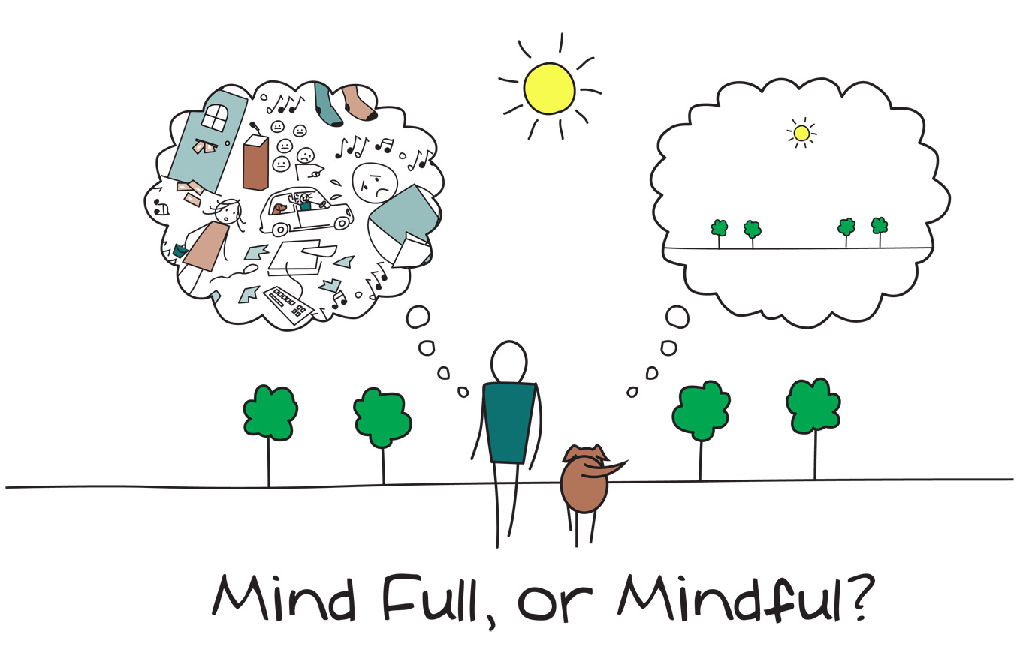

## 【The Iceberg Model of Mind】

In 1976, American anthropologist Edward T. Hall developed the Iceberg Analogy of Culture in his book “Beyond Culture”. He used iceberg as a metaphor to illustrate the complexity of culture. He reasoned that a culture has two aspects. One is external, visible, conscious and the other is internal, invisible, and subconscious. A culture is like an iceberg where the part above the water is visible and only constitutes a small portion of it (roughly 10%) and the part underneath the surface is invisible and constitutes the majority of it (roughly 90%). In order to understand a culture, one has to dive deep and get close to it.

In 1973, Chinese archaeologists uncovered four silk manuscripts of previously unknown works along with the well known Tao Te Ching when they excavated “Tomb Number 3” (dated back to 168 BCE) in an archaeological site in Hunan province (ancient state of Chu).

These four texts collectively are thought to reflect a branch of Taoism and provide new insights into the Taoist philosophy. The first text is the longest with about 5000 Chinese characters and is titled “The Constancy of Law”.

One paragraph from the first text is particularly interesting and can be thought of as the ancient equivalence of the modern iceberg model.

The original text in Chinese:

道者，神明之原也。神明者，处于度之内而见於度之外者也。处於度之（内）者，不言而信。 见于度之外者，言而不可易也。处于度之内者，静而不可移也。见于度之外者，动而□不可化也。动而静而不移，动而不化，故曰神。神明者，见知之稽也。

The translation in English (by the author):

The Tao gives birth to the Mind. The Mind has internal virtues and external manifestations. The internal virtues are unspeakable yet authentic. The external manifestations may be described but not be misinterpreted.  
The internal virtues are tranquil and undisturbed. The external manifestations are moving but unwavering. From moving to tranquil free of disturbance, moving yet unwavering, it is the divine mystery of the Mind. The Mind is the source of knowledge and wisdom.

Like culture, mind is a complex adaptive system. At the surface are the manifestations through languages, speeches, emotions, and behaviors. These manifestations originate from our conscious mind and are visible and comprehensible. Below the surface are our mental models of the reality, our ideas and believes, our values and thought processes. These form our unconscious mind and are invisible and difficult to grasp.

Great minds think alike. The iceberg model of mind from ancient Chinese sages remarkably parallels the iceberg model of culture from the modern American anthropologist, more than 2000 years apart.

Is there a deeper connection between mind and culture other than the fact that they both share the same iceberg model? Underlying a culture are people and the essence of a person is his or her mind. May we simplify a culture as a system of individual minds?



## 【Systems Thinking in Buddhism】

Buddhism is more than a religion. It is also philosophy and psychology. Some even claim it is science.

At the core of its teachings are ways of seeing the true reality of the phenomenal world, understanding the root causes of the human sufferings, and achieving the enlightenment and eternal happiness through practices of kindness and mindfulness.

One of the fundamental concepts of Buddhism is the Three Universal Truths or Three Dharma Seals(Tri-drsti-namitta-mudrā in Sanskrit or 三法印 in Chinese）. It summarizes the many Buddhist teachings at a deeper, higher and more abstract level and also serves as the benchmarks to validate whether a teaching or a practice adheres to the Buddhist ideology.

The First Universal Truth is called “Impermanence” (“Anitya” in Sanskrit, “无常” or “诸行无常” in Chinese) . It can be interpreted as “All phenomena are impermanent”.

The Second Universal Truth is “Non-self” (“Anatman” in Sanskrit，“无我” or “诸法无我” in Chinese）. It can be interpreted as “Selfness is a fleeing phenomenon and hence is non-existent.”

The Third Universal Truth is “Liberation”（“Nirvana” in Sanskrit, “涅槃” or “涅槃寂静” in Chinese). It can be interpreted as “Human beings can be forever freed from endless sufferings through mindfulness and enlightenment” .

Here we see clear parallel between the 2500 year old ancient Eastern Buddhist thinking and the less than century old modern Western systems thinking.

Buddhism sees the world as a complex system in which many constantly changing and evolving phenomena interact with each other. The world as a whole constantly changes and evolves as causes and effects are interwoven and emergent properties and behaviors come and go like non-stop running water. Buddhism advises its followers to have a right view of the world and not to be fooled by the human tendency of desiring a constant and fixed reality.

Buddhism also sees the human beings as complex systems and are an integral part of the world and advises its followers to have a right view of ourselves and not to be fooled by our egos which are really non-coherent, non-existent, and fleeting phenomena. Our thoughts are based on the static mental models of the dynamic world and hence do not represent the true reality. Our minds are the obstacles to the right views of the complex world and only the practices of mindfulness can remove the ignorance and indulging desires and save us from endless sufferings.

What you see if what you think. What you think is what you act. Before you can act systemically you have to think systemically. Before you can think systemically you have to see systemically.

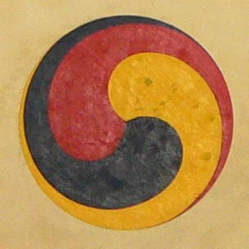

## 【The Humility of A Systems Thinker】

There are two core principles of systems thinking that are fundamental for systems thinkers.

First, a systems thinker must recognize the limitation of his or her senses and mind.

We only see what our eyes can see, smell what our noses can smell, hear what our ears can hear, touch what we our hands can touch. What we see, smell, hear, and touch only provides us partial image of the truth and the whole. The ancient Indian story of the blind men and the elephant elegantly explained this phenomena.

Our mind is also limited since it relies on our senses for information. Our mental model of the truth and the whole is incomplete and imperfect. Hence, our thinking is not completely correct or objective, and our actions driven by our thinking is not completely right or effective.

Human beings are not perfect, we don’t know everything. So the most important virtue of a systems thinker is humility. Recognize our limitation and respect the reality, complexity, and uncertainty.

Secondly, it is perfect to be imperfect.

It is all right not to know the entire truth. It is fine to have unknown mysteries. If human mind has the power and psychic to know everything, then there is no complexity, no uncertainty, no mystery. Hence, there is no beauty of life and no need for systems thinking as a discipline and no need for systems thinkers as problem solvers.

So be humble and embrace complexity and uncertainty.



## 【Two Dimensions of Systems Thinking】

We live in the confine of space and time. Our thinking naturally encompasses these two dimensions accordingly. The spatial dimension focuses on the structure while the temporal dimension focuses on the evolution.

Systems thinking as a discipline started out with the emphasis on system structure - the parts, the relationships, the hierarchy, and the whole. The foundation of systems thinking is holistic thinking which is about the spatial dimension of a system.

The temporal dimension of systems thinking has become more and more important in recent years as the world has become more and more complex plagued with mounting intractable problems. Scholars and scientists started investigating the ecological, social, political, and cultural systems which are much more complex than typical engineered systems such as mechanical, electrical, or information systems.

To solve social problems, it is not sufficient to just look at the present structure of the social system. One has to investigate the past, analyze the present and envision the future. We all desire a stable society that can sustain over time. Stability and sustainability reflect the two dimensions of systems thinking.

In addition, solving social problems requires much more than a surgical approach based on the spatial dimension of systems thinking. It requires an evolutionary and adaptive approach based on the temporal dimension of systems thinking.

While spatial dimension of systems thinking focuses on structural analysis and synthesis, temporal dimension of systems thinking looks deeper to understand the origin, the purpose, and the evolution of the systems, the root causes of the problems, the vision for future, and the meaning and means to effect the changes.

## 【All Roads Lead to Rome】

Modern western systems thinking was developed from the advancement and convergence of various scientific disciplines such as physics, chemistry, and biology and various engineering disciplines such as mechanical engineering, electrical engineering, and industrial engineering. It was developed as an alternative to the reductionist approach of analyzing the parts and aggregating the results.

Ancient eastern systems thinking was formed naturally from ground up as a holistic approach several thousands of years ago by simply observing the Universe, the Nature, and the society. The scholars and sages reached at systems thinking via personal reflection, meditation, and self-cultivation. They did not enjoy the help and paradoxically suffer the hindering of modern science, technology, and engineering. They started with a holistic view point at the very beginning.

Even though all roads lead to Rome, depending on which path they take, people arrive with different experiences and different personalities.

Modern western systems thinking came loaded with methods and tools that were the influences of reductionist approach. Modern well-educated people believed that these methods and tools are the key to solve complex modern problems.

Ancient eastern systems thinking came with very few luggage. It only brought simple teachings, fundamental principles, and intriguing ideas. It believed that in order to see the true world, you have to remove barriers between your mind and the reality.  
You don’t need more tools, you just need less obstacles. You need to experience it, not analyze it.

## 【Three Equations of System Thinking】

Systems thinking can be described with three equations.

1. The Whole = The Sum of The Parts

This is the nature of a simple system.

For example, a bag of sands or a waiting line at the grocery checkout counter is a simple system.

This type of systems is too simplistic to require any inquiry into its purposes, functions, properties, and inner working. So it is really not in the domain of systems thinking.

1. The Whole < The Sum of The Parts

This is the nature of a convoluted or failed system.

For example, a dysfunctional family, an ineffective team, a society in turmoil, or an information system that failed to satisfy its user’s needs. Too many modern social, political, and economical systems are considered convoluted or failed systems with too many interlocking problems.

1. The Whole > The Sum of The Parts

This is the nature of a complicated or complex system.

For example, a tree, a happy family, a high performing team, a harmonious society, or a well designed information system that meets the user’s needs and improve their efficiency and effectiveness.

## 【The Whole】

A system can be simply defined as a whole. A system is a whole. Period.

Any additional words or sentences will break the whole. The moment we start describing the individual parts within the whole, the relationship and interactions between the parts,  
the relationship and interactions between the parts and the whole, and the relationship and the interactions between the whole and its surroundings, the whole shatters and its existence disappears.

The Tao Te Ching（道德经), the classic teachings of the Taoism written 2500 years ago,  
begins with a very short but profound sentence:

“The tao that can be told is not the eternal Tao” (道可道，非常道).

In Taoism, the Tao is the Way, the Ultimate Reality, or the Ultimate Truth.

In modern concept, the Tao can be thought of the System. A system can be a concrete thing as big as the Universe, the Earth, or as small as a human being, a tree, or an ant. It can be an abstract thing such as a school of thoughts, a religion, a culture, or a society.

The Tao as the System is a whole. It can not be fully described in words. It can not be completely communicated in bits and bytes. It has to be experienced. Even the human experience has the limitation of being able to “see” the whole.

Peter Senge concluded his best selling book “The Fifth Discipline: The Art and Practice of The Learning Organization” with a short chapter titled “Indivisible Whole” in which he told the story of American astronaut Rusty Schweickart and his experience of looking at the Earth from far out in the space.

Rusty Schweickart described his experience:

“Up there you go around every hour and a half, time after time after time. As you eat breakfast you look out the window and there’s the Mediterranean area, and Greece, and Rome, and North Africa, and the Sinai. And you realize in one glance that what you’re seeing is what was the whole history of man for years- the cradle of civilization. And you think of all the history you can imagine looking at the scene. …… nd that identity – that you identify with Houston, and then you identify with Los Angeles and Phoenix and New Orleans and everything. And the next thing you recognize in yourself, is you’re identifying with North Africa. You look forward to that, you anticipate it. And there it is. That whole process begins to shift what it is you identify with. You begin to recognize that your identity is with the whole thing. And that makes a change.

You look down there and you can imagine how many borders and boundaries you crossed again and again and again. And you don’t even see ‘em. You know there are thousands of people killing each other over some imaginary line that you can’t see. From where you see it, the thing is a whole, and it’s so beautiful. a nd you wish you could take one from each side in hand and say, “Look at it from this perspective. Look at that. What’s important?” ……

Peter Senge concluded that:

Floating in the space, Rusty discovered the first principles of systems thinking. But he discovered them in a way that few of us ever do - not at a rational or intellectual level but at a level of direct experience.

So, the whole is indivisible, indescribable and has to be experienced.

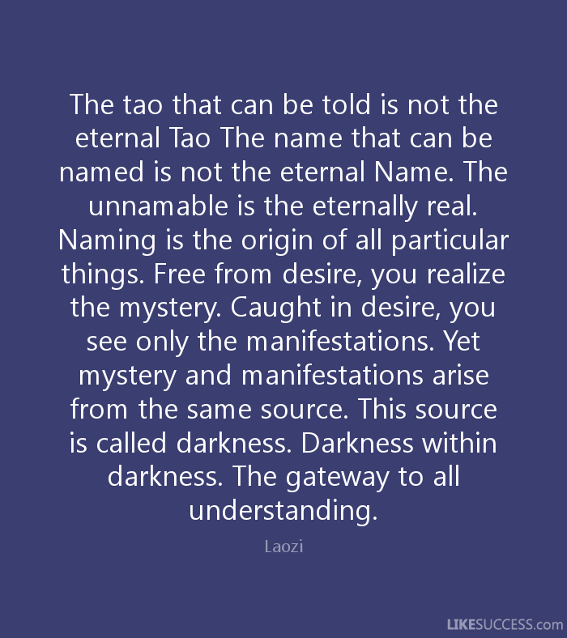

## 【Systems Thinking: How Ancient Chinese Think】

The concept of systems thinking was first developed by a modern western scholar, the MIT professor Jay Forrester, in 1956 when he established the field of systems dynamics. At the core of systems thinking is the concept of holism or holistic view. The term “Holism” was first coined by the British army general and South African statesman J. C. Smuts in his book “Holism and Evolution” published in 1926. Smuts defined holism as “underlies synthetic tendency in the universe, and is the principle which makes for the origin and progress of wholes in the universe”.

While systems thinking benefited from the advances in modern sciences such as physics, chemistry and biology and emerged from the reductionist approach of analyzing the parts and aggregating the results less than a century ago, ancient Chinese had already formed the concept of systems thinking three thousand years back by observing the nature and the society, practicing meditation, and applying intuition.

The I Ching (易经）, or the Book of Changes, developed 3000 years ago by ancient Chinese scholars , explained how the world is composed of many different parts and how the parts relate to and interact with each other to form the ever changing, dynamic but orderly universe. Generations of Chinese used this book and its divination techniques to gain insights and wisdom into the universe and the society, and to manage their personal lives and family affairs.

The binary system used in the modern computer science can be traced back to I Ching. In I Ching, a broken or dashed line represents Yin（阴） or 0, and a solid or closed line represents Yang （阳） or 1.  
Yin and Yang are the basic elements of the universe. Eight trigrams (卦） representing eight different but related elements are formed when three lines are stacked together (2 x 2 x 2 = 8). When two trigrams are stacked together, sixty four hexagrams （卦） are formed (8 x 8 = 64) which help to gain more granular insight into the world. This was essentially a modern 64 bit computing system.

Two major Chinese philosophies Taoism（道） and Confucian（儒） were established based on the foundation of the I Ching. The Taoism focused on the observation of the nature, the appreciation of its beauty and mystery, and the following of its laws and virtues. The Confucian on the other hand focused on the study of the societal structure, the roles and responsibilities each individual should play and take in order to keep the society in harmony and prosperity.

Some fundamental principles of systems thinking are reflected in the ancient Chinese philosophy, religion, and culture but are not commonly recognized or emphasized in western style of systems thinking.

For example, the concept of self-cultivation (修身）. An essential part of the self-cultivation is sacrifice. It is assumed that in order to have an optimized whole, some level of sacrifice from the parts are required. This is very much evident in the Confucianism. Sacrificing one’s individual interests and welfare for the well-being of others and the harmony of the family, the community and ultimately the society is the most respected and honored virtue anyone can have.

Another concept is no-action (无为）which is rooted in and is a key to the Taoism. No-action is not simply “do nothing”. Rather it is about appreciating and respecting the complexity of a system, and understanding and following the karmic nature of a system. Follow the flow instead of taking unnecessary and damaging actions. Let the natural force works its wonder and do not disturb or disrupt the natural behavior of a system. Act only when it is necessary and when it is not against the natural flow of law and order.

## 【Complexity】

To an ordinary person, 1 + 1 = 2 is a simple math problem while square root of 144 = 12 is a complex one. But to a little baby, 1 + 1 = 2 is too complex to grasp, and to a high school student, the square root of 144 = 12 is quite simple.

So, complexity and its opposite simplicity are both relative terms. They are only germane to the capacity and limitation of human brain.

Complexity also has to do with interests or purposes of human beings. We only need to know what we have to know or what we want to know. A star up in the night sky is quite simple if we only care about the twinkles. But if we are interested in how far it is from the earth or what it would be like to live there, then a star is very complex and appears beyond our comprehension.

Human beings have choices. We can choose either simplicity or complexity or anything in between. We can simplify a complex matter or we can complicate a simple situation.

So it is all about us, the mankind. We are the host of the world and we can decide how we want to live our life and what we want the world to be. All human endeavors start from human beings and end at human beings. This is the beauty of being mankind. We are in control of our own destiny. But the root of human troubles and tragedies also lies in hands of mankind. Think of conflicts and wars among different states, religions, races, families, and individuals, they are all man made.

# （三）茶文化

## 【Tea and Talk】

The word “Talk” begins with “T” or “Tea” for the matter at hand. It is not just a coincidence. There is a connection between the two. But before I go on to explain the subtle link between these two beautiful ingredients of life, let me first “tea” up the topic by talking about talk.

We talk every day. At home, we talk to our spouse, we talk to our children. At work, we talk to our colleagues, we talk to our customers. In addition to traditional face to face talks, we talk virtually through phone, email, and text messaging. We not only talk to each other, we talk to ourselves too as we reflect on everyday events, joys, and troubles.

Like foods and drinks, talk is an important part of our daily life. The most distinguishing characteristic that

separates human beings from the rest is that we are social and live in a society. Our survival as well as our happiness and triumph are so much dependent upon the interaction with others and talk is the most used form of interactions we have with each other.

Let’s evaluate how effective we are at talking.

I find we are great at opening a talk. We say “how are you?” everyday to everyone, to our neighbors, to our co-workers and even to strangers. But I also find that we are not that good at talking when it comes to the real meaning of talk.

When we say “how are you?” we don’t really mean it. We don’t look at the person in the eyes and wait patiently to listen to his or her response. We don’t really care about the answer. Even when we do, we don’t have time to pause and listen.

We don’t talk much to our spouse, to our children and to our parents. When we do talk to them, we tend to rush the conversation because we are stressed from our long commutes and challenging jobs in addition to mundane day to day chores.

Many of us are sons or daughters as well as parents. We know we should call and talk to our parents on a regular basis. But many of us make the calls when we are on the road driving or waiting at the checkout line in a grocery store.

Not to mention our poor record of talking quality when it comes to challenging situations such as talking to mediate conflicts, disputes and differences in ideas.

Along with unhealthy fast foods, talks have become hasty and unfulfilled.

Tea comes to rescue.

Discovering the many health benefits of tea, more and more people are turning to the green leaves for the health of our body, mind and spirit. For the health of our human relationship, let’s add tea to our talk too.

Tea can calm our temperament down and warm our heart up. Tea can slow down our pace and even help us pause when we attempt to rush. Only when we are calm and warm, we are able to enjoy the conversation and bring joy to others.

People from Eastern cultures generally are not as expressive as those from Western cultures. For example, they hardly show their passion for their loved ones in sentences like “I love you.” That does not mean they talk less. They actually talk more. How can you say less and talk more? Isn’t it contradictory? Well, the answer lies in the Tao of tea.

Next time before you pick up the phone and call someone; or when you and your friends get together, make a cup or a pot of hot and aromatic tea first. Let the rising mist, the unfolding leaves and the soothing liquid kick off the talk. Infuse the magic leaves into the interactions gradually and take the time to brew the conversation slowly. You will be amazed by the results of a talk infused with tea through time.

Tea, talk and time are the most powerful trio that works in tandem to enrich, enhance and enlighten our lives.

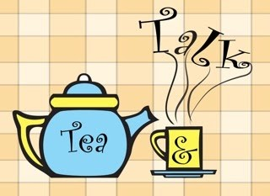

## 【Tea and Time】

Tea and time have something in common. They both begin with the letter “T”. There is a reason for that. Under that commonality also lies a lesson of life.

To enjoy tea, we need to take time.

First of all, even before the steeping starts, we observe the tea leaves. Leaves from different types of tea come in different shapes, texture and colors. The shapes are typically from the delicate hand rolling. The majority of the workers in a tea garden are women. Imagine how those beautiful girls and ladies pluck the leaves on a sunny spring morning. After the leaves are dried, they hand roll them to form a certain shape and sort them out at the end. Tea is no longer mere leaves but a form of art from beautiful hands.

Second, you pour hot water into the cup. You don’t just sit and wait (and get bored and even impatient). Watch the leaves unfold and dance up and down slowly. This “agony of the leaves” is necessary for the flavors and nutrients to be released.

Steeping is also about timing. Not too long, not too short. The timing depends on our individual preference in taste.

Finally, we don’t gulp a cup of tea as we do with a can of soda. We sip. Before we sip, we observe the color and the uprising mist of the liquid. We smell the aroma. These are all part of the enjoyment of tea.

It all takes time. All the good things in life take time to brew and to enjoy.

Time is the most precious thing. It is also the most constant thing as well. We can’t get more of it by rushing it. We could potentially lose it if we rush - not only time but also all the great things in life that must be enjoyed with and over time.

A Chinese proverb says it all, “Hurry and impatience prevents the enjoyment of hot tofu.”

You may ask, what about the need for speed and convenience?

Yes, they are sometimes our friends. They are the propellers of civilization and evolution from nomadic to agricultural to industrial society. Mankind invented automobiles, aircraft and spacecrafts to move from A to B faster. Fast foods have become a part of our diet in the past decades as more and more families have two working parents and more and more people are into sports, travel and adventures. The faster pace of living demands speed and convenience.

But there is a limit. Overdose of speed and convenience can and have already hurt our quality of life. Recent years have seen increased health problems such as obesity and cancer. More people and families are suffering from stress of all kinds. Our physical and psychological well being does not improve even though economically we are better off.

It may be time to slow down a little bit and to get back to the basics of life. Tea can help in many ways with its powerful healing power and the lesson it teaches us about time and timing.



# （四）其他

## 【Loyola MBA Application Personal Statement】

I obtained my Bachelor’s degree from the School of Economics and Management of Tsinghua University in Beijing in 1986. Tsinghua is one of the top-ranked universities in China. The School of Economics and Management is the first business school in mainland China accredited by AACSB and is the only one with both AACSB and EQUIS accreditation. The former Premier Zhu Rongji was the founding dean of the School. I received my Master’s degree in Economics and Master’s degree in Statistics from the University of Toledo, Ohio in 1993. I was admitted to the Economics Doctoral Program by Cornell University in 1993. Due to my personal financial situation and family responsibilities, I decided to enter the job market and started my career in information technology. During the past 15 years, I have applied my management knowledge into my professional practice and have had increasing responsibilities in various roles and capacities. I worked as an independent IT consultant for several years with my own incorporated company and handled every aspect of the business operations. I was the Vice President of Product Development for a small software product company and led the effort in developing the leading Financial Aid Management System for higher education institutions. With my current employer Lockheed Martin, I also have ascending responsibilities. I was a principal investigator leading a small team on a mission critical R & D project. The team developed a prototype system that was successfully demonstrated to our government customer. The effort received accolades from Lockheed, the customer and our technology partner. I am currently working as an Integrated Product Team (IPT) lead for United States National Archives Electronic Records Archives program, I am responsible for the full life cycle development of the Search & Access project from customer liaison, systems engineering, software development to testing and deployment. I was able to meet every milestone on time with limited resources within project scope and budget constraints. I have received various awards from Lockheed including the prestigious Honors Recognition award in 2008 for my strong technical leadership and my contribution and commitment to the organization.

The theory and practice of management have always been my interest. I enjoy reading books on management, in particular, books by Peter Drucker, the Father of Management Science. I first read his classic “The Effective Executive” when I was in college many years ago and find myself drawn back to it from time to time ever since. I applied his advice and techniques in both my professional practice and my personal life. I am very much influenced by his philosophy of “Efficiency is doing things right, Effectiveness is doing the right things”. I always make sure what the right things are first before I even think about doing things the right way. Former GE CEO Jack Welch’s books are also my favorites. His second book “Winning” has had a profound impact on my professional work. I apply his “4 E and 1 P” framework in my daily work. I am always positive, energetic. I motivate and energize people, especially during tough times such as schedule crunches and unexpected obstacles. At difficult times, I always help the team analyze the situations with a positive perspective and navigate through the storms with the team together. When it comes to leadership and management, I put more emphasis on people than on processes. People are the center of any human endeavor. As Peter Drucker has it, “Management has mostly to do with people, not techniques and procedures. Their engagement is what matters”. I even go further to say that engagement should not only apply to associates and employees. The management and the managers’ engagement in the day to day work are equally important, especially in a large corporation with many layers of hierarchies.

I am also interested in and very much intrigued by ancient Chinese philosophy. As I read the ancient stories and texts, I always relate them to management theory and practice today. Even though they were written thousands of years ago, these books contain theories on management and leadership that are very much applicable in modern society. “The Art of War” written during 6th century B.C. by Sun Tzu is one of the oldest books on military strategy in the world. In its opening chapter it talks about five key elements that define the war strategy - The Moral law, Heaven, Earth, the Commander and the Method and Discipline. It says “The Moral Law causes the people to be in complete accord with their ruler, so that they will follow him regardless of their lives, undismayed by any danger”. This is what we all know as vision and mission in business management. It is the number one factor that drives business activities and determines the survival and sustainability of a business. Especially at times of great danger or even chance of defeat, the Moral Law is what binds the soldiers together with the generals and the commander. Heaven and Earth represent the natural, socio-economical environment that businesses have to operate under but have no control over. The commander is the modern CEO who has to effectively communicate the vision and mission to employees and strive to lead the organization into victory and prosperity in a competitive landscape with great uncertainty. To be successful, a business also needs to have the right processes and good discipline. Ancient armies with primitive weapons applied these five fundamental principles to win battles and wars. Modern businesses today, even well equipped with advanced technologies still rely on them as core strategies.

In this ever changing and globally complex economy, businesses and executives face increasing competitions and challenges. For example, the ability to understand different cultures and to manage virtually and globally is now a new skill required for a manager. The management discipline also needs to advance its knowledge frontier and to develop new strategies to help businesses effectively cope with globalization. As a practitioner of management and leadership, I realize the imperative to acquire new skills in order to stay ahead of the game. As a lifetime student of management science, I realize that there are emerging territories of knowledge that are still uncharted or are only being explored recently. This leads me to the search for an academic program that is focused on theoretical foundation, management strategies and leadership development in a rapidly changing global environment with the right balance of theory and application. Loyola College in Maryland Evening MBA Program stands out. Its emphasis on leadership and teamwork, social responsibility and ethics, application of information technology and creation of value in the global market will help improve my skills and performance in my current job and also prepare me for future challenging responsibilities. Its flexible schedule can accommodate my demanding work and family needs. In return, my real-world hands-on experiences in both technology and management can contribute to the success of peer students and the program. I will bring back fresh ideas and polished skills from this program to my work place and further contribute to Lockheed’s innovative culture and full-spectrum leadership initiative.



## 【Loyola MBA Capstone Personal Reflection】

As I sit down, reflect and write this last paper for my MBA program, I feel a sense of relief. The long and arduous journey has finally come to an end.

I started this part-time MBA program over five years ago in the Fall of 2008. I was a senior software engineer and technical lead at that time and was aiming to grow my career to become a project manager and eventually to move up in the corporate ladder at Lockheed Martin. MBA program was a natural choice especially one from an accredited institution like Loyola. This would provide me with business knowledge, leadership skills， and the credentials necessary to get ahead in a large corporation.

The first few courses went by rather fast and painlessly thanks to the quantitative nature of the courses and the excitement I had at the very beginning. As time went by, courses were getting more and more complex. Some are both qualitative and quantitative, some require case studies, projects， and presentations. With the initial excitement subsiding, it has become more and more challenging to keep up. At the same time, I also came to realize that the corporate ladder is not as straightforward as I thought. I observed cronyism and bureaucracy at my workplace and started having doubts about my original career development plan. It became apparent to me that a MBA degree wouldn’t be of much help. From time to time, I was thinking of giving up my MBA program.

Thanks to the interesting courses and engaging professors, I was able to keep going despite the setback. Loyola courses offer the right balance of theory and practical application which make them so much approachable to full-time professionals like me. Loyola professors are professionals themselves with years of real-life experiences. They respect and nurture students and encourage class participation which makes the classes lively and fun. I was often able to relate the course materials and discussion topics to my work situations and used what I learned from the classroom to improve my performance at work.

I entered the program with the goal of obtaining a MBA degree and the plan of using it as a shining credential to enhance my career advancement. Over the past five years, I have learned, experienced. and gained so much from this program that my initial goal and plan have become much less relevant.

Today, I am a better leader and manager because of my Loyola business education. I learned management theory and leadership skills from a management & leadership course a couple of years ago. The knowledge and skills were reinforced in the business ethics course later when we examined the ethical dilemma of businesses and the moral obligations of leaders. Near the end of the business strategy course, professor Everett really hit the homerun when he discussed personal effectiveness and its importance in the successful implementation of business strategies. Professor Everett used materials and ideas from Stephen R. Covey’s best-selling book “Seven Habits of Highly Effective People”. Coincidentally, I bought and read the book over two decades ago when it first came out and the book still sat in my bookshelf with dust since then. Of course, I went home that night after the class and immediately took the book out of the shelf, shook off the dust and started refreshing my memories.

An effective leader is first an effective person. Personal effectiveness is driven by who you are rather than by what you do or what you say. To be effective, we have to start with building trust with our character ethics and internal strength rather than charisma ethics and external strength. I examined the leaders in my workplace and could hardly find good examples. Some leaders don’t engage themselves in the daily work, show very little concern for the employees. You rarely see them on the floor and interact with employees. The rare time you hear from them is likely from emails which most often than not were written to urge people to work harder, evenings or weekends, in order to hit the deadline. This kind of apathetic top-down bureaucratic management structure and leadership style have plagued everywhere in corporate America.

Loyola puts the right amount of emphasis on ethics and leadership development throughout the course of its business curriculums. In addition, the professors interject into their courses with ethics and leadership issues.This prepares the students to become better leaders. I was able to apply the principles and techniques I learned from the program to my daily work over the past several years and see myself improve and grow.

As a technical lead and project manager, I led a cross functional team of about a dozen members including business analysts, software developers, and testers. We are very productive and effective as a team. But at the same time, we enjoy strong personal relationships and have fun working together. While corporations, especially larger ones, put process and profit over people, I do exactly the opposite. I am more like a small business owner running a small shop. I take ownership and responsibility. I am on the ground day in and day out with my team members. They are more of my peers than subordinates. I don’t give orders, rather I provide support and directions. I respect everyone and treat them fairly and equally. At the same time, I have high standards and hold everyone accountable. For high performers, I recognize and reward them. But everyone is not performing at the same level in a team. For those lacking behind, I provide timely feedback and constructive criticism so that they realize the problem and make improvements. People are different. They all have different strengths and weaknesses in addition to different interests and dislikes. I try to downplay their weakness and focus on their strength. I also find out what their interests are and try to align assignments with their interests. When team members compliment and cover for each other, a team becomes most effective and thriving.

Caring for employees is not just about paying them and providing them with employment benefits. Care has to be given to employees in their daily work. The software lead of my team has a long commute. I provided him with a laptop so that he can work from home once per week. Several occasions, when he was supposed to come on site but the road condition was bad due to inclement weather, I sent him text messages early in the morning and asked him to stay and work from home. What goes around comes around. Care for and trust in your employees are not just the right things to do, they come back to help the team and the business bottom line. My team members go extra miles without hesitation when we have tight schedules. They also are more proactive in their work and require little supervision. I know of some leaders who micromanage their employees and the team ends up with low morale and low productivity.

In his famous Gettysburg address in 1863, Lincoln spoke of “Government of the people, for the people, by the people”. This should apply to business as well. Any business, small or large, profit or not, is human endeavour and should be of the people, for the people and by the people. People are the beginning, the end and the core of any business. Business leaders talk frequently about customers, employees, suppliers,and partners and how important they are. But in fact, they only see them as tools for corporate profits and shareholder returns. Profits and returns always triumph people. This is a very sad reality of corporate America. Today, as I look forward to entering the finish line of the program, I see beyond the degree certificate and its perceived face value. The past five years have already been transformative for me at both personal and professional level. I am more knowledgeable in the business environment and business operations. I am more skillful in critical analysis and decision making. But most importantly, I am a better person and a better leader coming out of this program. Better yet, Loyola and its dedicated professors and staff have equipped me with tools and skills to continue to grow better and stronger as a future leader with a higher and broader impact on my family, community, workplace and the society as a whole.

Despite the busy work schedule and MBA courses, I also was able to squeeze in two Marathon races, Baltimore Marathon in 2011 and Marine Corp Marathon in 2012. I consider my Loyola MBA program a Marathon MBA since it takes me more than 5 years to complete and both require dedication, discipline and perseverance. Crossing the Marathon finish line is just the beginning of a healthy lifestyle as I continue to run on a regular basis. By the same token, Completing the Marathon MBA is certainly not the end of the story. It is only the beginning of a new chapter in my life long learning, personal and professional development.



## 【RMU Doctoral Application Personal Statement】

I have been working in the information technology field for over two decades and have held various positions with increasing responsibilities from software engineer, system engineer, and chief engineer to technical lead, project manager, scrum master, and VP of product development. I have worked in both the private sector such as telecommunication, software product development, banking and financial industries and in the public sector supporting federal government agencies including IRS, NARA, SSA, FDA, and FAA. While my work mostly relates to addressing business issues with practical solutions, I am always interested in theoretical inquiries and philosophical thinking. One key aspect of my profession is to apply lessons learned from one domain area to another, one client to another. This requires the skills of generalization and abstract thinking. Some areas of my interests include systems thinking, leadership development and organizational culture. These interests propelled me to pursue a part-time professional MBA degree from Loyola University Maryland in 2008. I finished my MBA program and obtained the degree in 2014.

I recently accepted a job offer as a principal systems engineer from MITRE and started my new career on Monday March 21, 2016. Different from my previous employer Lockheed Martin which is a for-profit publicly traded large corporation, MITRE is a not for profit organization and is focused on conducting objective researches on critical national issues ranging from homeland security to cyber security, from defense to healthcare, and providing unbiased advisory to the federal government agencies without conflicts of interests. Instead of implementing solutions and supporting operational systems which have been the major focus of my career with Lockheed Martin in the past ten years, MITRE’s primary mission is to conduct research and development on critical national matters and to advise federal government agencies in defining strategies, selecting vendors and validating solutions. This is a paradigm shift in my career. I will have to deal with more abstract and high level issues and matters. I will have to do more writings, perform more analysis. I will have to do more presentations. I realize that I need to upgrade my research skills in order to excel in my new position and to better serve the government sponsors. Thanks to a former colleague at Lockheed, current colleague at MITRE, current student in the RMU doctoral program, Fred Robinson, I was invited to attend the information session held at Washington Center and also attended the follow-on session at MITRE the following day. I got to meet Dr. Rota, Dr. Kohun, and Dr. Paulett. I was truly impressed by their enthusiasm about the program and their commitment to the students’ success. A doctoral degree is no longer an abstract goal in my dream. It is attainable and it will be both fun and fulfilling at RMU thanks to the warmth and care they have shown to me and other interested professionals.

I had a Bachelor of Engineering degree in Management Information System from Tsinghua University, a nationally top-rated university in Beijing, China with a strong tradition in science and technology. I also had a Master of Art degree in Economics and a Master of Science degree in Statistics both from the University of Toledo. While these academic studies provide a strong foundation for my pursuit of the doctoral degree, I know that I need to improve the skills of conducting rigorous research both at academic and applied level. I need help from a program that can not only refresh and reinforce what I have already learned but more importantly also teach me research methodology and academic inquiry skills. From my interaction with the three faculty members, I am convinced that they possess the knowledge and techniques and they can guide me through the process. I also take comfort knowing that all faculty members of the program are available all the time, willing and happy to help us. This personal touch is especially valuable for professionals like me who have to balance work and family while pursuing academic degrees. The above national average of the graduation rate of RMU program is a testament of the value of this unique approach.

I believe this doctoral program will prepare me for future challenges and opportunities. The cohort, executive style, in-person, on premise program not only accommodates the special needs of working professionals, but also takes advantage of the collective and diversified experiences and wisdom of professionals from all walks of lives. I appreciate the opportunity to be reviewed and considered as a candidate for this great program and am looking forward to the journey at RMU very soon.

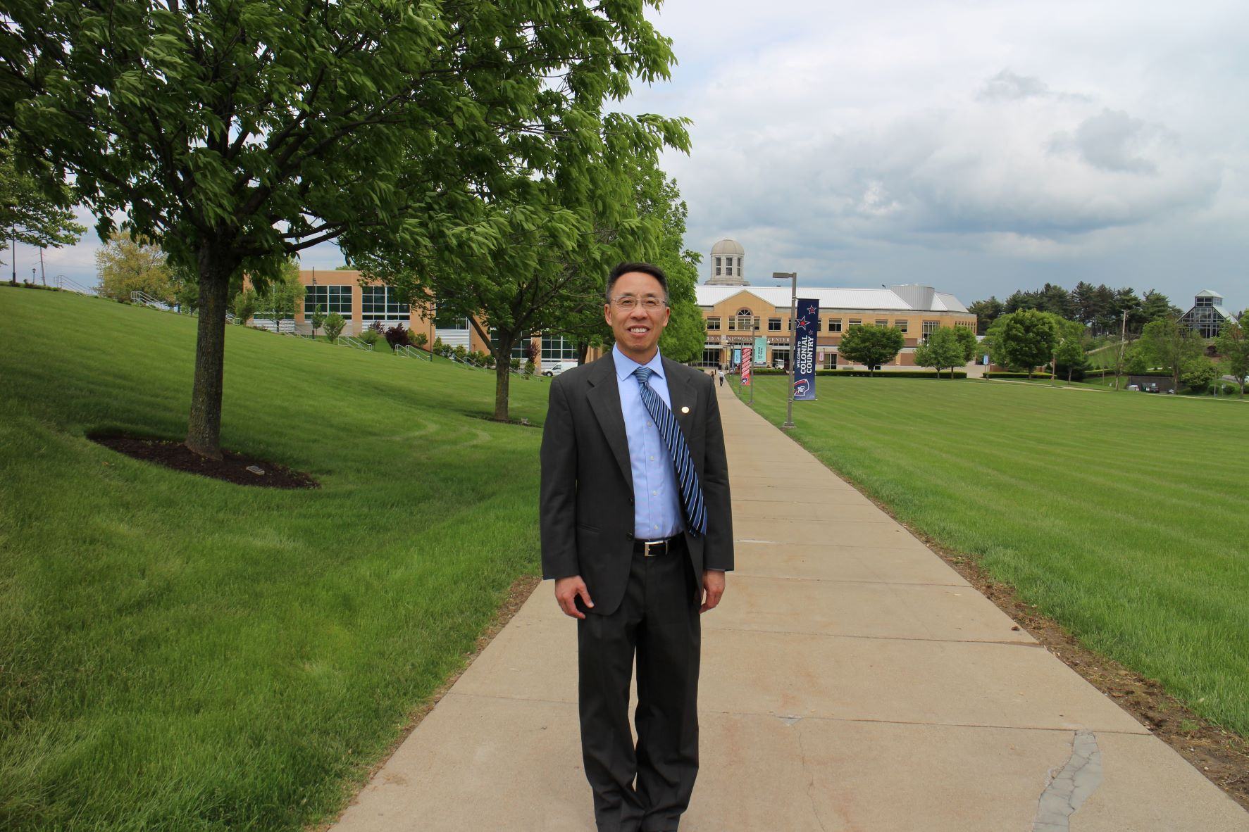

## 【Incense as An Economic Barometer】

A specialty gift store owner in New York City reported an interesting observation that “incense sales have always been a great barometer of the economy in my store. As the economy tanks, candle sales drop and incense sales pick up.”

Like the stock market, incense can be an economic barometer? incense sales and candle sales go in opposite directions just like interest rate and bond price?

This gets me thinking. Why?

People use candles to decorate their homes and to create a romantic atmosphere. So candles are considered luxury goods. When the economy is bad, demand for the luxury goods goes down, hence candle sales go down.

On the other hand, incense is mostly for religious rituals, meditation, personal reflection, relaxation, and aromatherapy. When the economy is bad, people endure more hardship and more stress. Burning incense can help relax the body, calm the mind, and soothe the soul. It is also inexpensive. During hard times, people tend to work out more, such as running, practicing yoga. People also tend to be more spiritual and look inward for peace and strength. All these lead to more use of incense.

