# **R Training: Introductory lessons for PGRs at the University of Southampton**

*Spring 2020*

*Chris Jochem*

## 1. Download the files used for the workshop

* All the **materials** that we will use are available on my Github page: <https://github.com/wcjochem/R_Training>
* Go to the page and download the **R_Training** folder to your computer
  + The easiest way to get the files is to **Click** on the “Clone or download” button on the right side of the page and then “Download ZIP” as shown below:

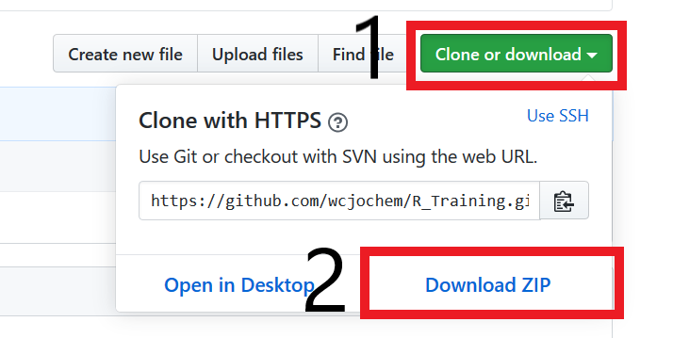

* + **Download** and **unzip** the folder on your computer.
    - This will provide folders with code, data, etc, slides, and this document

## 2. Install R and RStudio

* **R** is a free, open-source software for statistical computing and programming.
  + **Download** the software yourself from the Comprehensive R Archive Network (CRAN): <https://cran.r-project.org/index.html>
    - Follow the appropriate link to download and install a precompiled binary for R. After following the link, if the next page asks for a subdirectory, select the link to the “base” distribution to “Install R for the First Time.”
    - Finish installing R before installing RStudio (see below)
  + If you have an old version of R. It is recommended that you upgrade or uninstall/re-install R to get the latest version.
* **RStudio** is an application which is a type of graphical user interface to R, specifically it is an integrated development environment (IDE). This is highly recommended to make R easier to use.
  + **Download** the Open Source Edition (free) of RStudio suitable for your operating system: <https://rstudio.com/products/rstudio/download/>

## 3. Test your installation

* **Open** **RStudio** and you should see a window appear which looks similar to the one below
  + Note that you can use R directly through the command line or its own interface. RStudio sites on top and works with R and provides a more user-friendly interface.

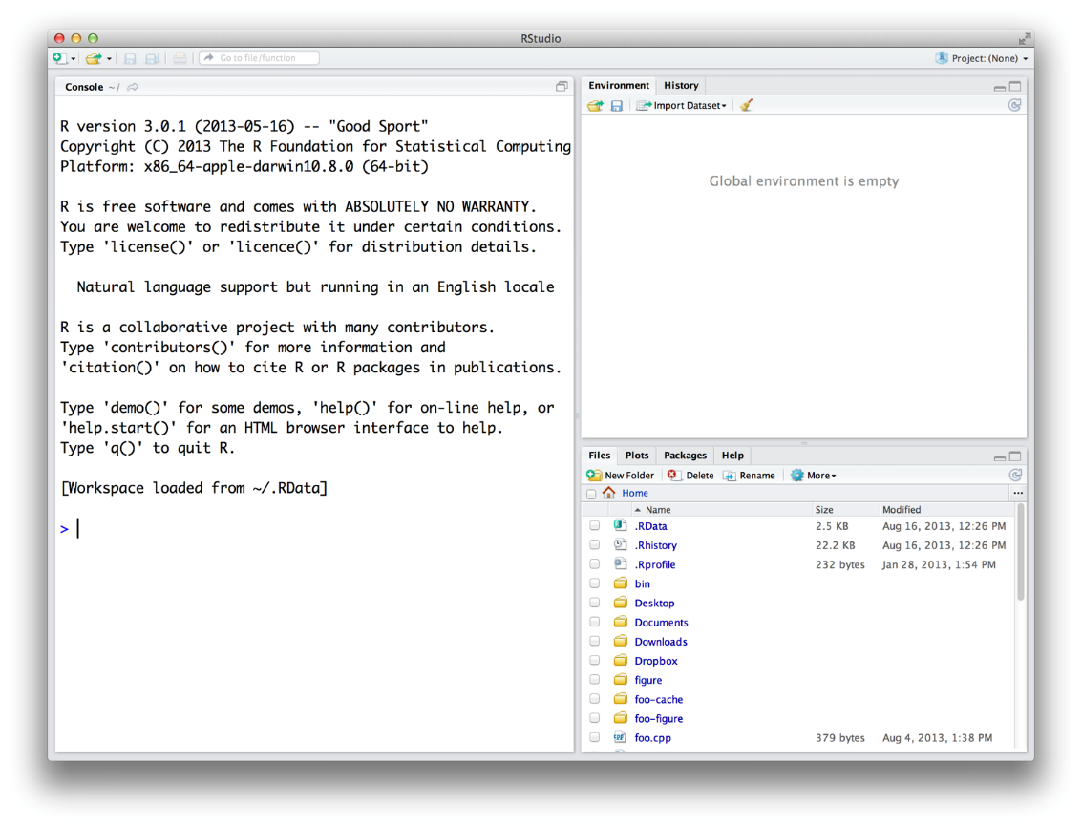

* This window shows three panes (which we will discuss more, and see a fourth pane, later):
  + **Console** –left side of the window
  + **Environment** and **History** – upper right
  + **Files**, **Plots**, **Packages**, **Help** – lower right
* Note that you can change the appearance of RStudio using the menu: Tools > Global Options > Appearance [or Pane Layout]
  + See also: <https://support.rstudio.com/hc/en-us/articles/200549016-Customizing-RStudio>
* You can **interact** directly with R in the console
  + Click on the line to the right of the “>” and type 2 + 2 and hit enter. R executes this command.
* For most work, we want to create program files with multiple commands following the R programming language. We call these code files “scripts”.
  + R scripts are files with the **.R** extension. These can be read with any text editor as well as with R and RStudio
  + **Create** a new script using the menu options: File > New File > R Script
  + Creating a new script should open a new pane in the window with a blank document. If you already have a scripting pane, then a new tab with a blank document will open

## 4. R Packages

* The real power of R comes from its vast repository of free **packages** that users have created to solve common problems, implement new methods, and share/access datasets.
  + A list of all packages is maintained here: <https://cran.r-project.org/web/packages/available_packages_by_name.html>
  + Each package will have a manual
* R comes with a set of “base” packages providing most general functionality. Before using other packages, you need to **install** them which can be done directly within RStudio.
  + Try to install a package by typing in the console: install.packages(“lubridate”)
  + You may be given a long list and asked to select a location download the package. Choose a site which close to you. They should all have the same data.
  + Lots of text will be printed to the screen. Once finished, you can load the package by typing: library(lubridate)
    - Note that “ ” are needed in the install, but not in the loading step.
* For this first workshop we will introduce two other packages. Repeat the steps above to install: raster and sf. Substitute these names for lubridate.
  + If there is an error, read the error message carefully, check that you have internet access and write permissions for your computer. You may need to start RStudio as an administrator or allow R to install packages to a local, user directory (usually your documents folder).

## 5. Closing RStudio

* When you **exit** RStudio it may ask you if you want to save the workspace. This will store the data and any variable you created. I recommend saying ‘No’ so that each time you open RStudio it will be fresh.
  + You can set an option to stop RStudio asking this. Tools > Global Options > General > Workspace
  + The default option for RStudio is to reopen (but not run) any R scripts you had open