MediChannel
  - Corrected 13-Table ERD & UI Workflow Alignment
IT404050 Full Stack Development — Group Assignment 2 | Lanka Care Hospital, Colombo
Revision v2.1 • 9 November 2026 • Status: implementation-ready DESIGN CANDIDATE, NOT group-approved or database-tested

1 Decision summary
Result: The group’s prior ERD and the leader’s HTML sample are compatible at the architectural level. This revision closes the identified missing attributes and explicitly maps all required screens to data ownership without introducing any new tables.
Check | Result
Database structure | 13 required tables; 16 explicit foreign-key relationships retained.
Corrected gaps | Gender and walk-in identity; persistent queue; payments; consultation end state; feedback moderation; account-reset/lockout state.
Business rules | BR-01–BR-11 and RT-01–RT-04 assigned to database, Spring Boot and WebSocket responsibilities.
Privacy | No medical reason, notes, prescription or chat in Admin/Manager DTOs, responses or subscriptions.
Source boundary | Lecturer brief = requirements; leader HTML = illustrative screens only; schema and endpoint names here = proposed design choices.

2 Exact corrections included
Area | Resolved data model | Rule and UI outcome
Patient details | patients.gender_ciphertext, full_name_ciphertext, NIC/DOB/phone/address ciphertext; users.email_ciphertext + HMAC. | Register and profile forms can save all required fields. BR-10 validation still belongs to Spring Boot.
Walk-in | patients.user_id UNIQUE but nullable (proposed). | Reception can book without requiring a customer login. Accounts/notification limitations must be agreed.
Live queue | sessions.now_serving_number; sessions.next_appointment_number. | Queue display persists. RT-01 WebSocket broadcasts from service changes.
Unique booking | appointments(session_id,appointment_number) unique, booking_reference unique, partial active patient/session unique index. | Concurrent last-number bookings require a row lock and transaction; SQL uniqueness alone is insufficient.
Payment | appointments.payment_status, payment_method, paid_at, fee_lkr_snapshot. | Reception can show PENDING/PAID, CASH/CARD; revenue uses paid historical fee.
Clinical | consultations.status ACTIVE/ENDED, ended_at, diagnosis/advice/prescription ciphertext. | Doctor notes and prescription; patient print; chat read-only after ended.
Chat | chat_messages.message_ciphertext + participant FK. | Typing and connection status are temporary WebSocket events (not new tables).
Alerts | notifications.recipient_user_id + event_type/is_read and optional session/appointment FKs. | 3-away, called, delayed, cancelled, consultation started notifications.
Feedback | feedback.rating (1–5), moderation_status PENDING/APPROVED/HIDDEN/DELETED. | One rating per appointment; deleted means hidden from view, record retained.
Admin security | users.must_change_password, failed_login_attempts, locked_until, is_active. | Block self-deactivation and require password change after reset in backend service.
Audit | audit_logs actor, action, time, IP; append-only trigger. | Log consultation record opening and other events without medical content.

3 Three detailed ERD views
The following three diagrams are readable subsets of the SAME 13-table model. Repeated reference boxes are not additional tables. The separate full-size PNG shows the complete connected view.

A • Identity, Doctor & Session Scheduling
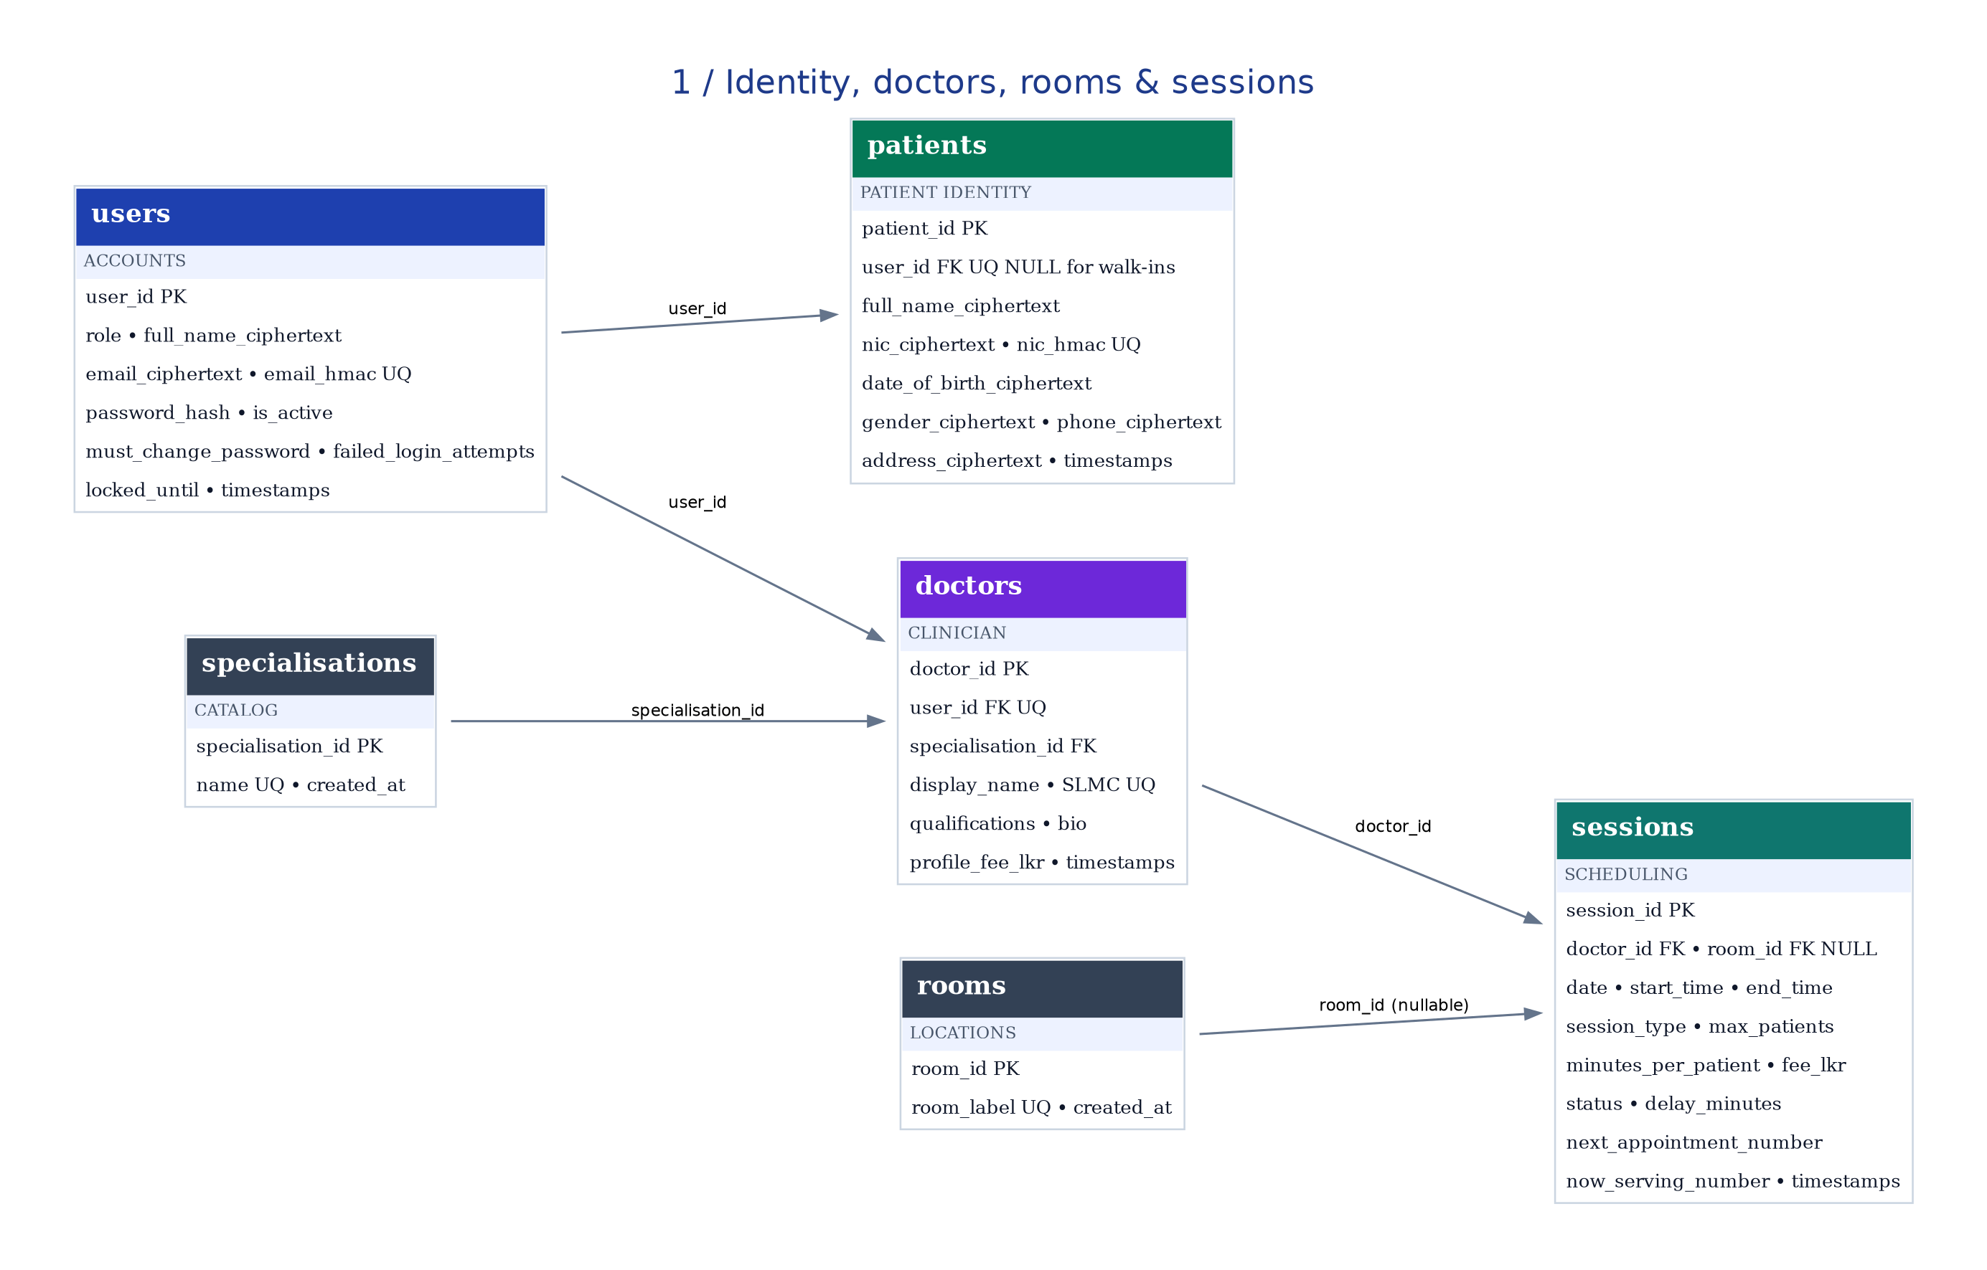
Diagram shows PK/FK and relevant business fields; exact column types and constraints are in the supplied SQL design draft.

B • Bookings, Payments & Consultations
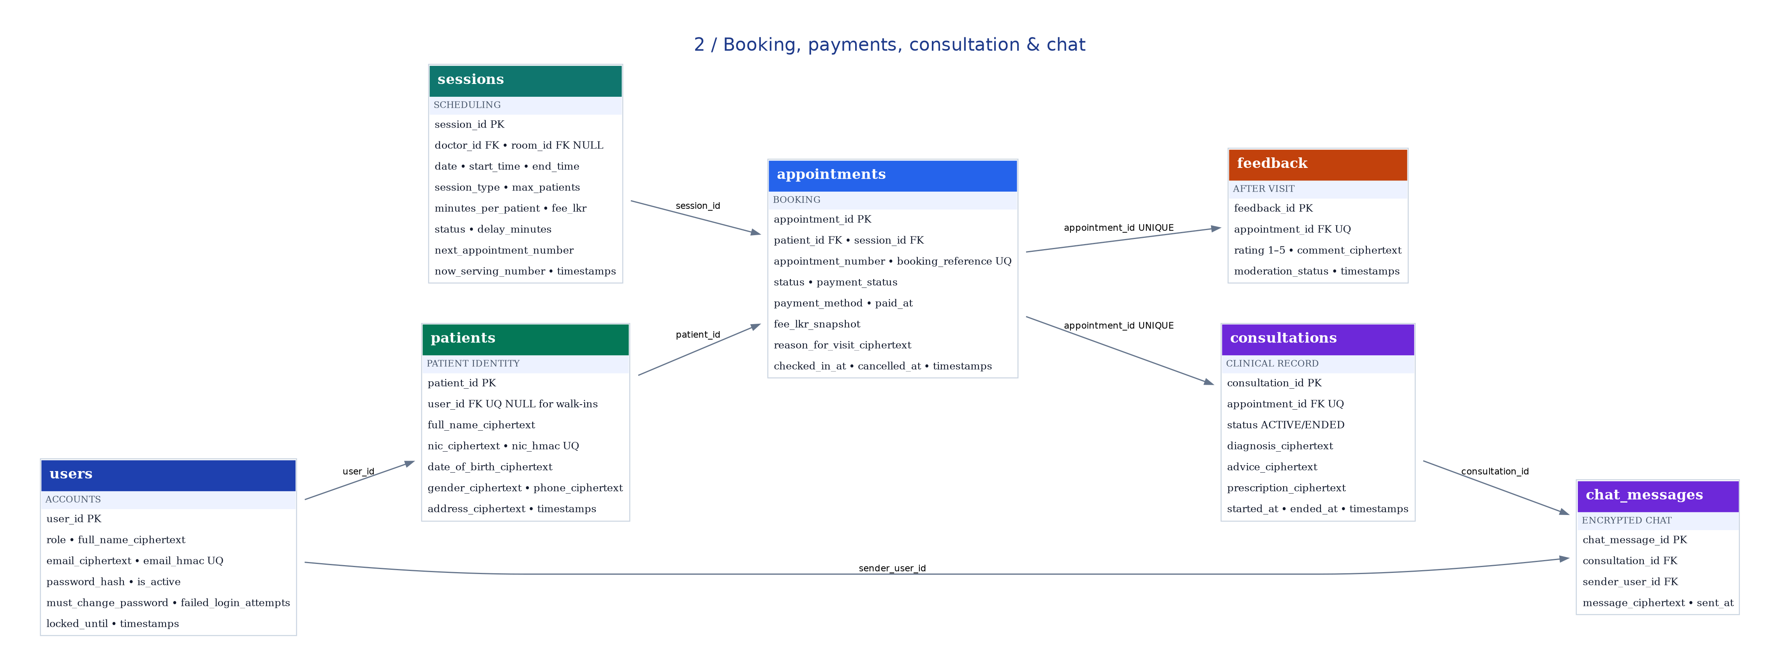
Diagram shows PK/FK and relevant business fields; exact column types and constraints are in the supplied SQL design draft.

C • Alerts, Notices & Audit
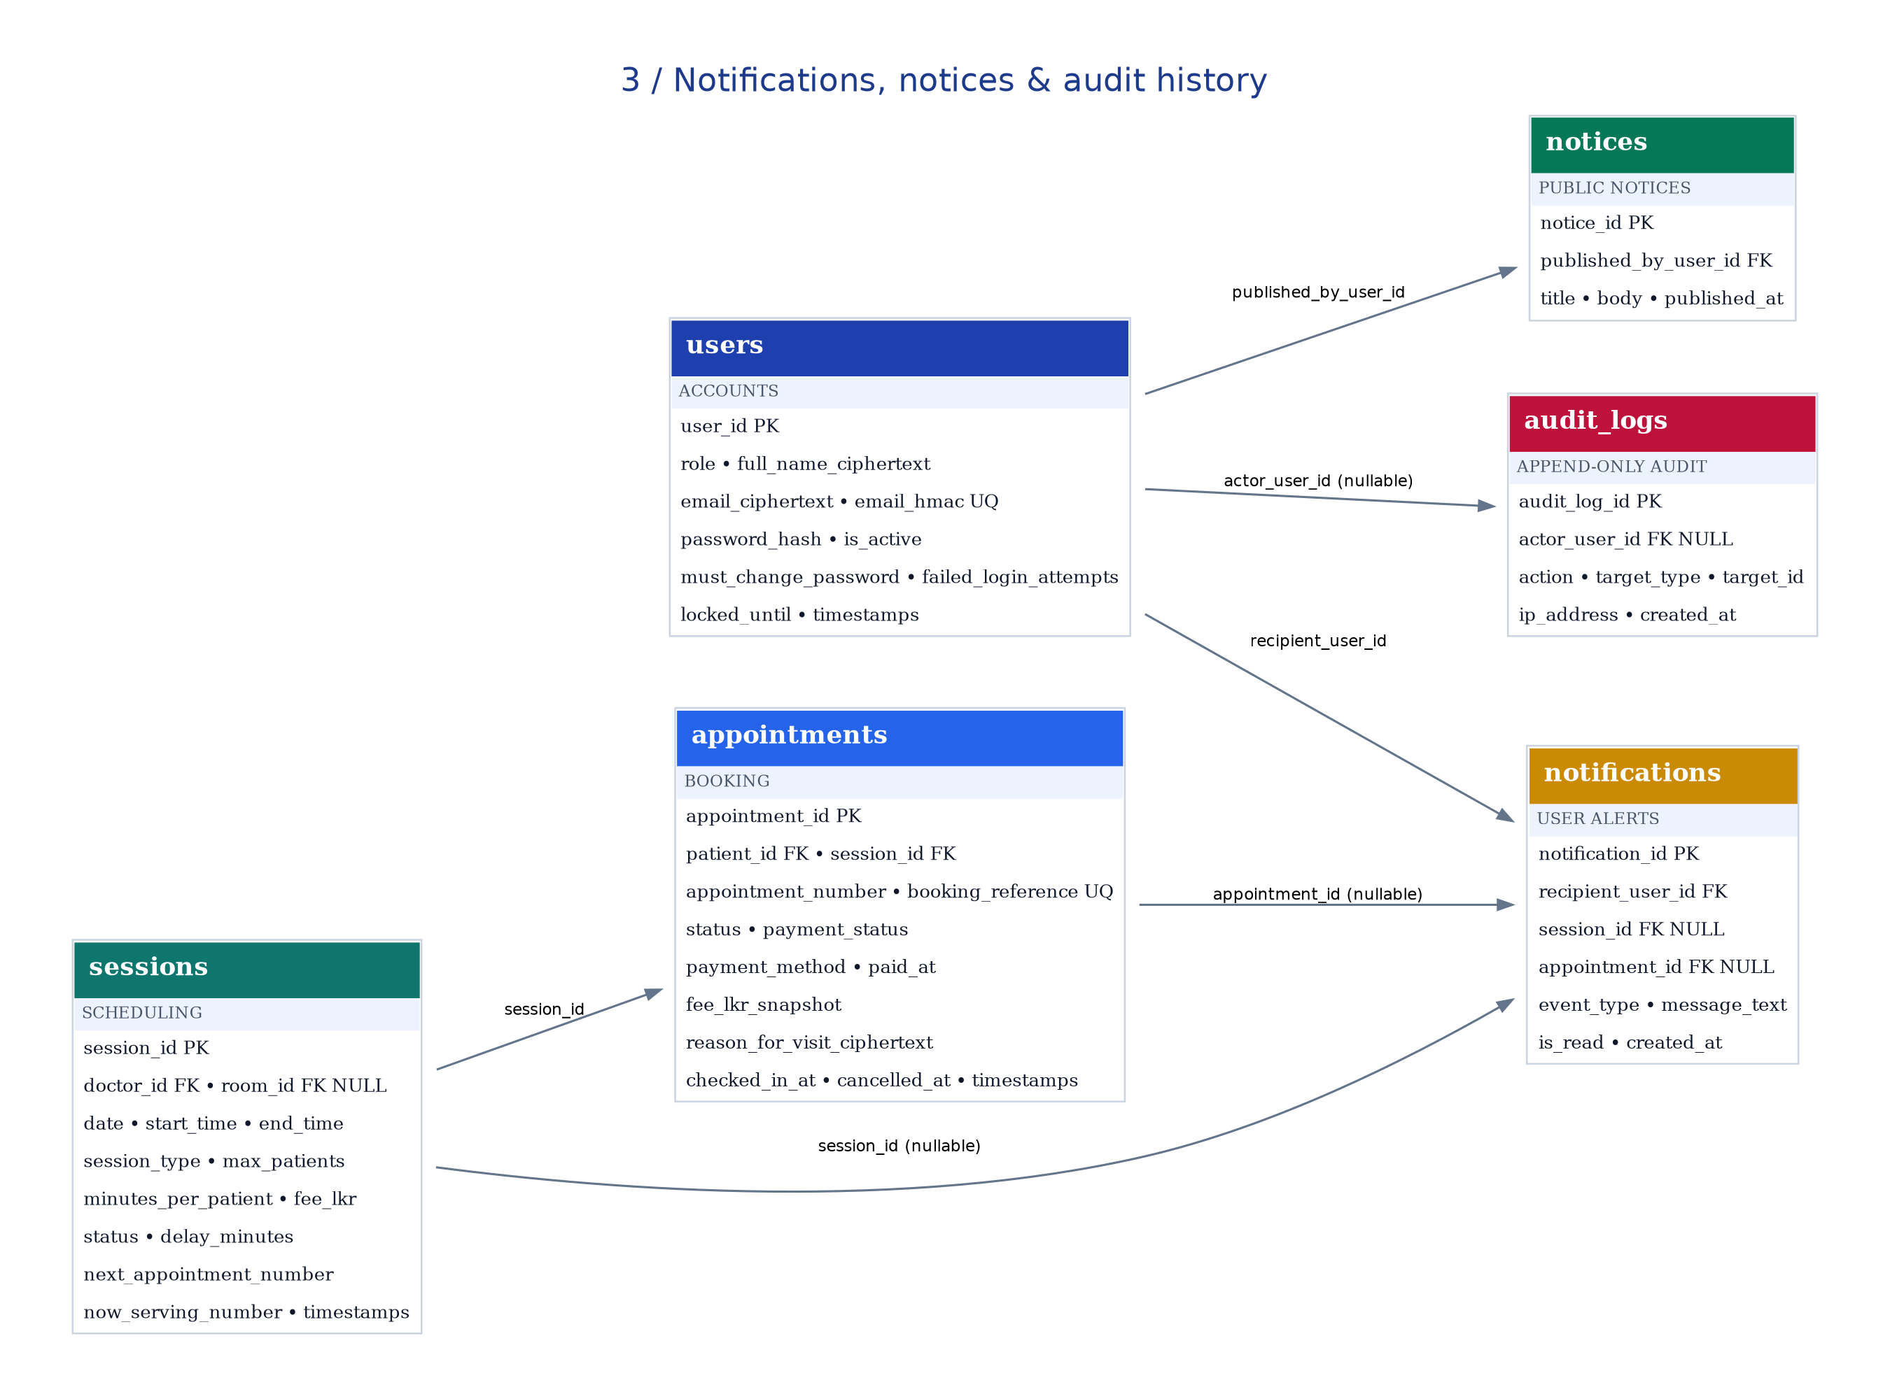
Diagram shows PK/FK and relevant business fields; exact column types and constraints are in the supplied SQL design draft.

4 Screen / action → database crosswalk
Role | Screen / action | Tables involved | Enforcement / response
Guest | Doctor & specialty search | doctors, specialisations, sessions, rooms | Public read; cache TTL with invalidation.
Guest | Numbers left | sessions | Derived from max_patients and next_appointment_number; live event.
Patient | Register / login | users, patients | Email/NIC HMAC unique; personal data encrypted; bcrypt; 5-failure lock.
Patient | Edit profile | patients, users | Only own records; never expose ciphertext/HMAC to UI.
Patient | Book physical or online | sessions, patients, appointments | Booking service chooses session; type comes from selected session.
Patient | Booking confirmation | appointments, sessions, rooms | Return number, reference, estimated time, room if physical.
Patient | Cancel booking | appointments, sessions, notifications | Only PENDING and at least 3h before; keep record; number not reused.
Patient | My appointments & queue | appointments, sessions | Own data only; now_serving and patients-before-me derived.
Patient | Notifications bell | notifications | Scoped by recipient_user_id; read/unread state.
Patient | Private online chat | consultations, chat_messages | Only treating doctor and booked patient; saved encrypted.
Patient | Print summary | consultations, appointments | Read-only own diagnosis/advice/prescription.
Patient | One feedback | feedback, appointments | UNIQUE appointment; 1–5 and post-visit service validation.
Doctor | Own sessions and queue | doctors, sessions, appointments, patients | Treating doctor only; protected patient names decrypted in service.
Doctor | Call next / no-show / complete | sessions, appointments, notifications | Atomic status changes, queue update and user events.
Doctor | Notes and prescription | consultations | Create/update encrypted fields; audit every consultation record opening.
Manager | Doctor/speciality/room/session management | doctors, specialisations, rooms, sessions | Overlap constraints; delay/cancel affects estimations and alerts.
Manager | Reception walk-in/check-in | patients, appointments | Walk-in user_id nullable choice; no private reason in manager response.
Manager | Receive payment | appointments | Set paid status, CASH/CARD, paid_at; fee snapshot.
Manager | Notices and feedback | notices, feedback | Publish, approve, hide, soft-delete; audit decisions.
Manager | Reports | sessions, appointments, doctors, feedback | SQL/JPA aggregates; no medical fields in report DTO.
Admin | Staff accounts | users, doctors | ADMIN creates staff; service blocks self-deactivation.
Admin | Audit records | audit_logs | Append-only and no medical content; restrict access.

5 Mandatory runtime rules outside the ERD
- BR-02: PostgreSQL GiST exclusion constraints prevent overlapping doctor/room sessions; also validate before updating in Spring Boot.
- BR-03: In one database transaction lock the sessions row, ensure next_appointment_number <= max_patients, create the appointment and increment the allocator. Never decrement on cancellation.
- BR-05 / BR-06: Compute booking cutoff and estimated time with Asia/Colombo local session date/time, applying delay_minutes.
- BR-07: Only the patient’s unpaid appointment can be cancelled at least three hours before session start, with confirmation and retained cancellation record.
- BR-08: Physical BOOKED→ARRIVED→IN_CONSULTATION→COMPLETED; online BOOKED→IN_CONSULTATION→COMPLETED. NO_SHOW and CANCELLED are terminal paths. Validate in service layer.
- BR-09: Create/open online consultation only when the doctor starts that specific appointment; after consultation ENDED, return history read-only and reject new sends.
- RT-01–RT-04: WebSockets require JWT authentication and subscription/message authorization on every event; reconnect automatically and re-fetch current state.
- Privacy: Manager/Admin must never receive reason_for_visit_ciphertext, consultation summaries/prescriptions or chat content through any DTO, API or WS payload.
- BR-11: Use status changes and history preservation. Audit insert-only; timestamps use TIMESTAMPTZ; money uses NUMERIC.

6 Explicit decision register for the group
ID | Proposed choice | Approval/qualification
D-01 | Walk-ins stored in patients with nullable user_id. If later registered, securely link to CUSTOMER. | Group must approve account and notification behavior for walk-ins.
D-02 | Availability = max_patients − numbers ever issued. A cancellation emits an availability event but cannot restore an old number. | Required by BR-03; discuss RT-02 wording with lecturer if a cancellation is expected to increase the number left.
D-03 | Notification recipient_user_id required; session_id and appointment_id optional. | Agrees with prior ERD. No anonymous in-app notifications.
D-04 | Store now_serving_number in sessions; compute patients-before-me from eligible appointments. | Group/API owner should fix event payload and state transition logic.
D-05 | API-specific DTO allowlists, decrypt only for owner/treating doctor; websocket access checked server side. | Mandatory privacy rule; test direct API requests and subscriptions.

7 Acceptance tests to execute on real implementation
Test | Expected behavior
T01 | Register with all required fields; invalid NIC and phone show field-specific errors.
T02 | Duplicate canonical email/NIC rejected using HMAC lookup.
T03 | Five failed login attempts cause 15-minute lock; reset forces password change.
T04 | Admin cannot deactivate their own account via UI or API.
T05 | Doctor/room overlapping sessions rejected by backend/database.
T06 | Physical session requires a room; online session rejects room assignment.
T07 | Two simultaneous last-slot bookings result in exactly one booking.
T08 | Cancelled appointment number never issued again; capacity limit never exceeded.
T09 | Same patient cannot hold two active bookings in one session.
T10 | Booking cutoff is 60 min physical and 30 min online.
T11 | Unpaid early cancellation succeeds; paid or late cancellation fails.
T12 | Reception records check-in and CASH/CARD paid state; paid amount reports correctly.
T13 | Queue updates instantly in two browsers; three-away/called events target only patient.
T14 | Doctor can start/end online consultation; unauthorized customer and manager are rejected.
T15 | Chat accepts <=1000 chars; typing/connection updated; ended chat read-only.
T16 | Admin/Manager cannot access reason, notes, prescription or chat via direct URL/API/WS.
T17 | Doctor saves encrypted notes; patient can read/print; database contains unreadable ciphertext.
T18 | One feedback per completed appointment; hidden/deleted feedback retained but not displayed publicly.
T19 | Session delay/cancellation recomputes time, cancels affected appointments and alerts targeted users.
T20 | Audit captures consultation record opens, login, account changes and cancellation without medical content.

8 Handover and validation status
Files delivered together: this DOCX, a candidate PostgreSQL schema, a full ERD PNG/SVG, and three detailed ERD views. These are aligned design artifacts—not proof of executed migrations, connected APIs, live WebSockets, runtime encryption, passed tests, or group sign-off.
Implementation sequence: (1) group approves D-01/D-02/D-04 choices; (2) database owner reviews/executes schema on a fresh PostgreSQL 16 instance and records DDL/test evidence; (3) backend owner implements DTOs/transactions/encryption/WebSockets; (4) frontend owner aligns screens and routes; (5) group runs the acceptance tests above.
Sources: (a) Lecturer’s 8-page “IT404050 Assignment 2 (Group): MediChannel” brief, issued 5 November 2026; (b) earlier “MediChannel — Corrected 13-Table ERD” design reference; (c) leader’s illustrative medichannel-system (11).html. Proposed attributes, table nullability and sample API conventions are engineering choices, not additional lecturer mandates.

