MediChannel — Corrected 13-Table ERD
Relationship diagrams, table purposes, system usage, constraints and design decisions
IT404050 Full Stack Development · Assignment 2 (Group) · Source: lecturer’s 8-page brief (5 November 2026)

1. Purpose and design boundary
This document refines the group’s 13-table relationship overview into a consistent relational design for Lanka Care Hospital. It preserves the 13 required tables and documents why each is needed, how it participates in hospital workflows and which rules must be enforced outside the diagram.
The lecturer specifies the table names, required system functions, BR-01–BR-11, RT-01–RT-04, PostgreSQL constraints, encryption and role restrictions. Individual column names and some relationship optionalities below are proposed implementation choices; they must be aligned with the group’s schema.sql and API contracts.
Notation: PK = primary key; FK = foreign key; UNIQUE = uniqueness constraint; “_enc” = proposed AES-256-GCM ciphertext column; “_hmac” = proposed HMAC-SHA256 lookup column; “0..1” = zero or one child record; “0..*” = zero or more children. Arrows point from referenced parent table to FK-owning child. Dashed lines indicate optional references, not a separate table.

13 required tables at a glance
Operational area | Tables
Accounts and profiles | users · patients · doctors
Scheduling | specialisations · rooms · sessions
Appointment handling | appointments
Clinical consultation | consultations · chat_messages
Communication and feedback | notifications · feedback · notices
Audit and security evidence | audit_logs
Figures 1–3 show different readable portions of the same relational model. Each table has one definition, even where a reference box is repeated.

2. ERD — identity, doctors and scheduling
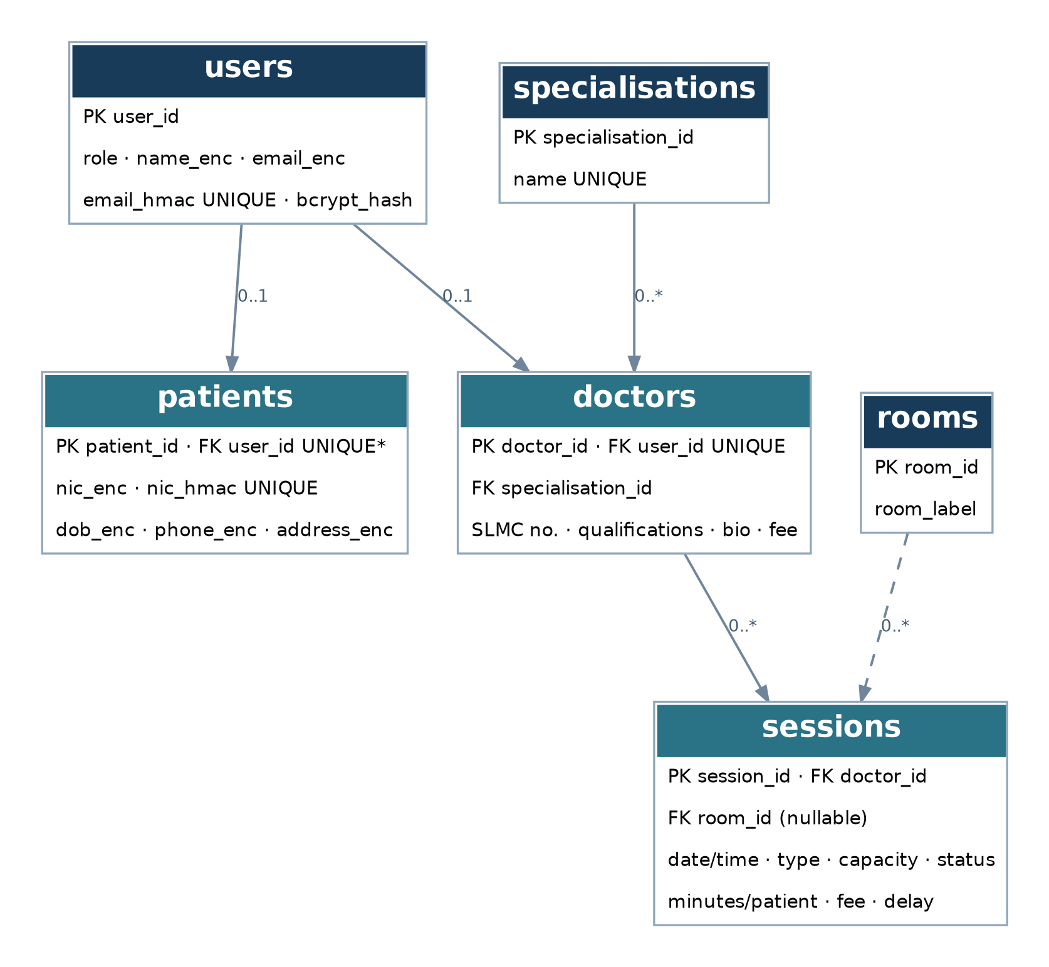
Figure 1. Users, patients, doctors, specialisations, rooms and sessions. The patient-to-user link is marked * because walk-in account handling needs group clarification.
Design note: A PHYSICAL session requires a room; an ONLINE session has no room. Doctor and room overlap restrictions are business rules requiring additional validation and appropriate database protection.

3. ERD — appointments and consultations
This view continues the same ERD using patients and sessions as references from Figure 1. It covers booking, consultation records, live-chat persistence and one-feedback-per-appointment relationships.
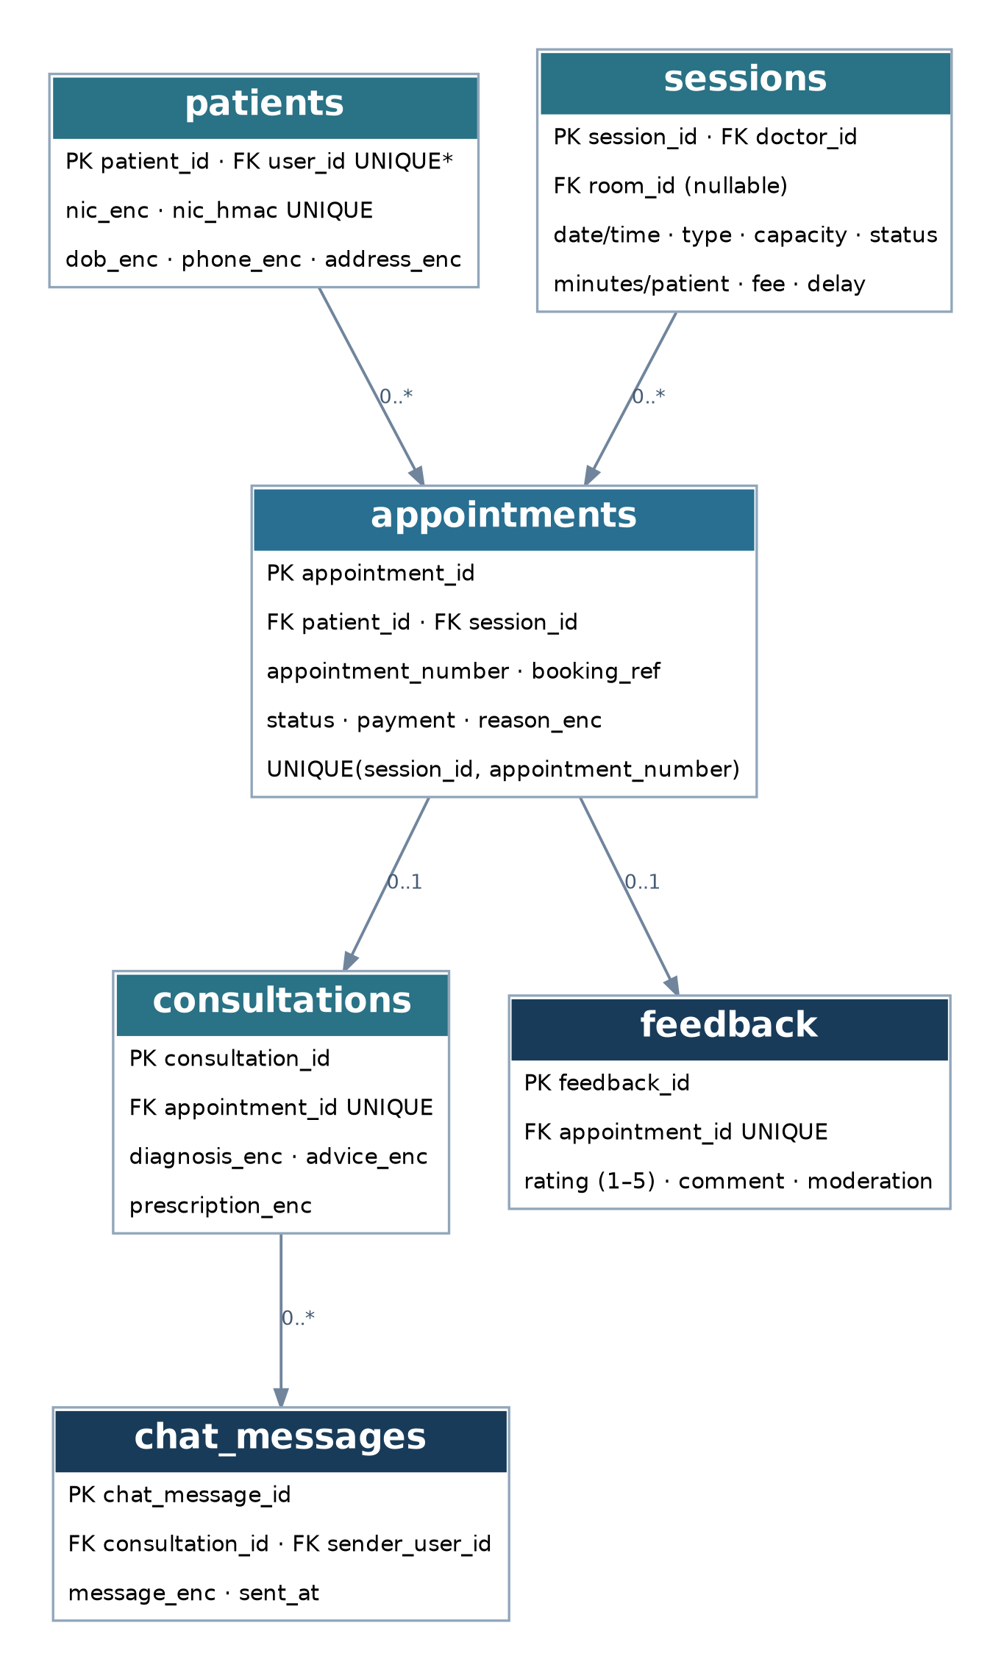
Figure 2. Central appointment relationships: unique per-session appointment number, optional consultation, optional feedback and consultation chat messages.
Critical distinction: UNIQUE(session_id, appointment_number) prevents duplicates, but issuing numbers atomically and never reusing a cancelled number also requires transactional allocation logic.

4. ERD — notifications, notices and audit
Users, sessions, appointments and chat_messages reappear here only to show their relationships to supporting records. These references do not add tables: the complete data model still contains exactly 13 unique tables.
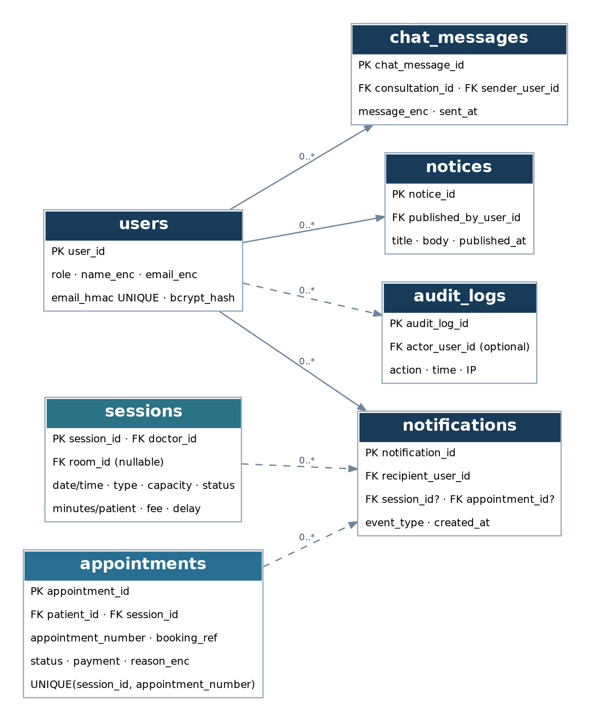
Figure 3. User-owned events and notices, optional session/appointment notification links, chat senders and audit actors.
Each notification must have a recipient user. Its session or appointment link may be absent when the event does not concern that record. The precise notification payload should be defined without exposing private medical data. Audit entries may have no identifiable actor for unauthenticated events.

5. Why the ERD is split into three views
Figures 1–3 are separate readable views of one connected relational model. A single page containing all 16 relationships would make foreign-key labels difficult to read. The complete FK relationship inventory appears in Section 7 and gives the cross-figure connections unambiguously.

6. All 13 tables — purpose, location and safeguards
The following catalogue explains why each table exists, where it is used in MediChannel and which other records it links to. Field names are concise design proposals unless the brief explicitly names them.

01. users
Why it exists. Central account and identity record for CUSTOMER, DOCTOR, MANAGER and ADMIN. Holds login credentials, role and account status.
Where it is used. Registration, login, staff account creation, access control, password reset and lockout; identity for notifications, notices, messages and audits.
Relationships. One user may have one patient profile or one doctor profile; users are referenced by notifications, notices, chat messages and audit logs.
Required safeguards / design notes. Use bcrypt password hashes only. Encrypt full name and email; keep a unique email HMAC for login/search. Enforce five failed login attempts/15-minute lockout; ADMIN creates staff accounts; first ADMIN comes from environment variables.

02. patients
Why it exists. Stores patient-specific registration and contact details without duplicating common account credentials.
Where it is used. Customer profile, reception booking, medical-appointment lookup and patient-to-appointment association.
Relationships. patient_id is referenced by appointments; user_id is a proposed UNIQUE FK to users.
Required safeguards / design notes. Encrypt NIC, date of birth, phone and address (with personal full name/email encrypted in users). Keep a UNIQUE NIC HMAC. Whether walk-in patients require an account or may have a nullable user_id needs explicit group clarification.

03. specialisations
Why it exists. Controlled catalogue of the hospital’s medical specialisations.
Where it is used. Public doctor search/filter and MANAGER specialisation management.
Relationships. One specialisation is referenced by zero or many doctor profiles via doctors.specialisation_id.
Required safeguards / design notes. Provide PK and a sensible unique specialisation name; validate required values. No separate table is needed for search filters.

04. doctors
Why it exists. Professional profile for each visiting doctor, distinct from their login account.
Where it is used. Public doctor listing and search, MANAGER doctor management, session assignment and fee/profile display.
Relationships. doctors.user_id → users.user_id (UNIQUE); doctors.specialisation_id → specialisations.specialisation_id; sessions.doctor_id references doctors.
Required safeguards / design notes. Include SLMC number, qualifications, fee and bio. The name can be obtained from the linked user profile. Validate role ownership and preserve session history.

05. rooms
Why it exists. Lists the rooms available for physical examinations.
Where it is used. MANAGER room management, session scheduling and physical-appointment confirmation.
Relationships. sessions.room_id optionally references rooms.room_id; each room may be used by many non-overlapping sessions over time.
Required safeguards / design notes. For PHYSICAL sessions room_id must be present; for ONLINE sessions it must be absent. A simple room label is a proposed field; room time conflicts must be prevented.

06. sessions
Why it exists. Represents each doctor’s dated physical or online channelling session, capacity, timing, fee and state.
Where it is used. Doctor schedule, public live availability, MANAGER session creation/delay/cancellation, live queues and appointment eligibility.
Relationships. sessions.doctor_id → doctors; sessions.room_id → rooms when PHYSICAL. One session can have many appointments and related notifications.
Required safeguards / design notes. Enforce BR-01 capacity 1–60, minutes per patient 5–30, valid statuses, NUMERIC fee, type/room condition, no doctor/room overlap, booking cutoffs and delay-adjusted estimation.

07. appointments
Why it exists. Persistent booking and queue-number record linking one patient to one session.
Where it is used. Customer booking and cancellation, reception check-in/payment, doctor queue, no-show/completion and patient history.
Relationships. appointments.patient_id → patients; appointments.session_id → sessions; consultations and feedback reference one appointment each; notifications may reference appointments.
Required safeguards / design notes. UNIQUE(session_id, appointment_number), UNIQUE booking reference, valid status/payment values, encrypted reason for visit. No number reuse or duplicate active booking; all critical allocation rules are enforced transactionally.

08. consultations
Why it exists. Holds the completed or ongoing doctor–patient medical record associated with a specific appointment.
Where it is used. DOCTOR diagnosis/advice/prescription entry and CUSTOMER consultation-summary/prescription viewing and printing.
Relationships. consultations.appointment_id → appointments (UNIQUE); one consultation can contain many chat messages.
Required safeguards / design notes. Encrypt diagnosis, advice and prescription with AES-256-GCM; medical content is visible only to the patient and treating doctor. One appointment has at most one consultation.

09. chat_messages
Why it exists. Persists messages exchanged during an authorized online consultation.
Where it is used. Real-time DOCTOR–CUSTOMER chat with history, typing/connection UI supported by WebSocket events.
Relationships. chat_messages.consultation_id → consultations; sender_user_id → users.
Required safeguards / design notes. Encrypt every saved message; validate plaintext message length at most 1,000 characters. Only the treating doctor and booked patient may send/read; chat becomes read-only after completion.

10. notifications
Why it exists. Captures user-specific in-app notices about queue and session/consultation events.
Where it is used. Patient receives called, three-away, delay, cancellation and consultation-started notifications; WebSocket updates frontend immediately.
Relationships. recipient_user_id → users (required); session_id → sessions (optional); appointment_id → appointments (optional).
Required safeguards / design notes. Enforce user ownership on subscriptions/reads; avoid embedding protected medical content in notification messages.

11. feedback
Why it exists. Stores the single post-visit rating and comment associated with an appointment.
Where it is used. CUSTOMER feedback after visit; MANAGER moderation; average doctor ratings in reports.
Relationships. feedback.appointment_id → appointments (UNIQUE ensures at most one feedback per appointment).
Required safeguards / design notes. Enforce rating CHECK 1–5; support approve/hide/delete behavior while preserving historical records according to BR-11 (e.g., status-based handling).

12. notices
Why it exists. Stores hospital announcements that are publicly readable.
Where it is used. MANAGER publishes hospital notices; guests and logged-in users read them.
Relationships. published_by_user_id → users.user_id identifies the publishing manager.
Required safeguards / design notes. Server validates MANAGER permission and safely displays user-entered text. Keep notice data separate from private consultation content.

13. audit_logs
Why it exists. Append-only record of security-sensitive events and access to consultation records.
Where it is used. ADMIN audit-log review; records logins, account changes, session cancellations and each consultation-record opening.
Relationships. actor_user_id → users.user_id, potentially nullable for unauthenticated activity.
Required safeguards / design notes. Record user/actor, action, time and IP; do not store medical content; prevent modification of log entries.

7. Complete foreign-key relationship register
The full list below verifies the arrows across all three ERD figures. Cardinality is expressed as “one referenced parent can have [number] children”; each child normally references one parent unless its FK is optional.
Parent → child | FK located in child | Children | Note
users → patients | patients.user_id | 0..1 | Account link; walk-in optionality to confirm
users → doctors | doctors.user_id | 0..1 | One doctor profile per staff account
specialisations → doctors | doctors.specialisation_id | 0..* | One specialisation per doctor
doctors → sessions | sessions.doctor_id | 0..* | One doctor per session
rooms → sessions | sessions.room_id | 0..* | Session room FK nullable (online)
patients → appointments | appointments.patient_id | 0..* | One patient per appointment
sessions → appointments | appointments.session_id | 0..* | One session per appointment
appointments → consultations | consultations.appointment_id | 0..1 | UNIQUE FK
appointments → feedback | feedback.appointment_id | 0..1 | UNIQUE FK
consultations → chat_messages | chat_messages.consultation_id | 0..* | Only authorized consultation senders
users → chat_messages | chat_messages.sender_user_id | 0..* | Sender user
users → notifications | notifications.recipient_user_id | 0..* | Recipient required
sessions → notifications | notifications.session_id | 0..* | Optional event link
appointments → notifications | notifications.appointment_id | 0..* | Optional event link
users → notices | notices.published_by_user_id | 0..* | Publishing manager
users → audit_logs | audit_logs.actor_user_id | 0..* | Actor can be absent

8. Required constraints and where to enforce them
Rule area | Database/backend handling
Primary/foreign keys | PostgreSQL PK/FK for all table links; UNIQUE on one-to-one links.
Unique appointment number | UNIQUE(session_id, appointment_number) plus atomic allocation under concurrent requests. Never reuse a cancelled number.
One active booking | Service validation plus a suitable conditional unique index for active appointment states (implementation proposal).
Session eligibility | CHECK for capacity 1–60, minutes 5–30, allowed statuses/type, physical room required; service handles cutoffs, overlaps and time calculation.
Identity and encryption | AES-256-GCM with random IV for specified fields; unique email/NIC HMAC; bcrypt password hashing; secrets in environment variables.
Feedback and chat | CHECK rating 1–5; chat plaintext length ≤1000 validated before encryption; authorization of participants.
History and audit | Status-based history retention, audit event immutability and no medical content in logs.
Indexes | At least 2. Suggested: sessions(doctor_id, session_date), appointments(patient_id, status), chat_messages(consultation_id, sent_at).

9. Design issues requiring group clarification
The lecturer supplies mandatory rules but does not specify every implementation detail. These questions must be resolved with the team or lecturer without changing BR-01–BR-11 or RT-01–RT-04.
D-01 · Walk-in registration — The MANAGER can book for walk-in patients. Determine whether a walk-in patient has a CUSTOMER account or can exist without a linked users record; this determines patients.user_id nullability.
D-02 · Capacity after cancellation — BR-03 prohibits number reuse and numbers above capacity, while RT-02 asks for live availability updates after cancellations. Confirm how “numbers left” is calculated/displayed when a previously issued number is cancelled.
D-03 · Notification links — Confirm when notifications refer to a session, an appointment, both or neither, while always keeping recipient_user_id required.
D-04 · Current queue state — Confirm the persistent session field(s) representing “now serving” and the exact WebSocket payloads; the ERD overview does not mandate one column name.
D-05 · Role-driven data boundaries — Confirm DTOs and permissions so ADMIN/MANAGER cannot retrieve medical notes, prescriptions, reasons or chat even through direct API/WebSocket requests.

10. Final result and handover
Outcome: All 13 required tables are preserved and connected by 16 explicit FK relationships. The one-to-one appointment–consultation and appointment–feedback relationships are constrained; session room optionality, encrypted fields, unique appointment numbering, notification ownership and audit history are documented. No additional tables or new product features have been introduced.
Status: Corrected ERD design reference, ready for group review. It is not proof of a working schema.sql, passed concurrency tests, data encryption or a deployed system. The database/backend owners must implement and test these constraints, and the frontend owner must align with approved API contracts.
Source: IT404050 Full Stack Development, Assignment 2 (Group), “MediChannel: Hospital Channelling and Appointment System,” issued 5 November 2026. Primary references: Section 2 (roles/privacy); Section 3 (features); Section 4 (BR-01–BR-11); Section 5 (RT-01–RT-04); Section 6 (security); Section 7 (PostgreSQL database requirements).
Academic integrity: The group should review, understand and adapt this AI-assisted draft, disclose AI assistance as directed in the assignment, and ensure the submitted design reflects the group’s actual implementation.

