Collin Matthews

COMP 2710

Alvin Lim

11/06/2017

**Lab 3 Software Process**

**Analysis**

The snake and ladders maze game is a multiplayer game. A player will start at a pre-determined position on the “game board”. Each position, or node, has 4 directions in which a user can move. All directions are not always available. Certain nodes will contain a snake or a ladder. If this is the case, you will immediately travel to the node that the snake or ladder is attached to. A player moves on the board by rolling a die. The first player to reach the pre-determined end node wins the game.

**Design**

Classes:

Player – represents player of the game.

Dice – Die object that the player will roll. Produces a random

number 1-6.

Node – represents every position of the game board

Graph – Dynamic game board

Game – contains functions dealing with the game and actually

starts the game

Class Diagram:

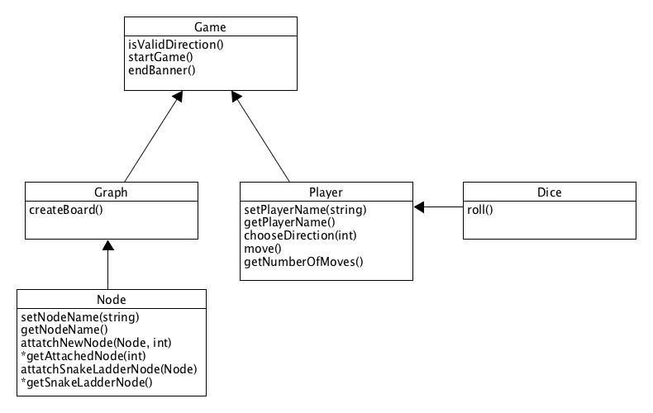

DFD:

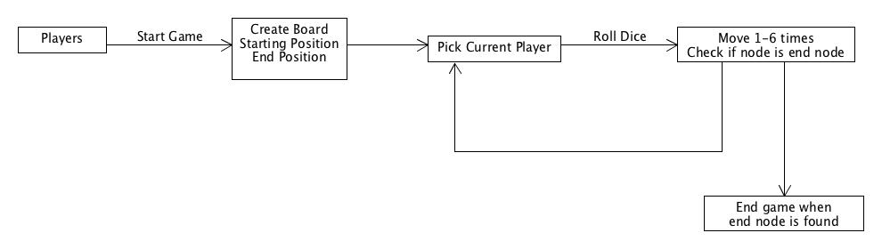

Testing:

System

* Must have more than 2 players
* Die must only roll numbers 1-6
* Only be able to move to valid positions
* Create board of any size (small to large)
* End game when final node reached

Player

* Check for number of moves and make sure it is counting correctly
* chooseDirection() should only be able to move to valid directions

Node

* Allow for 4 directions and a special pointer for snake or ladder.
* Check that each direction corresponds with the correct position in the array of pointers
* Pointer = null if not connected to another node in a specific direction

Graph

* Creates graph of any size (large or small)
* Reads file correctly and connects nodes correctly

Game

* Allow for many players
* Check starting position
* Check ending position
* Quit when end is found
* Throw error when an invalid direction is chosen
* Switch nodes immediately if a snake or ladder is found