Will Mohr CS677A3Fall2023

1. Are there any ”obvious” patterns? For example, for higher σ and µ are there more green points?

2. are points of the same color located close to each other?

3. do patterns repeat from year 1 to year 2?

4. do you expect nearest-neighbor classifier trained in year 1 to do well in year 2?

GME 2020:

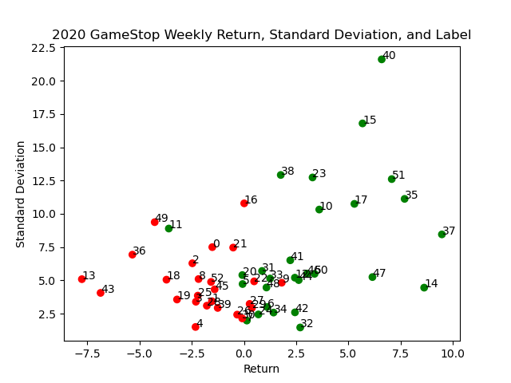

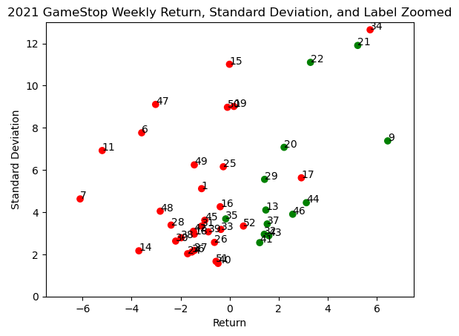

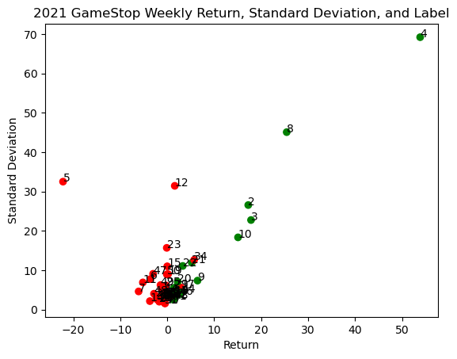

For the most part, positive returns are green and negative returns are red.

There is wide dispersion but not much intermixing of points. This pattern does repeat from year to year.

I do you expect a nearest-neighbor classifier trained in year 1 to do well in year 2.