Will Mohr CS677A3Fall2023

GameStop Plots:

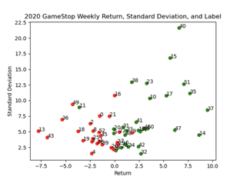

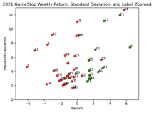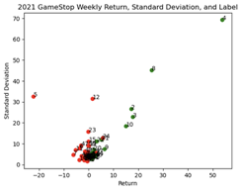

For the most part, positive returns are green and negative returns are red.

There is wide dispersion but not much intermixing of points. This pattern does repeat from year to year. I do you expect a nearest-neighbor classifier trained in year 1 to do well in year 2, though it would likely struggle with the weeks with near zero return.

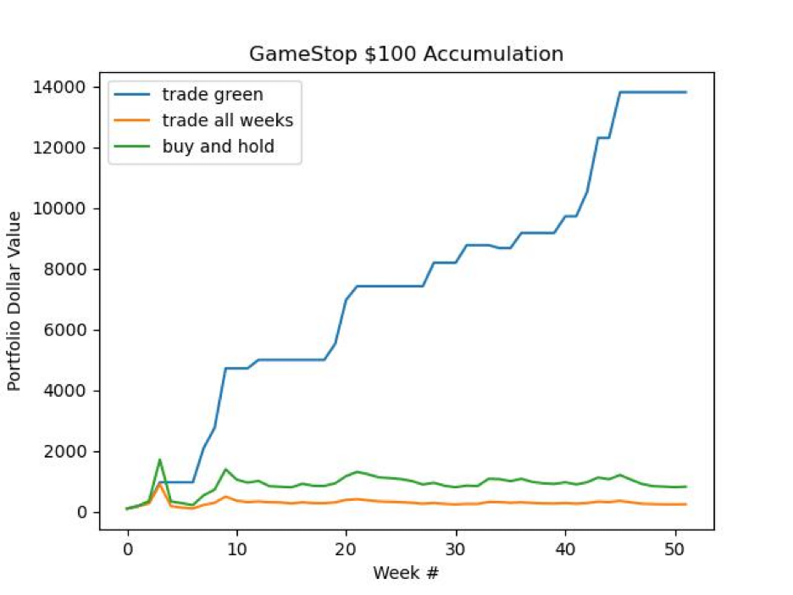

Here we see the returns based on trading green (buy open Monday, sell adjusted close Friday on green weeks compared with portfolio value of $100 invested at the beginning of week 0 left in the market till the end of 2021. Note the impact on returns of being out of the market on weekends, in addition to the clear benefit to returns of foresight.

S&P 500 Plots:

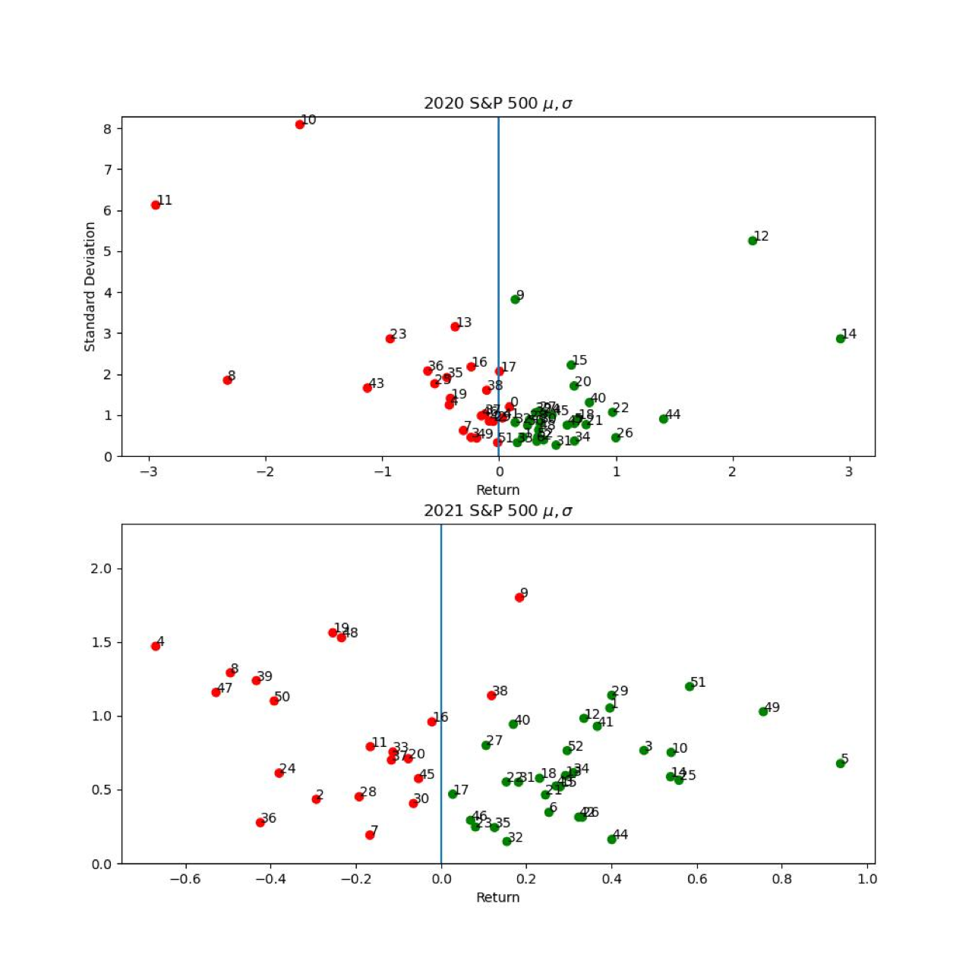

For the S&P 500, most positive return weeks are labeled green and all negative trading weeks are labeled red. There are some exceptions for positive return weeks with high volatility to return ratios. This makes sense from the standpoint of my subjective labeling algorithm, which was mostly following the rule of: green if returns compensate maximum accumulated mid-week loss. Points of the same color are close to each other, and this pattern repeats from year 1 to year 2. I would expect a nearest-neighbor classifier to do well, though it might struggle with weeks of near-zero return.

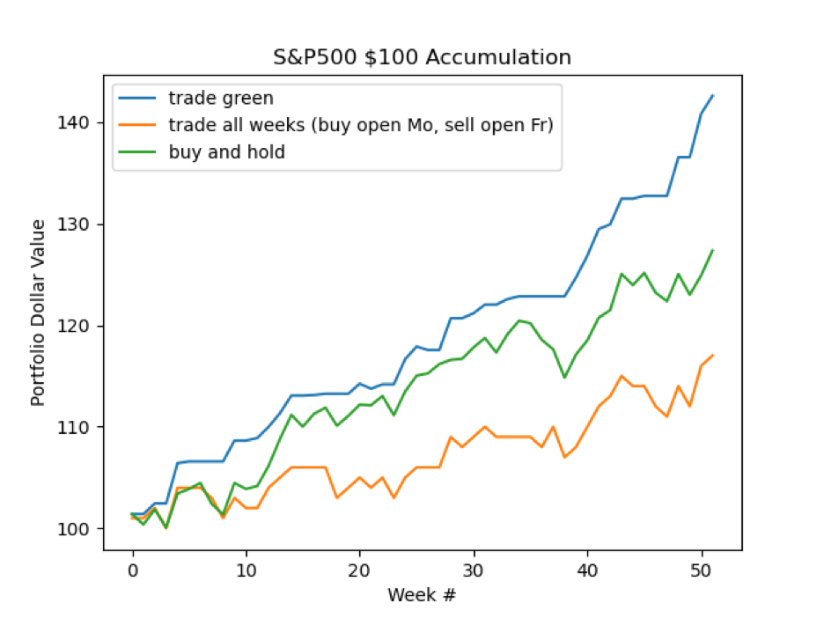

Above we see that there is again significant impact from not being invested during the weekend, as well as from knowing which weeks to be out of the market. Presumably the impact of foresight would be even greater if weekend returns were considered.