Lecture 6 (October 11, 2023)

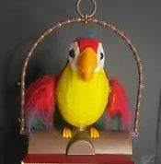

Quiz #2

Homework 6

