Lecture 5 (October 4, 2023)



No Quiz

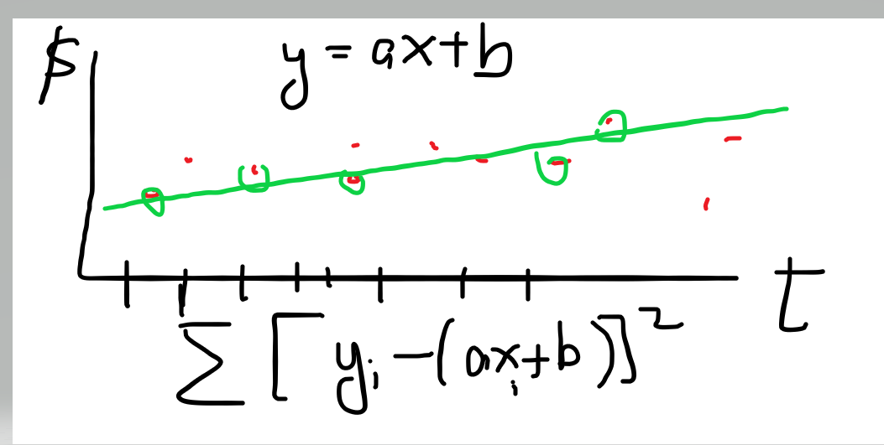

Homework (of course)

1. Sleep Analysis
2. Linear separability
3. Weekly Trading with Statistical oracle