William Mohr Homework 2.

Year | |S| | P(S) | P(S)/|S| | |L| | P(L) | P(L)/|L| | |S+L| | P(S+L) | P(S+L)/|S+L|

------------------------------------------------------------------------------------------------

1 | 36 | 44.31 | 1.23 | 165 | -588.65 | -3.57 | 201 | -544.34 | -2.71

2 | 91 | -86.92 | -0.96 | 89 | 68.61 | 0.77 | 180 | -18.31 | -0.1

3 | 101 | -13.2 | -0.13 | 143 | 107.45 | 0.75 | 244 | 94.25 | 0.39

4 | 136 | -53.97 | -0.4 | 110 | -57.29 | -0.52 | 246 | -111.26 | -0.45

5 | 142 | -24.08 | -0.17 | 102 | -35.2 | -0.35 | 244 | -59.29 | -0.24

1_5 | 506 | -133.86 | -0.26 | 609 | -505.09 | -0.83 | 1115 | -638.95 | -0.57

The above is for GME

Year | |S| | P(S) | P(S)/|S| | |L| | P(L) | P(L)/|L| | |S+L| | P(S+L) | P(S+L)/|S+L|

------------------------------------------------------------------------------------------------

1 | 0 | 0 | 0 | 251 | -1853.09 | -7.38 | 251 | -1853.09 | -7.38

2 | 4 | 25.17 | 6.29 | 250 | -1366.6 | -5.47 | 254 | -1341.44 | -5.28

3 | 0 | 0 | 0 | 251 | -965.37 | -3.85 | 251 | -965.37 | -3.85

4 | 1 | 3.62 | 3.62 | 249 | -638.28 | -2.56 | 250 | -634.66 | -2.54

5 | 16 | 7.33 | 0.46 | 233 | -225.22 | -0.97 | 249 | -217.89 | -0.88

1_5 | 21 | 36.12 | 1.72 | 1234 | -5048.57 | -4.09 | 1255 | -5012.45 | -3.99

The above is for SPY

1. what is the average daily profit for your stock and ”spy”? Since you always start with $100, this number will coincide with percentage profit.

Answer: The avg daily profit is -.057 for GME and -3.99 for SPY

1. is the profit from ”long” positions (when you buy) higher or lower than your profit from ’short” positions (when you sell short)? What is more profitable: long or short positions?

Answer: For GME profit is higher for short positions. For SPY, profit is also higher for short positions.

1. suppose you add a restriction that you will trade only if the absolute value of overnight return is more than some threshold value x (e.g. 5%). (for example, unless stock price rises or falls overnight by more than 5%, you will not trade). With such a restriction, you will trade less frequently but maybe your profut per trade will increase. We would like to investigate the impact of this hyperparameter x. Take 100 points for x from 0 to 10% and plot the average profit per trade P (S + L)/|S + L| (over 5 years). Discuss your findings. Any patterns? Any optimal values for x?

Answer: for GME profits decrease, bottom out around a 6% threshold, and then increase steadily to peak near the end of the range investigated of 10%

For SPY on the other hand, profits keep on decreasing as the threshold increases.

1. The ‘long ’ positions generally become less profitable until ~ 6% and then increase in profitability once again for GME, while for spy they decrease until around .9 before increasing slightly thereafter. For SPY profitability keeps dropping till the end of the hyperparam range.

The “short” positions behave very similarly to the ‘long positions.’ They are wavy for GME with the min profitability with the hyperparam around 6% and they keep decreasing for SPY.

1. 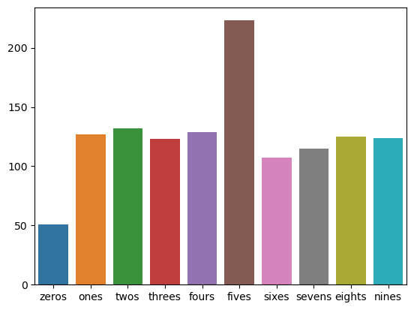

From the above, it is apparent that GME has far more fives and much fewer zeros than the other digits.

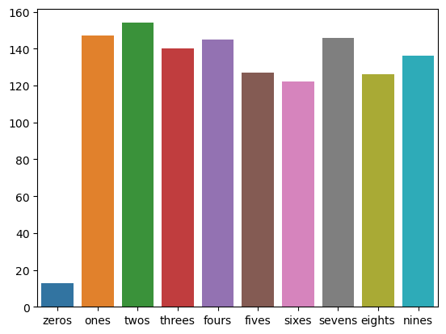

From the above it is apparent that there are far fewer zeros than would be expected by chance for SPY.