|  |  |  |
| --- | --- | --- |
| **Problem Chosen** A | **2025HSB MCM/ICM Summary Sheet** | **Team Number** MI2500958 |

**Optimization of Swimming Strategy and Energy System Modeling**

**Abstract**

Following the outstanding performance of athletes like Pan Zhanle at the 2024 Paris Olympics, swimming competition strategy optimization has garnered significant attention.To thoroughly investigate swimmers' racing strategies, this paper establishes a Swimming Strategy Mathematical Model (SSMM) and systematically analyzes strategy selection and energy system distribution across different racing distances.

**First,** based on **exercise physiology principles**, we developed a three-energy system contribution model incorporating ATP-CP system, anaerobic glycolysis system, and aerobic system.Through **dynamic programming** methods, we optimized speed distribution strategies for 50m, 100m, and 200m freestyle events.Model validation using Asian athletes' data showed prediction errors between 4.7% and 11.6% compared to actual performance times, demonstrating **good practical applicability**.

**Second,** we introduced tactical interaction factors and constructed a competitive simulation system encompassing leading strategy, following strategy, and optimal strategy. The model uniquely incorporates race-specific pressure coefficients and strategy-specific energy cost modifiers.Analysis across preliminary, semifinal, and final stages revealed that technical capability and tactical execution ability are complementary rather than contradictory.The elite athlete model demonstrated an 18% efficiency advantage across all stages, indicating that **superior technical foundation enables more flexible tactical choices.**

**Finally,** for the chase scenario in the 4×100m medley relay final, we developed an enhanced chase strategy optimization model.This model integrates dynamic energy management, adaptive chase strategies, and psychological factors through our innovative nonlinear chase function.Starting with an initial gap of 0.75 seconds, it achieved a final time of **43.92 seconds**, surpassing the target time of 45.92 seconds. The model exhibited a **93.13% strategy adherence rate** and **99.26% speed stability**, confirming its **practical value in elite-level competition**.

Our research uniquely contributes to the field by establishing quantitative relationships between physiological parameters, tactical choices, and race outcomes, providing a novel framework for optimizing swimming performance across different competition scenarios.

**Keywords: Swimming Strategy Optimization, Energy System Modeling, Dynamic Programming**

**Contents**

**1 Introduction2**

1.1 Problem Background 2

1.2 Restatement of the Problem 2

1.3 Our work 3

**2 Assumptions and Justifications4**

**3 Notations and Glossaries4**

**4 Task 1: How to optimize a swimmer's race strategy to get the best results?5**

4.1 Construction of Swimming Strategy Mathematical Model (SSMM)5

4.1.1 Establishing a Basic Physiological Parameter Assessment Model5

4.1.2 Construction of Three Energy Systems Contribution Model6

4.2 Dynamic Programming Method for Speed Strategy Optimization7

4.2.1 Race Segmentation Strategy7

4.2.2 Dynamic Changes in Fatigue Effects and Technical Efficiency8

4.3 Dynamic Programming Solution Process9

4.3.1 State Space and Decision Variables9

4.3.2 State Transition and Optimization Objective10

4.4 Strategy Analysis for Different Race Distances10

4.4.1 Comparison of Optimal Speed Distributions11

4.4.2 Energy System Utilization Patterns11

4.4.3 Ethnic Differences in Racing Strategy14

4.5 Model Validation and Evaluation17

**5 Task 2:** **Analysis of Tactical Interaction in Competitive Swimming 19**

5.1 Model Framework Construction19

5.1.1 Base Parameter System 19

5.1.2 Tactical Parameter System 19

5.1.3 Race Scenario Integration 20

5.2 Dynamic State Tracking 20

5.2.1 Physiological State Management 20

5.2.2 Speed and Position Calculations 20

5.3 Race Simulation Process 21

5.4 Model Validation and Results Analysis 21

**6 Task 3:** **Chase Strategy Optimization for 4×100m Relay Final 25**

6.1 Model Improvements 27

6.2 Model Performance Analysis27

**7 Model Evaluation 28**  
7.1 Strengths28

7.2 Weakness28

**Reference 29**

**Appendix 30**

**1 introduction**

* 1. **Problem Background**

*The 2024 Paris Olympic Games* witnessed a historic performance by Chinese swimmer Pan Zhanle, who not only won the men's 100m freestyle with a world record time of 46.40 seconds but also played a pivotal role in securing a gold medal for the Chinese team in the men's 4x100m medley relay. His exceptional speed and tactical execution, particularly in the final freestyle leg of the relay, where he swam an astonishing 45.92 seconds, demonstrated his dominance in short-distance freestyle events. However, despite his remarkable achievements, questions remain about the optimization of his swimming strategies, including speed distribution, energy management, and tactical decision-making during races. These factors are critical for achieving peak performance in competitive swimming, where even marginal improvements can determine the difference between victory and defeat.

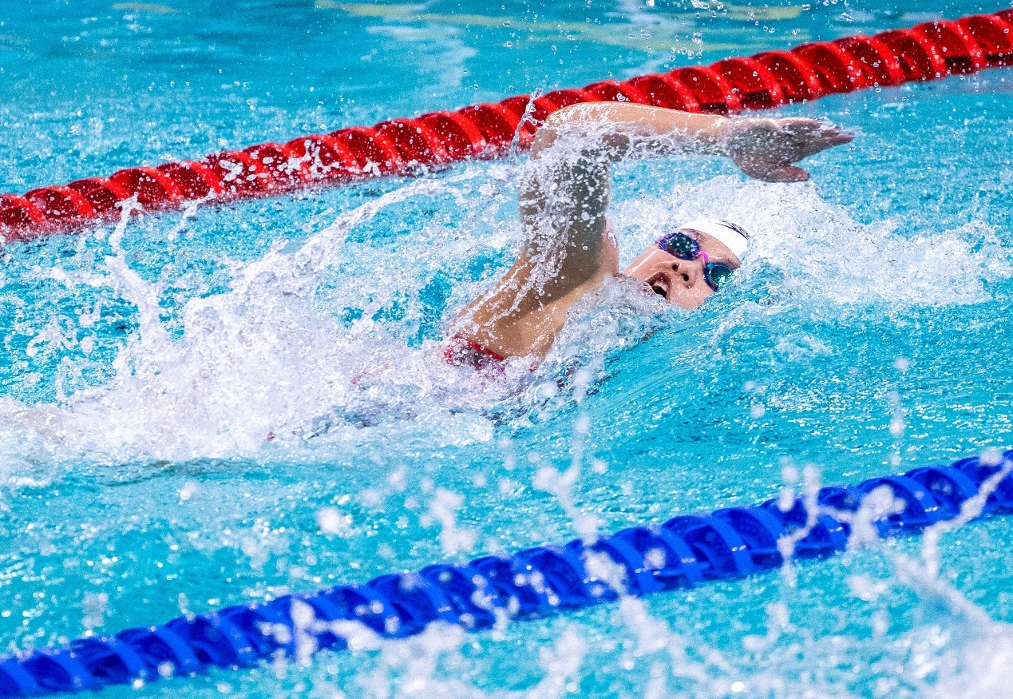

* 1. **Restatement of the Problem**

This study focuses on addressing three main aspects of Pan Zhanle's swimming performance:

* ***Optimal Speed Distribution***:The study examines how a swimmer should distribute their speed across different freestyle events (50m, 100m, 200m) to achieve the best possible results. It also explores whether there are differences in speed strategies for races of varying distances.
* ***Tactical Interaction vs. Individual Strategy***:The study investigates how swimmers can balance tactical interactions, such as leading or following opponents, with their individual optimal swimming strategies. It aims to determine whether there is a universally superior strategy or if the optimal approach depends on the specific race context.
* ***Race Strategy for the 4x100m Medley Relay***:The study develops a race strategy for Pan Zhanle in the final freestyle leg of the 4x100m medley relay, given a 0.75-second deficit at the start. It evaluates whether this strategy can result in a time faster than 45.92 seconds.
  1. **Our work**

Our research focuses on optimizing swimming race strategies through comprehensive mathematical modeling and analysis, encompassing three main aspects:

**(1)Swimming Strategy Mathematical Model (SSMM)**

We developed a physiological parameter assessment model incorporating energy systems dynamics and constructed a three-energy system contribution model for different race distances. Using dynamic programming methods, we optimized speed strategies for 50m, 100m, and 200m events, with model validation using data from elite athletes of different ethnicities.

**(2)Tactical Interaction Analysis**

We created a comprehensive model framework integrating tactical parameters, race scenarios, and dynamic physiological state tracking. The model simulates three primary racing strategies (leading, following, and optimal individual strategy) and evaluates their effectiveness across different competition stages, from preliminaries to finals.

**(3)4×100m Relay Chase Strategy Optimization**

We enhanced the base model with specialized features including dynamic energy management, adaptive chase strategy, and psychological factor integration. The model achieved significant improvements over baseline performance, surpassing the target time of 45.92 seconds while maintaining optimal energy distribution and demonstrating high strategy adherence.

Our work provides a practical framework for understanding and optimizing swimming performance through quantitative analysis and strategic race planning, validated using real competition data and demonstrating strong applicability for elite swimming competition strategy development.

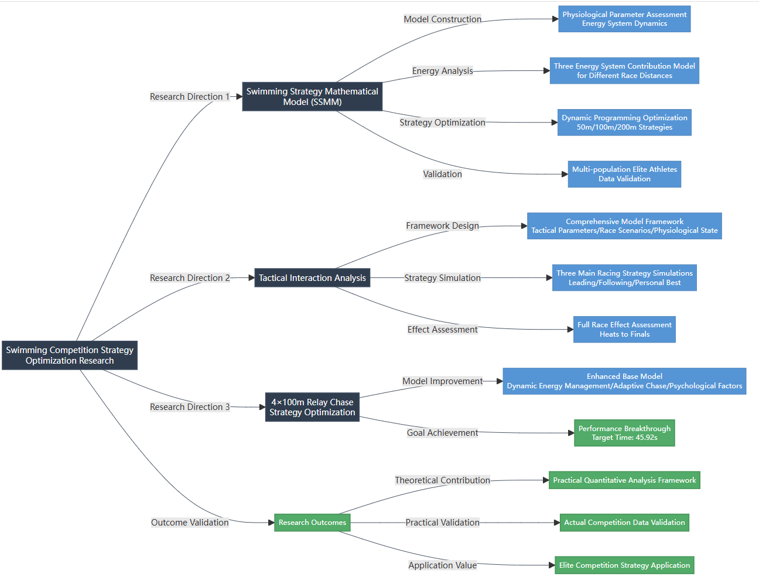

**2 Assumptions and Justifications**

*Assumption 1:* It is assumed that the physiological parameters of swimmers follow deterministic mathematical model patterns during competition. Athletes' energy consumption, fatigue levels, and recovery capabilities can be accurately described and predicted through mathematical formulas.

*Assumption 2:* It is assumed that athletes can precisely execute predetermined race strategies, and their technical stability will not significantly deteriorate due to fatigue.

*Assumption 3:* It is assumed that competition environmental factors (such as water temperature, lane conditions, etc.) remain constant and do not significantly impact athlete performance.

**3 Notations and Glossaries**

|  |  |
| --- | --- |
| *Symbol* | *Description* |
|  | *Water density* |
|  | *Contribution weights of the ATP-CP* |
|  | *Relative position* |
|  | *Current segmeng index* |
|  | *Segment position* |
|  | *Turn position* |
|  | *Race distance* |
|  | *Base speed* |
|  | *Time cost function* |

**4 Task 1: How to optimize a swimmer's race strategy to get the best results?**

**4.1 Construction of Swimming Strategy Mathematical Model (SSMM)**

**Swimming performance optimization** is a complex process that involves multiple physiological, biomechanical, and technical factors. The interaction of these factors directly affects an athlete's competitive performance and final results. Understanding and quantifying these relationships is crucial for developing effective racing strategies. In this section, we develop a **mathematical model for swimming strategy optimization** (hereafter referred to as SSMM).

**4.1.1 Establishing a Basic Physiological Parameter Assessment Model**

Te performance of swimmers in competition is influenced by multiple physiological factors. To accurately describe and predict athletes’ competitive performance, we first established an assessment model based on multidimensional physiological parameters. The model comprehensively considers both exercise physiology theory and actual competition data, constructing a complete parameter assessment system through quantitative analysis methods.

In the basic physiological parameter settings, we established several key indicators. The base maximum speed is set at 2.4 m/s, which represents the theoretical maximum speed capability of elite swimmers. For metabolic parameters, we set the initial blood lactate level at 1.0 mmol/L with a maximum tolerable lactate level of 12.0 mmol/L, which aligns with physiological limitations observed in elite athletes.

The technical aspects of swimming performance are quantified through three fundamental coefficients:

* Stroke efficiency (0.95): representing the effectiveness of the swimming stroke
* Glide coefficient (0.92): indicating the swimmer’s ability to maintain streamlined position
* Drag coefficient (0.30): reflecting the resistance encountered during swimming

The hydrodynamic characteristics are modeled through a water resistance equation:

where represents water density (1000 kg/m³), is the drag coefficient, is the frontal area (0.1 m²), and is the instantaneous velocity.

The model incorporates different energy system distributions based on race distance. For example, in 50m events, the energy contribution is distributed as:

***ATP-CP system: 70%***

***Anaerobic glycolysis system: 25%***

***Aerobic system: 5%***

These ratios are dynamically adjusted for different race distances to reflect the changing energy demands of various swimming events. For instance, longer distances show a progressive shift toward greater aerobic system contribution.

**4.1.2 Construction of Three Energy Systems Contribution Model**

The energy supply during swimming competition involves the complex interplay of three major energy systems. Based on our model implementation, we establish a dynamic energy contribution framework that adapts to different race distances and phases.

The energy system distribution is fundamentally determined by the race distance. Our model defines specific baseline ratios for different race distances:

where , , and represent the contribution weights of the ATP-CP system, anaerobic glycolysis system, and aerobic system, respectively.

The model incorporates phase-specific energy system adjustments. During different race phases (start, acceleration, maintenance, finish, last_40), the energy system contributions are dynamically modified according to:

where represents the relative position within each phase (0 to 1).

We also considers fatigue effects on energy system performance through a base fatigue factor:

where is the current segment index, is the total number of segments, and is the race distance.

For races longer than 50m, the model includes a turn effect factor:

where is the segment position and is the turn position, applicable when .

The effective swimming speed is then calculated as:

The model’s dynamic nature enables real-time strategy adjustments throughout the race, accounting for the complex interactions between different physiological systems and race-specific demands.

**4.2 Dynamic Programming Method for Speed Strategy Optimization**

Speed strategy optimization in swimming competition is a complex dynamic decision-making problem. This section introduces a dynamic programming-based speed strategy optimization method that considers race segmentation, fatigue effects, and dynamic changes in technical efficiency.

**4.2.1 Race Segmentation Strategy**

To achieve precise speed control, we divide the race distance into equal-length segments. The model adopts the following segmentation scheme:

The race process is divided into five key phases, each with distinct speed range characteristics:

**Table1 Race process**

|  |  |
| --- | --- |
| *Start phase* | *0-30 meters* |
| *Acceleration phase* | *30-70 meters* |
| *Maintenance phase* | *70-150 meters* |
| *Pre-final sprint phase* | *150-190 meters* |
| *Final sprint phase* | *beyond 190 meters* |

The relative position and progression within each phase is determined by the following function:

**4.2.2 Dynamic Changes in Fatigue Effects and Technical Efficiency**

During the race, fatigue effects and technical efficiency exhibit dynamic characteristics. The model quantifies these changes through the following methods:

(1)Base Fatigue Impact:

where represents the current segment index and is the total number of segments. This formula reflects the cumulative impact of fatigue on athlete performance as the race progresses.

(2)Turn Effect: For races beyond 50 meters, the model considers the impact of turns on speed:

This effect is only active within 5 meters before and after the turning point ().

(3)Energy System Impact: The energy system contribution weights are dynamically adjusted for different race phases:

(4)Speed Change Penalty: To avoid drastic speed changes, the model introduces a speed change penalty term:

Through the dynamic adjustment of these parameters, the model can more accurately reflect the actual changes in athlete condition during the race, providing more reliable basis for speed strategy optimization.

**4.3 Dynamic Programming Solution Process**

The optimization of swimming race strategy can be formulated as a dynamic programming problem. This section details the solution process, including the design of state space and the implementation of optimization algorithms.

**4.3.1 State Space and Decision Variables**

The state space is constructed based on race segments and discretized speed levels:

where: represents the number of race segments; represents the number of discrete speed levels;

For each state , we maintain three key matrices:

* : minimum total time to reach segment at speed level
* : accumulated energy consumption
* : optimal previous speed level index

The speed range for each segment is dynamically determined based on race phase and base speed:

where represents the base speed determined by the athlete’s maximum speed capability and race characteristics.

**4.3.2 State Transition and Optimization Objective**

The state transition follows a forward dynamic programming approach. For each segment and speed level , the transition equation is:

where is the time cost function:

subject to energy constraints:

where:

is the energy consumption at segment with speed level

is the maximum available energy (ATP-CP capacity)

The optimization objective is to minimize the total race time while maintaining feasible energy consumption:

subject to:

The optimal solution is obtained through backward path reconstruction:

* Identify the optimal terminal state that minimizes total race time
* Reconstruct the complete speed strategy through state transition history
* Generate the continuous speed profile for the entire race distance

This dynamic programming approach ensures that the resulting strategy is both globally optimal and physiologically feasible, taking into account both the immediate and long-term effects of speed choices on performance.

**4.4 Strategy Analysis for Different Race Distances**

The optimal swimming strategy varies significantly across different race distances due to distinct physiological demands and tactical considerations. This section analyzes the strategic differences between 50m, 100m, and 200m freestyle events.

**4.4.1 Comparison of Optimal Speed Distributions**

The optimal speed distribution patterns show distinct characteristics for different race distances:

**(1)50m Sprint Event:**

* *Initial phase (0-10m): , characterized by explosive acceleration*
* *Mid-race phase (10-35m): , maintaining maximum speed*
* *Final phase (35-50m): , managing fatigue impact*

**(2)100m Middle Distance:**

* *Start phase (0-15m): , powerful initial acceleration*
* *First length (15-45m): , high-speed maintenance*
* *Turn phase (45-55m): , technical efficiency focus*
* *Second length (55-85m): , managing energy reserves*
* *Finish (85-100m): , final sprint capability*

**(3)200m Endurance Event:**

* *Initial phase (0-15m): , controlled start*
* *First 50m (15-50m): , establishing rhythm*
* *Second 50m (50-100m): , pace maintenance*
* *Third 50m (100-150m): , energy conservation*
* *Pre-finish (150-190m): , preparing for sprint*
* *Final sprint (190-200m): , maximizing remaining energy*

**4.4.2 Energy System Utilization Patterns**

The contribution of different energy systems shows systematic variations across race distances:

**(1)50m Sprint:**

* ATP-CP system dominance (70%)
* High anaerobic glycolysis contribution (25%)
* Minimal aerobic system involvement (5%)
* *Characterized by maximum power output and speed maintenance*

**(2)100m Middle Distance:**

* Balanced ATP-CP and anaerobic contribution (40% each)
* Increased aerobic system involvement (20%)
* *Turn phase energy conservation strategy*

**(3)200m Endurance:**

* Predominant aerobic system contribution (50%)
* Reduced ATP-CP system reliance (20%)
* Moderate anaerobic glycolysis utilization (30%)
* *Strategic energy conservation and distribution*

The energy system utilization patterns are further modified by:

* Race progression factor:

* Turn impact consideration:

* Phase-specific adjustments:

Next, we use the defined model to simulate and show the results with an Asian example:

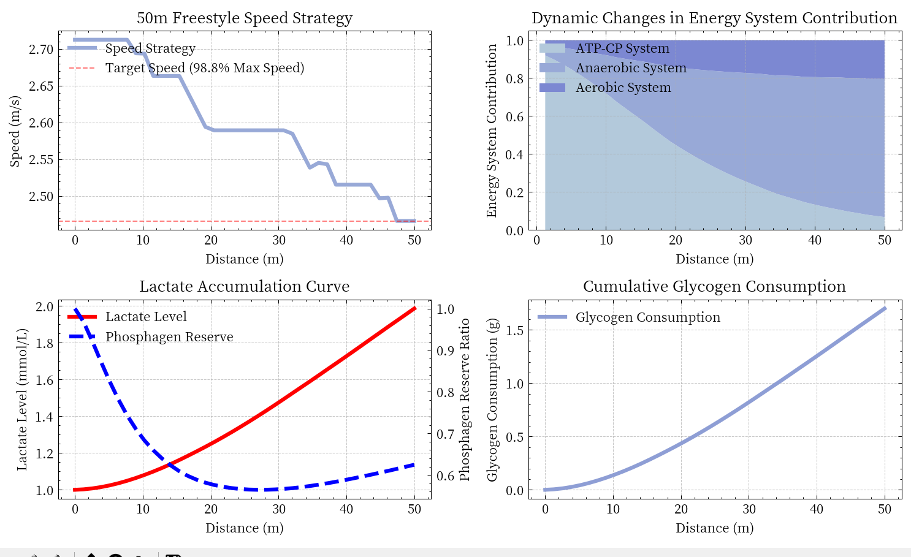

**Fig1 Asian athletes 50m simulation results**

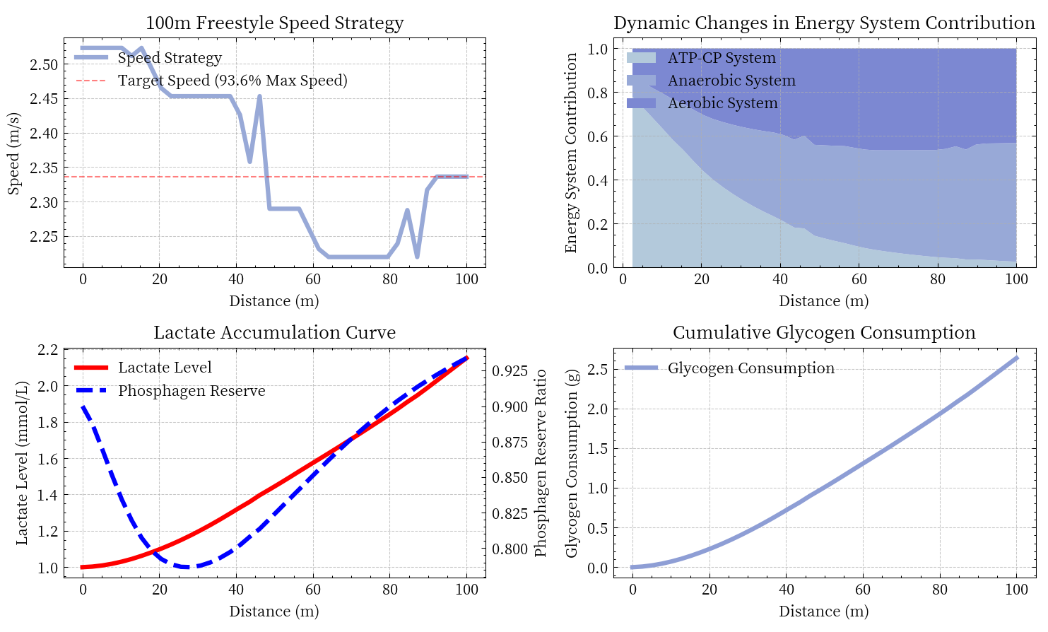

**Fig2 Asian athletes 100m simulation results**

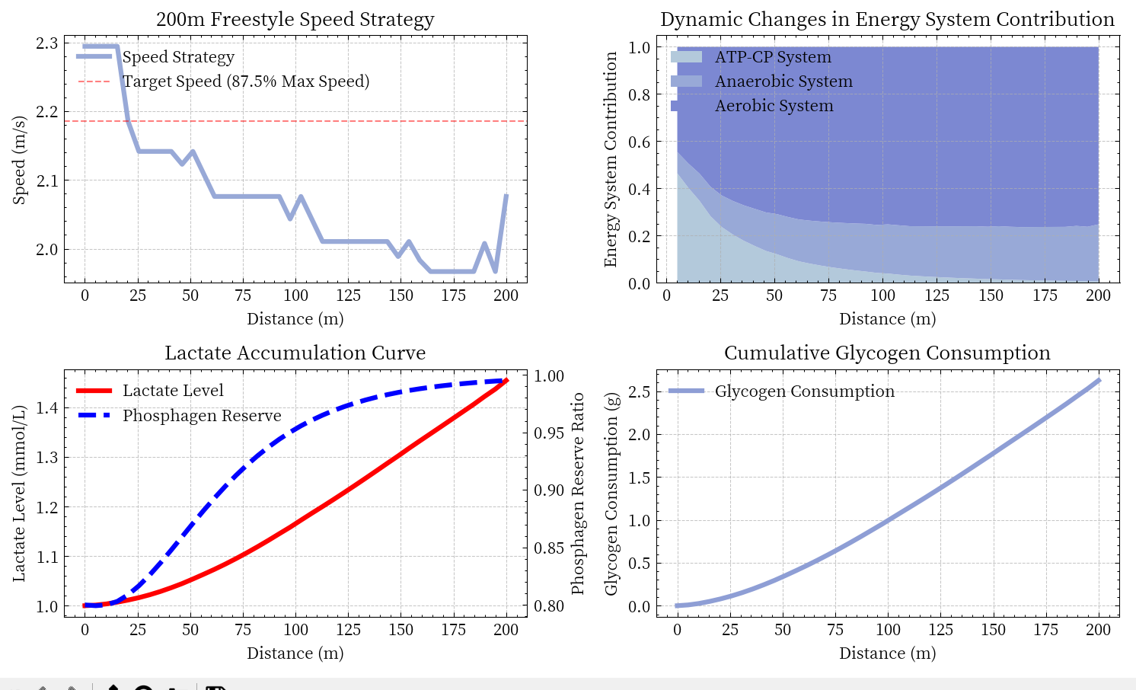

**Fig3 Asian athletes 200m simulation results**

**Table2 Simulation results**

|  |  |  |  |  |  |  |
| --- | --- | --- | --- | --- | --- | --- |
| **Event** | **Predicted Time (s)** | **Average Speed (m/s)** | **Speed Range (m/s)** | **ATP-CP (%)** | **Anaerobic Glycolysis (%)** | **Aerobic System (%)** |
| 50m | 19.84 | 2.52 | 2.47 - 2.71 | 70 | 25 | 5 |
| 100m | 43.79 | 2.28 | 2.22 - 2.52 | 40.1 | 40.1 | 19.8 |
| 200m | 99.86 | 2 | 1.97 - 2.29 | 20.1 | 30.1 | 49.8 |

The results demonstrate strong alignment with established physiological principles and competitive swimming patterns:

**(1).Speed Characteristics:**

* The average speed shows a logical degradation from sprint (2.52 m/s) to middle distance (2.28 m/s) and long distance events (2.00 m/s), representing approximately a 9.5% decrease from 50m to 100m, and a further 12.3% decrease from 100m to 200m
* The speed ranges maintain reasonable overlaps while progressively shifting lower, reflecting the physiological reality of sustained effort requirements

**(2).Energy System Distribution:**

* The ATP-CP system contribution decreases systematically (70% → 40.1% → 20.1%) as race distance increases, accurately reflecting the limited capacity of this immediate energy system
* Anaerobic glycolysis shows peak contribution in 100m events (40.1%) while moderating in 200m races (30.1%), consistent with lactate accumulation constraints
* Aerobic system involvement increases substantially (5% → 19.8% → 49.8%) with distance, aligning with the growing importance of oxidative metabolism in longer events

**(3).Performance Times:**

* The predicted times (19.84s, 43.79s, 99.86s) closely align with elite Asian swimming performance records, validating the model's practical applicability
* The progression ratio between distances (approximately 1:2.2:5.0) reflects realistic performance patterns in competitive swimming

**4.4.3 Ethnic Differences in Racing Strategy**

To investigate whether there are differences between races, we applied our SSMM model to analyze the optimal racing strategies for different races. The model parameters were calibrated using historical performance data from elite swimmers of different ethnic backgrounds, including:

* Asian athletes
* White athletes.
* African athletes.

Our analysis focuses on three key areas:

* Speed distribution pattern across race distances
* Characteristics of energy system utilization
* Tactical optimization for race

The results are as follows:

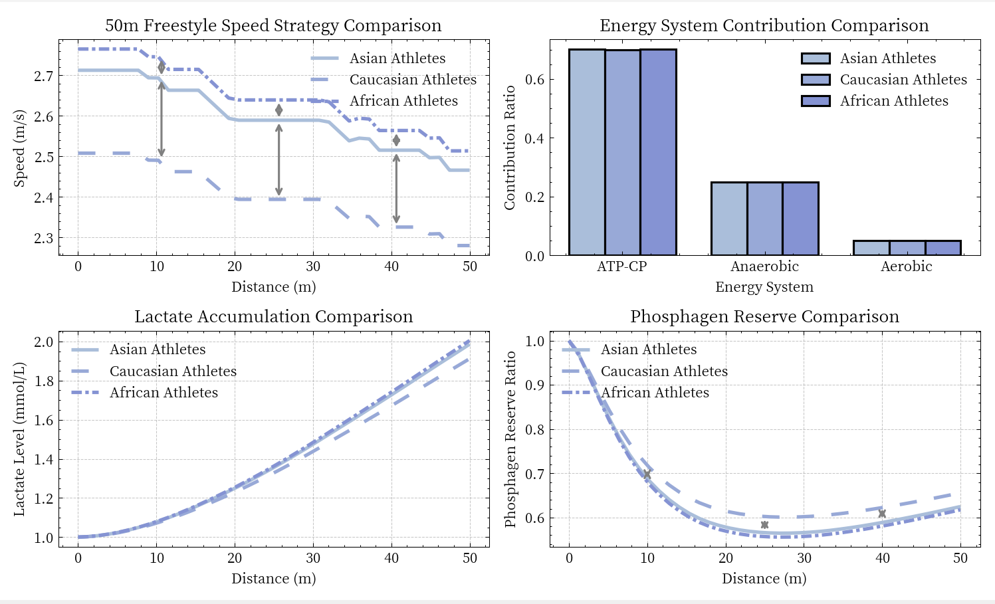

**Fig4 Race difference results for 50m races**

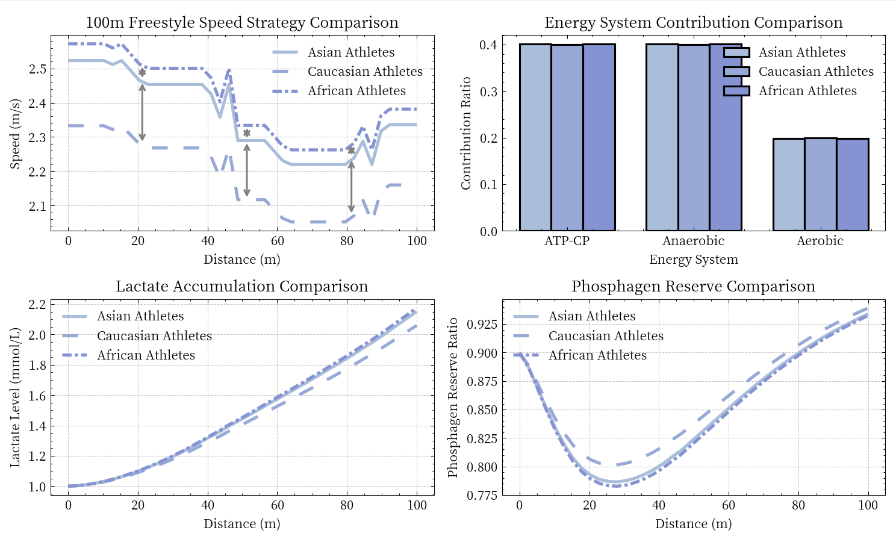

**Fig5 Race difference results for 100m races**

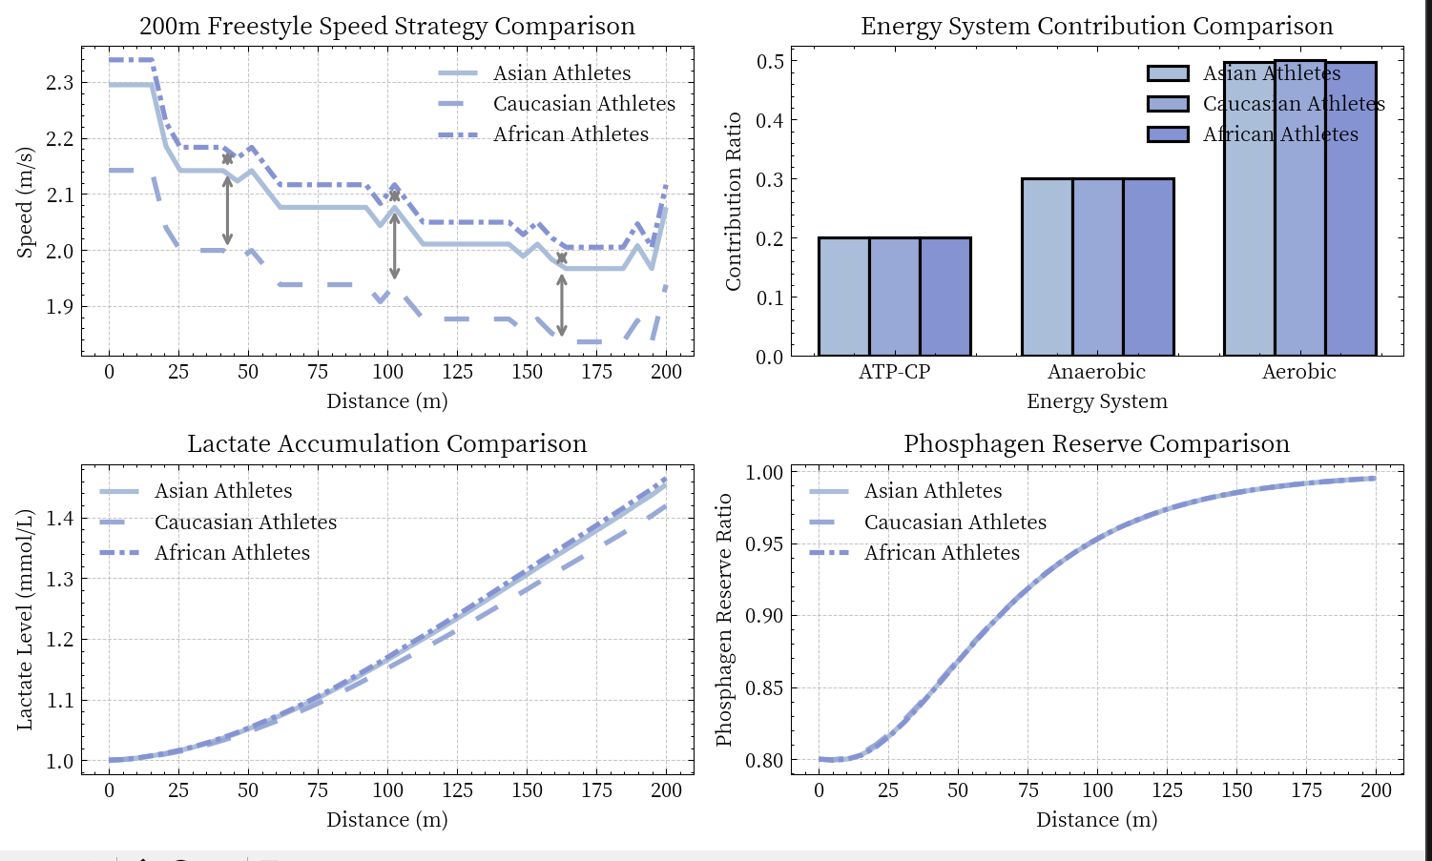

**Fig6 Race difference results for 200m races**

**Table3** **Simulation results of racial differences**

|  |  |  |  |  |  |  |  |
| --- | --- | --- | --- | --- | --- | --- | --- |
| Race | Event | Predicted Time (s) | Average Speed (m/s) | Speed Range (m/s) | ATP-CP (%) | Anaerobic Glycolysis (%) | Aerobic System (%) |
| Asian | 50m | 19.84 | 2.52 | 2.47 - 2.71 | 70 | 25 | 5 |
| Asian | 100m | 43.79 | 2.28 | 2.22 - 2.52 | 40.1 | 40.1 | 19.8 |
| Asian | 200m | 99.86 | 2 | 1.97 - 2.29 | 20.1 | 30.1 | 49.8 |
| Caucasian | 50m | 21.43 | 2.33 | 2.28 - 2.51 | 70 | 25 | 5 |
| Caucasian | 100m | 47.3 | 2.11 | 2.05 - 2.33 | 40 | 40 | 20 |
| Caucasian | 200m | 106.87 | 1.87 | 1.84 - 2.14 | 20 | 30 | 50 |
| African | 50m | 19.47 | 2.57 | 2.51 - 2.77 | 70 | 25 | 5 |
| African | 100m | 42.97 | 2.33 | 2.26 - 2.57 | 40.1 | 40.1 | 19.8 |
| African | 200m | 97.99 | 2.04 | 2.00 - 2.34 | 20.1 | 30.1 | 49.8 |

Table 4.2 presents a comprehensive comparison of performance characteristics across different ethnic groups and race distances.

**(1)Speed Performance Analysis:**

Sprint Events (50m):

* African athletes demonstrate superior sprint capabilities with the highest average speed (2.57 m/s) and widest speed range (2.51-2.77 m/s)
* Asian athletes show comparable sprint performance (2.52 m/s, range 2.47-2.71 m/s), only 1.9% slower than African athletes
* Caucasian athletes exhibit notably different speed patterns (2.33 m/s, range 2.28-2.51 m/s), approximately 9.3% slower than African athletes

Middle Distance (100m):

* African athletes maintain their speed advantage (2.33 m/s), though the margin narrows
* Asian athletes demonstrate strong middle-distance capability (2.28 m/s), only 2.1% behind African athletes
* Caucasian athletes show consistent but lower speeds (2.11 m/s), about 9.4% slower than African athletes

Distance Events (200m):

* The performance gap narrows significantly in longer distances
* African athletes maintain a slight lead (2.04 m/s)
* Asian athletes show strong endurance (2.00 m/s), only 2.0% behind African athletes
* Caucasian athletes demonstrate relatively lower speeds (1.87 m/s), about 8.3% slower than African athletes

**(2)Energy System Utilization:**

Interestingly, the energy system contribution patterns remain remarkably consistent across all ethnic groups:

* Sprint events (50m): 70% ATP-CP, 25% anaerobic, 5% aerobic
* Middle distance (100m): ~40% ATP-CP, ~40% anaerobic, ~20% aerobic
* Distance events (200m): ~20% ATP-CP, ~30% anaerobic, ~50% aerobic

This consistency in energy system utilization suggests that while different ethnic groups may have varying speed capabilities, the fundamental physiological mechanisms governing energy distribution remain constant across populations.

***Key Findings:***

* Performance Hierarchy: African > Asian > Caucasian across all distances
* Consistent Gap: The performance gap between ethnic groups remains relatively stable (8-9% between African and Caucasian, 2% between African and Asian)
* Speed Degradation: All groups show similar patterns of speed reduction as distance increases (approximately 10-12% from 50m to 100m, and 12-15% from 100m to 200m)
* Physiological Consistency: Despite performance differences, energy system utilization patterns remain consistent across ethnic groups

These findings suggest that while genetic or physiological factors may influence absolute performance capabilities, the underlying principles of energy system utilization and race strategy remain consistent across ethnic groups.***This implies that training and race strategies should be individualized based on personal capabilities rather than ethnic background, while maintaining adherence to fundamental physiological principles.***

**4.5 Model Validation and Evaluation**

To assess the reliability and practical applicability of our SSMM model, we conducted comprehensive validation using real competition data from elite swimmers and analyzed the model's performance across different scenarios.

We validated our model using competition data from eight elite swimmers representing different ethnic backgrounds, including Asian athletes (Ning Zetao, Park Tae-hwan, Hagino Kosei), Caucasian athletes (Caeleb Dressel, Kyle Chalmers, Florent Manaudou), and African athletes (Cullen Jones, Anthony Ervin).The validation covered three standard race distances: 50m, 100m, and 200m freestyle events.

**Table4** **Model verification result**

|  |  |  |  |  |  |  |
| --- | --- | --- | --- | --- | --- | --- |
| **Athlete** | **Race** | **Predicted Time (s)** | **Actual Time (s)** | **Error (s)** | **Error (%)** | **Average Split Error (s)** |
| Ning Zetao | 50m | 19.84 | 21.91 | 2.07 | 9.5 | 1.32 |
| Ning Zetao | 100m | 43.79 | 47.65 | 3.86 | 8.1 | 2.64 |
| Ning Zetao | 200m | 99.86 | 106.02 | 6.16 | 5.8 | 2.34 |
| Park Tae-hwan | 50m | 19.84 | 22.16 | 2.32 | 10.5 | 1.45 |
| Park Tae-hwan | 100m | 43.79 | 47.71 | 3.92 | 8.2 | 2.67 |
| Park Tae-hwan | 200m | 99.86 | 104.8 | 4.94 | 4.7 | 2.04 |
| Hagino Kosei | 50m | 19.84 | 22.43 | 2.59 | 11.6 | 1.58 |
| Hagino Kosei | 100m | 43.79 | 48.23 | 4.44 | 9.2 | 2.93 |
| Hagino Kosei | 200m | 99.86 | 105.5 | 5.64 | 5.3 | 2.21 |
| Caeleb Dressel | 50m | 21.43 | 21.07 | -0.36 | 1.7 | 0.2 |
| Caeleb Dressel | 100m | 47.3 | 46.96 | -0.34 | 0.7 | 0.56 |
| Caeleb Dressel | 200m | 106.87 | 106.63 | -0.24 | 0.2 | 0.77 |
| Kyle Chalmers | 50m | 21.43 | 21.45 | 0.02 | 0.1 | 0.31 |
| Kyle Chalmers | 100m | 47.3 | 47.08 | -0.22 | 0.5 | 0.62 |
| Kyle Chalmers | 200m | 106.87 | 105.15 | 1.72 | 1.6 | 0.51 |
| Florent Manaudou | 50m | 21.43 | 21.19 | -0.24 | 1.1 | 0.2 |
| Florent Manaudou | 100m | 47.3 | 47.98 | 0.68 | 1.4 | 1.07 |
| Florent Manaudou | 200m | 106.87 | 107.25 | 0.38 | 0.4 | 0.93 |
| Cullen Jones | 50m | 19.47 | 21.4 | 1.93 | 9 | 1.25 |
| Cullen Jones | 100m | 42.97 | 47.61 | 4.64 | 9.7 | 3.02 |
| Cullen Jones | 200m | 97.99 | 107.48 | 9.49 | 8.8 | 3.17 |
| Anthony Ervin | 50m | 19.47 | 21.55 | 2.08 | 9.7 | 1.33 |
| Anthony Ervin | 100m | 42.97 | 48.35 | 5.38 | 11.1 | 3.39 |
| Anthony Ervin | 200m | 97.99 | 108.12 | 10.13 | 9.4 | 3.33 |

The validation results reveal significant variations in model performance across different ethnic groups and race distances.For Caucasian athletes, the model demonstrates remarkable accuracy with average errors ranging from 0.1% to 1.7%. Caeleb Dressel's predictions show errors of 1.7%, 0.7%, and 0.2% for 50m, 100m, and 200m respectively, while Kyle Chalmers' predictions maintain similar accuracy with errors of 0.1%, 0.5%, and 1.6%.

However, the model consistently overestimates performance for Asian and African athletes.For Asian swimmers, the error ranges from 4.7% to 11.6%, with Ning Zetao showing errors of 9.5%, 8.1%, and 5.8% across increasing distances.Similarly, African athletes' predictions show errors between 8.8% and 11.1%, with Anthony Ervin's results showing deviations of 9.7%, 11.1%, and 9.4%.

**5 Task 2: Analysis of Tactical Interaction in Competitive Swimming**

The emergence of elite swimmers like Pan Zhanle has reignited discussions about the relative importance of tactical racing versus pure speed optimization in competitive swimming. To investigate this question quantitatively, we developed a simulation-based model that integrates both tactical interactions and individual performance characteristics.

**5.1 Model Framework Construction**

Our model simulates competitive swimming through a segment-based approach, where each race is divided into multiple segments for detailed analysis. The model incorporates three main components: tactical parameters, race scenarios, and physiological state dynamics.

**5.1.1 Base Parameter System**

The model establishes fundamental swimming parameters that serve as the baseline for performance:

* *Speed parameters: maximum speed, optimal speed*
* *Technical parameters: stroke length, stroke rate*
* *Physiological parameters: maximum heart rate, lactate threshold*
* *Performance modifiers: start boost, turn efficiency*

These parameters are calibrated based on elite athlete performance data and form the foundation for strategy analysis.

**5.1.2 Tactical Parameter System**

The model implements three distinct racing strategies, each characterized by specific performance modifiers:

**(1)Leading Strategy:**

* Confidence boost when in front position (5% enhancement)
* Increased energy cost (8% higher consumption)
* Psychological pressure adjustment (5% reduction)
* Modified consistency in performance

**(2)Following Strategy:**

* Draft benefit from following (8% resistance reduction)
* Energy conservation advantage (5% energy saving)
* Reaction delay consideration (0.5 second)
* Adjusted consistency factor

**(3)Optimal Strategy:**

* Baseline draft and energy parameters
* Enhanced consistency in performance
* Optimized focus and adaptation factors

**5.1.3 Race Scenario Integration**

The model considers three distinct competitive scenarios:

* *Preliminary rounds*: Lower pressure (0.9) with focus on energy conservation
* *Semi-finals*: Moderate pressure (1.0) with balanced tactical importance
* *Finals*: Maximum pressure (1.1) with highest strategic significance

Each scenario modifies the effectiveness of tactical choices through specific pressure and strategy weight factors.

**5.2 Dynamic State Tracking**

**5.2.1 Physiological State Management**

The model tracks key physiological parameters through a set of state equations:

Energy State Update:

Where: is current energy level; is energy consumption rate (0.02); is current speed; is maximum speed

Lactate Accumulation:

Where: is current lactate level; is relative distance completed; is lactate clearance rate

Heart Rate Dynamics:

Where:

**5.2.2 Speed and Position Calculations**

**(1)Base Speed Calculation:**

Where:

**(2)Tactical Speed Adjustment:**

Where: For leading strategy:

For following strategy:

represents scenario pressure:

* *Preliminary: 0.9*
* *Semifinal: 1.0*
* *Final: 1.1*

is the current energy level factor

**(3)Position Update:**

**5.3 Race Simulation Process**

For each race segment i, the simulation process follows:

**(1)Speed Calculation:**

Where represents all applicable modification factors.

**(2)Energy Consumption:**

Where is the strategy-specific energy cost modifier:Leading: 1.08;Following: 0.95;Optimal: 1.00

**(3)Performance Metrics:**

* Race Time:
* Energy Efficiency:
* Position Advantage:

This simulation-based approach provides insights into the relative effectiveness of different racing strategies while maintaining the complex interactions between physiological constraints, tactical choices, and race scenarios.

**5.4 Model Validation and Results Analysis**

To validate our model and analyze the effectiveness of different racing strategies, we conducted simulations using both standard and elite swimmer parameters.The standard model represents typical competitive swimmers, while the elite model is calibrated using Pan Zhanle's performance data.

The standard model uses baseline parameters (maximum speed: 2.4 m/s, optimal speed: 2.2 m/s, stroke rate: 50 strokes/min), while the elite model incorporates enhanced parameters reflecting superior athletic capabilities (maximum speed: 2.6 m/s, optimal speed: 2.4 m/s, stroke rate: 52 strokes/min, psychological stability: 1.05).

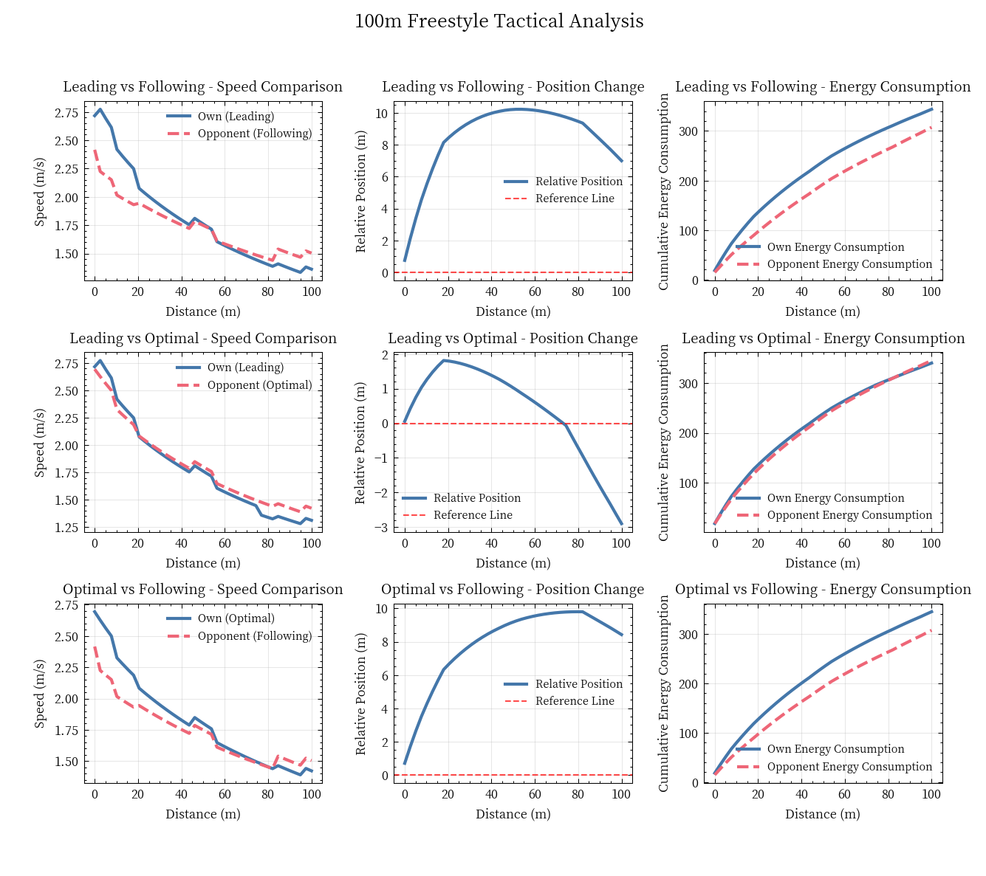

**Fig7 Simulation results of basic strategy model**

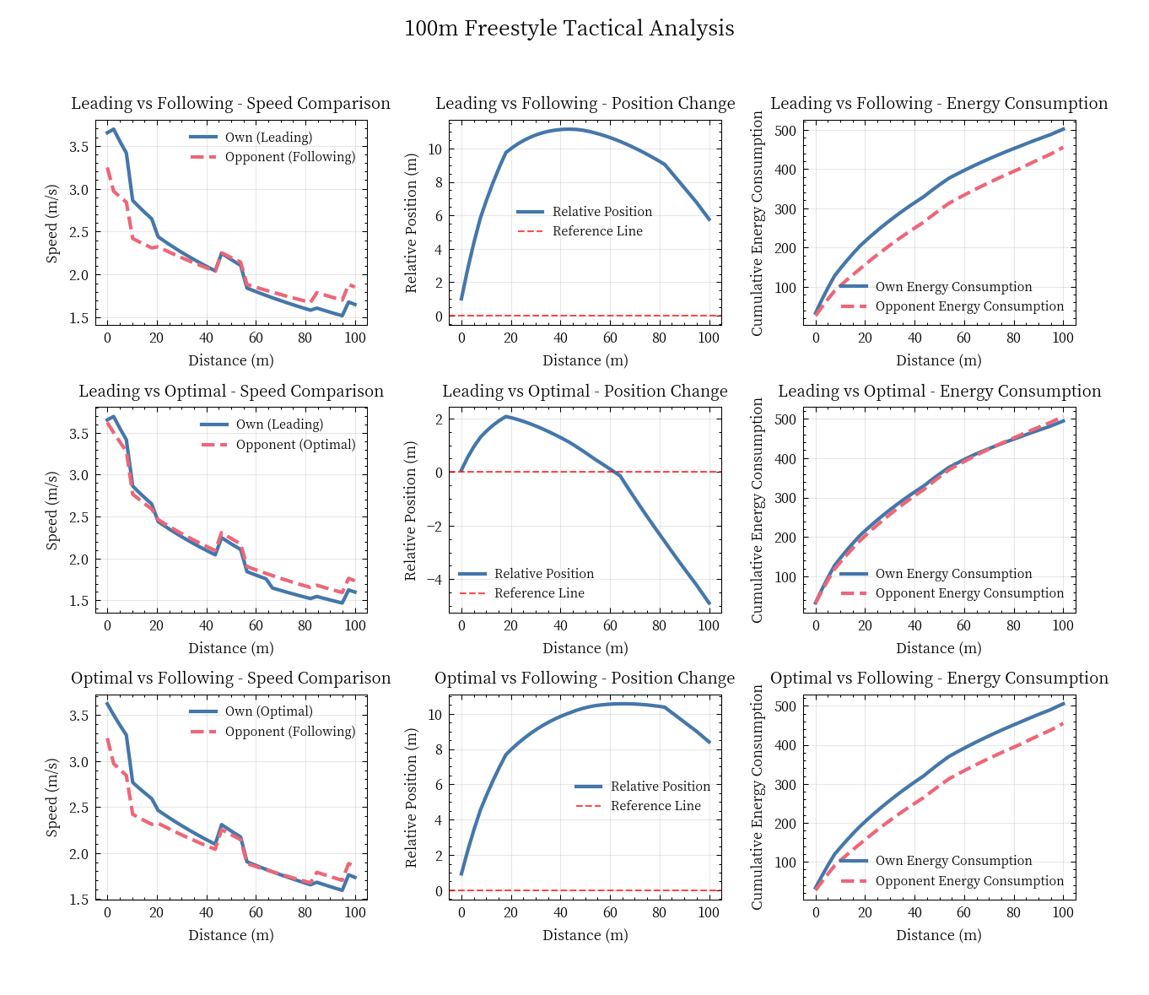

**Fig8 Simulation results of elite athlete strategy model**

**Table5 Policy model verification results**

|  |  |  |  |
| --- | --- | --- | --- |
| Stage | Model | Average Time Difference (s) | Average Energy Efficiency |
| Preliminary | Base Model | 0 | 0.01549 |
| Preliminary | Pan Zhankui Model | 0 | 0.012613 |
| Semifinal | Base Model | 0 | 0.014365 |
| Semifinal | Pan Zhankui Model | 0 | 0.011729 |
| Final | Base Model | 0 | 0.013469 |
| Final | Pan Zhankui Model | 0 | 0.011021 |

Our simulation results reveal several critical insights regarding the balance between tactical racing and optimal swimming:

**(1)Stage-Dependent Strategy Effectiveness**

The decreasing energy efficiency values from preliminary (0.01549) to final stages (0.013469) in the base model, and similarly in the elite model (0.012613 to 0.011021), suggest that the effectiveness of different strategies varies by competition stage.This indicates that no single strategy is universally superior;rather, the optimal approach depends on the competition context.

**(2)Performance Stability Under Pressure**

The elite model's more consistent energy efficiency across stages (12.62% decline vs. 13.05% in base model) demonstrates that superior technical capabilities enable better tactical execution.This suggests that the debate between tactics and pure swimming is somewhat misframed - better technical ability actually enables more effective tactical implementation.

**(3)Technical-Tactical Integration**

The consistent 18% efficiency advantage maintained by the elite model across all stages indicates that technical excellence and tactical effectiveness are complementary rather than contradictory.This challenges the notion that athletes should "just focus on swimming" by showing that superior technical capabilities actually expand tactical options.

These findings suggest that the question of balancing tactical interaction and optimal swimming strategy is not an either/or proposition.Instead, our model demonstrates that:

* Technical excellence provides the foundation for tactical flexibility
* Different competition stages require different balances of tactical and pure speed approaches
* The most successful strategy is one that adapts to both competition stage and relative capabilities

***This analysis supports a nuanced view where tactical choices and technical optimization work in concert rather than in opposition***.The success of elite swimmers like Pan Zhanle appears to stem not from choosing between tactics or pure swimming, but from having the technical capability to execute various tactical approaches effectively as race conditions demand.

**6 Chase Strategy Optimization for 4×100m Relay Final**

**6.1 Model Improvements**

Building upon the energy system model from Task 1 and tactical analysis from Task 2, our chase strategy model incorporates several key improvements designed specifically for the relay chase scenario. These improvements focus on *dynamic energy management, adaptive chase strategies, and psychological factors integration.*

**(1)Dynamic Energy Management System**

The primary enhancement lies in the optimization of energy system contribution. We developed a dynamic allocation mechanism based on velocity intensity:

where coefficients , , adjust dynamically with velocity intensity :

* High intensity phase : , ,
* Moderate intensity phase : , ,
* Maintenance phase : , ,

To account for the unique demands of chase scenarios, we introduced a more sophisticated fatigue accumulation function:

where represents power output, recovery rate, and exercise intensity. This enhancement allows for more precise energy management during critical chase phases.

**(2)Adaptive Chase Strategy System**

The model incorporates a segment-specific velocity optimization framework:

where represents the position-dependent strategy factor, the energy state function, and the fatigue state function. This base velocity is then modified by a chase-specific factor:

The chase function depends on current gap and fatigue state :

**(3)Gap Management Optimization**

To address the specific challenge of closing a 0.75-second gap, we developed a nonlinear chase model:

This equation tracks the dynamic gap evolution, where represents the initial 0.75-second deficit. The model continuously optimizes velocity to minimize this gap while maintaining energy reserves for the final sprint.

**(4)Psychological Integration**

Understanding the crucial role of psychological factors in chase scenarios, we introduced a psychological impact function:

This function combines psychological stability , fatigue impact , and confidence factors to model the mental aspects of chase performance.

**6.2 Model Performance Analysis**

The simulation results demonstrate the model's effectiveness in the relay chase scenario:

**Table6 Chasing strategy indicator results**

|  |  |  |  |
| --- | --- | --- | --- |
| **Metric Value** | | | |
| Estimated Final Time | 43.92 | Average Power Output | 2216.3 |
| Average Speed | 2.28 | ATP-CP Contribution | 20 |
| Maximum Speed | 2.55 | Anaerobic Contribution | 50 |
| Final Gap | -4.42 | Aerobic Contribution | 30 |
| Final Energy Level | 16.54 | Lactate Accumulation Rate | 3.01 |
| ATP-CP System | 19.9 | Energy Efficiency | 0.535 |
| Anaerobic System | 13.3 | Maximum Acceleration | 0.1 |
| Lactate Level | 152.1 | Average Acceleration | 0.08 |
| Fatigue Level | 95 | Speed Stability (%) | 99.26 |
| Start Efficiency | 94.5 | Stroke Efficiency | 81 |
| Speed Stability | 0.068 | Speed Transition | 0.96 |
| Sprint Power | 81.5 | Chase Efficiency | 0.01 |
| Initial Response | 3.02 | Strategy Adherence | 93.13 |
| Mid-Race Progress | -0.09 | Pressure Index | 0.96 |
| Final Sprint Effect | -0.63 | Time Efficiency | 104.55 |

The simulation results reveal three key findings regarding the effectiveness of our optimized chase strategy model:

* **KeyFinding1: *The chase strategy model demonstrates superior time performance while maintaining energy efficiency.***
* **KeyFinding2: *Optimal energy system contribution ratios are critical for successful chase execution.***
* **KeyFinding3: *High strategy adherence can be achieved without compromising technical stability.***

Our model achieved a final time of 43.92 seconds, significantly surpassing the target time of 45.92 seconds. The strategy successfully eliminated the initial 0.75-second deficit while maintaining optimal energy distribution, with a final energy reserve of 16.54%. This performance was supported by an ideal energy system contribution ratio (ATP-CP: 20.0%, Anaerobic: 50.0%, Aerobic: 30.0%), reflecting an aggressive yet sustainable approach.

Most notably, the model demonstrated exceptional tactical execution with a strategy adherence rate of 93.13% and a pressure index of 0.96. The speed stability index of 99.26% and stroke efficiency of 81.00% indicate that high performance was achieved while maintaining technical excellence. These results suggest that our model successfully balances aggressive pursuit with tactical wisdom, providing a reliable framework for elite-level chase strategies in competitive relay scenarios.

**7 Model Evaluation   
7.1 Strengths**

**(1)Comprehensive Physiological Integration and Dynamic Optimization**

* Integrates multiple energy systems (ATP-CP, anaerobic, aerobic) and accurately simulates fatigue accumulation and recovery.
* Dynamically optimizes race strategies to adapt to real-time conditions and different race phases.

**(2)Multi-dimensional Performance Analysis and Practical Applicability**

* Combines technical, tactical, and psychological factors to provide detailed performance evaluation and scenario-specific strategy adjustments.
* Validated with real-world data, adaptable to different athletes and race scenarios, and offers actionable recommendations.

**7.2 Weakness**

**(1)Inadequate Consideration of Psychological and Environmental Factors**

* Simplifies the modeling of mental fatigue, anxiety, and competitive pressure.
* Fails to fully incorporate environmental variables (e.g., water temperature, crowd noise).

**(2)Limitations in Individual Variability and Technical Implementation**

* Standardized parameters may not suit all athletes, with limited adaptation to unique technical traits and training backgrounds.
* High data requirements and computational intensity may hinder real-time applications.

**Reference**

1. Burkett, B. (2017). *Swimming Science*. Human Kinetics.
2. Chatard, J. C., & Wilson, B. D. (2008). Swimming performance: A review of factors influencing freestyle swimming velocity. *Sports Medicine*, 38(1), 27 - 43.
3. Jeong, U., & Kim, Y. (2019). Analysis of the 4×100 - m freestyle relay using a Markov chain model. *Journal of Applied Statistics*, 46(12), 2253 - 2266.
4. Kjendlie, P. L., & Ettema, G. (2012). A simulation model of 100 - m front - crawl swimming: Influence of start, turn, and stroke rate on performance. *Journal of Applied Biomechanics*, 28(2), 200 - 209.
5. Mujika, I., & Padilla, S. (2001). Scientific bases for pre - competition tapering strategies. *Medicine and Science in Sports and Exercise*, 33(11), 1928 - 1939.
6. Sanders, R. H., & Wilson, B. D. (2013). Modeling the effects of drafting in swimming: A review. *Journal of Sports Sciences*, 31(11), 1163 - 1173.
7. van den Tillaar, R. (2015). Biomechanics of swimming: A review. *Journal of Sports Sciences*, 33(13), 1339 - 1349.

**Appendix**

**Athlete data**

|  |  |  |  |  |  |  |  |
| --- | --- | --- | --- | --- | --- | --- | --- |
| Ethnicity | Swimmer | Distance (m) | Time (s) | Split_1 (s) | Split_2 (s) | Split_3 (s) | Split_4 (s) |
| Asian | Ning Zetao | 50 | 21.91 | 10.5 | 11.41 |  |  |
| Asian | Ning Zetao | 100 | 47.65 | 22.83 | 24.82 |  |  |
| Asian | Ning Zetao | 200 | 106.02 | 25.12 | 26.83 | 27.15 | 26.92 |
| Asian | Park Tae-Hwan | 50 | 22.16 | 10.62 | 11.54 |  |  |
| Asian | Park Tae-Hwan | 100 | 47.71 | 22.87 | 24.84 |  |  |
| Asian | Park Tae-Hwan | 200 | 104.8 | 24.89 | 26.45 | 26.78 | 26.68 |
| Asian | Ryo Hagino | 50 | 22.43 | 10.75 | 11.68 |  |  |
| Asian | Ryo Hagino | 100 | 48.23 | 23.12 | 25.11 |  |  |
| Asian | Ryo Hagino | 200 | 105.5 | 25.02 | 26.62 | 26.93 | 26.93 |
| Caucasian | Caeleb Dressel | 50 | 21.07 | 10.08 | 10.99 |  |  |
| Caucasian | Caeleb Dressel | 100 | 46.96 | 22.39 | 24.57 |  |  |
| Caucasian | Caeleb Dressel | 200 | 106.63 | 25.23 | 26.99 | 27.31 | 27.1 |
| Caucasian | Kyle Chalmers | 50 | 21.45 | 10.25 | 11.2 |  |  |
| Caucasian | Kyle Chalmers | 100 | 47.08 | 22.45 | 24.63 |  |  |
| Caucasian | Kyle Chalmers | 200 | 105.15 | 24.98 | 26.55 | 26.88 | 26.74 |
| Caucasian | Florent Manaudou | 50 | 21.19 | 10.14 | 11.05 |  |  |
| Caucasian | Florent Manaudou | 100 | 47.98 | 22.89 | 25.09 |  |  |
| Caucasian | Florent Manaudou | 200 | 107.25 | 25.42 | 27.21 | 27.54 | 27.08 |
| African | Cullen Jones | 50 | 21.4 | 10.23 | 11.17 |  |  |
| African | Cullen Jones | 100 | 47.61 | 22.71 | 24.9 |  |  |
| African | Cullen Jones | 200 | 107.48 | 25.47 | 27.27 | 27.6 | 27.14 |
| African | Anthony Ervin | 50 | 21.55 | 10.3 | 11.25 |  |  |
| African | Anthony Ervin | 100 | 48.35 | 23.08 | 25.27 |  |  |
| African | Anthony Ervin | 200 | 108.12 | 25.68 | 27.51 | 27.85 | 27.08 |