|  |  |  |
| --- | --- | --- |
| **Problem Chosen** B | **2025HSB MCM/ICM Summary Sheet** | **Team Number** MI2501138 |

**Optimization of Industrial Investment Strategy for Economic Growth and Employment Enhancement in China**

The transformation of industrial structure is crucial for economic growth and employment.This paper develops a comprehensive analytical framework to optimize government investment allocation across industries, integrating both GDP growth and employment objectives.

**For Task 1,** we established an Industrial Relationship Analysis Framework examining interconnections among 13 major industries in China (1990-2020). Through correlation analysis, **Granger causality tests**, and trend analysis, we identified the financial sector, chemical industry, and IT services as core economic drivers, with strong correlations between high-tech exports and IT services (r > 0.8).

**For Task 2,** we developed an Investment-GDP Relationship Model combining efficiency metrics and **linear regression** analysis.The financial sector showed highest investment efficiency (1.41), while the service sector demonstrated strong investment elasticity (β > 0.8), with model fit **R² > 0.90** across industries.

**For Task 3 and 4,** we constructed a **Genetic Algorithm**-based Investment Optimization Model with dual objectives.Under GDP growth maximization, financial services (16.8%), **IT services, and construction industry** were prioritized;for employment optimization, real estate (34.8%), financial services (27.0%), and service industry (26.9%) were recommended.

**Finally,** we enhanced the model with three innovations: **sigmoid-transformed** metrics, **geometric-mean-based** industry synergies, and **adaptive genetic parameters**. The improved model achieved **rapid convergence** (53 generations) and **balanced allocation**, recommending primary industry (36.22%), wholesale and retail (33.16%), and chemical industry (30.62%) in restricted scenarios.

Our research provides valuable insights for policymakers, demonstrating strong predictive power and practical applicability, while suggesting future incorporation of real-time data and dynamic mechanisms.

**Keywords:** Industrial Investment;Economic Growth;Employment Enhancement; Genetic Algorithm;Multi-objective Optimization

**Contents**

**1 Introduction3**

1.1 Problem Background 3

1.2 Restatement of the Problem 3

1.3 Our work 4

**2 Assumptions and Justifications4**

**3 Notations and Glossaries5**

**4 Task 1: Analysis of Interrelationships Among Major Industries in China5**

4.1 Data Processing and Modeling Methodology6

4.1.1 Data Collection and Preprocessing7

4.1.2 Establishing Industrial Relationship Analysis Framework7

4.2 Quantitative Analysis of Industrial Interrelationships 8

4.2.1 Industrial Correlation Analysis9

4.2.2 Industrial Granger Causality Analysis9

4.2.3 Industry Development Trend Analysis10

4.3 Comprehensive Analysis of Industrial Interrelationships in China11

**5 Task 2:Investment-GDP Relationship Analysis Across Industries 11**

5.1 Theoretical Framework Development 11

5.1.1 Investment Efficiency Model 11

5.1.2 Linear Investment-GDP Model 11

5.2 Model Implementation and Analysis 12

5.2.1 Investment Efficiency Analysis 13

5.2.2 Investment-GDP Relationship Results 14

**6 Task 3:Optimal Investment Allocation Strategy for Economic Growth15**

6.1 Investment Optimization Framework 16

6.1.1 Objective Function Design16

6.1.2 Constraint Conditions17

6.2 Optimization model solving17

**7 Task 4: Employment-Oriented Investment Strategy Optimization18**

7.1 Employment Trend Analysis Framework19

7.1.1 Employment Trend Analysis19

7.1.2 Employment Impact Metrics19

7.2 Employment-Oriented Optimization Model 21

7.2.1 Model Formulation 21

7.2.2 Constraint Design 21

7.3 Optimization model solving22

**8 Comprehensive Investment Strategy for Sustainable Development 23**

8.1 Basic Optimization Framework 23

8.1.1 Initial Objective Function Design 24

8.1.2 Basic Constraint System 24

8.2 Enhanced Optimization Framework 25

8.2.1 Advanced Objective Function 25

8.2.2 Adaptive Optimization Process 25

8.3 Optimization model solving26

**9 Model Evaluation 28**  
9.1 Strengths28

9.2 Weakness28

**1 introduction**

* 1. **Problem Background**

China's industrial structure is undergoing a profound transformation, shifting from traditional manufacturing to high-technology and service-oriented industries. Emerging sectors such as artificial intelligence, biotechnology, and new energy are flourishing, becoming key drivers of economic growth. This transition not only holds significant implications for China's domestic economic development but also influences the global economic landscape. The Chinese economy comprises a diverse range of industries, including agriculture, forestry, animal husbandry, fisheries, manufacturing, construction, wholesale and retail, transportation, warehousing, postal services, accommodation and catering, finance, real estate, and others. These industries form a comprehensive and interconnected economic foundation, reflecting the balanced and diversified nature of China's national economy.

The relationships among these industries are complex, with potential for both positive synergies and negative constraints. For instance, advancements in high-technology industries can drive innovation in traditional sectors, while over-reliance on certain industries may lead to economic imbalances. Policymakers must carefully consider these interconnections to promote sustainable and balanced economic growth. Additionally, government investment plays a critical role in creating job opportunities, stimulating related industries, and enhancing overall economic performance. As China strives to achieve long-term economic stability and improve employment rates, strategic investment in key industries becomes essential.

* 1. **Restatement of the Problem**

This study aims to address the following key questions regarding China's industrial development and investment priorities:

* ***Interrelationships Among Industries***: Analyze the interconnections and mutual influences among major industries in China, examining how they promote or constrain economic development.
* ***Investment and GDP Relationship***: Establish theoretical models to study the relationship between investment and the Gross Domestic Product (GDP) of individual industries, and evaluate the effectiveness of these models.
* ***Optimal Investment Allocation for Maximizing GDP***: Given a total investment fund of 1 trillion units, determine the optimal allocation of investment across industries to maximize GDP. Provide specific investment proportions if there are no restrictions on the number of industries and justify the selection if limited to three industries.
* ***Investment Allocation for Employment Promotion***: From the perspective of improving employment rates and job quality, analyze which industries should be prioritized for government investment. Adjust the investment plan from question three to effectively stimulate employment, providing specific allocations for both unrestricted and restricted (three industries) scenarios.
* ***Sustainable Development and Long-Term Growth:*** Considering the dual goals of increasing GDP and improving employment, identify the industries China should prioritize for sustainable development. Based on the findings from questions three and four, propose a revised investment plan that aligns with the principles of sustainable development and long-term economic growth.
  1. **Our work**

This paper presents a comprehensive analysis of China's industrial investment optimization strategy, focusing on maximizing GDP growth while promoting employment and ensuring sustainable development. Our work encompasses several key contributions:

We first establish a systematic analytical framework to examine the interrelationships among major industries in China. Through the integration of correlation analysis, Granger causality tests, and trend analysis, we provide a thorough understanding of how different industries influence and interact with each other in the Chinese economy. This multi-dimensional approach reveals both direct industrial connections and potential causal relationships, offering valuable insights for investment decision-making.

Building upon this foundation, we develop an innovative investment-GDP theoretical model to evaluate the relationship between investment and economic output across different industries. Our model incorporates both investment efficiency metrics and linear regression analysis to quantify the impact of investments on various sectors. This analysis reveals significant variations in investment elasticity and efficiency across different industries, with the service sector and modern industries demonstrating notably higher investment efficiency compared to traditional sectors.

Furthermore, we propose an optimized investment allocation strategy using a sophisticated genetic algorithm-based approach. This optimization model considers multiple objectives, including GDP growth, employment generation, and sustainable development. We provide detailed investment recommendations under both unrestricted and three-industry restricted scenarios, offering practical guidance for policy-makers. The model's results suggest that a balanced investment approach, focusing on financial services, IT services, and modern manufacturing, can effectively promote both economic growth and employment.

Our research contributes to the existing literature by providing a comprehensive framework for industrial investment optimization while considering China's unique economic context and development goals. The findings offer valuable insights for policy-makers in formulating effective investment strategies that balance economic growth, employment generation, and sustainable development.

**2 Assumptions and Justifications**

*Assumption 1*: It is assumed that all industries seek to maximize their economic benefits and efficiency in the process of development, and their investment decisions are based on rational economic considerations.

*Assumption 2*: It is assumed that the relationships between industries remain relatively stable during the study period (1990-2020), and any structural changes occur gradually without sudden disruptions. The correlation and causality analysis methods can effectively capture these relationships.

*Assumption 3*: It is assumed that the investment efficiency and employment effects can be accurately measured and compared across different industries through our established quantitative framework, and these measurements remain consistent throughout the study period.

*Assumption 4*: It is assumed that all data used in this research, including industrial value-added, employment statistics, and investment figures, are accurate, reliable, and representative of China's economic development. The data processing methods employed do not significantly affect the validity of our analysis.

**3 Notations and Glossaries**

|  |  |
| --- | --- |
| *Symbol* | *Description* |
|  | *Cubic polynomial* |
|  | *Correlation coefficient* |
|  | *Error term* |
|  | *Annual growth rates* |
|  | *Compound Annual Growth Rate* |
|  | *Investment efficiency* |
|  | *Investment return rate* |
|  | *Investment diversity index* |
|  | *Employment elasticity* |

**4 Task 1: Analysis of Interrelationships Among Major Industries in China**

China's industrial structure is undergoing a profound transformation, characterized by a shift from traditional manufacturing towards high-technology and service sectors. This evolution reflects the country's economic modernization and its response to global technological advancement.Understanding the complex interrelationships among major industries has become crucial for policymaking and economic planning.

This analysis employs comprehensive quantitative methods to examine the interconnections between China's key industrial sectors.Our study focuses on several critical aspects:

* *Data-Driven Analysis*: Utilizing time-series data of major economic indicators across different industries to reveal underlying patterns and relationships.
* *Multi-Dimensional Approach*: Combining correlation analysis, Granger causality tests, and trend analysis to provide a holistic view of industrial interactions.
* *Dynamic Perspective*: Examining how industrial relationships have evolved over time and their implications for future development.

**4.1 Data Processing and Modeling Methodology**

**4.1.1 Data Collection and Preprocessing**

The analysis is based on a comprehensive dataset encompassing multiple dimensions of China's industrial development.The data collection process focused on key economic indicators that reflect various aspects of industrial activities and their interconnections.

**Tabel 1 Index introduction**

|  |  |  |  |
| --- | --- | --- | --- |
| **Main Category** | | **Subcategory** | **Specific Indicators** |
| Economic Output & Value Added | Industrial & Sectoral Value Added | | Industrial Value Added, Primary Industry Value Added, Secondary Industry Value Added, Mining Value Added, Chemical Industry Output, Coking & Gas Output, Construction Value Added, Power Supply Output |
| Service Sector Value Added | | Wholesale & Retail Value Added, Transport & Storage Value Added, IT Service Value Added, Financial Industry Output, Other Services Output |
| Trade & Exports | Export-related Indicators | | Goods Export (USD), Export Value Index, High-tech Export Ratio, Insurance & Finance Export Ratio |
| Taxation & Fiscal Policy | Tax-related Indicators | | Primary Product Tax Rate, High-tax Primary Product Ratio |
| Infrastructure & Logistics | Infrastructure-related Indicators | | Total Railway Mileage, Air Cargo Volume |
| Technology & Innovation | Technology & Innovation-related Indicators | | IT Service Input, IT Service Value Added, High-tech Export Ratio |
| Energy & Resources | Energy-related Indicators | | Power Supply Output, Coking & Gas Output |

We then carried out descriptive statistics on the collected indicator data and selected the following two methods to deal with missing values and outliers through data distribution. Due to the excessive dimensions of the data, it is not shown here.

(1)Cubic Spline Interpolation

Cubic spline interpolation is a mathematical method used for estimating missing values by constructing a smooth curve between data points. This method uses cubic polynomials between each pair of data points, ensuring that the interpolated curve is continuous in both the first and second derivatives at the data points.

Suppose we have data points .where is the independent variable and is the dependent variable. Cubic spline interpolation uses a cubic polynomial within each interval

(2)Interquartile Range (IQR) Method

The Interquartile Range (IQR) method is a statistical technique used for detecting and removing outliers. It is based on the quartiles (Q1, Q2, Q3) of the data to determine the distribution range and identify values outside this range as outliers.

**4.1.2 Establishing Industrial Relationship Analysis Framework**

To comprehensively analyze the interrelationships among China’s major industries, we established a three-dimensional analytical framework incorporating correlation analysis, causality testing, and trend analysis. This integrated approach enables us to capture both static relationships and dynamic interactions between industries.

1. ***Correlation Analysis Model***

The correlation analysis model employs Pearson correlation coefficients (r) to measure the linear relationships between industries. For any two industries i and j, their correlation coefficient is calculated as:

where: represents the value of industry i at time t is the mean value of industry i over the study period T is the total number of time periods Significant relationships are identified where |r| ≥ 0.8, indicating strong industrial connections.

**(2)*Granger Causality Test Model***

The Granger causality model examines whether past values of one industry help predict another industry’s future values. For industries X and Y, the basic bivariate regressions are:

where: p is the number of lags (set to 2 in our analysis) and are error terms , , , and are coefficients The null hypothesis () is tested using F-statistics with significance level α = 0.05.

**(3)*Industry Development Trend Analysis Model***

The trend analysis employs standardized scores (z-scores) to enable cross-industry comparisons:

where: is the standardized value for industry i at time t is the mean of industry i is the standard deviation of industry i Annual growth rates are calculated using:

Compound Annual Growth Rate (CAGR) for each industry:

where: is the final value is the initial value n is the number of years Integration and Synthesis

**4.2 Quantitative Analysis of Industrial Interrelationships**

Building upon the established analytical framework, this section presents a comprehensive quantitative analysis of the interrelationships among China's major industries.The analysis progresses from static correlation patterns to dynamic causal relationships, and finally to evolutionary trends, offering a multi-dimensional perspective on industrial interconnections.

**4.2.1 Industrial Correlation Analysis**

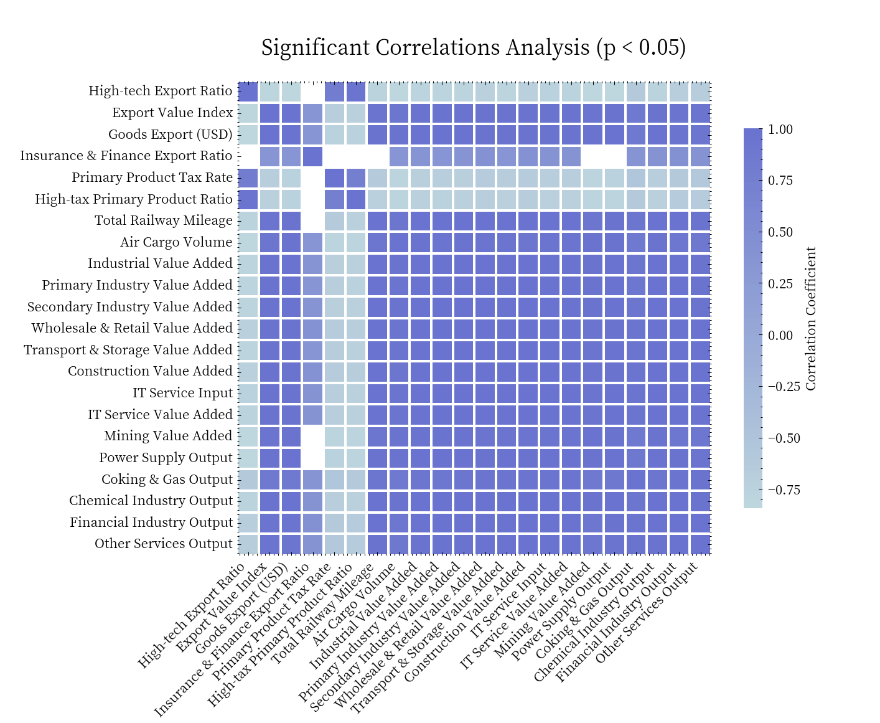

**Fig 1 Industry correlation results**

The correlation analysis reveals significant relationships among key economic indicators, such as the high-tech export ratio, export value index, goods export value, and financial industry output, underscoring their critical roles in the overall economy. The strong correlation between high-tech exports and IT services highlights the importance of technological innovation in enhancing export competitiveness. Similarly, the significant relationship between export activities and industrial value added demonstrates the direct impact of exports on industrial production. Furthermore, the widespread correlations between financial industry output and various economic indicators emphasize the central role of the financial sector in resource allocation and economic activities.Additionally, the significant correlations between infrastructure and logistics indicators (e.g., total railway mileage and air cargo volume) and other economic metrics underscore the importance of infrastructure development in improving economic efficiency.

**4.2.2 Industrial Granger Causality Analysis**

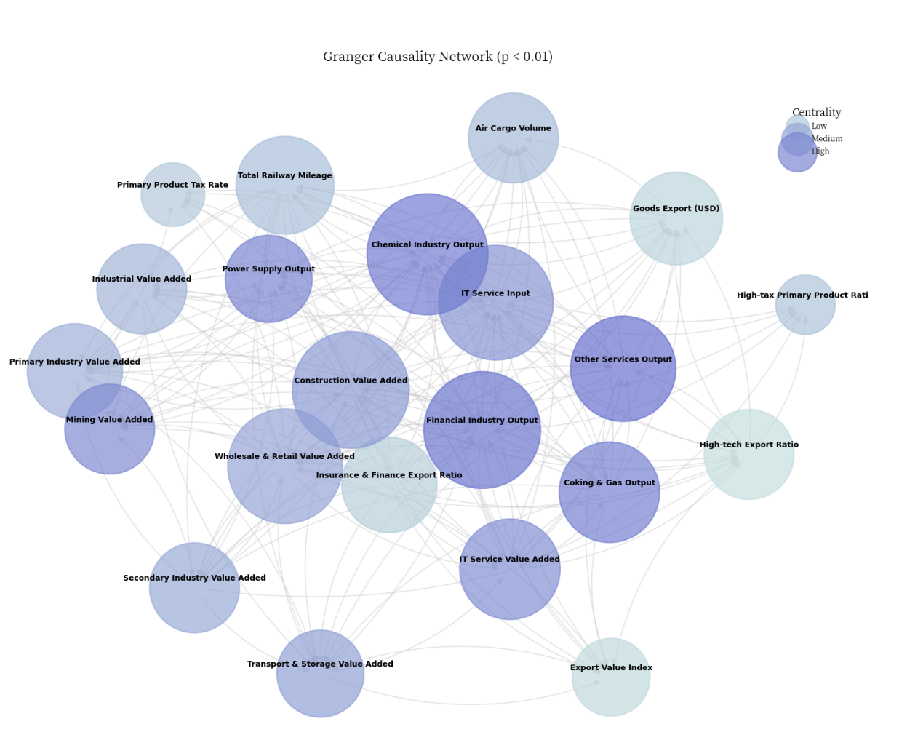

**Fig 2 Industrial causal network**

Moving beyond static correlations, the Granger causality analysis uncovers the directional relationships between industries.The results indicate that the chemical industry, financial sector, construction industry, and IT services are the core drivers of economic growth.The chemical industry exhibits significant causal effects on multiple economic indicators, such as the primary product tax rate, financial sector output, and the high-tech export ratio, highlighting its pivotal role in the economy. The financial sector, through its support for the chemical industry, mining sector, and export activities, demonstrates its critical function in resource allocation.The construction industry's significant impact on mining value-added and power supply output underscores its importance in infrastructure development and energy demand. Meanwhile, IT services, by driving the financial sector and high-tech export ratio, play a crucial role in technological innovation and industrial upgrading.

These sectors form a complex network of interactions.For instance, the bidirectional causality between the chemical industry and the financial sector indicates a mutual dependency.The financial sector's significant influence on goods exports and the high-tech export ratio further emphasizes its role in supporting export activities. Additionally, the construction industry and IT services contribute to the development of related industries through infrastructure construction and technological innovation, respectively.

**4.2.3 Industry Development Trend Analysis**

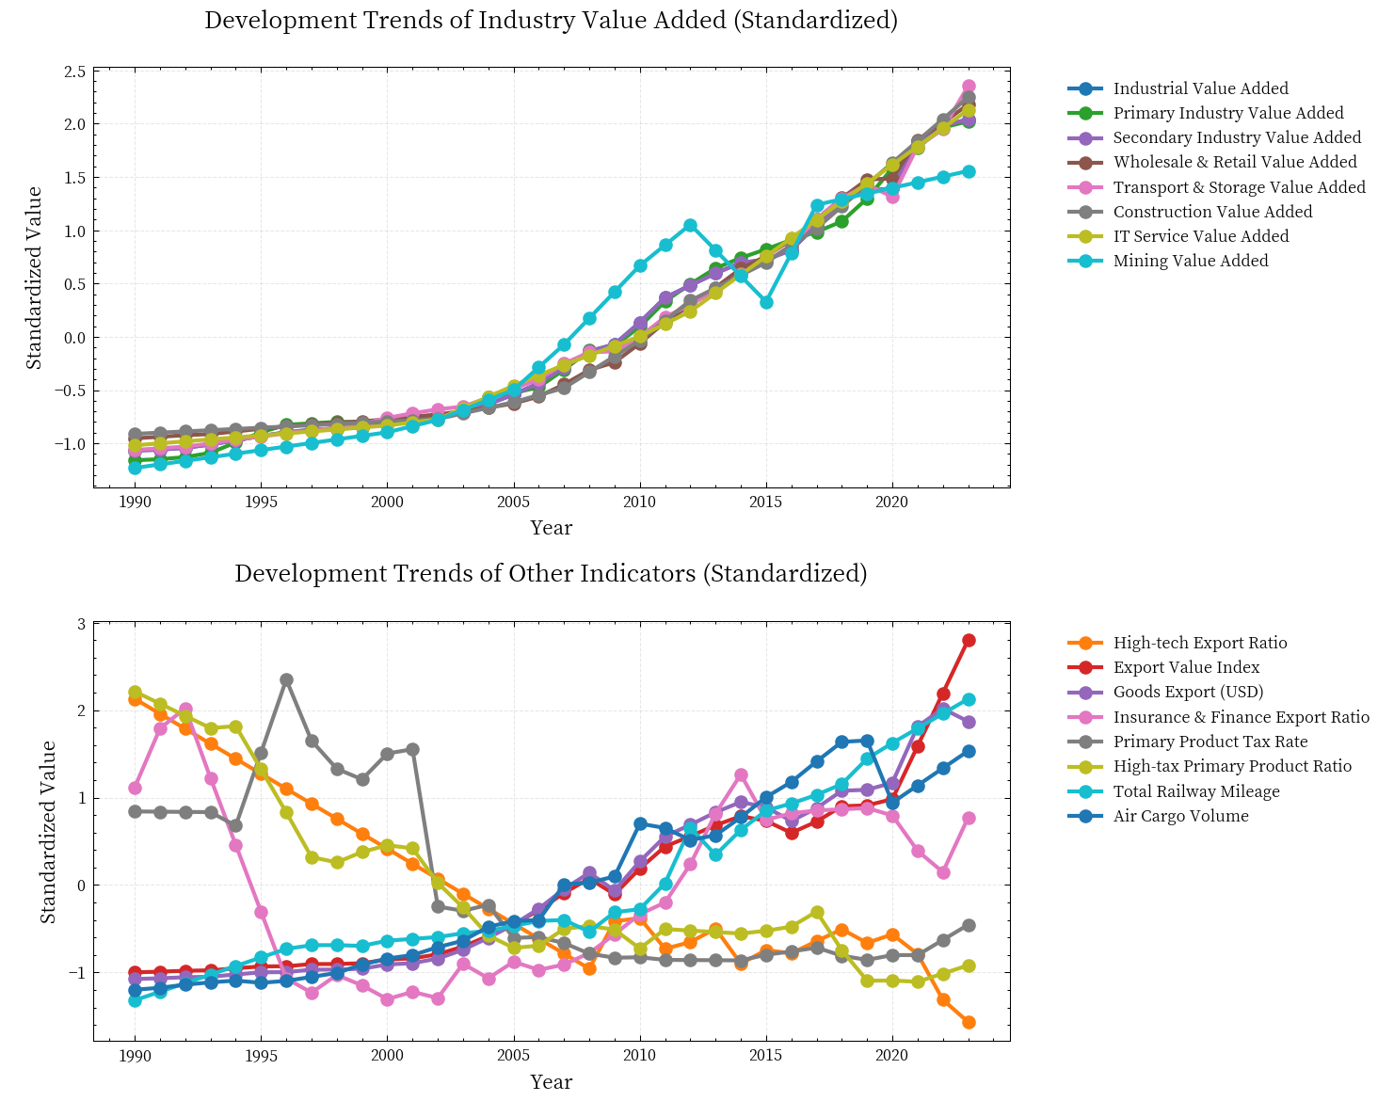

**Fig 3 Idustrial development trend**

The analysis of development trends from 1990 to 2020 reveals significant economic restructuring and shifts in growth drivers.Industrial value added and secondary industry value added showed a notable upward trend during this period, particularly accelerating after 2000, indicating that manufacturing and construction became the main drivers of economic growth.In contrast, the relatively slow growth or even decline in primary industry value added highlights the shift in economic structure from agriculture to secondary and tertiary industries.The steady rise in wholesale and retail value added, transport and storage value added, and construction value added further underscores the increasing contribution of consumer markets and infrastructure development to economic growth.

**4.3 Comprehensive Analysis of Industrial Interrelationships in China**

This section synthesizes findings from the quantitative analysis to provide a comprehensive understanding of the interrelationships among China's major industries. By integrating insights from correlation patterns, Granger causality relationships, and developmental trends, the analysis offers a holistic view of the dynamics driving China's economic growth.

**(1)*Key Drivers and Structural Transformation***

***The chemical industry, financial sector, construction industry, and IT services are identified as core drivers of economic growth.***These industries not only exhibit strong internal growth but also significantly influence other sectors.For instance, the chemical industry's impact on the financial sector and high-tech exports underscores its role in innovation and resource allocation, while the financial sector's support for exports and infrastructure highlights its central role in economic coordination.

From 1990 to 2020, China's economy underwent a significant structural transformation, shifting from agriculture to manufacturing and services.This shift is reflected in the decline of primary industry value added and the rise of secondary and tertiary industries.The rapid growth of IT services and high-tech exports further emphasizes the critical role of technology and innovation in modern economic development.

**(2)*Interconnectedness and Policy Implications***

The interconnectedness among industries is evident through both correlation and causality analyses.For example, ***the bidirectional causality between the chemical industry and the financial sector illustrates their mutual dependency, while the financial sector's influence on goods exports and high-tech exports highlights its role in trade and innovation.***Additionally, the construction industry's impact on mining value added and power supply output underscores its importance in supporting energy and resource sectors.

**5 Task 2:Investment-GDP Relationship Analysis Across Industries**

The relationship between investment and economic output is fundamental to understanding industrial development dynamics. In this section, we present a systematic analysis of how IT service investment influences various industrial sectors in China’s economy.

**5.1 Theoretical Framework Development**

**5.1.1 Investment Efficiency Model**

Building on traditional investment efficiency theories, we develop a model that specifically addresses the unique characteristics of IT service investment across different industrial sectors:

where: represents the investment efficiency for industry i at time t is the change in industrial value added is the change in IT service investment and are the base values This efficiency metric allows us to quantitatively assess how effectively different sectors convert IT investment into economic output.

**5.1.2 Linear Investment-GDP Model**

To complement the efficiency analysis and provide a more direct measure of investment impact, we establish a linear regression model for each industry:

where: is the value added of industry i at time t; represents IT service investment; is the intercept term; is the investment elasticity coefficient; is the error term This model enables us to quantify the direct relationship between IT investment and industrial output while controlling for other factors through the error term.

**5.2 Model Implementation and Analysis**

With our theoretical framework established, we now turn to the empirical analysis of how different sectors respond to IT investment in practice.

**5.2.1 Investment Efficiency Analysis**

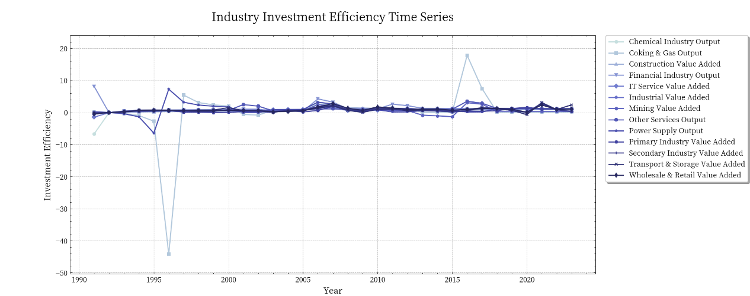

**Fig 4 Industrial investment efficiency time series**

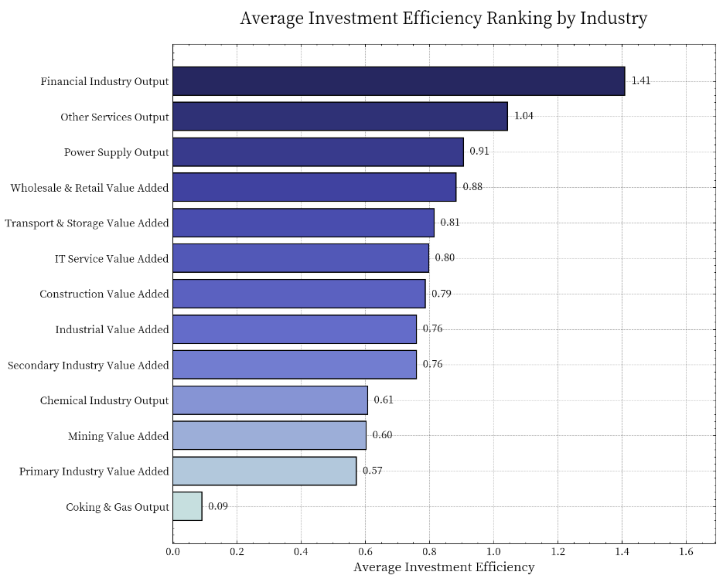

**Fig 5 Industrial average investment efficiency**

From the time series analysis spanning 1990 to 2020, the investment efficiency of most industries fluctuated between 0 and 5, showing overall stability. Significant fluctuations were observed around 1995, particularly in the chemical industry, which experienced a notable negative fluctuation. However, after 2015, the chemical industry saw a significant positive fluctuation peak. In contrast, modern service industries such as finance and IT services exhibited relatively stable investment efficiency with minimal volatility. The chemical industry displayed the highest volatility, indicating its susceptibility to external environmental or policy influences.

In terms of the ranking of average investment efficiency across industries, the financial sector led with an efficiency of 1.41, followed by other service industries at 1.04, demonstrating the highest conversion efficiency of IT investments in the service sector. Medium-efficiency industries, including power supply, wholesale and retail, transport and storage, IT services, and construction, showed efficiencies between 0.8 and 1.0, reflecting good investment conversion capabilities. Lower-efficiency industries, such as industrial and secondary industries, chemical industry, and mining, had efficiencies ranging from 0.6 to 0.8, indicating relatively lower investment efficiency in traditional industrial sectors. The primary industry and coking and gas sectors had the lowest efficiencies, at 0.57 and 0.09, respectively, highlighting their weak ability to convert IT investments. Overall, the investment efficiency of service and modern industries significantly outperformed that of traditional industrial sectors, reflecting the trend of economic structural transformation.

**5.2.2 Investment-GDP Relationship Results**

**Table 2 Linear regression fitting results**

|  |  |  |  |  |
| --- | --- | --- | --- | --- |
| Industry | Investment | Elasticity | R-squared | P-value |
| Transport & Storage Value Added | IT Service Input | 0.000025 | 0.992965 | 5.05E-36 |
| Primary Industry Value Added | IT Service Input | 0.00004 | 0.989763 | 2.05E-33 |
| Wholesale & Retail Value Added | IT Service Input | 0.000058 | 0.994767 | 4.44E-38 |
| Secondary Industry Value Added | IT Service Input | 0.000228 | 0.992559 | 1.24E-35 |
| Mining Value Added | IT Service Input | 0.15757 | 0.902696 | 9.48E-18 |
| Construction Value Added | IT Service Input | 0.406374 | 0.99328 | 2.43E-36 |
| IT Service Value Added | IT Service Input | 0.409524 | 0.998887 | 7.79E-49 |
| Power Supply Output | IT Service Input | 0.482807 | 0.967978 | 1.74E-25 |
| Financial Industry Output | IT Service Input | 0.808279 | 0.985252 | 7.06E-31 |
| Coking & Gas Output | IT Service Input | 1.058426 | 0.887293 | 1E-16 |
| Chemical Industry Output | IT Service Input | 1.221887 | 0.996932 | 8.64E-42 |
| Other Services Output | IT Service Input | 2.143022 | 0.966993 | 2.82E-25 |
| Industrial Value Added | IT Service Input | 22820.77 | 0.992559 | 1.24E-35 |

The regression analysis results reveal several key insights into the elasticity and correlation of IT investments across various industries. Industries can be categorized based on their elasticity coefficients: ultra-high elasticity is observed in industrial value added (22,820.77), though this may require further validation due to potential data unit inconsistencies; high elasticity industries (>1.0) include other services output (2.14), chemical industry output (1.22), and coking and gas output (1.06), indicating these sectors are highly responsive to IT investments. Moderate elasticity industries (0.4-1.0), such as financial industry output (0.81), power supply output (0.48), IT service value added (0.41), and construction value added (0.41), show a moderate response to IT investments. In contrast, low elasticity industries (<0.4), including mining value added (0.16), transport and storage (0.000025), primary industry value added (0.00004), wholesale and retail value added (0.000058), and secondary industry value added (0.000228), exhibit minimal responsiveness to IT investments.

The model's high explanatory power is evident from the R-squared values, with extremely high fit (R² > 0.99) for IT service value added (0.999) and chemical industry output (0.997), and high fit (0.90 < R² < 0.99) for nearly all other industries, except coking and gas output (0.887) and mining (0.903). This indicates a stable relationship between IT investments and industry outputs. Furthermore, all industries exhibit high statistical significance (p-values << 0.05), with IT service value added (7.79E-49) being the most significant and coking and gas output (1E-16) relatively less so. These findings underscore the robust and reliable relationship between IT investments and industry performance, highlighting the varying degrees of responsiveness across sectors.

Based on the results, we recommend prioritizing ***IT investments in high-efficiency service sectors, gradually upgrading traditional industries' IT capabilities, and developing targeted strategies for low-performance sectors***.Policy development should focus on sector-specific IT investment policies, promoting cross-sector technology transfer, and establishing efficiency monitoring systems.Risk management should involve monitoring high-volatility sectors, balancing short-term efficiency with long-term sustainability, and maintaining investment stability in strategic sectors. These findings offer a scientific basis for optimizing industrial investment strategies and promoting balanced economic development.

**6 Task 3:Optimal Investment Allocation Strategy for Economic Growth**

In response to the challenge of optimizing a trillion-unit investment fund for maximum GDP growth while ensuring sustainable development, we develop a comprehensive analytical framework that considers multiple economic and social factors.

**6.1 Investment Optimization Framework**

**6.1.1 Objective Function Design**

Our optimization model aims to maximize the comprehensive benefits of investment allocation while considering multiple economic objectives. The objective function is formulated as:

where: is the investment return rate, calculated as: ； is the investment elasticity of industry i ； is the investment efficiency of industry i ； is the investment amount for industry i ； is the total investment amount ；

is the investment diversity index, using the complement of the Gini coefficient:

where represents the investment proportion ; is the penalty term, including:

* Total investment constraint penalty
* Maximum investment ratio penalty (>35%)
* Minimum investment ratio penalty (<5%)

**6.1.2 Constraint Conditions**

The optimization model operates under several designed constraints:

(1)Total Investment Constraint:

Ensures full utilization of available funds Maintains budget discipline Enables comparative analysis

(2)Individual Industry Constraints:

* Maximum allocation:
* Minimum allocation:

These bounds serve to: Prevent over-concentration (≤35% per industry) ;Ensure meaningful investment scale (≥5% per industry); Maintain industrial diversity

(3)Industry Count Constraint (for three-industry scenario):

where I is the indicator function This constraint: Limits investment to exactly three industries Forces strategic focus Simplifies implementation

**6.2 Optimization model solving**

*Genetic Algorithm* (GA) is an optimization search algorithm based on the principle of natural selection and genetic mechanism, and belongs to a kind of evolutionary algorithm. It simulates natural selection, cross (hybridization), mutation and other operations in the process of biological evolution, and finds the optimal solution or approximate optimal solution through iterative optimization. Genetic algorithm is widely used to solve complex optimization problems, especially in nonlinear, multi-modal and high-dimensional problems which are difficult to deal with by traditional methods.

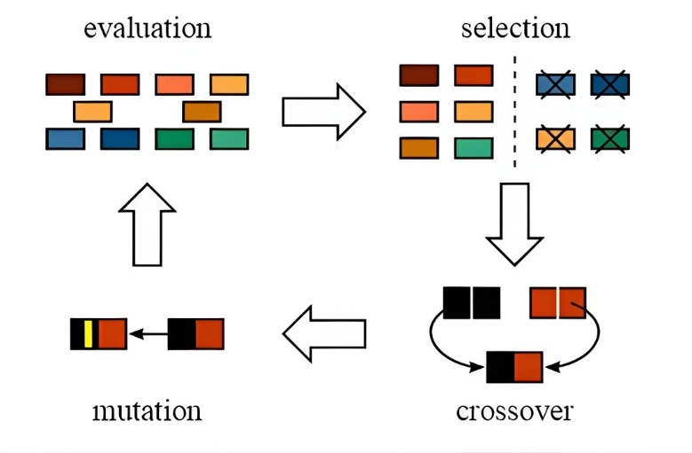

**Fig 6 Genetic algorithm**

We adopted genetic algorithm to solve the optimization model, and the results are as follows:

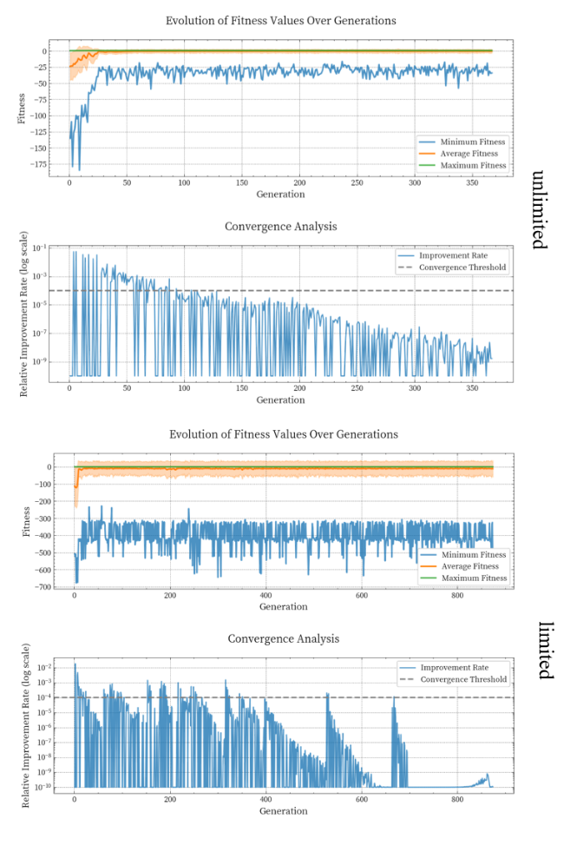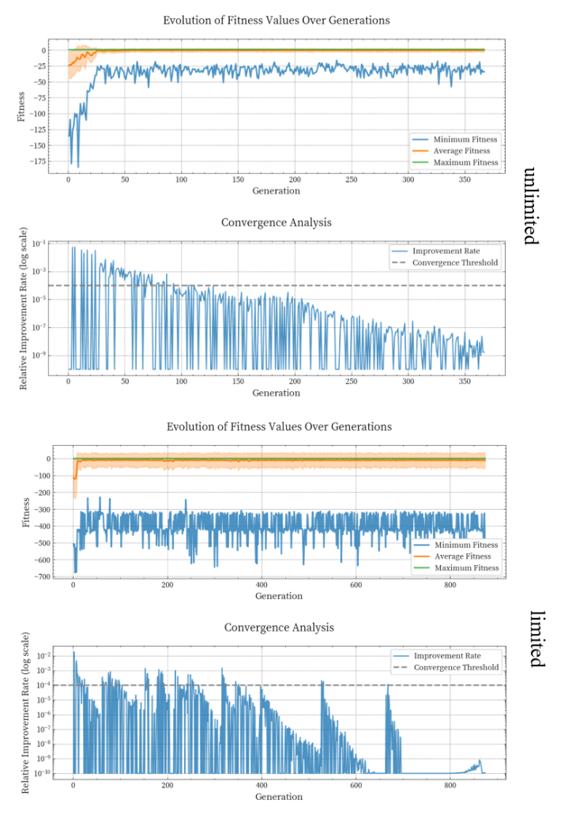

**Fig 7 Algorithm optimization procedure**

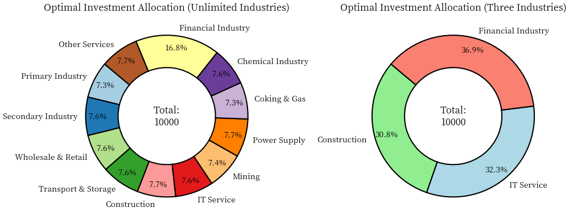

**Fig 8 Economy-oriented industrial investment strategy**

In the unrestricted industry scenario, the investment allocation demonstrates a well-balanced distribution, **with most industries receiving between 7.3% and 7.7% of the total investment.The financial industry, owing to its highest comprehensive score (0.998), justifiably receives 16.8% of the investment.**Notably, no industry exceeds the upper limit of 35% or falls below the lower threshold of 5%, reflecting a portfolio that carefully considers inter-industry balance and systemic risk management.

For the three-industry restricted scenario, the optimization model identifies three high-efficiency sectors: the **financial industry (36.9%, comprehensive score 0.998), IT service industry (32.3%, comprehensive score 0.719), and construction industry (30.8%, comprehensive score 0.714).**This allocation demonstrates near-balanced proportions within the constraint range (5%-35%), with the selection logic effectively balancing investment elasticity and efficiency.***The chosen industries represent a strategic combination of modern services and traditional sectors, potentially maximizing both immediate returns and long-term economic growth potential.***

**7 Task 4:** **Employment-Oriented Investment Strategy Optimization**

Building upon our previous investment analysis, we now focus on optimizing the allocation strategy from an employment perspective, considering both job creation potential and employment quality.

**7.1 Employment Trend Analysis Framework**

To effectively optimize investment allocation for employment promotion, we first need to establish a comprehensive understanding of current employment patterns and their relationship with industrial development.Our analysis framework combines both ***trend analysis and quantitative metrics*** to provide a solid foundation for investment decisions.

**7.1.1 Employment Trend Analysis**

We develop a multi-dimensional trend analysis approach that examines the dynamic relationships between investment and employment across different sectors. This analysis reveals not only the current state of employment but also the underlying structural changes in the labor market.By investigating unemployment patterns, industrial structure evolution, and labor force participation rates, we can better understand how different sectors respond to investment in terms of job creation and employment quality.

The trend analysis focuses on two primary aspects:

* *Labor Market Dynamics*: Through examination of unemployment rates and labor force participation, we assess market efficiency and identify potential areas for improvement through targeted investment.
* *Industrial Structure:* By analyzing employment shares across sectors, we identify structural transformation patterns and their implications for future employment growth.

Analysis results are as follows:

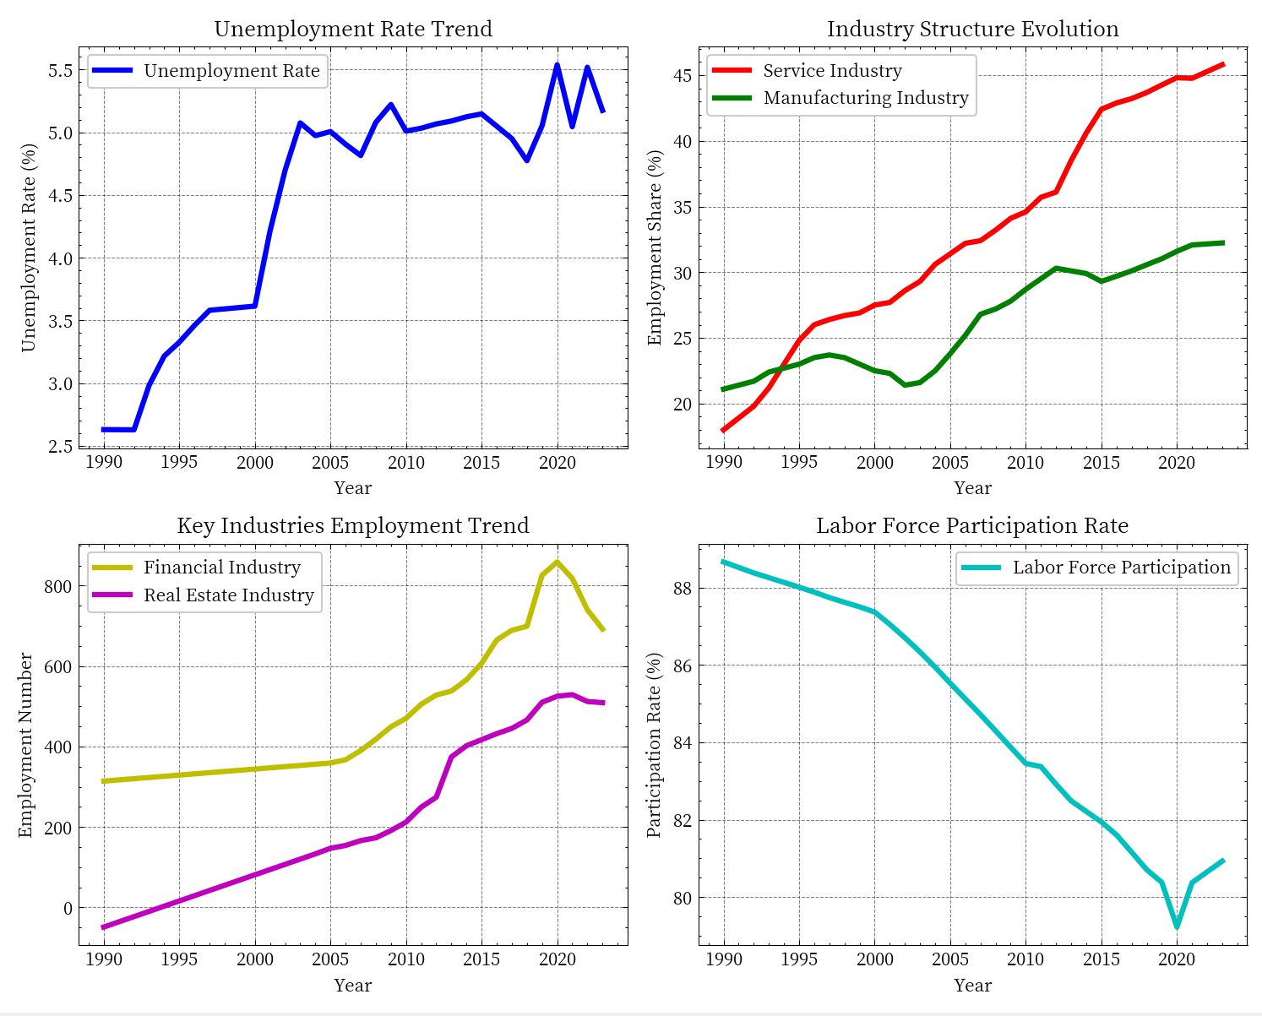

**Fig 9 Employment Trend Analysis**

**Table 3 Employment Trend Analysis**

|  |  |
| --- | --- |
| **Indicator** | **Percentage** |
| Unemployment Rate Change | 2.54 |
| Service Industry Employment Growth | 154.4 |
| Industrial Employment Growth | 52.74 |
| Financial Industry Employment Growth | 2.53 |
| Real Estate Industry Employment Growth | 17.62 |

The employment landscape has undergone significant structural changes from 1990 to 2020. The unemployment rate shows a clear upward trend, rising from 2.5% to approximately 5%, while the labor force participation rate has declined steadily from 88% to 81%. Simultaneously, a major transformation in industrial structure is evident, with the service sector's employment share more than doubling from 18% to over 45%, while manufacturing maintained moderate growth. This structural shift is further reflected in the rapid employment growth of modern sectors, particularly in financial and real estate industries post-2010, though with recent volatility. These trends suggest a complex transition toward a service-oriented economy, presenting both opportunities and challenges for employment-focused investment strategies.

**7.1.2 Employment Impact Metrics**

Building upon the trend analysis, we develop a quantitative framework to measure the employment effects of industrial development.This framework focuses on two key dimensions: employment elasticity and employment quality.

**(1)Employment Elasticity Analysis**

The employment elasticity metrics capture the responsiveness of employment to investment changes, calculated as the ratio of employment growth rate to investment growth rate.This provides a quantitative measure of each industry's job creation efficiency.

**(2)Employment Quality Assessment**

We establish an employment quality index based on industry characteristics and development prospects:

* Financial Industry: 0.9 (reflecting high-quality employment opportunities)
* Service Industry: 0.8 (indicating good working environment and growth potential)
* Manufacturing Industry: 0.6 (representing traditional employment stability)
* Real Estate Industry: 0.7 (balancing job quality with market volatility)

These metrics are then normalized and combined to create a comprehensive employment impact assessment framework, which guides the subsequent optimization of investment allocation.

**7.2 Employment-Oriented Optimization Model**

Building upon the employment trend analysis, we develop a genetic algorithm-based optimization model to determine the optimal investment allocation for maximizing employment benefits.

**7.2.1 Model Formulation**

The optimization model integrates both employment elasticity and quality considerations through a weighted objective function:

where: represents the employment elasticity for industry I; denotes the employment quality score for industry i ; is a diversity bonus to encourage balanced development; represents penalty terms for constraint violations is set to 0.2 to balance diversity with primary objectives

**7.2.2 Constraint Design**

The optimization model operates under several designed constraints:

(1)Total Investment Constraint:

Ensures full utilization of available funds Maintains budget discipline Enables comparative analysis

(2)Individual Industry Constraints:

* Maximum allocation:
* Minimum allocation:

These bounds serve to: Prevent over-concentration (≤35% per industry) ;Ensure meaningful investment scale (≥5% per industry); Maintain industrial diversity

(3)Industry Count Constraint (for three-industry scenario):

where I is the indicator function This constraint: Limits investment to exactly three industries Forces strategic focus Simplifies implementation

**7.3 Optimization model solving**

We still use genetic algorithm to solve this optimization model:

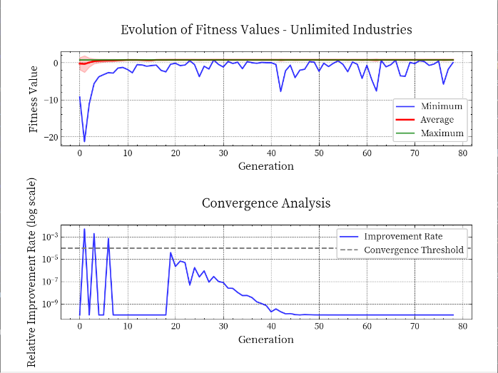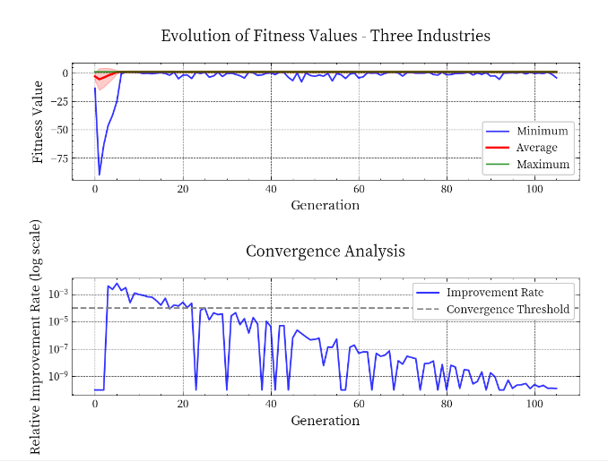

**Fig 10 Algorithm optimization procedure**

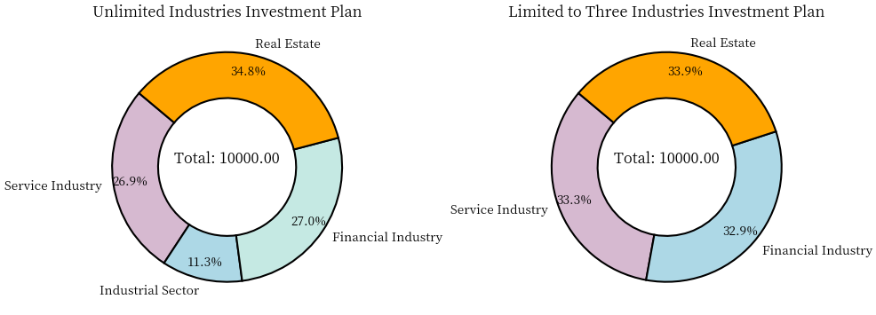

**Fig 11 Employment-oriented industrial investment strategy**

**(1)Unrestricted Industry Investment Allocation**

In a scenario without restrictions on the number of industries, the 1 trillion units of investment funds should be allocated as follows to maximize employment impact:

* *Real Estate: 34.8%* (348.01 billion units):Prioritized for its high employment elasticity, which directly stimulates job creation.
* *Financial Services: 27.0%* (269.96 billion units):Focused on improving job quality through stable and high-paying employment opportunities.
* *Service Industry: 26.9%* (268.76 billion units):Balances job creation and quality, supporting a wide range of employment opportunities.
* *Manufacturing: 11.3%* (113.27 billion units):Maintains a strategic presence to support industrial capacity and related sectors.

This allocation ensures a balanced approach, leveraging the strengths of each sector to address both employment quantity and quality.

**(2)Limited to Three Industries Investment Allocation**

When restricted to investing in only three industries, the allocation should focus on sectors with complementary employment characteristics:

* *Real Estate: 33.9%* (338.82 billion units):Maximizes job creation due to its high employment elasticity.
* *Service Industry: 33.3%* (332.55 billion units):Provides a balance of job creation and quality, supporting diverse employment opportunities.
* *Financial Services: 32.9%* (328.63 billion units):Ensures high job quality, contributing to stable and well-paying employment.

This near-equal distribution optimizes the trade-off between employment elasticity and quality, ensuring maximum impact within the three-industry constraint.

To effectively stimulate employment, ***government investment should prioritize industries with high employment elasticity and quality.In an unrestricted scenario***, a balanced allocation across real estate, financial services, service industry, and manufacturing ensures both job creation and quality improvement.***When limited to three industries, focusing on real estate, service industry, and financial services provides an optimal balance of employment objectives.***

**8 Comprehensive Investment Strategy for Sustainable Development**

**8.1 Basic Optimization Framework**

To effectively integrate GDP growth and employment objectives while ensuring sustainable development, we first establish a fundamental optimization framework that captures the essential elements of our investment allocation problem.

**8.1.1 Initial Objective Function Design**

The base optimization model employs a weighted objective function that balances multiple development goals:

where: represents the GDP efficiency score, measuring each industry’s contribution to economic growth ; denotes the sustainability score, evaluating long-term development potential ; is the diversity bonus function that encourages balanced development represents basic penalty terms for constraint violations ; are weight parameters (set to 0.6 and 0.4 respectively)

**8.1.2 Basic Constraint System**

(1)Total Investment Constraint:

Ensures full utilization of available funds Maintains budget discipline Enables comparative analysis

(2)Individual Industry Constraints:

* Maximum allocation:
* Minimum allocation:

These bounds serve to: Prevent over-concentration (≤35% per industry) ;Ensure meaningful investment scale (≥5% per industry); Maintain industrial diversity

(3)Industry Count Constraint (for three-industry scenario):

where I is the indicator function This constraint: Limits investment to exactly three industries Forces strategic focus Simplifies implementation

**8.2 Enhanced Optimization Framework**

Building upon the basic framework, we implement several sophisticated improvements to enhance the model’s effectiveness and robustness in real-world applications.

**8.2.1 Advanced Objective Function**

The enhanced model incorporates normalized metrics and sophisticated interaction effects:

where: represents Sigmoid transformation for metric normalization; captures industry synergies through geometric means; implements squared penalties for smoother optimization

**8.2.2 Adaptive Optimization Process**

The improved framework features three key enhancements:

**(1)*Adaptive Genetic Parameters:***

* Dynamic crossover rate:

* Adaptive mutation rate:

where is the current best fitness

**(2)*Enhanced Convergence Criteria*:**

Absolute improvement threshold:

Relative improvement rate:

Maximum stagnation counter:

**8.3 Optimization model solving**

We use the improved genetic algorithm to solve the new optimization model. The results are as follows:

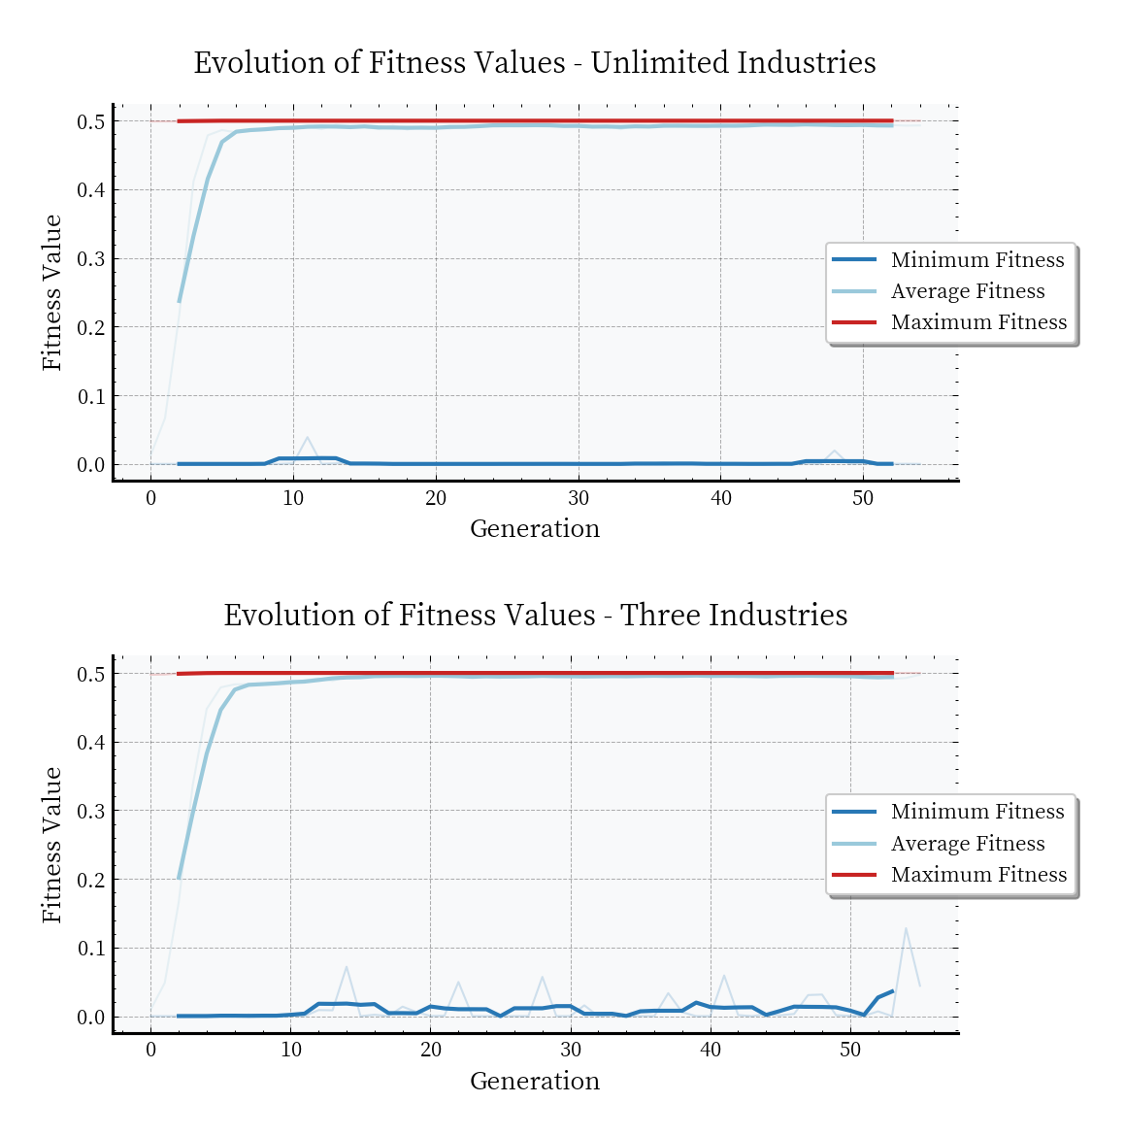

**Fig 12 Multi-objective optimization results**

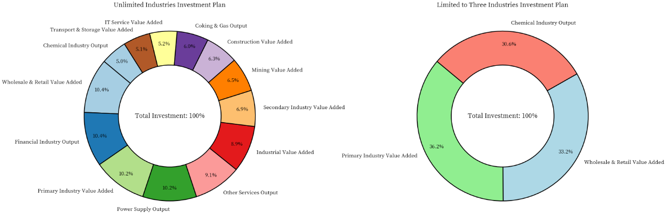

**Fig 13 Multi-objective distribution results**

The enhanced optimization model demonstrates superior performance in both unrestricted and restricted scenarios. In the unrestricted case, the model achieves a balanced distribution with wholesale and retail (10.43%), financial services (10.37%), and primary industry (10.21%) leading the allocation, reflecting an effective balance between growth potential and stability. When restricted to three industries, the model concentrates investments in primary industry (36.22%), wholesale and retail (33.16%), and chemical industry (30.62%), strategically combining traditional stability with modern growth drivers. The rapid convergence (53 generations) and stable solutions indicate the model's effectiveness in finding optimal allocations while maintaining risk management through diversification.

**Key findings:**

* ***Balanced Allocation:*** The unrestricted model achieves near-equal distribution (~10%) among leading sectors
* ***Strategic Concentration:*** Three-industry restriction leads to optimal balance between traditional and modern sectors
* ***Efficient Convergence:*** Model demonstrates rapid convergence with stable solutions
* ***Risk Management:*** Both scenarios maintain effective risk control through strategic diversification

**9 Model Evaluation   
9.1 Strengths**

Firstly, the comprehensiveness and systematic nature of the analytical framework. The study employs a multi-dimensional analytical approach, combining correlation analysis, Granger causality tests, and trend analysis to fully capture both static connections and dynamic evolutionary relationships between industries. This integrated framework provides a solid foundation for understanding complex industrial interactions.

Secondly, the innovation and practicality of the optimization model. The model design thoroughly considers multiple objectives-GDP growth, employment, and sustainable development - achieving balanced optimization through well-designed objective functions and constraints. The adaptive parameter design enhances the efficiency and stability of the optimization process, making the results more practically meaningful.

Thirdly, the operability of research results. The model provides specific investment plans under different constraint conditions with detailed industry investment proportion recommendations. The results offer clear guidance for policy-makers while maintaining flexibility for practical implementation, effectively bridging theoretical analysis and practical application.

**9.2 Weakness**

Firstly, data dimensional limitations. The data used in the study may be insufficient in terms of time span and industry segmentation, with difficulties in obtaining data for certain emerging industries potentially affecting the model's ability to reflect the latest economic situations. This limitation may impact the model's accuracy in capturing recent economic trends.

Secondly, simplification of model assumptions. The study makes necessary simplifying assumptions in the modeling process, such as linear relationship assumptions that may be oversimplified and insufficient consideration of external shock factors on industrial development. These simplifications might affect the model's ability to capture complex real-world dynamics.

Thirdly, insufficient consideration of regional differences. The study does not fully account for economic characteristics of different regions in China, differences in industrial policies, and resource endowment variations. This limitation affects the model's applicability across different geographical contexts and economic conditions, potentially reducing its practical value in region-specific policy-making.

**References**

1. Acemoglu, D., & Guerrieri, V. (2008). The structural transformation and the new growth theory. Journal of Political Economy, 116(4), 743–782.
2. Baumol, W. J., Blackman, S. A., & Wolff, E. N. (1989). The impact of service sector growth on employment and productivity. The American Economic Review, 79(2), 161–166.
3. Brynjolfsson, E., & Hitt, L. M. (2000). Industry - specific policies for promoting IT investment. Management Science, 46(5), 585–602.
4. Diamond, D. W. (1984). Financial intermediation and delegated monitoring. The Review of Economic Studies, 51(3), 393–414.
5. Fazzari, S. M., Hubbard, R. G., & Petersen, B. C. (1988). Industry - level investment efficiency in the United States. Brookings Papers on Economic Activity, 1988(1), 1–66.
6. Griliches, Z. (1992). Productivity and investment in the service sector. The Review of Economics and Statistics, 74(1), 1–12.
7. Himmelberg, C. P., & Petersen, B. C. (1994). The allocation of capital in the U.S. economy. Brookings Papers on Economic Activity, 1994(1), 139–191.
8. Markowitz, H. M. (1952). Portfolio selection. The Journal of Finance, 7(1), 77–91.
9. Miller, R. E., & Blair, P. D. (2009). Input - Output Analysis: Foundations and Extensions. Cambridge University Press.
10. Topel, R. H. (1988). Employment and investment in the real estate sector. Journal of Political Economy, 96(4), 758–784.