AGENCY ACTIVATION PLAYBOOK
DAYS 1–30 • Prescribed Steps · Embedded Links · Sample Reporting

Follow the steps post-contracting approval. Click any underlined item to open the tool, schedule the call, or email the contact directly. The training calendar at the bottom of page 1 shows the standing FYM live calls every agent should be on.
WEEK 1 · KICKOFF & TOOL ACCESS
- Schedule the kickoff call (60 min) with Melanie + FYM trainer — email melanie@FCP.com to book. Use the Kickoff Call Agenda to run the meeting.
- Send agent invites for kickoff with the FYM Agency in a Box 1-pager attached — [paste hosted link to the 1-pager]
- Confirm UNL Quote Tool access for every agent — unlquote.netlify.app
- Bookmark the Financial Modeler for agent income projections — hip75.netlify.app (request a customized 70-tier view if needed)
- Review state availability with the UNL Shield Series State Availability matrix — cross-check against your agency's licensure list to set selling lanes before agents start quoting.
- Add the 3x weekly FYM live training calls to every agent's calendar (see schedule below).
- Sample reporting delivered each Friday — send your distribution email list to melanie@FCP.com so agents are wired in week 1.

WEEK 2 · TRAINING BEGINS
- Listen to 4 sample sales calls with real clients — provided by FYM at kickoff.
- Load agents into Simulated Training (SYMTRAIN) for live training and testing — [paste SYMTRAIN access link]
- Join all 3 weekly FYM/UNL training calls for live Q&A with trainers (see calendar).
- Read the scripts: Hospital Indemnity Sales Script + UNL Call Checklist (host on Drive/Dropbox and paste the link).
- FYMCRM: load Medicare clients and complete training — [paste FYMCRM instructions link]
- For leaded agencies: load agents on Allcalls and complete training — email brent@FCP.com
- 15+ agents attending? Request a custom scaling track (Sales / CRM / Calculator) — email melanie@FCP.com

LIVE TRAINING CALENDAR — RECURRING WEEKLY
New agents attend all three FYM live calls during the launch month. Specific days, times, and join links supplied by FYM at kickoff.
DAY | TIME | SESSION | ACCESS
[Day] | [Time CT] | FYM Live — Product & Script  Agent-facing — UNL HIP & HHC product depth, current scripts, Q&A. | [FYM to provide]
[Day] | [Time CT] | FYM Live — Sales Coaching  Role play, objection handling, top-performer walkthroughs. | [FYM to provide]
[Day] | [Time CT] | FYM Live — Compliance & Routing  Prohibited language, GI suppression, recording protocol. | [FYM to provide]
Weekly | Flexible | Principal ↔ Melanie Check-In  Strategy, escalation, planning. 30 min. | Email to book →

WEEK 3 · LOAD MEDICARE CLIENTS · CALLS BEGIN
- Reps begin on real calls, starting with the existing Medicare book. Phase 1 (Oct–Mar): cross-sell after every Medicare enrollment. Phase 2 (Apr–Sep): lead with HIP/HHC.
- Daily or weekly huddle with the principal — what worked, what got pushback, who is stuck.
- First applications submitted. Payments on draft and weekly reports delivered every Friday by melanie@FCP.com.

WEEK 4 · REFINE & COACH
- Top performer share-out — 5-min walkthrough of one win at the team huddle. Replicate, don't reinvent.
- Join at least one weekly call with your team to share best practices as production starts.
- Need extra coaching? Email brent@FCP.com — we'll work with any agent that needs it.
- Scale: bring more agents onto the model and run wave 2.

TOOLS & RESOURCES
- FYM Financial Modeler hip75.netlify.app — team economics, agent income, lead breakeven math
- UNL Quote Tool unlquote.netlify.app — live Bronze / Silver / Gold tiers on every client call
- Hospital Indemnity Sales Script (with coaching notes) [paste hosted link] — the agent script for HIP cross-sell and Phase 2 lead-mode calls
- UNL Call Checklist [paste hosted link] — pre-call setup and post-call wrap items every agent runs every call
- UNL Shield Series State Availability [paste hosted link] — state-by-state matrix for HIP, GI HIP, HHC, Dental, Cancer, FE Life — confirm sellable markets
- Kickoff Call Agenda [paste hosted link] — 60-minute principal-led agenda for wave-1 launch (and every wave after)
- FYM Agent Activation Kit [FYM to provide link] — full library: scripts, routing tree, prohibited-language rules, Bronze/Silver/Gold framework
- UNL Consumer Flyer [FYM to provide link] — client-facing handout for agents to reference on calls
- Agency in a Box 1-pager + 72-Hour Contracting Timeline — in your Activation folder, for partnership overview and wave-2 contracting reference
CONTACT DIRECTORY
Italicized rows are FYM-side placeholders to fill in at kickoff.
ROLE | NAME | EMAIL / PHONE
Your Partnership Contact | Melanie Fox or Brent Depeppe | melanie@FCP.com / brent@FCP.com
FYM Onboarding & Contracting | [FYM to provide] | [FYM to provide]
FYM Lead Trainer | [FYM to provide] | [FYM to provide]
FYM Compliance | [FYM to provide] | [FYM to provide]
FYMCRM / Quote Tool Tech Support | [FYM to provide] | [FYM to provide]
FYM Agency Services (Advance & Comp) | [FYM to provide] | [FYM to provide]
UNL & GTL Carrier Support | [FYM to provide] | [FYM to provide]
SAMPLE REPORTING — WHAT YOU RECEIVE EVERY FRIDAY
Below is the format and depth of your weekly activity report. Names, agency, and policy IDs shown are samples; live reports include your real agency, agent roster, and policy detail by name.
DELIVERED  $5,814  121 policies | LAPSED  −$272  6 policies | NTO  $0  0 policies | AVG PREMIUM  $429  per policy | AVG ADVANCE  $48  per policy

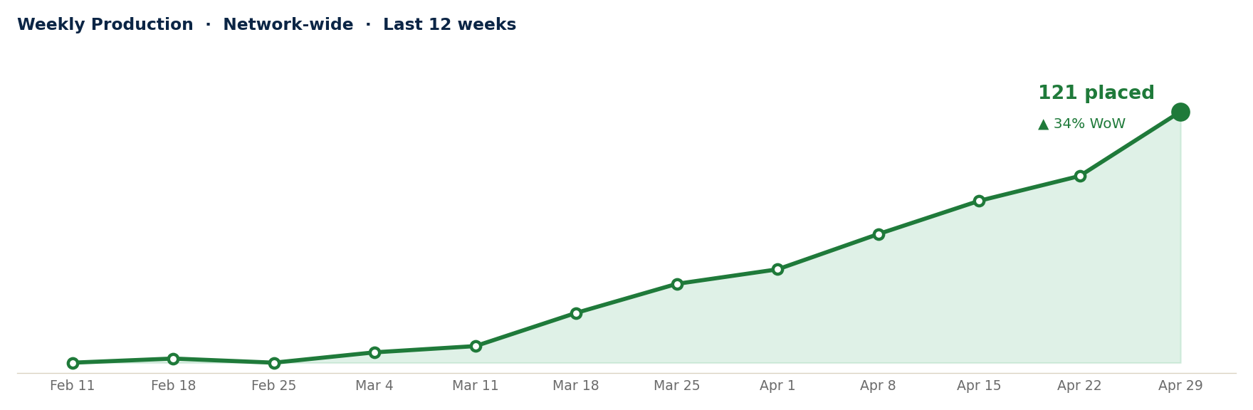
TOP TRANSACTIONS — WEEK OF [DATE]
POLICY | AGENT | TYPE | PLAN(S) | PREMIUM | AMOUNT
20H6112914 | A. JOHNSON | DELIVERED | UTHHC + UTCGB + UTASH | $1,108 | $166
20H6116634 | B. WILLIAMS | DELIVERED | UTHHC + UTCGB + UTASH +3 | $930 | $139
20H6116619 | C. DAVIS | DELIVERED | UTCGB + UTHHC +1 rider | $876 | $131
20H6117434 | D. MILLER | DELIVERED | UTCGB + UTHHC +1 rider | $862 | $129
20H6115890 | C. DAVIS | DELIVERED | UFGHI + UAMBF +1 rider | $795 | $119
20H6116335 | B. WILLIAMS | DELIVERED | UGHIP + UGOPS + UGAMB +2 | $794 | $119
20H6116150 | B. WILLIAMS | DELIVERED | UTHHC + UTASB + UTCGB +2 | $723 | $108
20H6117406 | E. TAYLOR | DELIVERED | UGHIP | $697 | $105
20H6116607 | F. ANDERSON | DELIVERED | UTHHC + UTCGB + UTASH +2 | $623 | $93

