**PT. Inax Furniture**

**床和床组件**

**包装需求**

|  |  |  |  |  |
| --- | --- | --- | --- | --- |
|  |  |  |  |  |
|  |  |  |  |  |
|  |  |  |  |  |
|  |  |  |  |  |
| 3 | Sammy Rochin | Brian E. Tudor | 13-Jul-09 | Fall 09 |
| 2 | Andrew Feudner | Brian E. Tudor | 08-Aug-08 | Fall 08 |
| 1 | Sean Ho | Alain Masse | 25-Nov-03 | Summer 04 |
| Initial | Sean Ho | Alain Masse | 06-Mar-03 | Spring 04 |
| **改版** | **初稿** | **审核** | **发布日期** | **生效日期** |

**1. 目标**

The purpose of this specification is to provide vendors with our basic packaging requirements for bed products, which includes headboards, footboards, siderails, slats, ladders, storage units, trundles and other accessories.

**2. 应用**

This procedure applies to all bed products that do not have specific packaging instructions. This specification does not cover mattresses. Contact WSI Packaging for details.

**3. 定义**

The following are example of various types of beds. Note: The various product types WSI

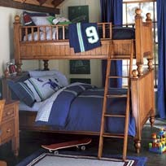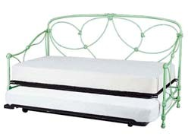

offers are not limited to those shown below.

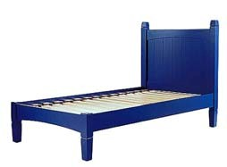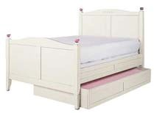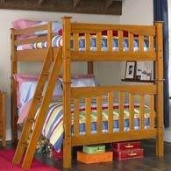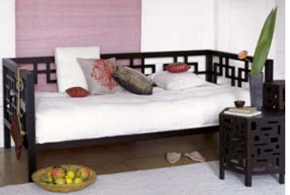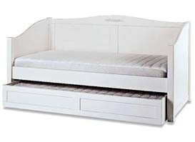

|  |  |  |
| --- | --- | --- |
| **Basic**  **Complete Bed** | **Standard**  **Headboard** | **Headboard**  **(Upholster)** |
|  |  |  |
| **Standard Bed**  **With Trundle** | **Bunk Bed**  **Full Over Full** | **Bunk Bed**  **Twin Over Full** |
|  |  |  |
| **Day Bed** | **Day Bed**  **With Trundle** | **Iron Day Bed**  **With Trundle** |
|  |  |  |

|  |  |  |
| --- | --- | --- |
| **Platform Bed**  **With Backrest** | **Storage Bed**  **Dresser** | **Storage Bed**  **(Headboard)** |
|  |  |  |
| **Storage Bed** | **Storage Bed** | **Loft Bed** |
|  |  |  |

**4. PACKAGE DESIGN ORGANIZATION**

Bed components must be packed in a specific manner. If a bed is packed in more than 1 carton, the carton must be marked “Carton 1 of X”. “X” being the total number of cartons to complete one unit of bed set. The component(s) should be grouped and packed in according to the following matrix. Additionally, there may be SKU / Set-SKU implication.

|  |  |  |  |
| --- | --- | --- | --- |
| **Product** | **Number of Carton** | **Carton**  **#** | **Contains** |
| **Headboard only** | 1 | 1 of 1 | Headboard |
| **Standard Bed** | 2 | 1 of 2 | Headboard and Footboard |
| 2 of 2 | Siderails, Slats, Finials and Hardware |
| **Day Bed** | 2 | 1 of 2 | Back Panel and 2 Side/End Panels |
|  | 2 of 2 | Siderails, Slats, Finials and Hardware |
| **Bunk Bed Standard**  Twin over Twin  Twin over Full  Full over Full | 4 | 1 of 4 | Headboard and Footboard (Same size Twin/Full) |
| 2 of 4 | Headboard and Footboard (Same size Twin/Full) |
| 3 of 4 | Siderails, Slats, Finials and Hardware |
| 4 of 4 | Ladder |
| **Loft Bed** | 2 | 1 of 2 | 2 End Panels |
| 2 of 2 | Siderails, Guard Rails, Slats, Finials and Hardware |
| **Storage Bed**  Standard | 2 | 1 of 2 | Headboard and Footboard |
| 2 of 2 | Siderails, Slats, Finials and Hardware |

Headboard with storage feature. May need to be palletized

|  |  |  |  |
| --- | --- | --- | --- |
| **Storage Bed**  Non-standard | 3 | 1 of 3 |  |
| 2 of 3 | Footboard |
| 3 of 3 | Siderails, Slats, Finials and Hardware |
| **Platform Bed** | 2 | 1 of 2 | Headboard and Footboard |
| 2 of 2 | Siderails, Slats, and Hardware |

The matrix above lists standard beds and standard options only. If a product has extra options, the extra options must be packed in the LAST of the series of cartons. If the option is large and cannot fit in the last carton, it must be packaged in its own carton.

**Example 1: Platform Bed with Backrest**

The matrix above identifies the number of cartons as 2 for a Platform bed. The headboard and footboard will be packaged in carton 1. The siderails, slats, and hardware will be packaged in Carton 2. The backrest, which is a non-standard feature, will be packed in the 3rd carton as long as it does not fit in the second carton.

**Example 2: Storage Bed**

If the storage component is integral to the headboard and the gross weight of the headboard package exceeds 150 lbs, the unit may need to be packed on custom pallet (Per WSI Specifications for Pallets: Product Palletization Requirements, Document Number 03-000088 & Pallet Construction Requirements, Document Number 03-000072). This is applicable for all individual cartons with a gross weight exceeding 150 lbs. (68 kg). Contact WSI Packaging Engineering if you have questions.

**Example 3: Storage Bed with Under-bed Dresser:**

In this example the Under-bed Dresser Component will be packaged in carton number 3.

**5. REQUIREMENTS:**

**Component Separation**

All components require separation from each other, as well as surface protection (see section 5.3). Corrugated board or foam should be used to protect and separate the different product layers / components within a carton – this is critical in KD (Knocked- Down) / RTA (Ready-To-Assemble) product construction.

**Void Fill**

Blocking and bracing within the void space(s) is critical when packing headboards and footboards. Fill the void space(s) within the corrugated carton with solid/rigid packaging material(s) to eliminate shifting and migration of both the product component(s) and the packaging material(s). Possible void fill components include: empty set-up corrugated box(es) (labeled as “EMPTY BOX”), EPS blocks, and corrugated build up pads (See Figures 2 – 5).

**Surface Protection**

5.1.1. All surfaces of a product must be clean and free from dirt, grease, glues, or foreign matter before packing.

5.1.2. Full coverage protection of the product with non-abrasive material(s) such as: layers of polyethylene foam sheeting, non-woven polypropylene fabric sheeting for High-Gloss products (Per WSI Specification for High Gloss Product Abrasion Protection Requirements, Document Number 03-000064), a poly-bag (Per standards outlined in WSI Specification for Construction of Plastic Bags & Tubes, Document Number 03-00073), third-web bubblewrap or non-abrasive

paper can be used where applicable. Stretch-wrapping around the product & non- abrasive materials to further restrict components movement is also

recommended.

5.1.3. Impact protection materials, such as expanded polystyrene (EPS), polyethylene (PE), built-up corrugated or hexacomb® /“honeycomb” forms, blocks, corners and planks, must be used to absorb shock and to block/brace the product from movement within the package (See Figures 2 – 5).

5.1.4. Removable finials should be wrapped in a non-abrasive material and packed separately inside its own corrugated carton. This carton should be packed with the siderails per the above table.

**Legs**

5.1.5. Legs must be protected to prevent structural as well as cosmetic damage by eliminating direct contact with other components and abrasive packaging material such as EPS foam & corrugated material.

5.1.6. To prevent pointed legs from puncturing through cartons, corrugated sheet(s), wood squares, plastic forms, etc. should be used - as needed - to increase surface contact area between the leg and the carton.

5.1.7. For all headboards and footboards that are packed inside of a corrugated container with a length greater than 60 in. (152.4 cm) – or Queen size and larger

– must be blocked and braced using a plywood plank 3/8 in. (9 mm) minimum thickness to prevent the legs from puncturing the corrugated container when in racking / storage. Secure the plywood plank to the shipping carton to restrict movement (See Figure 5). Additionally, this wood component will need to meet the requirements outlined in the Wood & Composite Wood Panel Packaging Material Requirements, Document Number 03-000087.

**Edge and Corner Protection**

All edges and corners must be protected from impact with corner blocks and angle pads.

5.1.8. A minimum coverage of 75% of any given length / edge should be protected.

For products weighing over 150 lbs. (68 kg), the minimum thickness of corrugated, EPS or EPE foam, angle / corner pads or channel pads must be 1.5 in. (3.8 cm). For products weighing below 150 lbs. (68 kg), the minimum thickness of 1 in. (2.5 cm) of corrugated, EPS or EPE foam, angle / corner pads

or channel pads. No more than 12 in. (30.5 cm) gap of any given edge is allowed without protection.

**When using Expanded Polystyrene (EPS):**

Preferred method - Molded EPS

Material density no lower than - 1.0 lb/ft3 (16 kg/m3) this applies to all critical components, edge protectors and corner protectors.

5.1.9. Siderail Bed-Hook / “J”-Hook protection: Protect metal hooks of the Siderails from end drops (impact) by increasing the bearing surface with rigid wood block or MDF blocks with slot cut-out for the hooks (See Figure 1). These wood components will need to meet the requirements outlined in the Wood & Composite Wood Panel Packaging Material Requirements, Document Number

03-000087.

**Figure 1**

Protect J-Hook / Bed-Hook with wooden/MDF block with cut-out

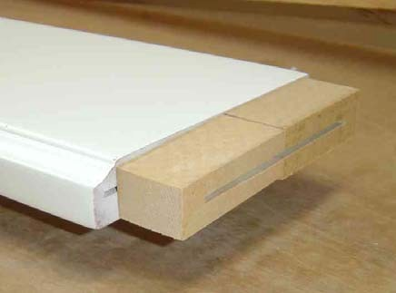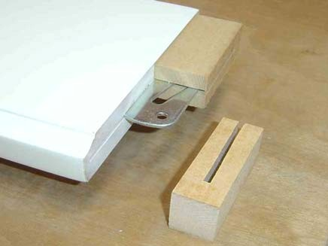

5.1.10. Stretchwrapping around the packaging and the product to further contain the components or tape packaging components to the abrasion barrier so they act as one unit is recommended

**Associated Hardware & QC Verification Sticker**

See the Packaging Requirements for Hardware, Document Number 03-000070 for packaging and identification of the Bed hardware.

**Inner Carton(s)**

Any and all inner cartons shall be printed with their contents and quantity as they relate to the Assembly Instructions (AI). Example: “Component A – Finials – Quantity 4”

**Outer Container**

In most cases, the outer container / box will be a FTD (Full Telescoping Design Style Trays), a FOL (Full Overlap Slotted Container), or FPF (Five Panel Folder) constructed from Doublewall (5-Ply) Corrugated with a Burst strength of a minimum of 275 lb/in2 (1896 kPa) test.

**Crating**

In special cases, open style crating may be required to ensure a product is properly protected from handling and shipping damage. The requirement for crating depends on the design complexity of the item. Reference the Wood & Composite Wood Panel Packaging Material Requirements, Document Number 03-000087, for details.

**Container Closure**

Use only approved carton closure methods / materials. Staples are not acceptable. Reference the Corrugated Container Specification, Document Number 03-000100 for details.

**Carton Marking / Labeling**

Reference the Specification for Carton Markings, Document Number 03-000071 for details.

**6. APPLICABLE DOCUMENTS**

|  |  |  |
| --- | --- | --- |
| 1) | 03-000100 | Corrugated Container Requirements |
| 2) | 03-000071 | Specification for Carton Marking |
| 3) | 03-000070 | Packaging Requirements for Hardware |
| 4) | 03-000087 | Wood & Composite Wood Panel Packaging Material Requirements |
| 5) | 03-000073 | Plastic Bag Requirements |
| 6) | 03-000088 | Product Palletization Requirements |
| 7) | 03-000072 | Pallet Construction Requirements |

**Figure 2**

Side rails and support slats

Wrap and secure support slats in bundle

Associated hardware protected inside carton

High density EPS pads to protect ends of bed side rails. Min. 1" (2.5 cm ) thickness

Protect all edges of side rails. No exposed length longer than

12" is permitted secure foam pads with clear tape

**Figure 3**

Head board frame

Foot-board frame Protect final and frame post corners with High

density EPS foam pads

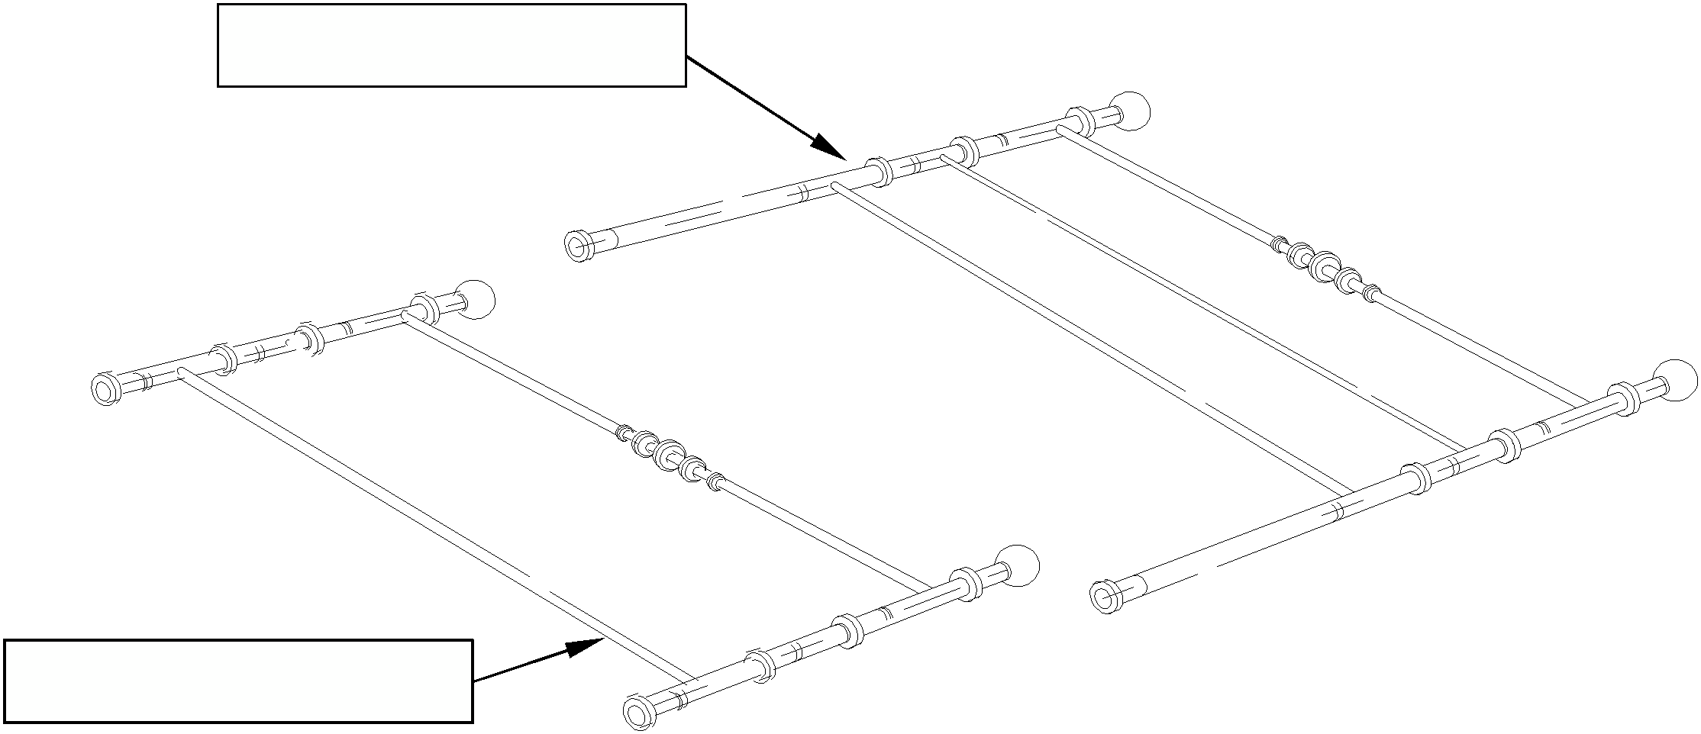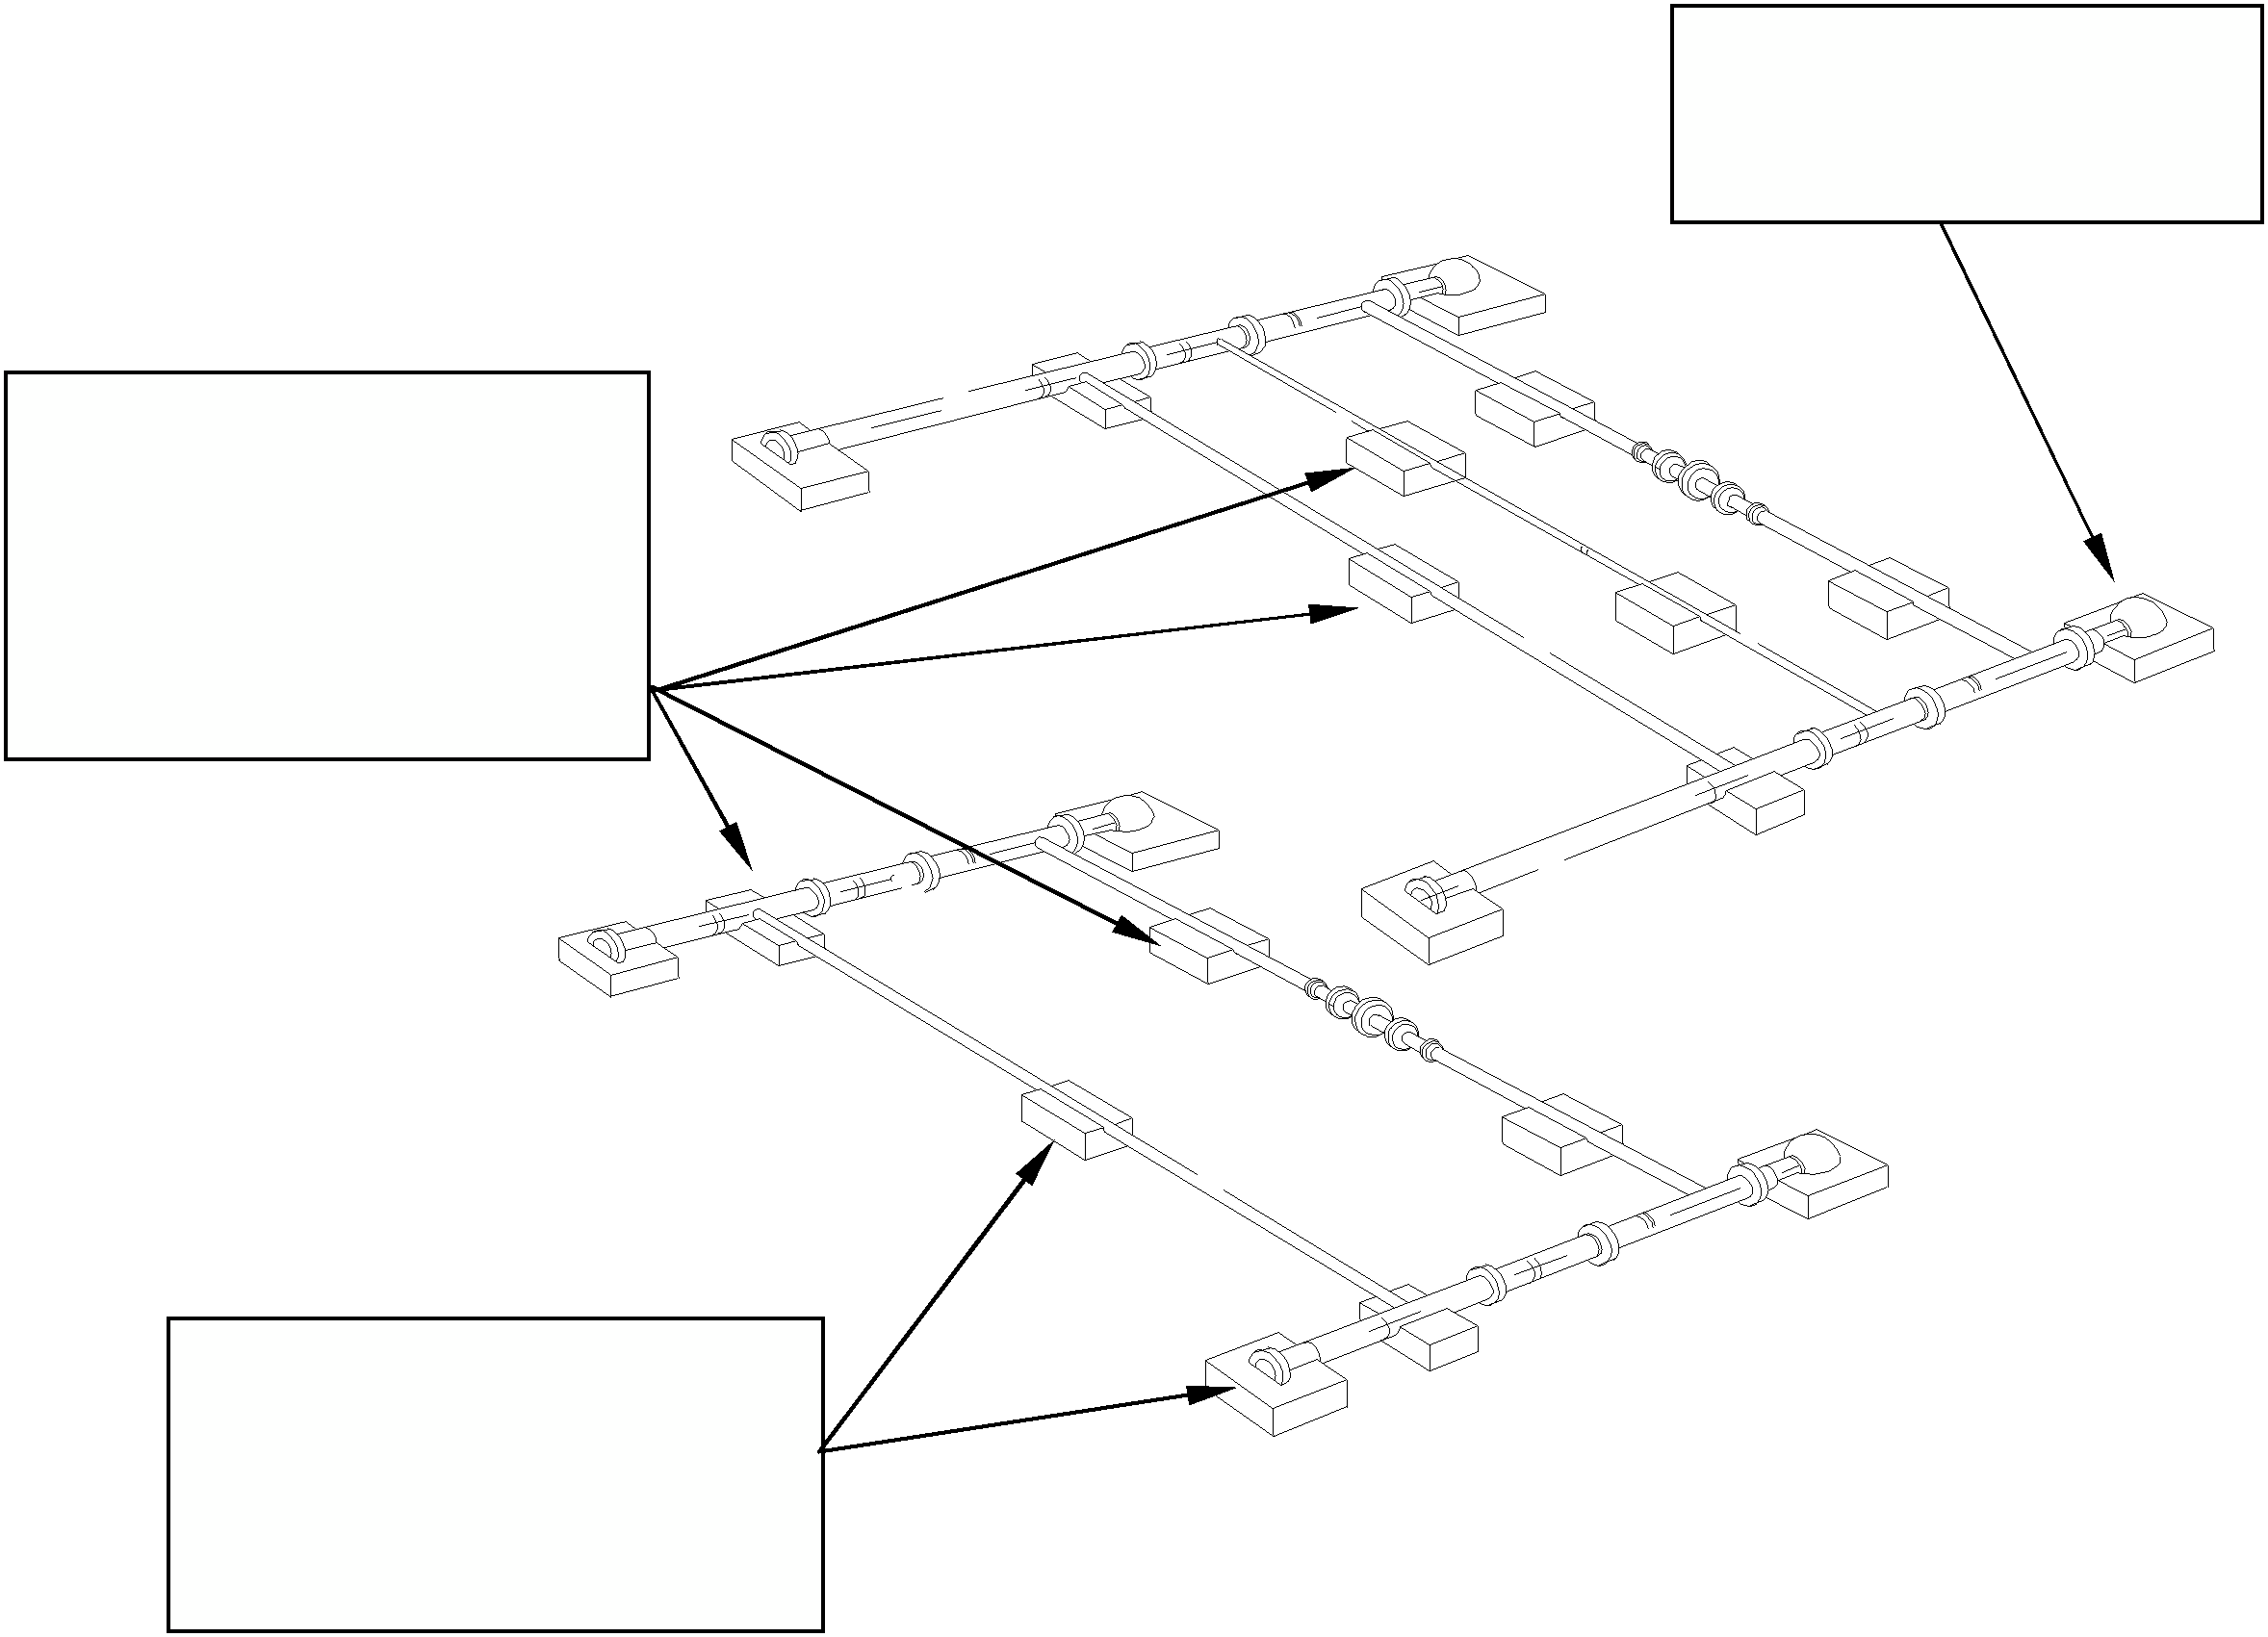

Support and protect frame edges and connecting joints with evenly spaced EPS foam pads

Protect feet and long spans from movement and from puncturing the corrugated container

**Figure 4**

Cap-off the EPS foam pad with top halves

Foot-board positioned on top of head-board frame. EPS pads (shaded void filled) must be installed to provide full support

Void fill carton

EXCLUSIVE AND CONFIDENTIAL PROPERTY OF WILLIAM SONOMA, INC.

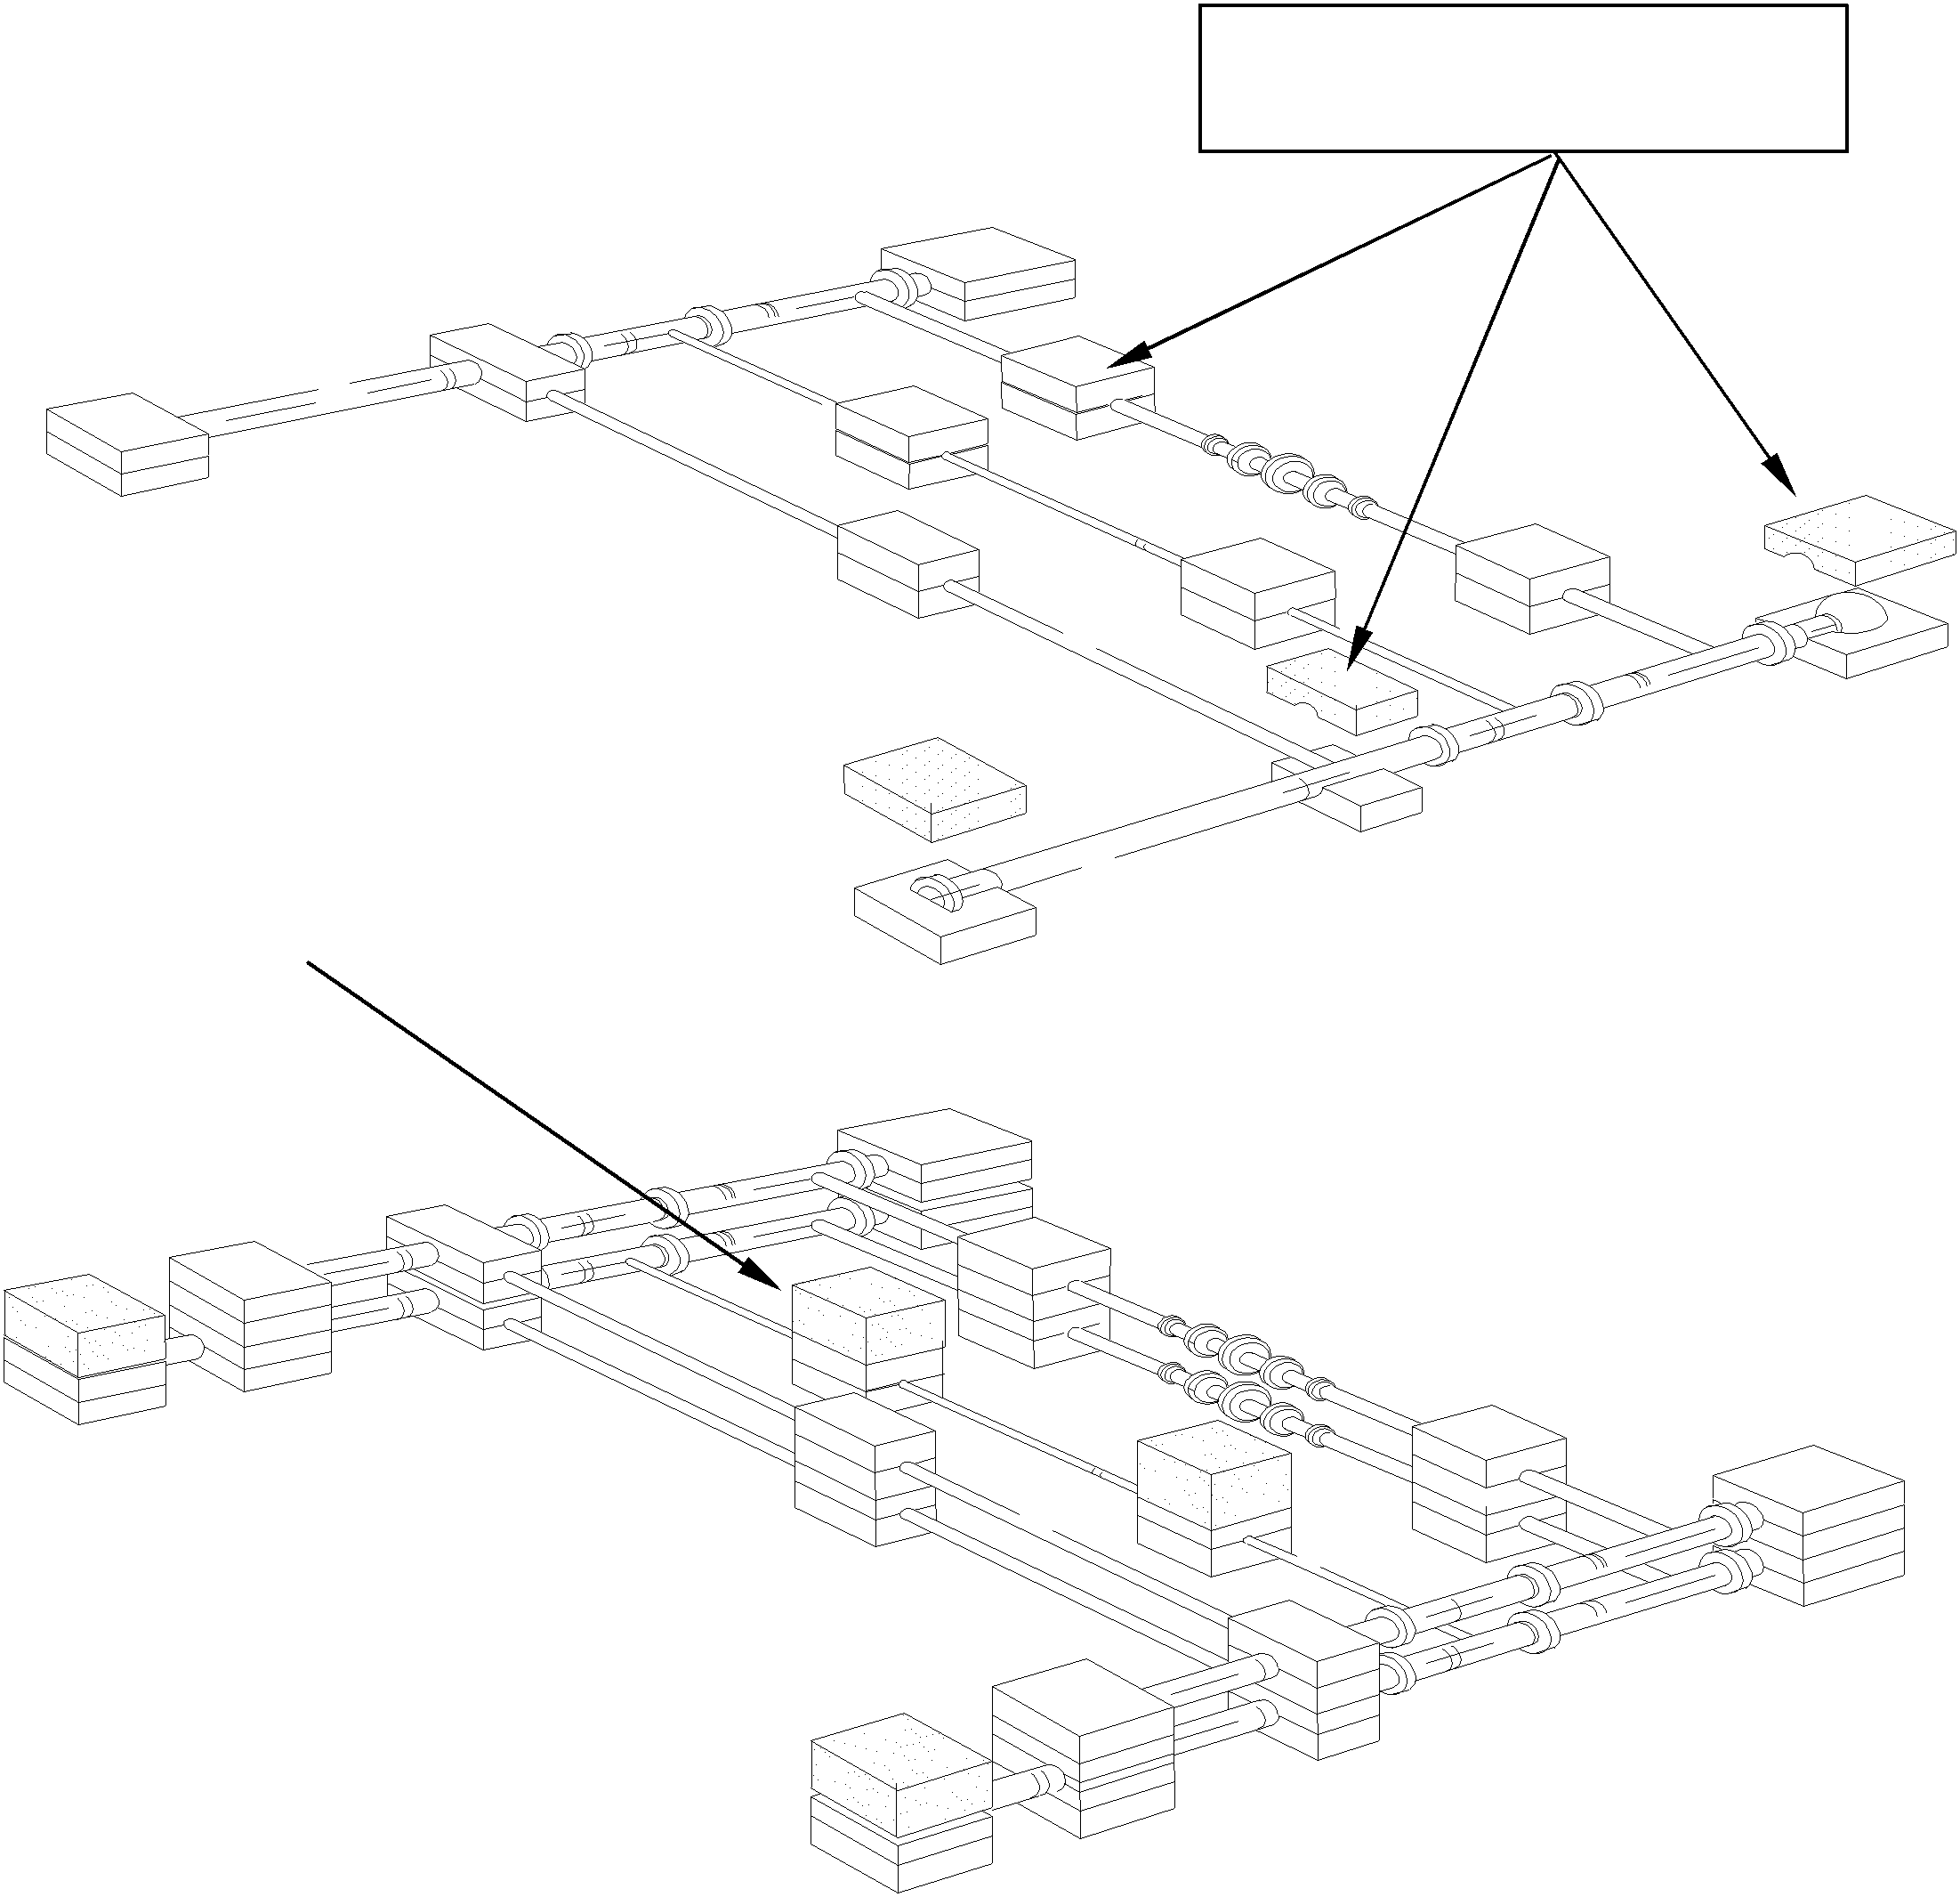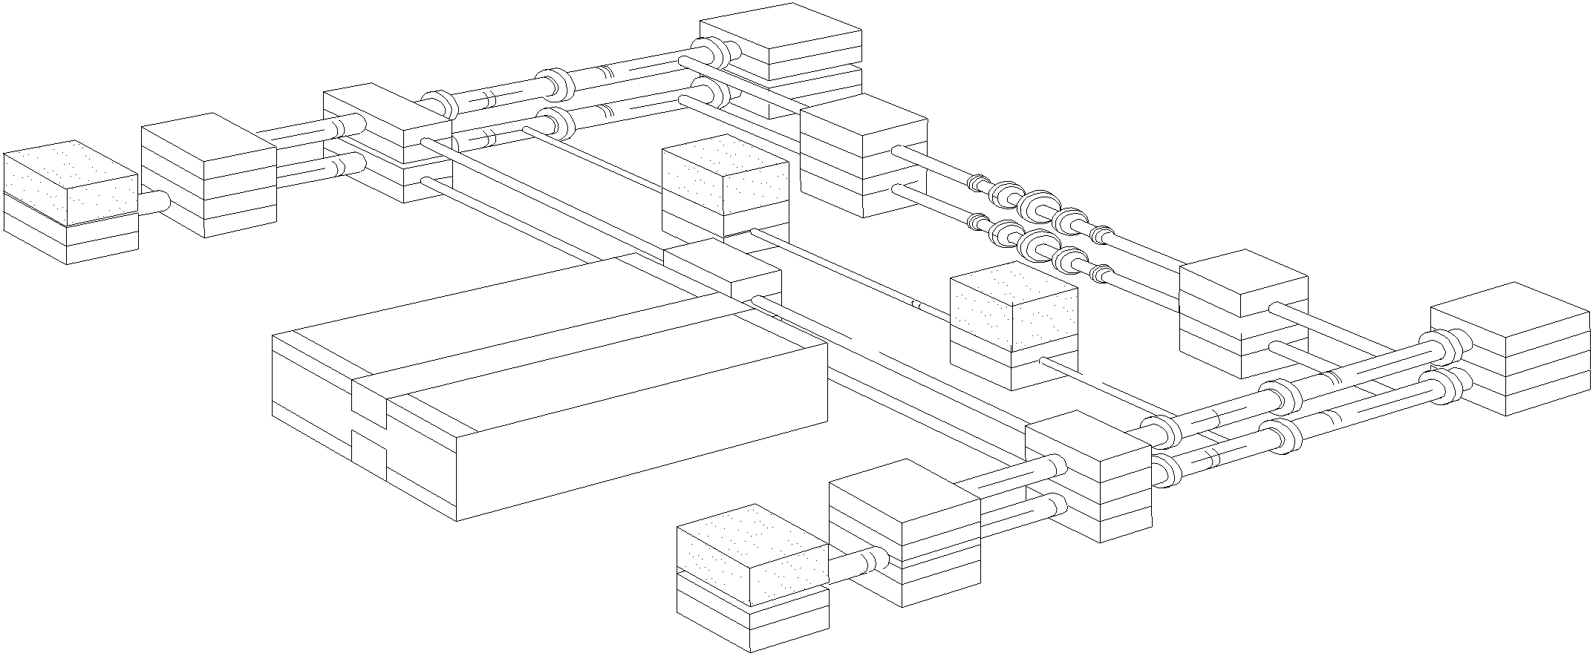

**Figure 5**

Void fill with carton or EPS foam pad(s) as appropriate to prevent collapsing

Place rigid plank to support the feet so that they cannot pierce the corrugated container (if greater than 60”). This plank must be long & wide enough to tightly fit the span of the carton.

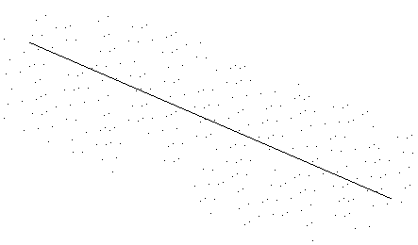

QC / Hardware verification sticker locates near labels

EXCLUSIVE AND CONFIDENTIAL PROPERTY OF WILLIAM SONOMA, INC.