  
  
  
David Whalen  
Chief Development Officer

  
  
  
Dr. Joia Mukherjee  
Chief Medical Officer

  
  
  
  
  
Gary L. Gottlieb, MD, MBA  
Chief Executive Officer

  
  
  
  
  
  
Dr. Emily Wroe  
Director of Clinical Services  
Partners In Health/Malawi

  
  
  
  
Ken Himmelman  
Chief Programs Officer

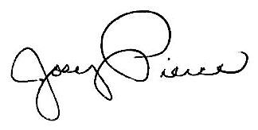  
  
  
  
  
Joey Pierce  
Deputy Chief Development Officer



John Malcolm

Chief Development Officer



Peter Drobac, MD, MPH

Executive Director

University of Global Health Equity