Find-O-Matic Instructions

_____________________________________________________________________________________

FindOmatic is a simple to use tool for searching within Raiser's Edge. FindOmatic generates instant results based on almost any parameter. Easily sort results with the drop-down options. Results are linked to records and a single click will open any record displayed. ([Link](https://www.omaticsoftware.com/Solutions/RaisersEdge/FindOmatic.aspx#!prettyPhoto))

_____________________________________________________________________________________

1. In Raiser’s Edge, press the ALT key twice.

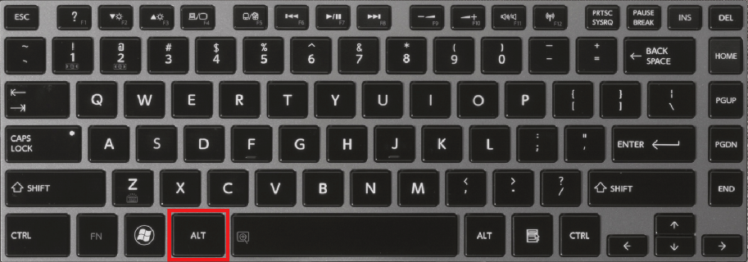

1. This will open the Find-O-Matic window.

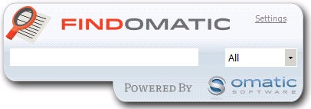

1. Here you can type (or copy/paste) search information and receive a list of results instantly.

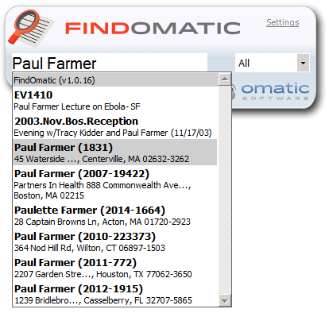

1. You can also narrow your search using the drop down on the right.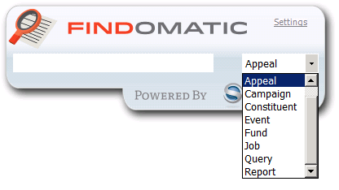
2. You can search by many criteria: name, constituent ID, email, address, etc. Furthermore, Find-O-Matic will open from anywhere within Raiser’s Edge—no need to navigate back to the records page or your home page.