page1_login_page

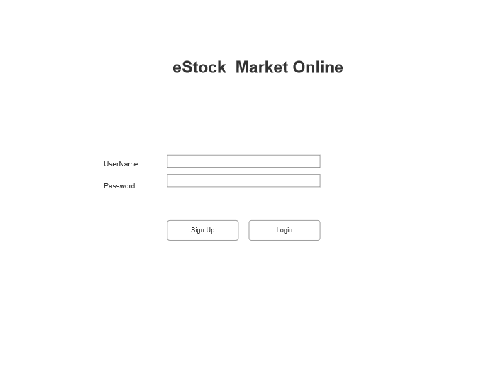

page2_Admin_Landing_Page、

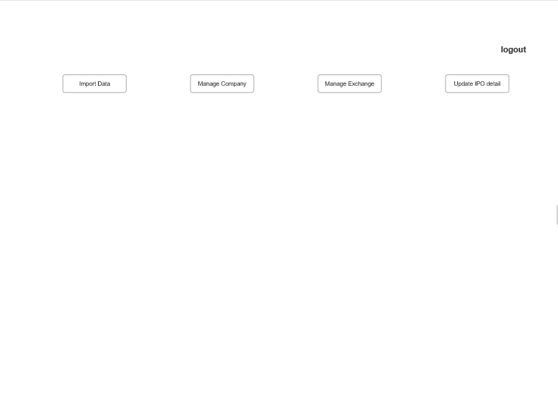

page3_Admin_Upload_Execel_to_Import_Data_1

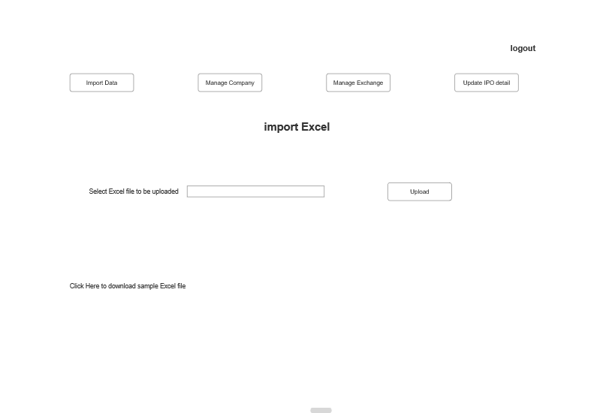

page3_Admin_Upload_Execel_to_Import_Data_2

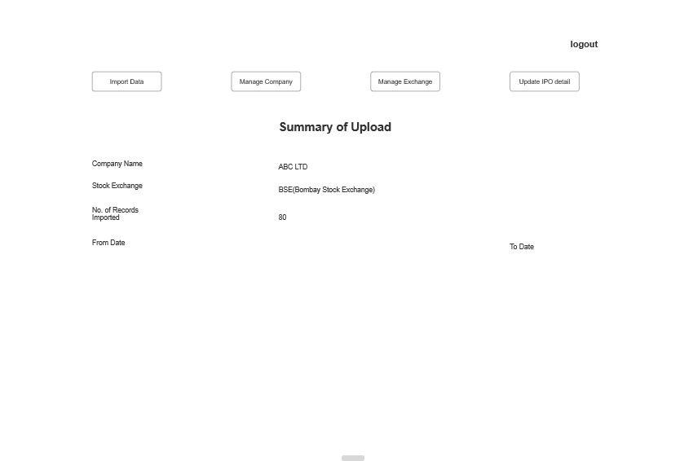

page4_Admin_Manage_Companies

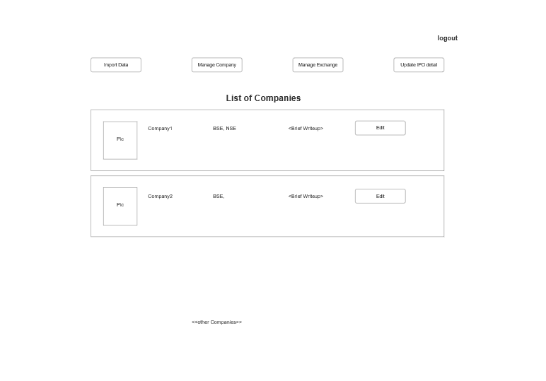

page5_Admin_Create_New_Company

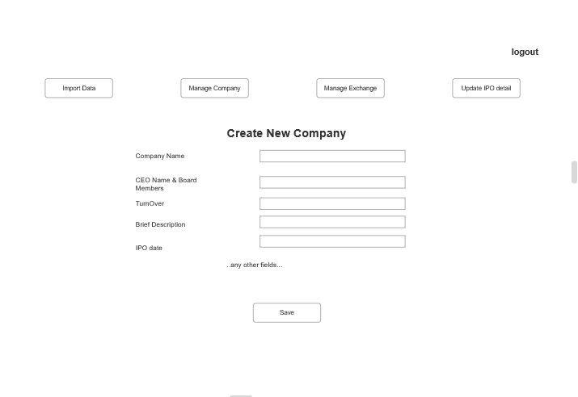

page6_User_Landing_Page

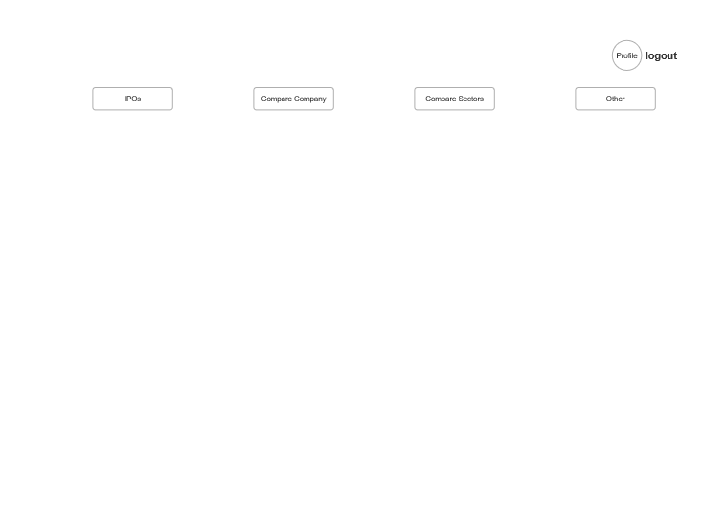

page7_User_Comparison_Charts

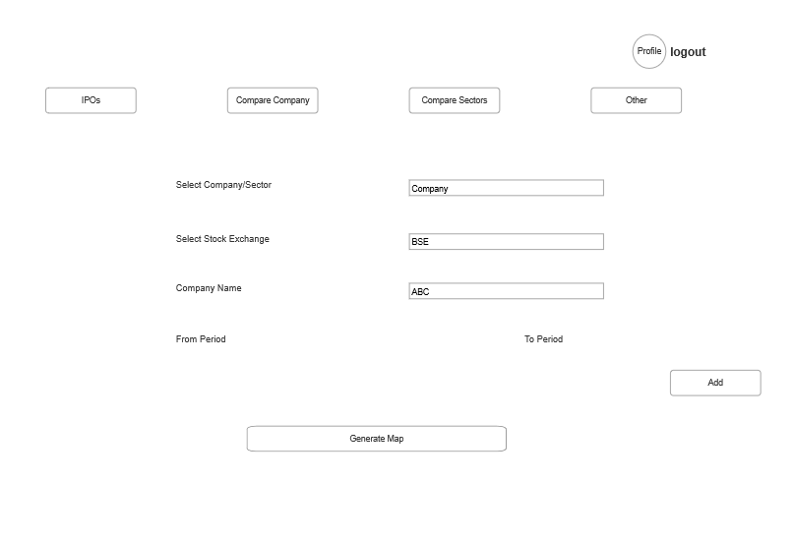

page8_USer_Company_Stock_Price

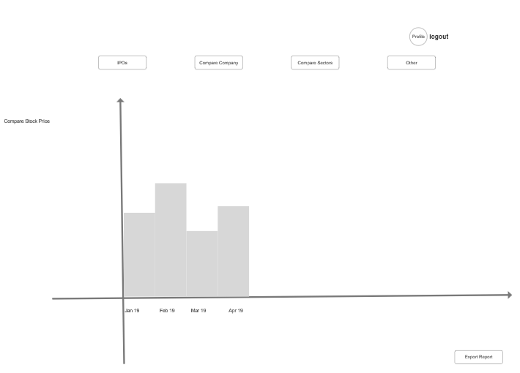

page1_User_login_SignUp_page

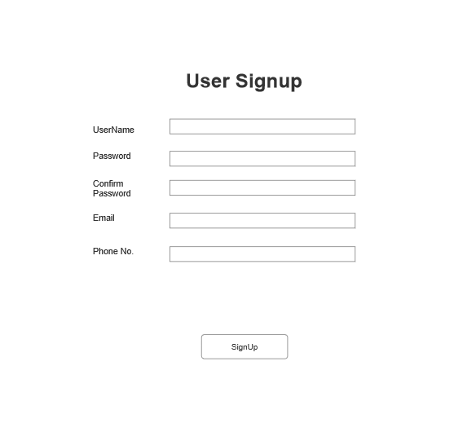

page9_User_Update_Profile_page

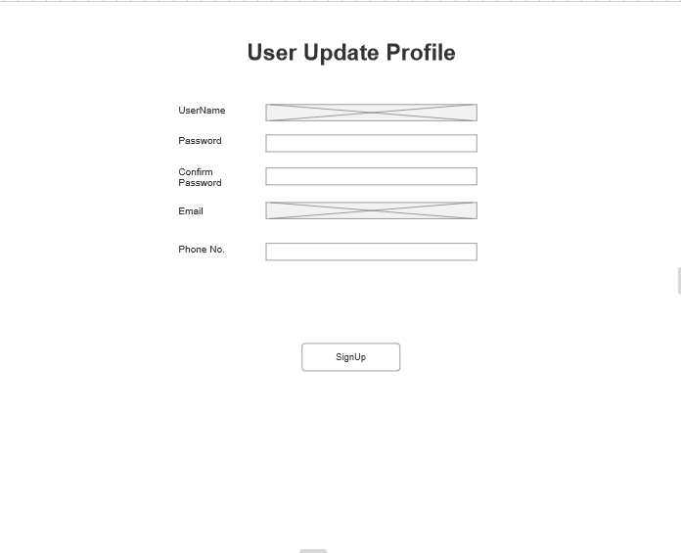

page10_User_Search_Company_page

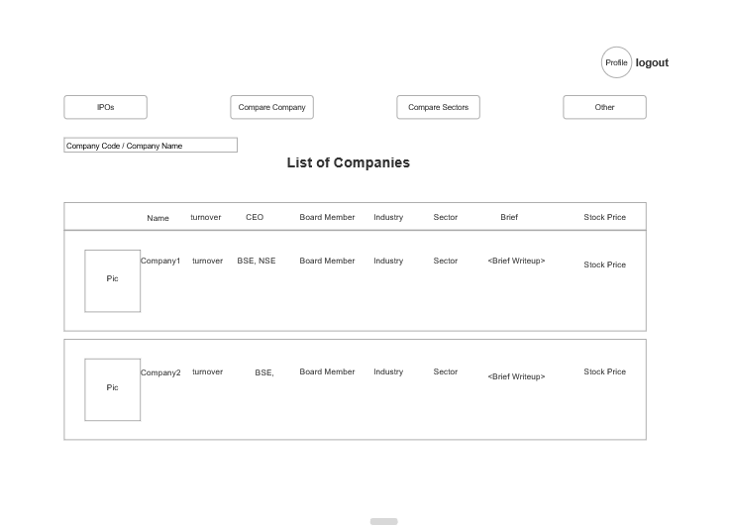

page11_USer_Request_Certain_Data

