**Recipe Finder Application**

* **Student Name:** Wilson Cordeiro
* **Student Number:** G00330453
* **College Name:** GMIT
* **Course:** Software Development
* **Module:** Windows Mobile Application Development
* **Lecturer:** Damien Costello
* **Current College Year:** 3rd Year
* **Project Title:** Recipe Finder Application

**Application Overview**

The RecipeFinder app is a universal application for the windows platform. This app has the mission of facilitate the search of recipes by searching using different criteria and in different bases. Upon launching the app, the user will face the main Screen for the app, in this screen the user can choose between two different types of search, a sorted list of recipes, a view of his own favorite recipes or the information screen about the app.

The RecipeFinder is powered by two free APIs, Food2Fork and Yummly, the communication between the app and the APIs is done using HTTP Requests and JSON responses. All data present in the app is from one of those APIs.

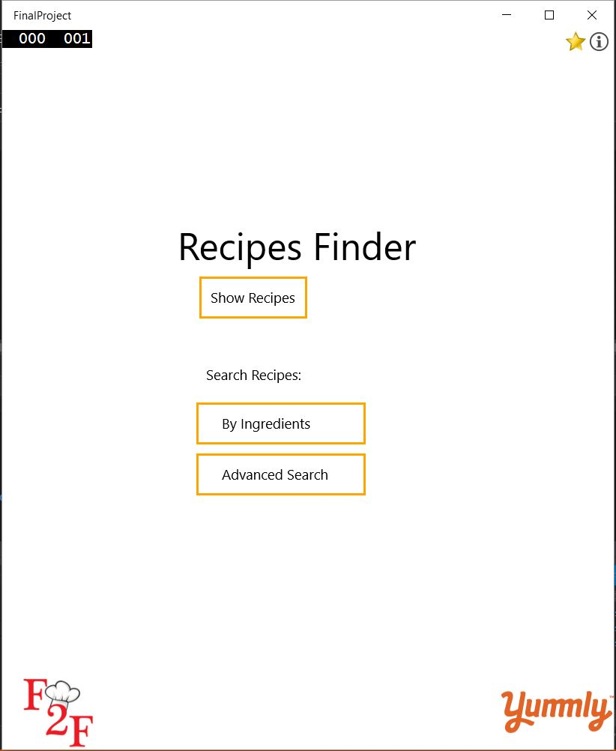

The application has a minimalist view and is simple to use and understand. The main screen shown above has in the top two options, the favorite screen and the information screen.

The favorite saving is done using Roaming Storage for the recipes that the user wants saved.

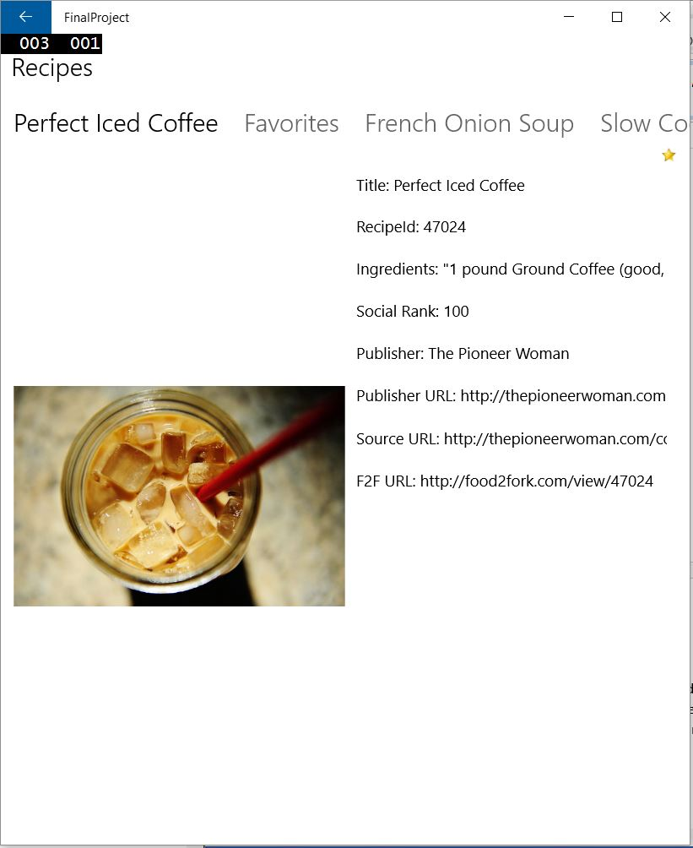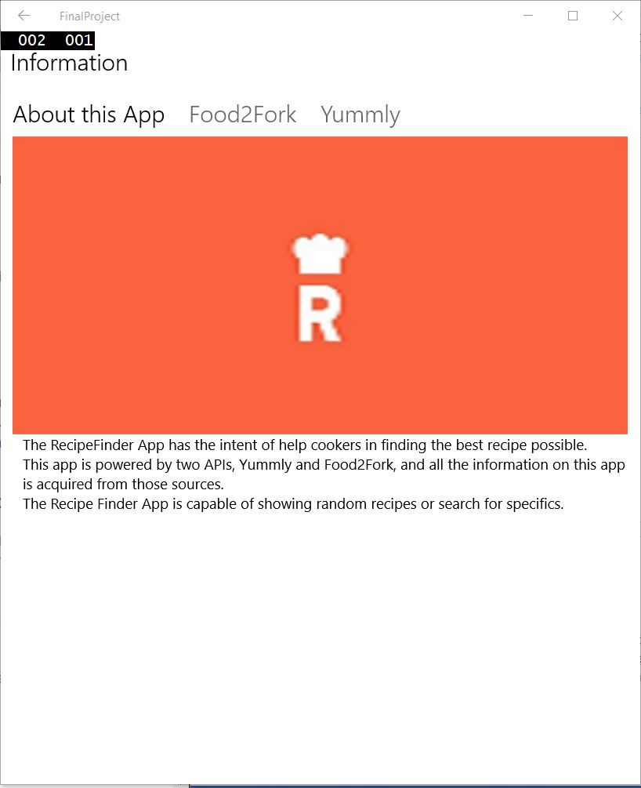

The Show Recipes shows a sorted list of recipes.

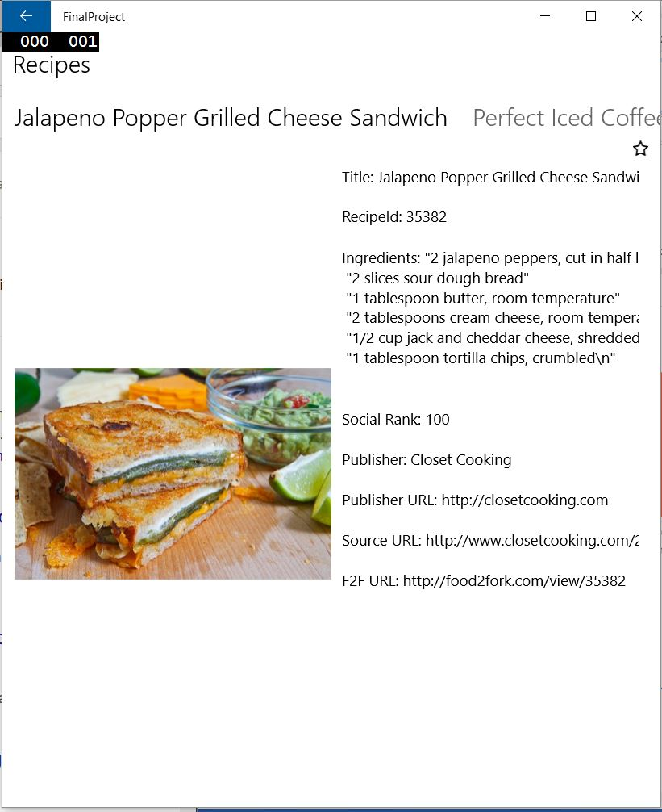

The Search by ingredients allow you to enter an unlimited number of ingredients and search for a recipe that use those.

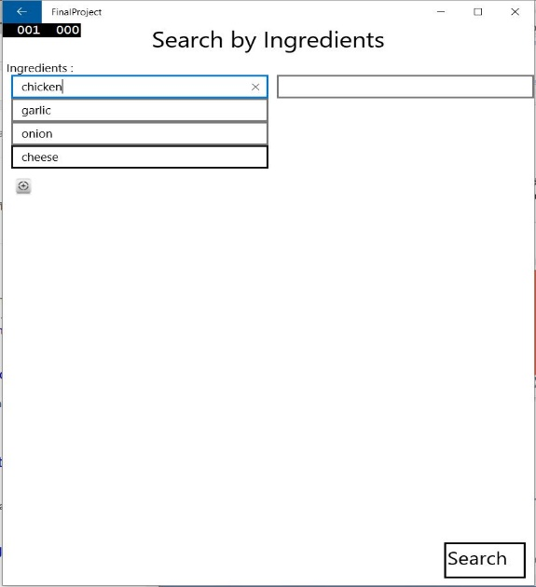

The advanced search is a complete search that allows the user to select a range of factors in order to find the right recipe.

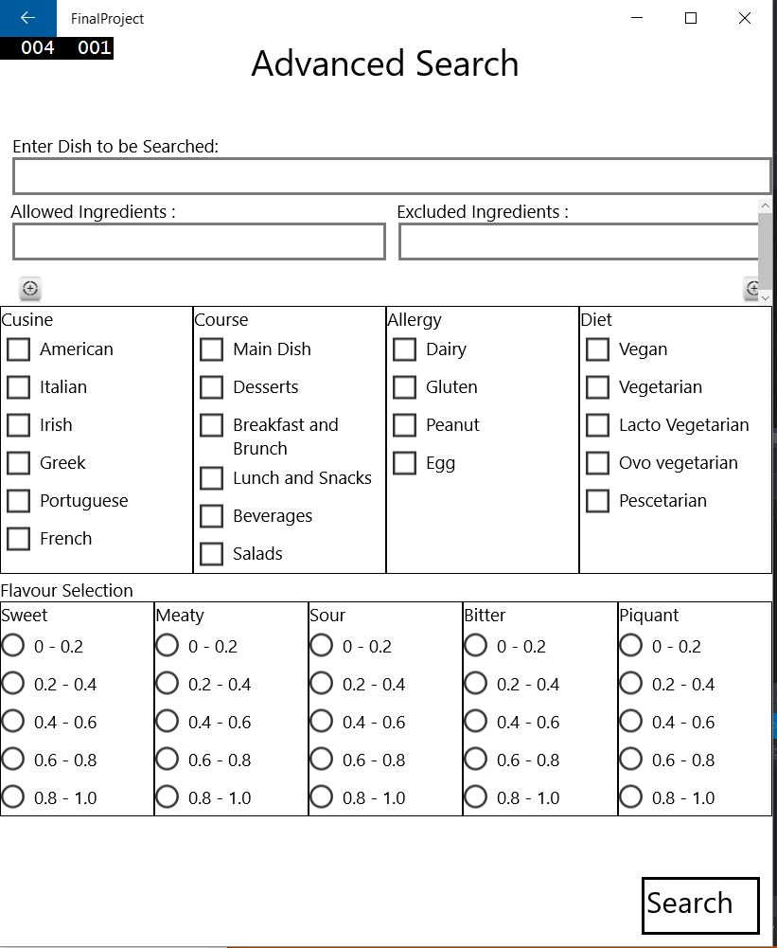

**Compatibility**

Because the app was created this as a Universal Application within Visual Studio 2015, it should download from the store and work on a number of different devices without any issues.

**Technical Information**

The Application was created using Visual Studio 2015. I chose a Universal App for this project to facilitate cross device deployment.

### Project Code / Pattern Structure

This project structure adheres to a Model View Controller paradigm, which consists of three programming languages.

* C# - Which is used as the Controller
* XAML - The visual display or View
* JSON - The data Model itself

### Instructions for Visual Studio 2015 deployment

* Download the zip file and unbundle to a folder of your choosing.
* Open using Visual Studio 2015.
* Follow the steps to install SQLite as outlined in previous header.
* Run.