# Week 6: How to be a tree

This week’s class is incredibly important – understanding how plants actually grow (and no, it’s not like what you see in the movies!).

We are going to start by learning about the main cell types in plant leaves, cells and roots (including their structure and function). Next, you will cut a cross section of a primary stem, identify the different types of cells and tissues, and draw a diagram of what you see. Finally, you will learn how secondary thickening works in dicotyledons.

The practical skills you should aim to perfect in this lab are:

1. recognition of the major cell types in plant stems
2. section cutting by hand with a razor blade, staining and mounting sections
3. using a compound microscope and drawing what you see

***FEEDBACK***: **You will likely be assessed on biological drawing from microscope sections in the practical exam. Hand in your drawing of the *Juncus* cladode and we will provide feedback.**

## Plant Cells

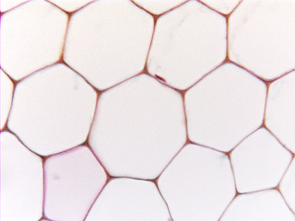Various different types of cells are found in the mature plant body. Each performs a specific function. You will be looking at a range of different plant tissues and you will be expected to be able to identify the major cell types. The notes given below should help to clarify the important features of each type.

### Parenchyma

The term parenchyma is used for tissues composed of *living* cells generally having *thin wholly primary walls* and a *polyhedral shape* [A wall is said to be wholly primary if the thickening of the wall is completed before the cell has reached its full size, any thickening laid down after the cell has reached its full size is said to be secondary.]

Parenchyma is the main representative of the ground tissue system: this forms a continuous tissue in all major plant organs, e.g., cortex of roots, pith and cortex of stems, ground tissue of petioles and mesophyll of leaves. In herbaceous plants 80% of the plant body is composed of parenchyma. Parenchyma cells also occur as components of complex tissue systems (such as xylem and phloem) either scattered singly or aggregated. A number of types of parenchyma can be recognised including:

*Parenchyma. Thin walled ground tissue. Parenchyma can be closely packed (as in this picture), or can have intercellular spaces.*

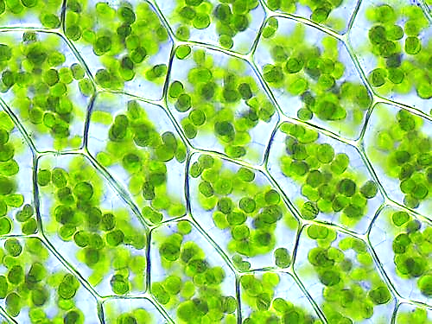**🡨 chlorenchyma**: parenchyma containing chloroplasts, most often found in leaves and the outsides of stems.

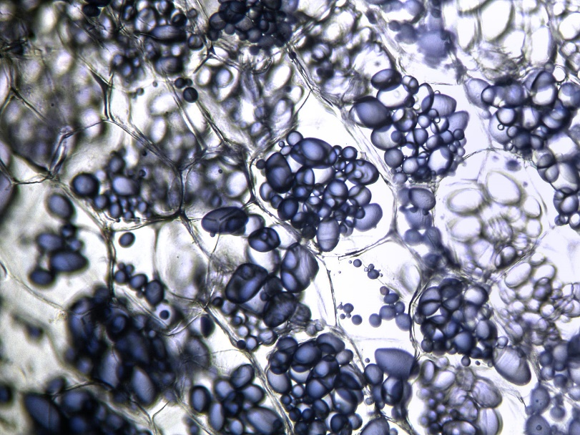

**Storage parenchyma 🡪**

Contains stored food reserves, most commonly starch grains but other reserves also occur such as sucrose, inulin etc.; may be found throughout the plant or concentrated in special storage organs such as tubers, rhizomes, storage roots etc. (e.g. amylophasts in potatoes);

### Related image🡨 Collenchyma

Collenchyma is a living tissue composed of more or less elongated cells with thick, non-lignified primary walls. The wall material is deposited unevenly and is particularly thick at cell corners. The cell walls are made of cellulose, hemicellulose and pectin [not lignin] and normally stain a very bright pink with toluidine blue.

It is the main supporting tissue in the leaves and stems of many dicotyledons, for example in the midrib and petiole of leaves and in strands in the outer cortex of stems (often forming ridges). Collenchyma is well adapted to function as support tissue in growing organs, as it combines high tensile strength with considerable plasticity. Unlike sclerenchyma it is extensible.

### Image result for sclerenchymaSclerenchyma 🡪

Sclerenchyma refers to a tissue composed of cells with thick, rigid, secondary walls (usually but not always lignified) whose function is support and/or protection; frequently the cells lack protoplasts at maturity. Many different cell types are involved but two major groups are recognized: fibres and sclereids.

* **Fibres** are long tapered interlocking cells, normally unbranched. Typically without protoplasts at maturity and with obscure simple pitting; frequently, but not always, lignified (unlignified fibres are most often associated with phloem). Fibres may occur singly or in groups and are often associated with vascular tissue.

Fibres produced by plants have been used commercially for centuries. At present, plants from 44 different families are used as sources of fibre. Common commercial fibres may be divided into textile fibres including flax (*Linum usitatissimum*) jute (*Corchorus* spp.) and hemp (*Cannabis sativa* - yes it does have a legitimate use!). Extraction of most fibres is by a process called "retting". This decomposes the middle lamellae between cells so that they separate. The plant material is left in water while decomposition occurs, then dried and passed between rollers which separates the fibres from the outer tissue.

* **Sclereids:** These vary greatly in shape. They differ from fibres in that they do not have a very elongated simple shape. Usually they have very thick secondary walls with obvious pits and are strongly lignified. Often classified on the basis of shape, but according to Esau (1977), this is of limited use because the various forms intergrade. These cells, individually or in groups are widely distributed in the plant body, but are particularly common in leaves, fruits and seeds.

### Xylem vessels and tracheids

Xylem is a complex tissue, composed of conducting (or tracheary) elements, fibres and parenchyma. Conducting elements are of two kinds, **tracheids** and **vessel members**. Both are elongated cells, thick walled and without living contents at maturity. The secondary wall is laid down in various patterns and usually becomes lignified.

* **Tracheids** are normally elongated and pointed at both ends. Tracheids are present in all divisions of vascular plants, and are the only tracheary elements in pteridophytes and gymnosperms.
* **Vessels** consist of chains of cells in a longitudinal file. They are present in the wood of nearly all angiosperms. In each file of cells the transverse end walls are perforated so that the lumens of adjacent cells are in continuity. Each 'cell' is known as a **vessel member**. Although vessel members are very short, vessels may be several centimetres long in some species. Xylem elements which differentiate during early phases of growth, usually have a thin primary wall with rings or helices of secondary wall thickening deposited on it. These 'annular' or 'helical' xylem elements (see figures) are extensible and often become very much stretched during the elongation of the organ in which they occur so that the thickenings become more widely spaced. Later formed elements have more extensive regions of secondary wall thickening and are not extensible. 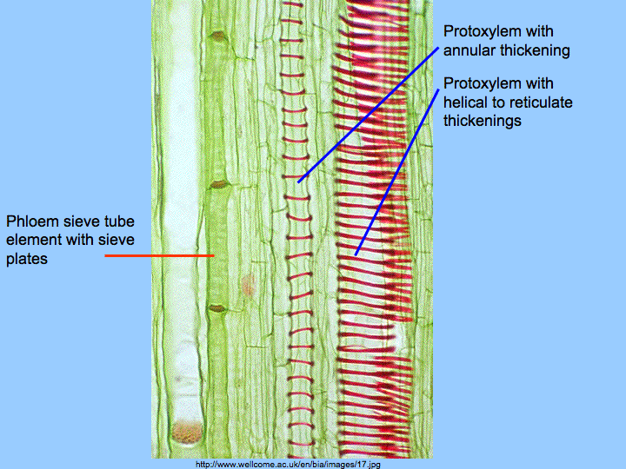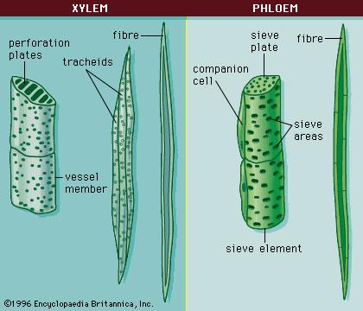

### Phloem

Phloem is a complex tissue comprising sieve tubes, companion cells, parenchyma, fibres and sclereids. The transporting elements are called the sieve elements. These are of two kinds, **sieve cells** (which occur in pteridophytes and gymnosperms) and **sieve tubes** which occur in angiosperms.

* 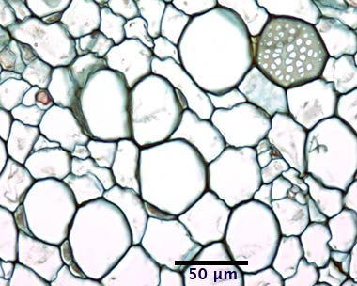**Sieve cells** are elongated cells with special sieve areas in lateral and occasionally terminal walls.
* **Sieve tubes** are longitudinal files of cells, each of which is called a **sieve tube member**. In these cells the sieve areas in the transverse walls are specialized and form a **sieve plate** (see Figure). This is a porous region of the wall through which the protoplasts of adjacent sieve tube members interconnect. Mature sieve elements have living contents (protoplasts) although they usually lack normal nucleus. They are usually closely associated with **companion cells** (see Figure). (These both originate by division of the same cell.) Companion cells are elongated cells with living contents including large nuclei and dense cytoplasm. From one to several companion cells are associated with each sieve element and it is thought that there is a close functional relationship between them, but the precise function of companion cells is controversial.

*Phloem. You can see a sieve plate, and several sieve tube members, accompanied by their small companion cells.*

The dye toluidine blue is very useful in differentiating between xylem and phloem. Vessels, tracheids, fibres and sometimes also the xylem parenchyma contain lignin in their walls, which will therefore stain bright blue or green. In contrast, the only cells in the phloem that are lignified are the fibres. Walls of sieve tubes, sieve cells and companion cells, which are not lignified usually stain a bright purple.

## 

### Practical exercise 1: Petiole of *Apium graveolens* (celery)

Cut a transverse section (T.S.) of a celery petiole, stain with toluidine blue and mount in 50% glycerol. Make sure the sections pass through vascular bundles.

Draw two labelled diagrams that show:

1. Parenchyma and collenchyma
2. A vascular bundle

Pull a “string” from the outside of the celery stalk. Is it stretchy? Why? What type of cell is this?

### Practical exercise 2: THE PRIMARY STEM: *Cucurbita* sp.

Examine xylem tissue in prepared slides of transverse (G11/1) sections of *Cucurbita* (cucumber) stem. Draw pictures showing the major structures and cell types. Make sure you find the phloem, the xylem, fibres, parenchyma, vascular bundles and the epidermis.

### 

## 

## Practical exercise 3: Secondary Thickening

Examine a prepared slide of a transverse section of a first year stem of *Cinnamomum camphora*.

There is already an active vascular cambium that has laid down a small amount of secondary xylem (although no secondary phloem is yet apparent). The cambium is thin-walled and tends to have been crushed during sectioning. Note the areas of more irregular primary xylem surrounding the pith.

Draw and label a low power diagram to indicate the distribution of tissues in the stem.

Note particularly the following primary tissues or regions:

* pith - what types of cells are present?
* pericyclic fibres - groups of thick-walled fibres outside the phloem - about how many cells separate adjacent fibre bundles?
* cortex - what type(s) of cells are present
* epidermis - closely fitting epidermal cells with domeshaped outer walls, carrying a well developed cuticle.

## 

## PRACTICAL ADVICE ON SECTIONING AND STAINING, USING A MICROSCOPE, AND BOTANICAL DRAWING

## Sectioning and Staining

Sectioning can be done by hand with a razor blade, or by using a mechanical cutting device (a microtome) that holds the material and advances it a section-thick distance after each slice of the knife.

### Sectioning By Hand

You will require:

1. a Petri dish or watch glass with a 0.5 cm depth of water;
2. a small paint-brush;
3. a *new* razor-blade (carefully protect its cutting edge all the time).

Hold the material with your left (or non-dextrous) hand so that the plane of cutting will be horizontal. The aim is to cut smoothly and fairly quickly producing dozens of sections from which a few are chosen: it is worth noting that it is often the incomplete sections with thin 'running-out' edges that provide the best study. The razor blade surface should be wet with one or two drops of water to prevent the newly-cut sections from drying out. When several sections mount up on the blade they are swept carefully off with the wet paint-brush into the water in the Petri dish.

**Do not let the material dry out at any stage.**

### Staining with Toluidine blue

**All stains should be treated as potential carcinogens and you should take care not to stain yourself. To protect skin and clothes from accidental staining please wipe up any spills immediately.**

Toluidine Blue is a very important dye that distinguishes lignified from unlignified walls. It is a positively charged dye which stains negative groups. Lignified walls stain blue and unlignified walls stain pink or purple. The pectin and hemicellulose fractions of the wall stain pink. Cellulose does not stain.

### Cell Chemical Group That Staining Structure Reacts With Colour

1. cytoplasm (phosphate groups in nucleic acids) purple
2. nucleus (phosphate groups in DNA) blue
3. cell walls (COOH groups in some unlignified carbohydrates e.g. pectin) pink
4. lignified walls (phenols) green to blue (turquoise blue)
5. some vacuoles (phenols) deep dark blue

### Staining and mounting specimens

1. Place the staining solution in a watch glass. Prepare a second watch glass about 2/3 full of distilled water ready for rinsing.
2. Transfer section from water to a drop of toluidine blue in a watch glass.
3. Leave until you can see differentiation of pink and blue tissue (seconds to minutes).
4. Transfer to distilled water in a second watch glass for a few seconds to wash out excess stain.
5. Transfer to a clean dry slide Sections can be mounted either in water or a drop of 50% glycerol. Cover with a clean cover-slip, lowered gently from one side to exclude air bubbles.

## Light Microscopy

**Operating procedure**

1. Place the microscope in a comfortable position on the bench.
2. Check that on/off switch (right hand side of base) is in the off position and the brightness control is at zero.
3. Plug in and switch on at the centre of the bench.
4. Turn on microscope lamp and increase brightness control until you can see some light coming through the condenser.
5. Make sure the 4x objective is in position.
6. Place specimen slide on stage and hold in position with stage clip. THE SPECIMEN SHOULD NEVER BE VIEWED WITHOUT A COVERSLIP.
7. Position specimen under 4x objective using mechanical stage controls.
8. Focus. Adjust brightness control if necessary.
9. Make interpupillary and diopter adjustments (see below).
10. Swing in desired objective. Re-focus.
11. Check that condenser height is optimum (should be raised above image of ground glass screen).
12. Close iris diaphragm to 2/3 (70%) of the exit pupil of objective (see below).
13. Fine focus and observe.

*How to correct interpupillary distance and diopter settings*

1. Hold the knurled dovetail slides of the right and left eyepiece tubes with both hands and put the tubes together, or pull them apart laterally, whichever is required, while looking through the eyepieces with both eyes, until perfect binocular vision is obtained.
2. Rotate the tube length adjustment ring on the right eyepiece tube to match your interpupillary distance setting, which is given on the scale above and left of the right hand eyepiece.
3. Look at the image through the right hand eyepiece with your right eye and focus on the specimen with the coarse and fine adjustment knobs.
4. Next, looking at the image through the left eyepiece with your left eye rotate the tube length of this eyepiece to focus on the specimen without altering the coarse and fine adjustment knobs.

### Automatic pre-focussing

This lever (inside ring of left hand focusing knob) locks the microscope at a particular coarse focus position to prevent further upward travel of the stage by means of the coarse adjustment knob. It prevents damage to objectives as a result of focusing the specimen slide up through the objective lens. It does not restrict fine focusing.

### Aperture iris diaphragm

The lever on the condenser controls the aperture iris diaphragm adjustment. The iris diaphragm should be adjusted to match the numerical aperture of the objective in use in order to get the best result. However, since the image usually lacks contrast a compromise is made and the diaphragm is stopped down to about 70% of the objective numerical aperture.

Remove the eyepieces: the circle of light represents the exit pupil of the objective. Adjust the diaphragm using the condenser lever until the iris impinges on the exit pupil by about 1/3. This should always be done when objectives are changed.

### Dos and don'ts

1. If lenses are dirty you may clean them, but only with either a blower brush or a fresh piece of lens tissue - NOT KLEENEX. (Xylene, alcohol or ether may be used in small amounts as a cleaning fluid.)
2. When carrying the microscope, keep it upright so that the eyepieces do not fall out. USE BOTH HANDS.
3. The tension on the coarse focus can be altered by rotating the innermost ring on the right-hand focus adjustment knob.
4. DO NOT TWIST THE TWO COARSE ADJUSTMENT KNOBS IN OPPOSITE DIRECTIONS SIMULTANEOUSLY AS THIS WILL CAUSE DAMAGE.
5. Do not spill water, oil or acid on the mechanical stage or any other part of the microscope. Oil or water between the slide and stage causes friction so that the slide will not move easily.

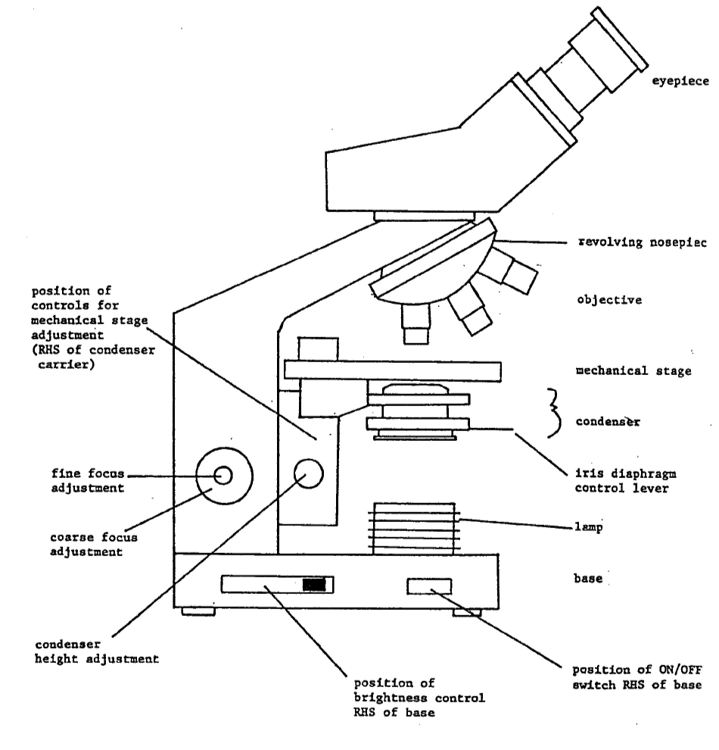

Diagram of a light microscope

## Botanical drawing

In this course we are not asking you to produce works of art (or imagination), but accurate representations of what you can see down the microscope. You are all capable of this - the principal requirements are practice and a sharp pencil (preferably HB).

There are two types of drawing, and *each should be accompanied by a scale:

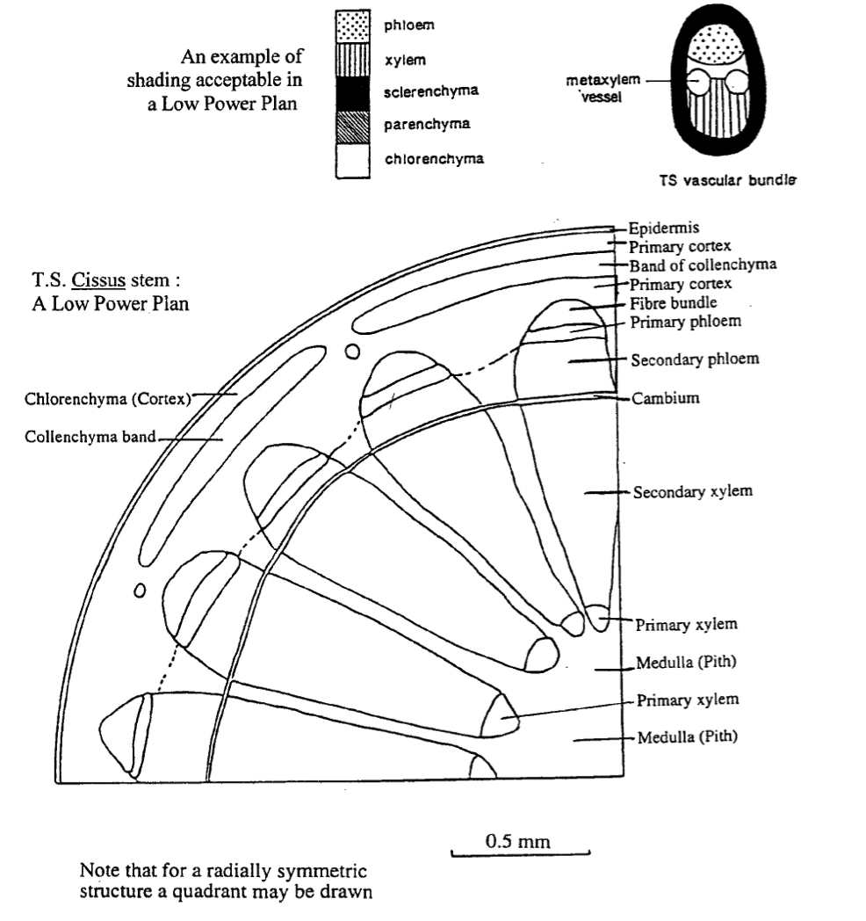

In a low power plan individual cells should not appear. The aim is to indicate boundaries between different tissues. Clearly you will need to introduce some simplification into such a diagram. For example, boundaries with many small scale convolutions may be portrayed as a straight line and diffuse boundaries by dotted lines.

### High Power Drawing

This should be an accurate drawing of a small number of cells. It should show details of cell outline and as much internal structure as is discernable. For example, if you are drawing a cell with chloroplasts, you should draw them in the correct position to the correct size, shape and number: they should not be drawn as a vague collection of squiggles around the edge of the cell. Cell walls, if accurately represented, will rarely have breaks in them.

Thick cell walls should be represented by a double line, and thin cell walls by a single line. You can use the distance between the two "double" lines to indicate wall thickness. Each cell should be enclosed by a completed line. See these points in the example below. Note how the thick walls of the epidermis, collenchyma and fibres are separated from intercellular space.

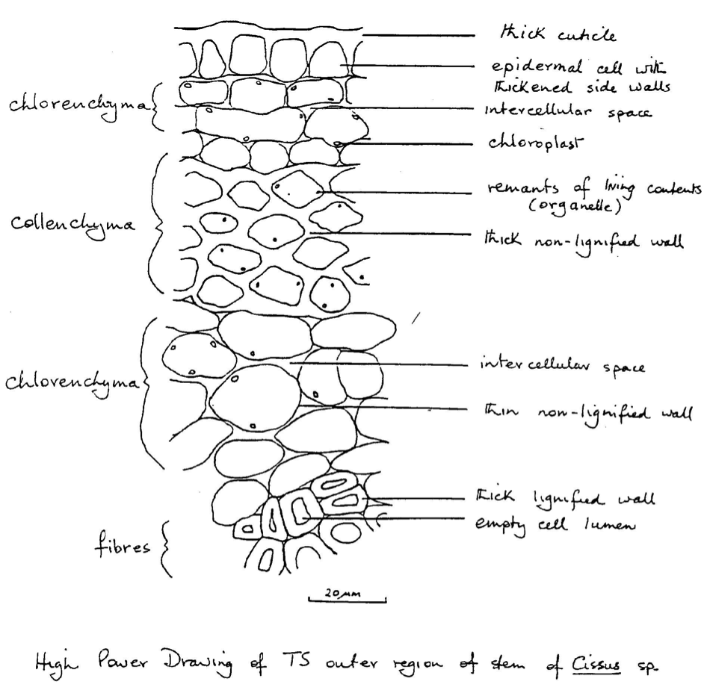

An example of a good high power drawing

### General points

1. Make drawings large.
2. All drawings should have a heading stating organ, species and plane of section.
3. All drawings should be in pencil. It is also highly desirable that labels should be in pencil so that corrections can be made easily and neatly.
4. Labels should appear to the side of a drawing and not be written across it. A *straight* line, and not an arrow, should connect the label to the area it refers to - the labels should be arranged in such a way that the lines do not cross. Labels should give detailed information about composition of structures where possible, based on staining reactions, eg. lignified wall.
5. It is usually not necessary to use cross-hatching or stippling to indicate particular tissue types in low power diagrams. If you must clarify your drawings by cross-hatching, make sure it is neat and does not cross the boundary line of the tissue. An example of the use of shading is given on page 12.
6. While drawing you should be constantly altering the plane of focus of the microscope in order to clarify details. You should also be prepared to change the objective: to a higher power to help the interpretation of fine detail; to a lower power to appreciate the relationship of what you are drawing to the structure of the whole organ.