# Week 5: Plant Cells

You should refer to the notes on Light Microscopy and the use of the Olympus CHA Microscope which you will find in the back of this manual.

Only a few types of cell are found in higher plants. These can be recognised on several basic features:

* shape
* wall thickness
* wall composition
* whether empty or full of cytoplasm
* presence or absence of specific organelles such as chloroplasts.

Once you are familiar with the diagnostic features of various cell types, you can recognise these in any unknown section and use the information to work out complex tissue arrangements in leaves, stems or roots.

The practical skills you should aim to perfect in this lab are:

1. recognition of the major cell types in supporting and ground tissue
2. section cutting by hand with a razor blade
3. drawing what you see

This practical deals *only* with the cell types found in supporting tissue. Cells modified for transport are dealt with later in the course.

## Parenchyma and Collenchyma

Celery is a leaf petiole. Strip off one of the celery "strings" - these are strands of collenchyma tissue. Do not confuse collenchyma with the vascular bundles. Note how elastic the strings are.

Cut several thin transverse sections of the petiole. Stain your thinnest sections with toluidine blue. You should stain them until the whole section becomes a deep purple with blue areas in the vascular bundles. The collenchyma walls now stain purple. Are these walls lignified? What colour do lignified walls stain?

**Make a high power drawing of three collenchyma cells showing the position of wall thickenings and middle lamella.**

Cut an L.S. and stain with toluidine blue and examine. Locate the ends of the cells. Make a sketch to illustrate the shape in 3-D of a collenchyma cell. How much longer are they than wide?

Compare the parenchyma cells in the ground tissue with the collenchyma with respect to the following:

1. overall cell diameter
2. diameter of cell lumen
3. colour of wall staining with toluidine blue
4. cell length
5. wall thickness
6. appearance of intercellular space

Make a high power drawing of **3 parenchyma** cells for comparison with the collenchyma to illustrate the differences.

## Aerenchyma and Chlorenchyma

These are two common types of specialised parenchyma.

Cut sections of the *Juncus* cladode. Rinse for 10 minutes, then stain with toluidine blue and examine

The pith of the cladode is filled with *aerenchyma* while the cortex is *chlorenchyma*.

* What is the characteristic of chlorenchyma?
* What are the diagnostic features of aerenchyma, with respect to wall thickness and staining, cell contents and cell shape?

Draw a few cells in an accurate, high power diagram and hand in for assessment.

Why should plants have aerenchyma?

***FEEDBACK***: **You will likely be assessed on biological drawing from microscope sections in the practical exam. Hand in your drawing of the *Juncus* cladode and we will provide feedback. A submission of this drawing will count towards your participation mark.**

## Sclerenchyma

### Sclereids

Taste the apple and pear and compare the texture of the two fruits. Cut thin sections through the pulp of each fruit. Rinse for 10 minutes, then stain with toluidine blue for 5 minutes, rinse again. Mount in glycerine and examine. You may have to squash the pear tissue. (When squashing a section on a slide, wrap the slide in a tissue and press gently but firmly with your thumb - taking care to avoid twisting - and not breaking the cover-slip.)

* Can you explain the difference in texture in cellular terms?

Draw a small (no more than 5) group of sclereids accurately.

Again determine wall thickness, chemical composition of the wall and whether the contents are living or not. Locate the pits by careful focusing using high power.

* Do both fruits have sclereids? What might be the possible functional significance of such cells in a fruit?
* Cut a section of the *Hakea* leaf provided. Where are the sclereids? What is their staining reaction with toluidine blue and what inference can you draw about wall composition? What do you need to do in order to confirm that these are indeed sclereids and not fibres?

### Fibres

Examine the leaves of *Lomandra longifolia* Notice how hard and stiff they are. Hard leaves contain large numbers of fibres and are often termed sclerophylls. Cut free hand sections across the leaf with a razor blade to determine the distribution of fibres. Stain with toluidine blue, rinse, mount in glycerine and examine.

The fibres occur in groups on either side of the vascular bundles to form leaf ridges. The lignin in their walls stains bright blue with toluidine blue. Determine wall thickness, composition, nature of contents etc. and draw if you have time.

Now cut sections at right angles to your previous ones, ie. paradermal, to obtain an LS through a fibre bundle and stain as above. What is the relationship between the length and width of these fibres? Which of those cell types you have studied today are the fibres most like and in what important ways do they differ from these?

## Plant Identification

We will examine the key traits and features of some of the **major Australian plant families** throughout this course. Details for these families are provided in the back of the lab manual (Plant Identification and Family Descriptions, and the Key to Australian Plant Families).

## Plant Cells: Supplementary Notes

Various different types of cells are found in the mature plant body. Each performs a specific function. In the practical classes you will be looking at a range of different plant tissues and you will be expected to be able to identify the major cell types. The notes given below should help to clarify the important features of each type.

### Parenchyma

In herbaceous plants 80% of the plant body is composed of parenchyma. The term parenchyma is used for tissues composed of *living* cells generally having *thin wholly primary walls* and a *polyhedral shape* (generally but not always isodiametric) (See Fiures). [A wall is said to be wholly primary if the thickening of the wall is completed before the cell has reached its full size, any thickening laid down after the cell has reached its full size is said to be secondary.] Parenchyma is the main representative of the ground tissue system: this forms a continuous tissue in all major plant organs, e.g., cortex of roots, pith and cortex of stems, ground tissue of petioles and mesophyll of leaves. Parenchyma cells also occur as components of complex tissue systems (such as xylem and phloem) either scattered singly or aggregated. Generally parenchyma is unlignified but lignified parenchyma can occur, particularly as a component of xylem. A number of types of parenchyma can be recognised including:

* **chlorenchyma**: parenchyma containing chloroplasts, found in leaves, outsides of stems and rarely in certain specialized roots;
* **storage parenchyma**: contains stored food reserves, most commonly starch grains but other reserves also occur such as sucrose, inulin etc.; may be found throughout the plant or concentrated in special storage organs such as tubers, rhizomes, storage roots etc.;
* **aerenchyma**: parenchyma in which the cells have extended processes so increasing the amount of intercellular air space in the tissue. Found in some leaves, e.g., *Ananas* (pineapple), *Canna*, some stems, e.g., *Juncus*, and the roots of many plants from waterlogged habitats.

### Collenchyma

Collenchyma is a living tissue composed of more or less elongated cells with thick, non-lignified primary walls (see Figures). It is the main supporting tissue in the leaves and stems of many dicotyledons, for example in the midrib and petiole of leaves and in strands in the outer cortex of stems (often forming ridges). Collenchyma is well adapted to function as support tissue in growing organs, as it combines high tensile strength with considerable plasticity. Unlike sclerenchyma it is extensible. The cell walls are made of cellulose, hemicellulose and pectin and normally stain a very bright pink with toluidine blue and are considered to be primary. *The wall material is deposited unevenly and is particularly thick at cell corners* - a good diagnostic feature in TS.

With age, the cells of collenchyma may, in some species become lignified and therefore the tissue changes into sclerenchyma.

### Sclerenchyma

Sclerenchyma refers to a tissue composed of cells with thick, rigid, secondary walls (usually but not always lignified) whose function is support and/or protection; frequently the cells lack protoplasts at maturity. Many different cell types are involved but two major groups are recognized: fibres and sclereids.

### Fibres

Fibres are long tapered interlocking cells, normally unbranched. Typically without protoplasts at maturity and with obscure simple pitting; frequently, but not always, lignified (unlignified fibres are most often associated with phloem). Fibres may occur singly or in groups and are often associated with vascular tissue (see Figures).

Fibres produced by plants have been used commercially for centuries. At present, plants from 44 different families are used as sources of fibre. Common commercial fibres may be divided into textile fibres including flax (*Linum usitatissimum*) jute (*Corchorus* spp.), hemp (*Cannabis sativa* - yes it does have a legitimate use!) and ramie (*Boehmeria nivea*), and cordage fibres, including sisal (*Agave sisalana*), bowstring hemp (*Sansevieria* spp.) and New Zealand flax (*Phormium tenax*). Extraction of most fibres is by a process called "retting". This decomposes the middle lamellae between cells so that they separate. The plant material is left in water while decomposition occurs, then dried and passed between rollers which separates the fibres from the outer tissue.

Bast is the name given to the fibres associated with phloem in various smooth barked trees, most notably the lime (*Tilia* spp.). This was formerly stripped from trees to make a coarse fabric.

### **Sclereids**

These vary greatly in shape. They differ from fibres in that they do not have a very elongated simple shape. Usually they have very thick secondary walls with obvious pits and are strongly lignified (see Figures). Often classified on the basis of shape, but according to Esau (1977), this is of limited use because the various forms intergrade. These cells, individually or in groups are widely distributed in the plant body, but are particularly common in leaves, fruits and seeds.

### Xylam vessels and tracheids

Xylem is a complex tissue, composed of conducting (or tracheary) elements, fibres and parenchyma.

Conducting elements are of two kinds, **tracheids** and **vessel members**. Both are elongated cells, thick walled and without living contents at maturity. The secondary wall is laid down in various patterns and usually becomes lignified.

* **Tracheids** originate from single cells, are normally elongated and pointed at both ends and are imperforate, i.e., pit closing membranes being present in the region of pits. Tracheids are present in all divisions of vascular plants (and were present in all fossil groups of vascular plant as well) and are the only tracheary elements in pteridophytes and gymnosperms.
* **Vessels** consist of chains of cells in a longitudinal file. They are present in the wood of nearly all angiosperms. In each file of cells the transverse end walls are perforated so that the lumens of adjacent cells are in continuity. Each 'cell' is known as a **vessel member**. Although vessel members are very short, vessels may be several centimetres long in some species. Xylem elements which differentiate during early phases of growth, usually have a thin primary wall with rings or helices of secondary wall thickening deposited on it. These 'annular' or 'helical' xylem elements (see figures) are extensible and often become very much stretched during the elongation of the organ in which they occur so that the thickenings become more widely spaced. Later formed elements have more extensive regions of secondary wall thickening and are not extensible. These are 'reticulate' or 'pitted' elements (see figures).
* *Phloem*: sieve tubes and companion cells. Phloem is a complex tissue comprising sieve tubes, companion cells, parenchyma, fibres and sclereids. The transporting elements are called the sieve elements. These are of two kinds, **sieve cells** (which occur in pteridophytes and gymnosperms) and **sieve tubes** which occur in angiosperms.
* **Sieve cells** are elongated cells with special sieve areas in lateral and occasionally terminal walls.
* **Sieve tubes** are longitudinal files of cells, each of which is called a **sieve tube member**. In these cells the sieve areas in the transverse walls are specialised and form a **sieve plate** (see Figure). This is a porous region of the wall through which the protoplasts of adjacent sieve tube members interconnect. Mature sieve elements have living contents (protoplasts) although they usually lack normal nucleus. They are usually closely associated with **companion cells** (see Figure). (These both originate by division of the same cell.) Companion cells are elongated cells with living contents including large nuclei and dense cytoplasm. From one to several companion cells are associated with each sieve element and it is thought that there is a close functional relationship between them, but the precise function of companion cells is controversial.

See Raven Ch 23 for more information on plant cells.

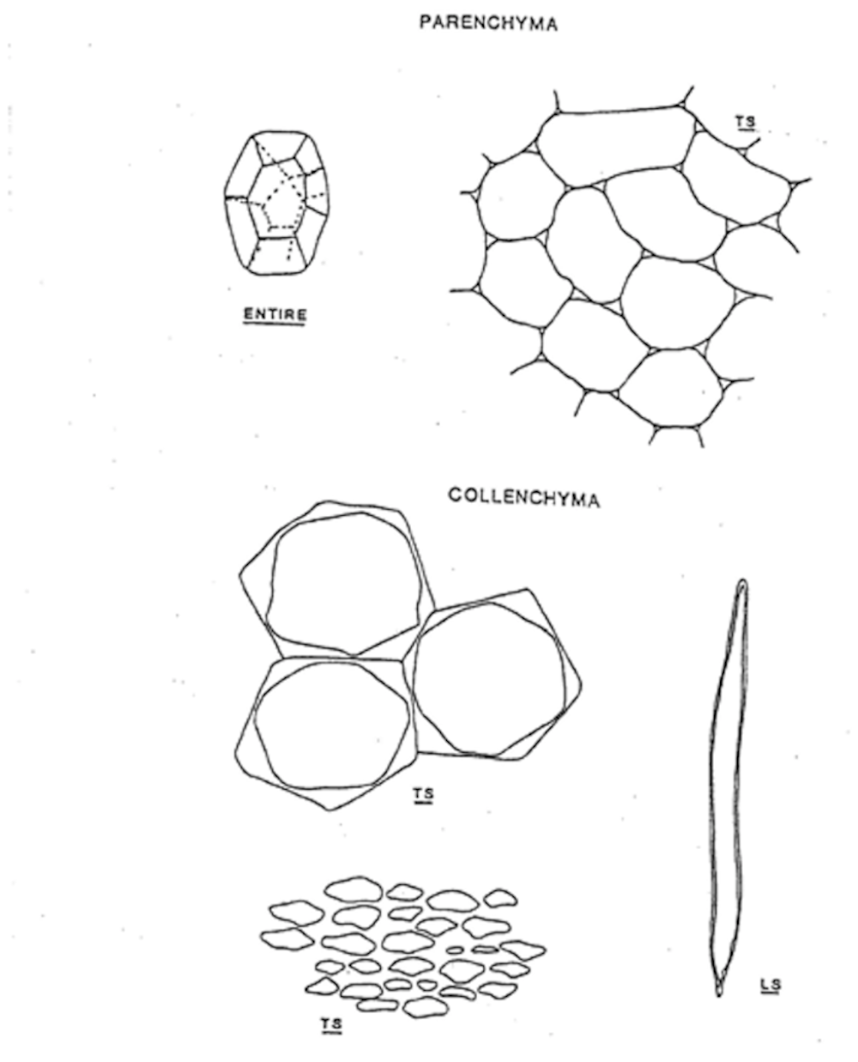

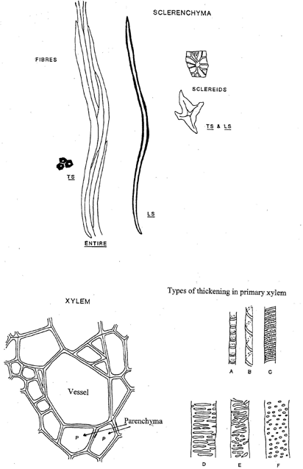

Sclerenchyma and Xylem

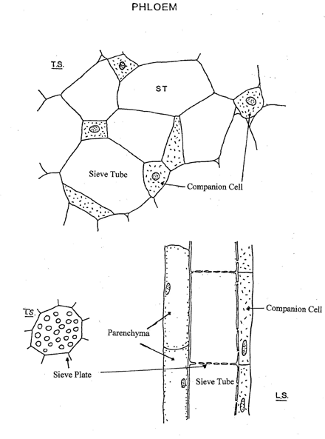

Phloem

# Week 7: Stem Structure and Secondary Thickening

## Vascular Tissue

References: Raven et al. (2013) ch 25-26

The cells involved in long distance transport invariably occur together in the same region of a stem or root. There are two systems: xylem, involved in water transport and phloem, in sugar (usually sucrose) transport. Collectively these are known as vascular tissue.

In stems, xylem and phloem occur together in vascular bundles, which are distributed either in a ring (dicotyledons) or scattered throughout (monocotyledons). In contrast in roots, they occur in the centre as a *stele*. The system is continuous throughout the plant and extends into the leaves as the major and minor veins.

The purpose of today's lab is to demonstrate the features of the types of cells that are found in xylem and phloem, so that these may be considered in relation to their role in transport.

### Vascular Cells And Tissue

*Xylem tissue comprise the following:*

1. vessels (transporting cells, only in angiosperms)
2. tracheids (transporting cells, all vascular plants)
3. parenchyma
4. fibres

*Phloem contains:*

1. sieve tubes (transporting cells)
2. sieve cells (transporting cells)
3. companion cells
4. parenchyma
5. fibres

The dye toluidine blue is very useful in differentiating between xylem and phloem. Vessels, tracheids, fibres and sometimes also the xylem parenchyma contain lignin in their walls, which will therefore stain bright blue or green. In contrast, the only cells in the phloem that are lignified are the fibres. Walls of sieve tubes, sieve cells and companion cells, which are not lignified usually stain a bright purple.

Apart from this, there are also important structural differences that distinguish the transporting cells in these two tissue types and the purpose of this lab is to investigate these.

## Xylem: tracheids and vessel elements

The transporting cells of the xylem are modified into either vessel elements or tracheids. In addition, xylem contains fibres and xylem parenchyma (which may or may not be lignified). The basic distinction between tracheids and vessel elements is that the tracheid is an imperforate cell while the end walls of vessel elements are perforated.

### Vessel elements

**Petiole of *Apium graveolens***

Cut both longitudinal and transverse sections (T.S.) of celery petiole, stain with toluidine blue and mount in 50% glycerol. Make sure the sections pass through vascular bundles.

Using the longitudinal sections (L.S.) examine and draw the different kinds of xylem vessels you see, paying particular attention to the pattern of lignin deposition and the structure of the end walls.

List features of xylem vessels as seen in T.S. (i.e. size, thickness of wall etc.).

How do vessels differ from

1. fibres?
2. collenchyma?
3. tracheids? when seen in T.S.

### L.S. and T.S. of stem of *Cucurbita* sp.

Examine xylem tissue in prepared slides of R.L.S. (G11/2) and T.S. (G11/1) sections of *Cucurbita* stem.

Determine the kinds of wall thickening present in xylem vessels. Draw perforated end walls (the slides are variable in quality).

Fresh material is also available for hand cut sections.

### Tracheids

Tracheids are the only xylem element found in conifer woods. These are elongated, tapered, thick-walled cells.

Examine the prepared slide of R.L.S. *Pinus* stem.

If you focus carefully along individual tracheids you will find that many of them

have tapered ends which overlap with the ends of adjacent tracheids. The pits in these tracheids are highly specialised and called bordered pits. Examine micrographs of these in the demonstration. What might be their purpose?

### **PHLOEM**: sieve tubes and companion cells

*Phloem tissue in* Cucurbita* sp.*

Vascular tissue in *Cucurbita* spp. is ideal for studying phloem because the sieve tubes are very large and the sieve plates are obvious.

Cut T.S. and L.S. of *Cucurbita* stem by hand, stain with toluidine blue. Find sieve tubes and companion cells.

*Phloem tissue* : Examine the demonstration photomicrographs of the development of sieve tubes and companion cells on the side bench.

## Secondary Thickening

The primary growth of the stem is laid down by the **procambium**. In dicots the vascular tissue is arranged in a cylinder near the periphery of the stem, with the primary xylem inside the primary phloem. Secondary growth results from activity of the **vascular cambium,** a lateral meristem that is derived from the procambial layer between the primary xylem and phloem. This layer is meristematic, i.e. it retains the capacity to divide. Derivatives of the vascular cambium give rise to **secondary xylem** internally and **secondary phloem** externally. Both these secondary tissues include **rays** that facilitate radial transport and which are also formed by divisions of the vascular cambium.

### Secondary growth in herbaceous plants

Many herbaceous plants have a limited amount of secondary growth in the older and slightly woody parts of the plant. A study of *Coleus* will help you to revise primary stem structure in the dicot, and illustrate the early stages of vascular cambial activity.

Cut thin transverse sections through an internode in *Coleus* from about the middle of plant. Stain with toluidine blue and mount in glycerine. Note the following features in the section:

1. Epidermis and cortex (indicate types of cells present).
   * The wider parts of the vascular cylinder which contain the original primary vascular bundles, (primary phloem and primary xylem).
   * A continuous ring of vascular cambium (small block-shaped thin-walled cells) that can be divided into those parts formed from procambium within the primary vascular bundles (the **fascicular cambium**) and those parts extending between the bundles and which were formed by de-differentiation of parenchyma (**interfascicular cambium**).
2. Is any periderm is forming in the cortex?

* The location of protoxylem with respect to the metaxylem. Is the development of the primary xylem **endarch** or **exarch** in this stem?
* Examine the fascicular cambium (within a bundle). In *Coleus* and most herbaceous dicots the fascicular cambium gives rise to some secondary xylem and secondary phloem, even when externally there is no obvious thickening of the stem. Distinguish the boundary between the primary and secondary xylem. Note the scattered large empty vessel elements in the secondary xylem. What other cell types are present?
* Now examine the interfascicular cambium (between the bundles). In many species this produces similar secondary xylem. In *Coleus*, however, the interfascicular cambium produces a regular tissue devoid of vessels. Are the walls of these cells lignified? Do the cells contain a protoplast? What sort of cell do you think is forming the interfascicular regions of the secondary xylem? What do you think this region of the secondary xylem contributes to the stem in a functional sense?

Draw a high power drawing of 2-3 cells from the interfascicular region of the vascular cambium, together with 2 cells on either side of each cambial initial (ie., a strip 2-3 cells wide and 5 cells deep)

### Secondary growth in woody plants

Activity of the cambium enables long life, by renewal of vascular tissue, as well as increase in size of the plant, by strengthening the stem. Secondary growth, both of vascular tissue and of periderm (cork), may be relatively continuous or seasonal.

*Morphology*

Examine the leaf-bearing branch of the Camphor Laurel (*Cinnamomum camphora* ) and note the obvious increase in thickness of stem with age. Note that this species develops winter-buds protected by bud scales (modified leaves that never expand or become photosynthetic). The buds expand to form a new section of stem bearing photosynthetic leaves each spring, the bud scales falling away to leave a cluster of scars. Hence the past positions of the winter buds can be determined by looking for these clusters of scars, and the length of stem between the groups of scars corresponds to one years growth. It is therefore possible to date any part of the stem by counting the number of winter-bud positions between that point and the apical bud.

Note that there is still no sign of bark development even on the thicker part of this branch. The outer surface is still the smooth epidermis with green cortex beneath.

By what factor has the diameter of the stem increased over the initial primary (first year) stem at its thickest point? By what factor must the epidermis have expanded?

What processes must have accommodated this increase?

## Activity of the Vascular Cambium

*Young stem of a woody plant*

You are provided with a transverse section of a first year stem of *Cinnamomum camphora*. There is already an active vascular cambium that has laid down a small amount of secondary xylem (although no secondary phloem is yet apparent). The cambium is thin-walled and tends to have been crushed during sectioning. Note the areas of more irregular primary xylem surrounding the pith. What are the obvious differences between this stem and the herbaceous stem of *Coleus* (above) and *Helianthus* (recall your first year work on Sunflower)?

Draw and label a low power diagram to indicate the distribution of tissues in the stem.

Note particularly the following primary tissues or regions:

* pith - what types of cells are present?
* pericyclic fibres - groups of thick-walled fibres outside the phloem - about how many cells separate adjacent fibre bundles?
* cortex - what type(s) of cells are present
* epidermis - closely fitting epidermal cells with domeshaped outer walls, carrying a well developed cuticle.