# Practical Skills

Practical work is an important component of this course. Apart from illustrating lecture material, it should teach you:

(a) how to handle and prepare plant material for study;

(b) how to make observations, both qualitatively and quantitatively;

(c) how to record those observations so that they are meaningful to others; observations must be clearly recorded so that they can be communicated to those who have not themselves examined the material.

## Sectioning and Staining

*GENERAL*

Plant structure is studied most often by cutting thin sections of the plant and examining them stained or unstained with the light microscope. The plant material to be sectioned may be living or 'fixed', which means that the material has been treated with a carefully chosen chemical that gels cell proteins and preserves intracellular structure with as little distortion as possible of the living state.

Sectioning can be done by hand with a razor blade, or by using a mechanical cutting device (a microtome) that holds the material and advances it a section-thick distance after each slice of the knife. Usually for microtome sectioning material is first impregnated with wax or plastic which is then solidified around and within the tissue to strengthen it during cutting. On hardening, a 'block' is formed with the specimen 'embedded' within a matrix of supporting material. Both tissue and embedding matrix are sectioned together and the extra support allows thinner sections to be cut, resulting in better resolution of tissue structure.

### Sectioning By Hand

You will require:

1. a Petri dish or watch glass with a 0.5 cm depth of water;
2. a small paint-brush;
3. a *new* razor-blade (carefully protect its cutting edge all the time).

Hold the material with your left (or non-dextrous) hand so that the plane of cutting will be horizontal. The aim is to cut smoothly and fairly quickly producing dozens of sections from which a few are chosen: it is worth noting that it is often the incomplete sections with thin 'running-out' edges that provide the best study. The razor blade surface should be wet with one or two drops of water to prevent the newly-cut sections from drying out. When several sections mount up on the blade they are swept carefully off with the wet paint-brush into the water in the Petri dish.

**Do not let the material dry out at any stage.**

### Staining Schedules

Place the staining solution in a watch glass. Prepare a second watch glass about 2/3 full of distilled water ready for rinsing. After staining the specimen for the appropriate time transfer it to the rinse solution. Note that staining times are usually critical, but sections can often be held in rinse water for several hours without damage.

**All stains should be treated as potential carcinogens and you should take care not to stain yourself. To protect skin and clothes from accidental staining please wipe up any spills immediately.**

Schedules for the stains you will use are outlined below.

### Mounting Sections

Always place a cover-slip over the section before examining it under the microscope. Sections can be mounted either in water or 50% glycerol. The advantage of glycerol is that it evaporates less quickly. However, if the preparation is drying out an additional drop of mounting solution can be added easily without removing the cover-slip, by carefully touching the drop (on a needle, pencil or pipette) against the edge of the cover-slip and allowing the liquid to flow under the cover-slip.

(Plastic-embedded sections are often mounted in oil or other non-aqueous media, rather than water: this gives improved resolution.)

### Staining Schedules

* *Toluidine Blue* (MULTIPLE STAIN)

Toluidine Blue is a very important dye that distinguishes lignified from unlignified walls. It is a positively charged dye which stains negative groups. Lignified walls stain blue and unlignified walls stain pink or purple. The pectin and hemicellulose fractions of the wall stain pink. Cellulose does not stain.

More detailed staining reactions are given below:

### Cell Chemical Group That Staining Structure Reacts With Colour

1. cytoplasm (phosphate groups in nucleic acids) purple
2. nucleus (phosphate groups in DNA) blue
3. cell walls (COOH groups in some unlignified carbohydrates e.g. pectin) pink
4. lignified walls (phenols) green to blue (turquoise blue)
5. some vacuoles (phenols) deep dark blue

### Staining Schedule

1. Wash section in distilled water (5 min.).
2. Transfer to a drop of toluidine blue in a watch glass.
3. Leave until you can see differentiation of pink and blue tissue (seconds to minutes).
4. Transfer to distilled water in a second watch glass for a few seconds to wash out excess stain. Check stain. If OK, then
5. Transfer to a clean dry slide in a drop of glycerol. Cover with a clean cover-slip, lowered gently from one side to exclude air bubbles.

### Safranin and Fast Green

Many prepared slides are stained with these two dyes. Safranin (red) is preferentially retained in lignified, suberized, or cutinised walls, as well as in regions rich in DNA or RNA (ie. nuclei), whereas Fast green stains protein (and, particularly, primary walls). Both stains are also fast (ie. permanent) on clothing and to a lesser extent on fingers, so should be used with care, and any spills mopped up with paper towel.

### Iodine in KI (STARCH)

* Iodine stains starch grains bright purple to blue-black.
* Wash briefly in distilled water.
* Transfer section to a drop of iodine on a slide.
* Leave for 2-5 minutes.
* Blot off the stain and add a drop of glycerine.
* Cover with a cover-slip, lowered gently from one side to exclude all air bubbles.

**Note:** Although Iodine is widely used as a disinfectant, some people are highly allergic to it. Treat all stains with care and do not allow them to come in contact with your skin.

## Light Microscopy

### Olympus Microscope

**Operating procedure**

1. Place the microscope in a comfortable position on the bench.
2. Check that on/off switch (right hand side of base) is in the off position and the brightness control is at zero.
3. Plug in and switch on at the centre of the bench.
4. Turn on microscope lamp and increase brightness control until you can see some light coming through the condenser.
5. Make sure the 4x objective is in position.
6. Place specimen slide on stage and hold in position with stage clip. THE SPECIMEN SHOULD NEVER BE VIEWED WITHOUT A COVERSLIP.
7. Position specimen under 4x objective using mechanical stage controls.
8. Focus. Adjust brightness control if necessary.
9. Make interpupillary and diopter adjustments (see below).
10. Swing in desired objective. Re-focus.
11. Check that condenser height is optimum (should be raised above image of ground glass screen).
12. Close iris diaphragm to 2/3 (70%) of the exit pupil of objective (see below).
13. Fine focus and observe.

**Correct setting up of the microscope *will be examined* in the practical examination.**

*How to correct interpupillary distance and diopter settings*

1. Hold the knurled dovetail slides of the right and left eyepiece tubes with both hands and put the tubes together, or pull them apart laterally, whichever is required, while looking through the eyepieces with both eyes, until perfect binocular vision is obtained.
2. Rotate the tube length adjustment ring on the right eyepiece tube to match your interpupillary distance setting, which is given on the scale above and left of the right hand eyepiece.
3. Look at the image through the right hand eyepiece with your right eye and focus on the specimen with the coarse and fine adjustment knobs.
4. Next, looking at the image through the left eyepiece with your left eye rotate the tube length of this eyepiece to focus on the specimen without altering the coarse and fine adjustment knobs.

### Automatic pre-focussing

This lever (inside ring of left hand focusing knob) locks the microscope at a particular coarse focus position to prevent further upward travel of the stage by means of the coarse adjustment knob. It prevents damage to objectives as a result of focusing the specimen slide up through the objective lens. It does not restrict fine focusing.

### Aperture iris diaphragm

The lever on the condenser controls the aperture iris diaphragm adjustment. The iris diaphragm should be adjusted to match the numerical aperture of the objective in use in order to get the best result. However, since the image usually lacks contrast a compromise is made and the diaphragm is stopped down to about 70% of the objective numerical aperture.

Remove the eyepieces: the circle of light represents the exit pupil of the objective. Adjust the diaphragm using the condenser lever until the iris impinges on the exit pupil by about 1/3. This should always be done when objectives are changed.

### Dos and don'ts

1. If lenses are dirty you may clean them, but only with either a blower brush or a fresh piece of lens tissue - NOT KLEENEX. (Xylene, alcohol or ether may be used in small amounts as a cleaning fluid.)
2. When carrying the microscope, keep it upright so that the eyepieces do not fall out. USE BOTH HANDS.
3. The tension on the coarse focus can be altered by rotating the innermost ring on the right-hand focus adjustment knob.
4. DO NOT TWIST THE TWO COARSE ADJUSTMENT KNOBS IN OPPOSITE DIRECTIONS SIMULTANEOUSLY AS THIS WILL CAUSE DAMAGE.
5. Do not spill water, oil or acid on the mechanical stage or any other part of the microscope. Oil or water between the slide and stage causes friction so that the slide will not move easily.

### Calibration of the microscope and making measurements

*Simple calibration calculations are usually on the board at the front of the lab.*

All microscopes are equipped with a micrometer eyepiece. This contains a glass graticule with a scale engraved at the centre. It has been inserted into the eyepiece and should be visible when you look through the microscope.

The value of the micrometer eyepiece changes as the magnification changes and it should be calibrated for each objective with a stage micrometer. The stage micrometer scale is usually 1.0 mm long, subdivided into 100 X .01 mm (10 m) divisions. To calibrate the eyepiece micrometer you need to determine the number of divisions on the stage micrometer that corresponds to a chosen number of divisions of the eyepiece micrometer.

The relationship is: $M=\frac{S×V}{E}$

M is the value (in mm or m) of *each* eyepiece micrometer unit to be determined.

V is the value of each stage micrometer unit (usually 0.01 mm).

S & E are the numbers of units on the stage and eyepiece micrometers, respectively, that correspond.

Once the value of M has been determined for a particular magnification, the eyepiece micrometer may then be used in the same way as a ruler.

The measurement is actually made by carefully lining up the two scales and counting the number of divisions in each that corresponds. The calibration should be done for each objective and the value recorded for future reference.

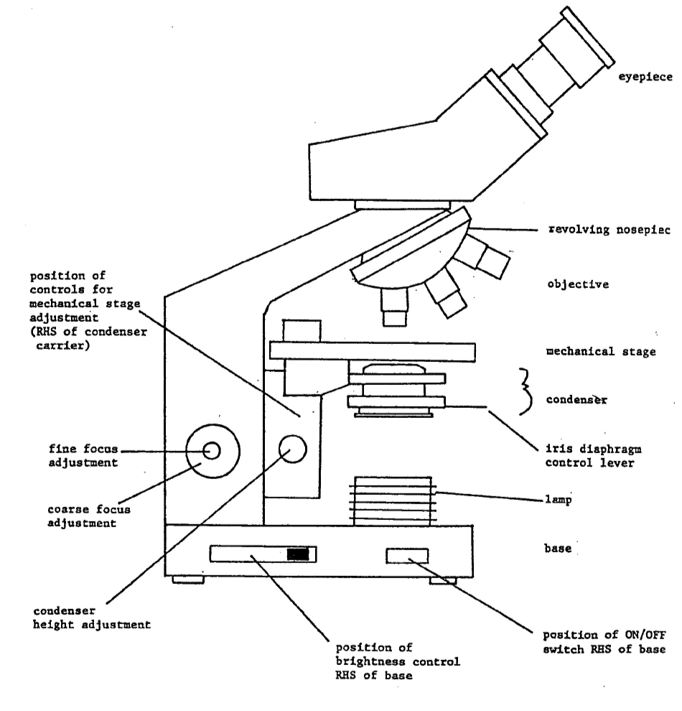

Diagram of a light microscope

## Botanical drawing

In this course we are not asking you to produce works of art (or imagination), but accurate representations of what you can see down the microscope. You are all capable of this - the principal requirements are practice and a sharp pencil (preferably HB).

There are two types of drawing, and *each should be accompanied by a scale:

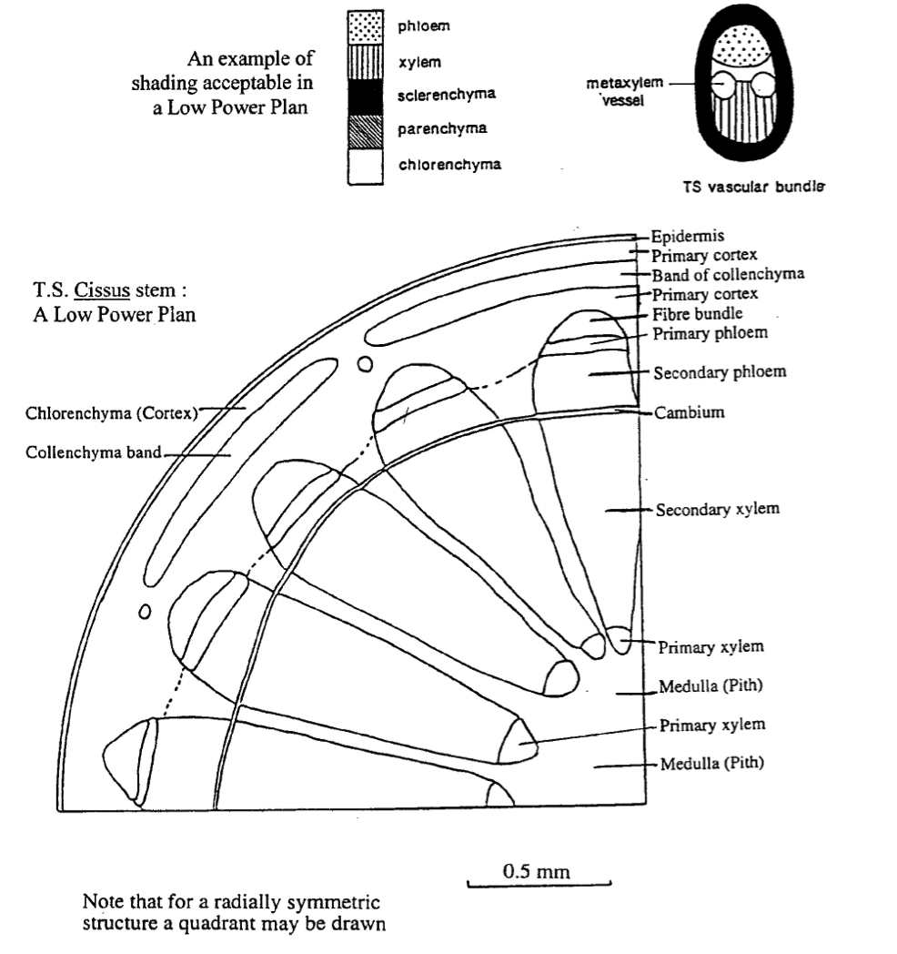

In a low power plan individual cells should not appear. The aim is to indicate boundaries between different tissues. Clearly you will need to introduce some simplification into such a diagram. For example, boundaries with many small scale convolutions may be portrayed as a straight line and diffuse boundaries by dotted lines.

### High Power Drawing

This should be an accurate drawing of a small number of cells. It should show details of cell outline and as much internal structure as is discernable. For example, if you are drawing a cell with chloroplasts, you should draw them in the correct position to the correct size, shape and number: they should not be drawn as a vague collection of squiggles around the edge of the cell. Cell walls, if accurately represented, will rarely have breaks in them.

Thick cell walls should be represented by a double line, and thin cell walls by a single line. You can use the distance between the two "double" lines to indicate wall thickness. Each cell should be enclosed by a completed line. See these points in the example below. Note how the thick walls of the epidermis, collenchyma and fibres are separated from intercellular space.

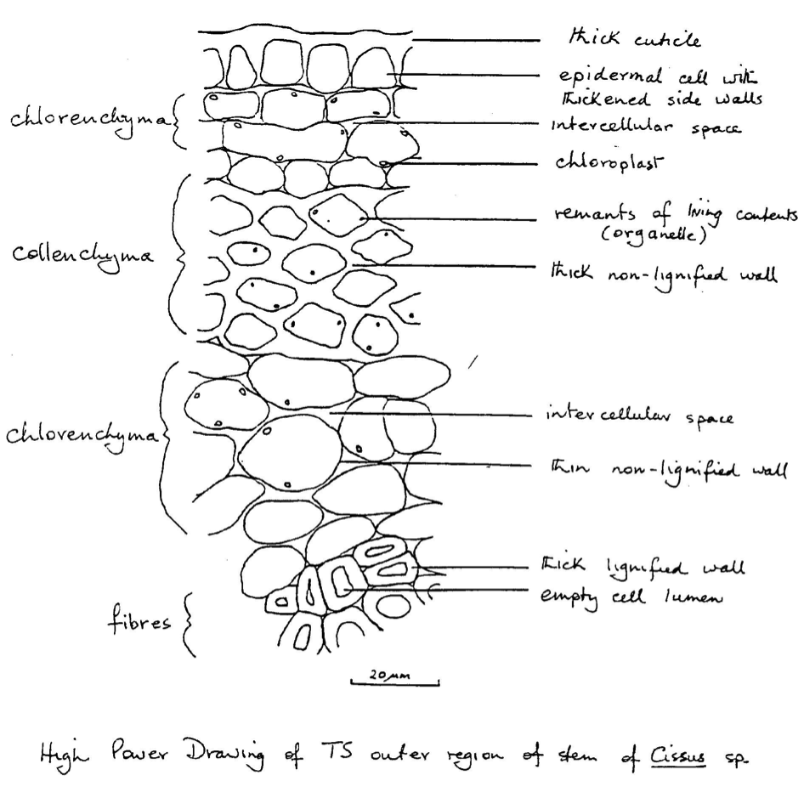

An example of a good high power drawing

## Constructing a scale

A scale must be of a rounded-off length (eg. 10 m, 50 m, 100 m, or 0.5mm or 1mm) that readily allows the viewer to calculate the real size of the whole structure and its parts.

### STEPS:

1. Measure (on the section) an *easily recognisable part* of the drawing using the ocular micrometer eg. the radial diameter of a vascular bundle = 54 units on the X4 objective
2. Calculate the actual size: (ie. multiply occular units by the length each represents on the objective used) eg. 54 x 25 =1350 m (or 1.35mm)
3. Measure the size of *the same part* on the drawing (ie. the diameter of the same bundle) eg. 76mm
4. Since 76mm on the drawing represents 1350m on the section, what distance on the drawing equals 1mm (1000m) on the section?

1 m = *76* therefore 1000m = *76* x1000 = 55.9mm

1350 1350

1. Draw a scale line 56mm long below the drawing and label it 1mm (ie.1000m).

### General points

1. Make drawings large.
2. All drawings should have a heading stating organ, species and plane of section.
3. All drawings should be in pencil. It is also highly desirable that labels should be in pencil so that corrections can be made easily and neatly.
4. Labels should appear to the side of a drawing and not be written across it. A *straight* line, and not an arrow, should connect the label to the area it refers to - the labels should be arranged in such a way that the lines do not cross. Labels should give detailed information about composition of structures where possible, based on staining reactions, eg. lignified wall.
5. It is usually not necessary to use cross-hatching or stippling to indicate particular tissue types in low power diagrams. If you must clarify your drawings by cross-hatching, make sure it is neat and does not cross the boundary line of the tissue. An example of the use of shading is given on page 12.
6. The scale of all drawings should be indicated (see instructions for constructing a scale above).
7. In labelling a drawing a certain amount of interpretation is necessary. Under some circumstances, interpretation of certain features of transverse sections may require confirmation from longitudinal sections.
8. While drawing you should be constantly altering the plane of focus of the microscope in order to clarify details. You should also be prepared to change the objective: to a higher power to help the interpretation of fine detail; to a lower power to appreciate the relationship of what you are drawing to the structure of the whole organ.
9. In this course we hope to improve your skills of observation and interpretation. In some exercises it will be left to you (with advice from your demonstrator) to decide what sections to cut, what stains to use and how to present the evidence. Drawings alone may be inadequate to record some observations; supplement by notes or tables when appropriate. It is not desirable to include too many notes in the labels.