Assignment
Course Code: | DA1A (hDAEthc)
Course Name: | Ethics and Communication for Data Science and AI
Assignment: | Assignment 1
Textbook: | N/A
Software: | VS Code, Git, Hugo, GitHub, GitHub Desktop
Materials and Resources
Assignment Description
During this week, you learned how to create and host a professional portfolio. This assignment provides for the formal grading of that deliverable.
Assignment Steps
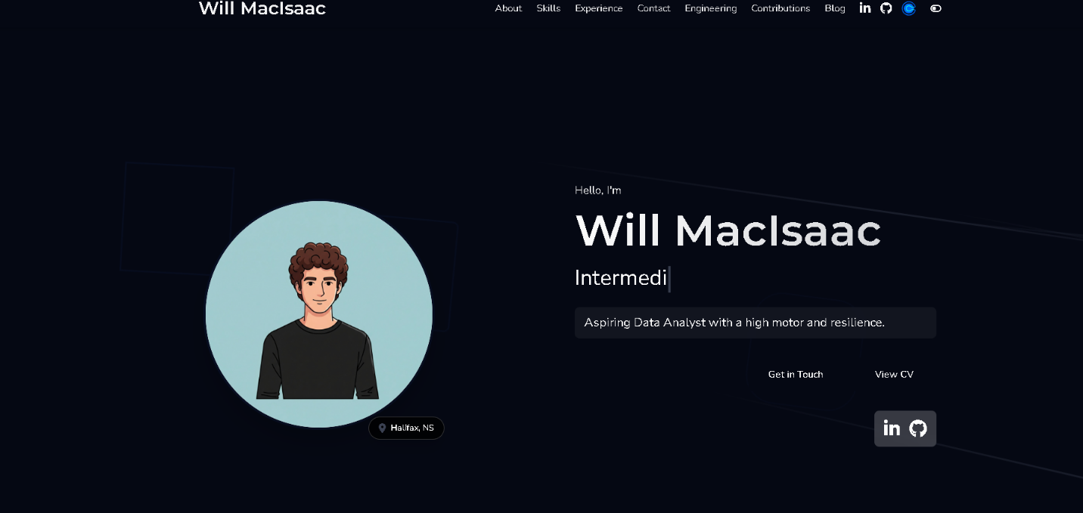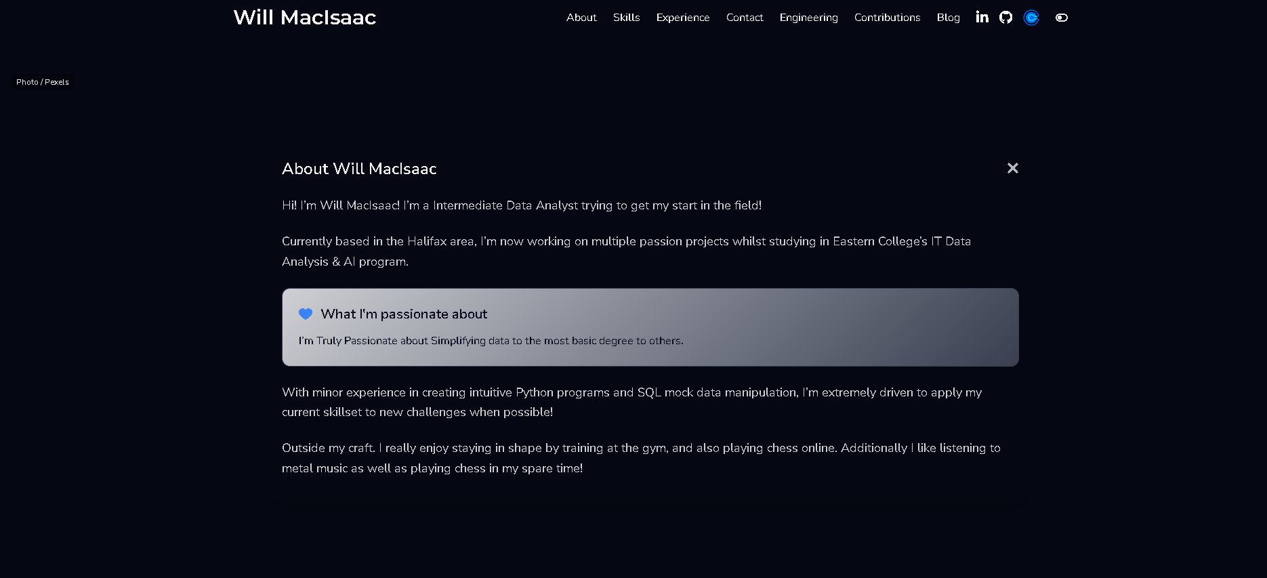
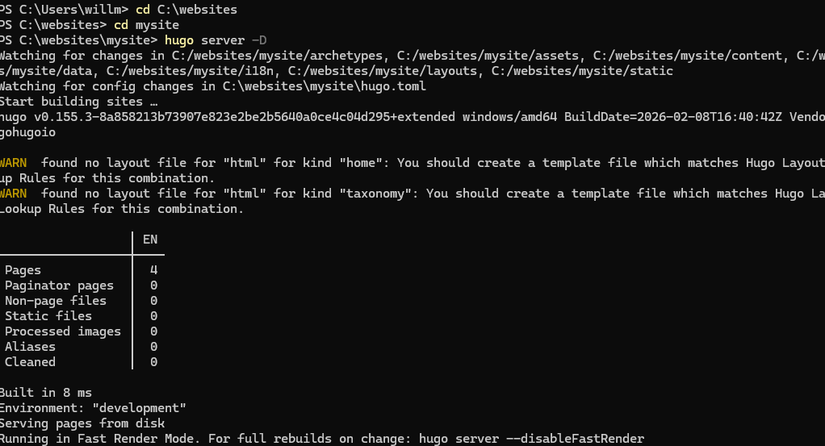
Activity Steps
- Install Hugo and Git on your Windows PC.
- Create a new Hugo website in a folder of your choice (e.g., C:\websites\mysite).
- Download and apply a Hugo theme of your choice to your Hugo website (e.g., the Hugo-Profile theme we used in class).
- Customize your Hugo website to create a professional portfolio and blog:
  - Remove or disable unnecessary elements.
  - Update all portfolio-related information (e.g., your personal details, professional information, tagline, etc.).
  - Replace default pics with ones unique to your portfolio.
  - Ensure you display at least three (3) links to other resources and online sites for which you maintain a presence (e.g., LinkedIn, X/Twitter, Facebook, Resume PDF, etc.).
  - Ensure that you have at least one (1) blog post that you provided content for.
  - Use colour, icons, pics, and CTA buttons/links appropriately.
- Review your portfolio and blog content for visual flow, as well as spelling and grammatical errors. If possible, elicit feedback and suggestions from others that you can incorporate.
- Create a GitHub.com account and host your website using GitHub Pages. Next, record the following information in the area provided:
https://github.com/wcoyi
https://github.com/wcoyi/wcoyi.github.io/tree/main :

- Compress your Hugo website folder (e.g., C:\websites\mysite) to a zip file (e.g., right-click the mysite folder > Compress to > ZIP File). Rename this file to YourName-Assignment1.zip
- Rename this assignment Word document file to YourName-Assignment1.docx.
- Access Brightspace and upload both YourName-Assignment1.zip and YourName-Assignment1.docx to the Assignment 1 section for this course.

Rubric
Criteria | Level 3  Exemplary | Level 2  Proficient | Level 1  Unsatisfactory
Completeness  Requirements: personal details; professional information; three (3) resource links, blog post | 15 Marks | 7-14 Marks | 0-6 Marks
 | Website contains all requirements in sufficient detail | Website is missing 1-2 requirements, or some are not provided in sufficient detail | Website is missing 3 or more requirements, or most requirements do not provide sufficient detail
Originality and Relevance | 5 Marks | 3-4 Marks | 0-2 Marks
 | Website content is original and relevant to its purpose as a portfolio and blog | Website content is somewhat original and relevant to its purpose | Website content is not original, or not relevant to its purpose
Spelling and Grammar | 5 Marks | 3-4 Marks | 0-2 Marks
 | There are no spelling or grammatical errors | There are 1-3 spelling or grammatical errors | There are 4 or more spelling or grammatical errors
Style and Clarity  Requirements: visually appealing; demonstrates effective use of colour, icons, pics, and CTA buttons/links | 5 Marks | 3-4 Marks | 0-2 Marks
 | Website demonstrates all requirements | Website does not demonstrate the effective use of 1-2 requirements | Website does not demonstrate a combination of most requirements
Total: / 30

