System Design
Components: instrument library + datalake service (+ testbed example)

❗ Why A New / Unified Design Is Needed
Production and evaluation historically ran as separate, loosely coupled workflows. Even when the same telemetry format could be emitted for live (online) and exported (offline) data, those artifacts still flowed through two distinct pipelines (prod usage vs. evaluation scripts) with fixed, code-embedded metrics. The unified design merges these paths by introducing a normalized execution record (LogUnit) and configuration-driven evaluation (MetricConfig), ensuring the same artifacts power both production capture and offline/online scoring without divergent loaders or hard-coded metric logic.

Side-by-Side Prior vs Unified Design

Prior: Separate Workflows | Unified: LogUnit + Config-Based Evaluation
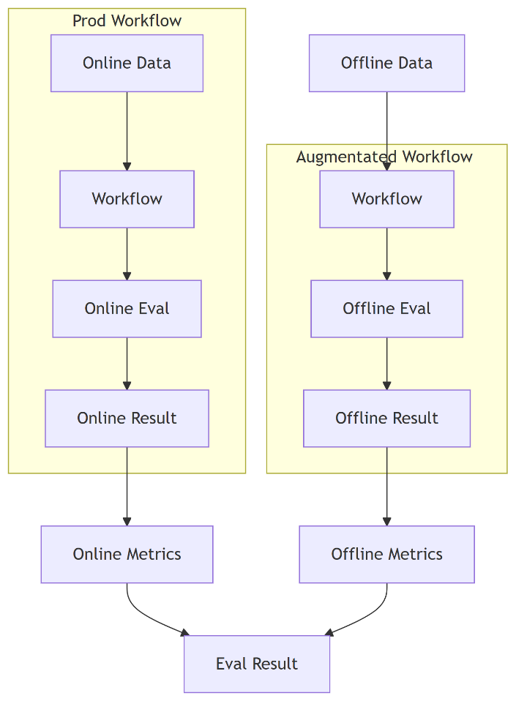 | 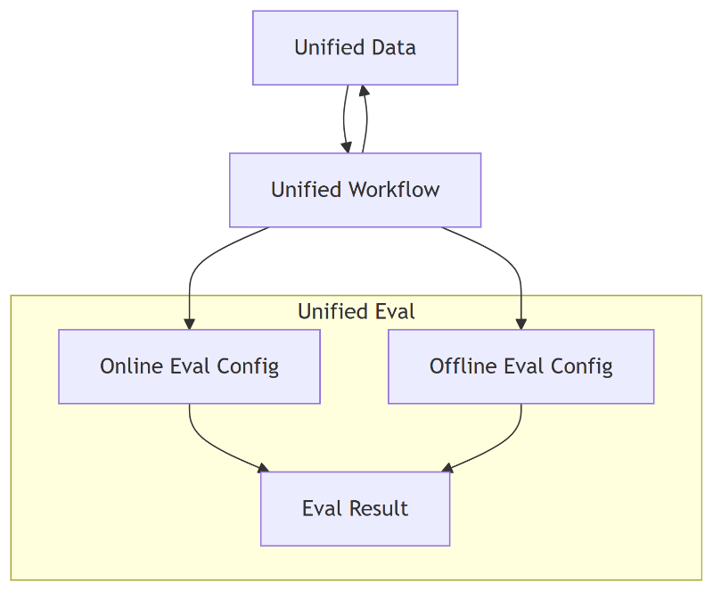
Key Traits (Prior)  Hard-coded metric logic inside evaluation scripts.  Two distinct loaders / execution paths (live vs offline export).  Ad hoc record shapes; no normalized LogUnit contract.  No autogen; metric evolution required code edits & redeploy.  Replay relied on synthetic mocks or re-execution.  High divergence risk: data shape & metric logic drift.  Maintenance overhead: duplicate parsing & environment-specific glue.  Slower iteration: export cycle gating metric changes. | Key Traits (Unified)  Canonical LogUnit schema standardizes all execution footprints.  Declarative MetricConfig (JSON) replaces hard-coded logic.  Single ingestion surface: evaluator consumes LogUnit[] from any source.  Deterministic replay using captured real units (no synthetic mocks).  Autogen can propose metrics from existing captured fields (including optional annotation tag units) without code edits.  Divergence risk reduced (shared artifacts & schema).  Lower maintenance (one loader, one schema, versioned configs).  Faster iteration (edit config / rerun; no export cycle gating).  Divergence Mitigations  Metric drift: unified declarative configs.  Data shape mismatch: stable LogUnit schema.  Loader fragmentation: single LogUnit ingestion path.  Slow evolution: config edits + autogen.  Replay inconsistency: real-unit based substitution.  Field discovery: autogen enumerates available captured fields (including annotation tag units).

High-Level Design Goals
- Unified offline/online eval pipeline
- Unified data collection & distribution
- Unified RPE (research/prototyping & experimentation) / prod environment surface
- Fast start for non‑dev / 3P users to run evaluation with their own data

How The Current Design Satisfies Them
Goal | Design Support
1. Unified eval pipeline | Shared LogUnit schema; metrics configs referencing tagId paths; replay reuses collected units for deterministic offline eval; same evaluator works on locally captured or remotely fetched units.
2. Unified data collection/distribution | instrument emits standardized LogUnits; optional sink posts to datalake which stores JSONL under canonical hierarchy; retrieval API provides nested or flat views for reuse in config generation & evaluation.
3. Unified RPE/prod environment | Same session API (startInstrumentSession, sinks) works locally or with remote endpoint; configs versioned / served from datalake (project:latest); remote fetching (evaluateAll shorthand) mirrors prod consumption.
4. Fast start for non-dev users | Decorators & logCall require minimal code changes; autogen (autoGenerateMetrics) bootstraps metrics from existing data fields (optionally including annotation tag units); replay enables running “as if” real calls without backend dependencies; simple curl-based ingest & browser UI list data.

🧩 Architecture Overview
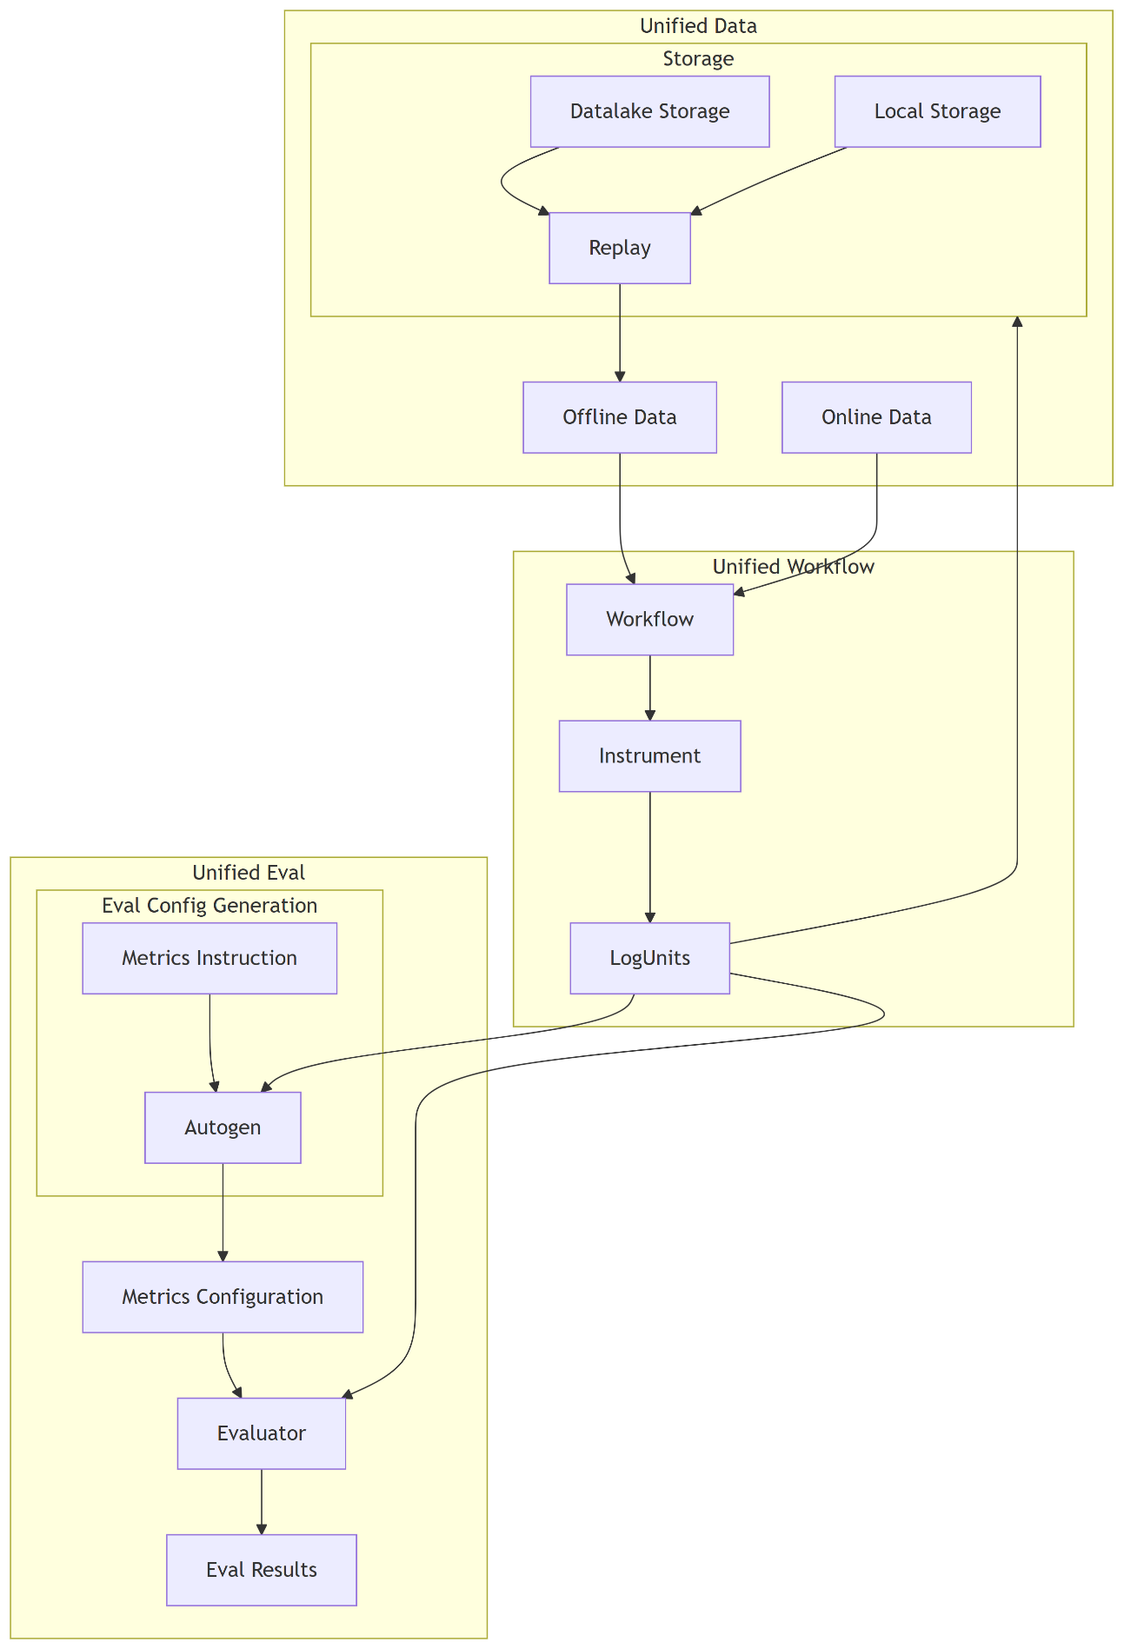

📦 Core Concepts

1. Instrument: What & Why
instrument provides runtime wrappers & decorators to capture structured execution footprints (arguments, variables, return values, errors, timing) into LogUnits.
Key APIs: - logCall(fn, options) – Wrap a function. - Decorators: @LogMethod(), @LogAll() – Instrument a single method or all methods of a class. - Inline capture: logInline(label, value), logVar(label, value) / logVars({...}). - Sessions: startInstrumentSession(project, sessionId, endpoint?) – Attach contextual project/session + sink posting to datalake. Returns array for live access to emitted units. - Replay control: setInstrumentSessionReplay(units) / clearInstrumentSessionReplay() – Override live emitted args/vars/return from prior captured units.
Design choices: - Uses AsyncLocalStorage to thread session & call context through sync/async boundaries. - Extensible sink: default console vs. HTTP POST to datalake endpoint. - Redaction & selective param logging to protect sensitive inputs. - Deterministic evaluation surface: every captured call transforms into a uniform LogUnit.

2. Replay: Purpose
Replay enables deterministic re-execution of evaluation logic without invoking original implementations or external dependencies. By loading previously persisted units (auto fetched on session start if endpoint + project + session match) it can: - Replace live arguments/vars/returns with historical values (payload.replayed = true). - Short-circuit flaky or slow operations for faster iterative metric tuning. - Guarantee consistency for offline regression checks.

3. Configuration-Based Evaluation Framework
Evaluation is driven by declarative MetricConfig[] describing: - methodology: algorithmic strategy (string match, QAG, DAG). - query: map of logical input names -> path expressions referencing LogUnit context (<tagId>.<field>). - params: methodology-specific knobs (thresholds, case sensitivity, etc.).
Benefits: - No hard-coded metric logic inside application code. - Allows versioning & remote distribution (store configs, fetch via project:latest). - Facilitates quick addition/removal/refinement without code redeploy.

4. Autogen (autoGenerateMetrics / autoGenerate)
Autogen is a bootstrapping utility that inspects collected LogUnits to propose initial metrics. Annotation tag units (if present) are treated like any other tag providing fields. Today it: - Loads a seed metrics template (testbed/src/eval.metrics.json). - May include metrics referencing fields from a tag (e.g., tagId === 'annotations' yielding annotation_summary) just like other tags. - Optionally enriches descriptions with a provided prompt. Future expansions can infer expected outputs, coverage targets, or dynamic methodology selection based on payload patterns.

5. Annotation Tag Units (Optional)
Annotation units (often using tagId: 'annotations') are ordinary LogUnits carrying human-provided fields (e.g., summary). Evaluation treats them exactly like other instrumented data; configs can reference their fields via standard path queries. Autogen may propose metrics using those fields without a distinct pipeline. Benefits: - Human-provided context available as regular data. - Metrics can compare model output to manually supplied fields using the same configuration mechanism.

🔁 End-to-End Evaluation Pipeline
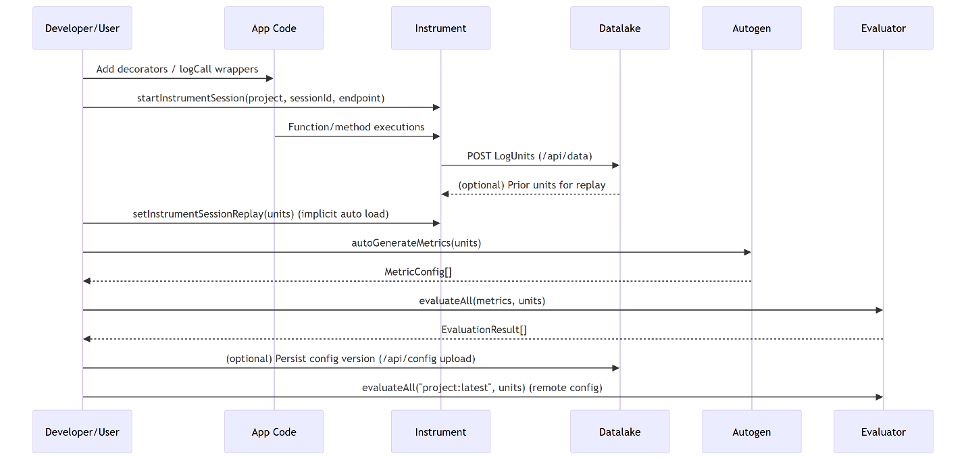

🛠 Usage Instructions / Demos

A. How Instrument Works
import { logCall, startInstrumentSession } from '@workspace/instrument';
function add(a: number, b: number) { return a + b; }
const loggedAdd = logCall(add, { label: 'add', logArgs: true, logReturn: true });
const units = startInstrumentSession('demo', 's1', 'http://localhost:3300');
loggedAdd(2, 3);
console.log(units.length); // 1
Decorator variant:
import { LogMethod, startInstrumentSession } from '@workspace/instrument';
class Calculator {
@LogMethod({ logArgs: true, logReturn: true })
multiply(x: number, y: number) { return x * y; }
}
startInstrumentSession('demo', 's2');
new Calculator().multiply(4, 5);
Selective parameter logging (use replay for return overrides):
const fetchUser = async (id: string, authToken: string) => ({ id, name: 'Jane' });
const wrapped = logCall(fetchUser, {
label: 'fetchUser',
params: ['id'], // only log id, hides authToken
logArgs: true,
logReturn: true,
});
// To override the return deterministically, capture a prior session and call:
// setInstrumentSessionReplay(previousUnitsWithFetchUserCalls)

B. How Autogen Config Works
import { autoGenerateMetrics } from '@workspace/instrument';
// After session concluded or mid-flight access live units
const metrics = await autoGenerateMetrics(units, 'Initial bootstrapping prompt');
// metrics: MetricConfig[] (seed + possible metrics derived from any captured fields, including optional annotation tag units)
Each metric’s query maps logical names to tag paths:
{
"name": "insightHasSummary",
"methodology": "string_match",
"query": {
"target": "getMeetingInsight.return",
"expected": "getMeetingInsight.vars.prompt.value"
},
"params": { "caseSensitive": false }
}

C. How Replay Works
Automatic replay when starting session with endpoint and matching prior data:
startInstrumentSession('demo', 'previousSession', 'http://localhost:3300');
// instrument will auto-load historical units and override live call outcomes.
Manual replay:
import { setInstrumentSessionReplay } from '@workspace/instrument';
setInstrumentSessionReplay(previousUnitsSubset); // tagId keyed; args/vars/return override
Replay replaces prior mockReturn capability: - To override outputs, capture a previous session’s units and apply setInstrumentSessionReplay(units); args/vars/return fields are substituted and flagged with replayed: true.

D. With Optional Annotation Tag Units
If no annotation tag exists: Autogen uses the base template only. If an annotation tag exists (tagId === 'annotations' or similar): Its fields are simply additional sources for potential metrics (e.g., annotation_summary). Add such data by logging a unit:
logInline('annotations', { summary: 'User intent classification looks correct.' });

E. Offline vs Online Data Evaluation
We distinguish evaluation contexts by data freshness and acquisition path, not by code changes. Instrumentation always emits LogUnits; evaluation always consumes LogUnit[] + MetricConfig[].
Mode | Data Source | Freshness | Examples | Typical Tools | Notes
Offline (historical) | Previously captured units from datalake (GET /api/data) | Stale / point-in-time | Re-running yesterday’s session; regression suite | startInstrumentSession + manual load; replay; evaluateAll | May use replay to avoid external calls; units can be loaded via a local file loader instead of service.
Offline (local file) | JSONL / JSON exported or side-loaded | Static | Team-shared dataset on disk | Custom dataloader -> LogUnit[] | Datalake optional; shape must match LogUnit.
Offline (annotation-enhanced) | Historical units + annotation tag units | Static + curated | Human labeled summaries / correctness tags | Autogen + annotation_* metrics | Adds derived metrics from annotation payload fields.
Online (real-time) | Live instrumentation posting to datalake | Fresh / streaming | Current session executing now | startInstrumentSession(project, session, endpoint) | Evaluation can run mid-flight on partial unit set.
Online (real-time + annotation) | Live units + operator/manual annotation capture | Fresh + evolving | Real-time QA / triage | Inline logInline('annotations', {...}) | Enables immediate feedback loop for adaptive metrics.
Offline evaluation means the units are already materialized (could still be pulled from datalake, just not live). Online evaluation means units are arriving and being appended as code executes.
Flows: 1. Offline (historical from datalake): - Query datalake for project/session -> assemble units[]. - Optionally setInstrumentSessionReplay(units) to simulate calls deterministically. - Load metrics (local file or project:latest). - evaluateAll(metrics, units). 2. Offline (local file loader): - Parse JSONL file(s) into LogUnit[]. - Run autogen if desired; evaluate. 3. Offline with annotations: - Ensure annotation tag units exist (e.g., annotations). - autoGenerateMetrics(units) adds annotation-derived metrics. - Evaluate; compare annotated vs generated output signals. 4. Online real-time: - Start session with endpoint. - Periodically snapshot current in-memory units array (it grows). - Evaluate incrementally (streaming scoring) or at end. 5. Online with live annotations: - Same as online; at any point log annotation unit. - Re-run autogen to incorporate new fields; continue evaluation.
Hybrid pattern: Fetch remote config (project:latest) but evaluate exclusively on replayed historical units—useful for ensuring new metric versions retain backward compatibility before deploying live instrumentation changes.
Design invariant: evaluation code never inspects “where” the units came from—just their content. This supports decoupling and portability.

Fetch Remote Config Example
import { evaluateAll } from '@workspace/instrument';
const results = await evaluateAll('demo:latest', units); // remote metrics fetch
Or using client:
import { EvalClient } from '@workspace/instrument';
const client = new EvalClient('http://localhost:3300');
const results = await client.evaluate('demo:latest', units);

Metrics Evaluation Result Handling
import { evaluateAll, printEvaluationTable } from '@workspace/instrument';
const results = await evaluateAll(metrics, units);
printEvaluationTable(results); // Console PASS/FAIL table

🔐 Redaction & Privacy (To be extended)
- Provide redact(key, value) in InstrumentOptions to transform sensitive data during serialization.
- Selective param logging prevents accidental exposure of secrets (e.g., only log id, skip authToken).

🧪 Methodologies Overview (To be extended)
Methodology | Purpose | Example Use
string_match | Token/substring expectation validation | Check prefix or keyword presence in generated summary
QAG | Question–Answer relevance scoring (LLM / heuristic) | Ensure answer covers asked factual question
DAG | Step coverage / structural comparison | Verify generated plan includes required steps

⚙ Path Query Semantics (To be extended)
Metric query paths use <tagId>.<field> addressing into a tag-context object built from LogUnits. Fields originate from payload keys (args, vars, return). Examples: - fetchContext.args.question → argument question of fetchContext. - getMeetingInsight.vars.prompt.value → captured variable prompt value. - planGenerator.return → returned value of planGenerator.

📈 Extensibility Points
- Eval methodologies: implement evaluate(ctx) returning EvaluationResult and register under REGISTRY, extend without affect existing config.
- Data Manipulation: enhancements replay, partial arg overrides, return overrides.
- Data Management: integrate UI for manual annotation.

❓ FAQ
Q: What does “decoupling instrument vs datalake” mean?
instrument & evaluator are content-centric: they define and consume the LogUnit & MetricConfig shapes only. They do not persist or version data. datalake is storage-centric: it organizes, versions, lists, and distributes data & configs. You can swap datalake for another store (files, S3, DB) by providing a sink and a loader that yield the same LogUnit[].
Q: Do I need datalake to evaluate?
No. You can evaluate purely on in-memory units captured locally or load data from local storage.

🔓 Decoupling: Responsibilities Matrix
Concern | Instrument Library | Evaluator | Datalake Service
Emit execution data | Yes | No | No
Define data schema (LogUnit) | Yes | Reads | Persists
Define evaluation schema (MetricConfig) | Re-export | Yes | Stores versions
Version configs | No | Consumes | Yes
Replay support | Provides mechanism | Consumes units | Supplies source units
Annotation interpretation | Autogen augments | Consumes metrics | Stores annotation units
Storage medium abstraction | Sink mechanism | Path queries | Filesystem hierarchy

