FINAL REPORT
{{type}}

Well: {{well_name}}
Field: {{field}}
Date: {{date}}

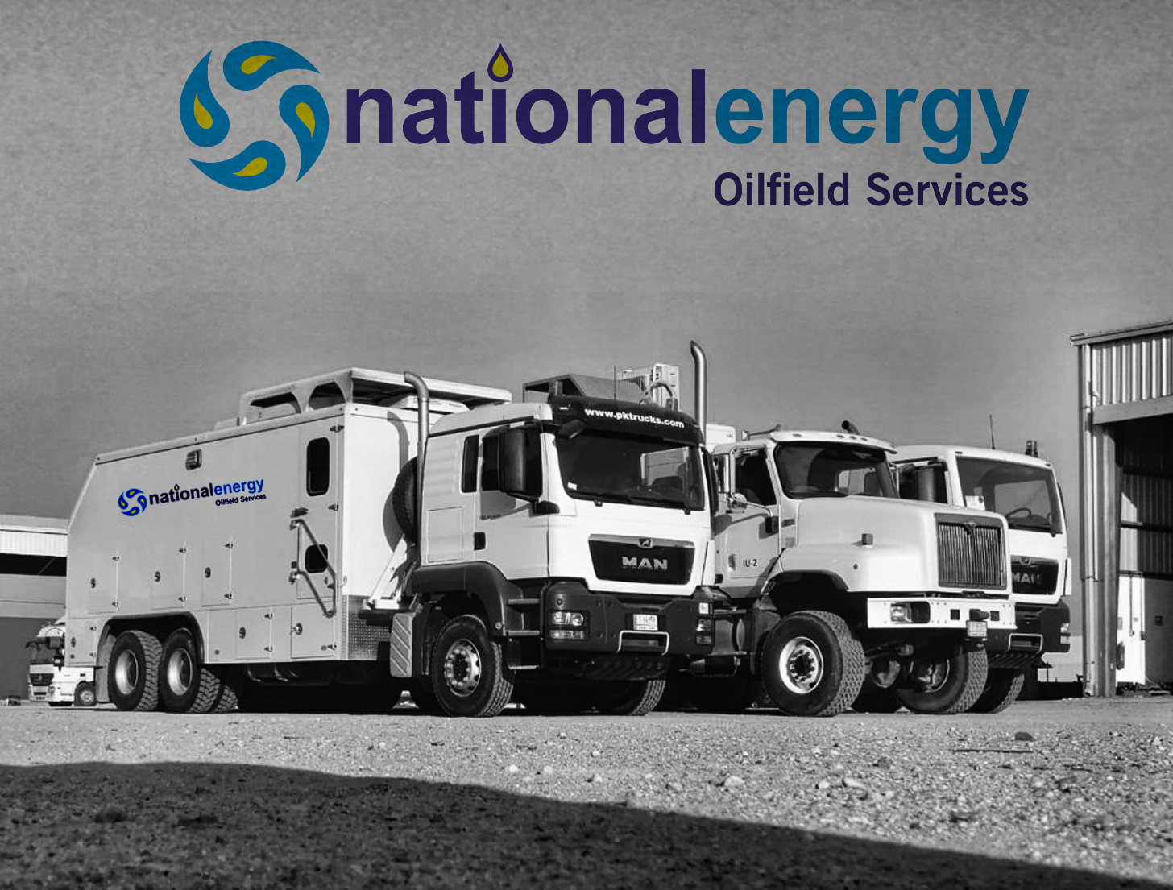

Table of Contents
Survey Objectives 3
Basic Well Information 4
Sequence Of Events 5
Static Gradient Survey Results Table 5
Static Gradient Survey Result Plots 6
Overall Downhole Memory Gauge Plot 7
Down Hole Memory Gauges Overall Comparison 8
Well Completion Diagram 9
Wellhead Picture 10
Slickline Memory Gauges String Diagram 11
PCE Schematic 12
Calibration Top Gauge D8701 13
Calibration Bottom Gauge D8700 14

Survey Objectives

A Pressure Survey was carried out on {{date}} in well {{well_name}} of {{field}} field to perform {{type}} to evaluate the bottom hole pressure and temperature

Basic Well Information

GENERAL INFORMATION
Company : ROO

Field : {{field}}

Well : {{well_name}}

DGS/CPS : {{dgs}}

Test : {{type}}

Rig : RIGLESS

Country/City : IRAQ- BASRA

Depth Reference : GL (Ground Level)

Unit System : Field System

OPERATION DETAILS:
Date of test : {{date}}

Co. Representative : ROO-SL Coordinator

NEOS Representative : {{spv}}

WELL DATA:

States before test : Producer

Well type : {{welltype}}

Fluid type : {{fluid}}

Completion type : {{packer}}
Well status : Producer

Min restriction : {{min-res}}

Casing size : {{casingsize}}

Tubing size : {{tubing}}

Liner size : N/A

Test interval : {{interval}}

Sequence Of Events

End | End | Time | Description
6:00 | 7:00 | 1:00 | NEOS slickline crew and equipment left from the base to R-043.
7:00 | 8:00 | 1:00 | Got PTW.
8:00 | 8:10 | 0:10 | Gas test was done (O2=20.9, Flammables =0% of LEL, H2S=0 PPM)Permit was signed off to PA.
8:10 | 8:20 | 0:10 | Review JSA and held tool box meeting with slickline crew Risk Assessment discussion JSA.
8:20 | 8:30 | 0:10 | Perform DROPs check list, offload equipment from transport truck and Scaffolding.
8:30 | 9:00 | 0:30 | Started R/U slickline equipment.
9:00 | 9:15 | 0:15 | Remove wireline valve from frame and connect hydraulic hoses.  1. Function test wireline valve rams with hydraulic supply (close 10 sec, open 9 sec).  2. Hydraulic accumulator testing:  a. Accumulator pre-charge pressure: 1500psi  b. Accumulator pressurized to 3000 psi  c. Function testing each rams with accumulator (close 7 sec, open 7 sec, close 8 sec, open 7 sec).  d. Residual accumulator pressure: 2300 psi.  e. Bleed off hydraulic and accumulator pressure.
9:15 | 9:25 | 0:10 | Pressure testing for Quick test sub 2700 psi /10 min.
9:11 | 10:32 | 1:21 | RIH two memory pressure /Temperature gauges Top SN: D8701, Bottom SN: D8700 and Stop at measuring depth 2915 mGL for 20 min.
10:32 | 12:55 | 2:23 | POOH gauges with 8 stations 10 min each (2905,2895,2885,2495,1995,995,495,0 ) mGL as per Client programing
12:55 | 13:30 | 0:35 | Slickline tools at surface, Bleed off LUB, disconnect memory gauges and download the data, inform ROOWSC2 and start R/D.
13:30 | 14:30 | 1:00 | Finished rig down and housekeeping .
14:30 | 15:15 | 0:45 | Pressure test wellhead flange with 250 psi for 5 minutes and 2700 psi for 10 minutes, test Ok.
15:15 | 16:00 | 0:45 | Close PTW.
17:00 | 18:00 | 1:00 | Crew back to base.

{{type}} Results Table
Bottom Gauge D-8700
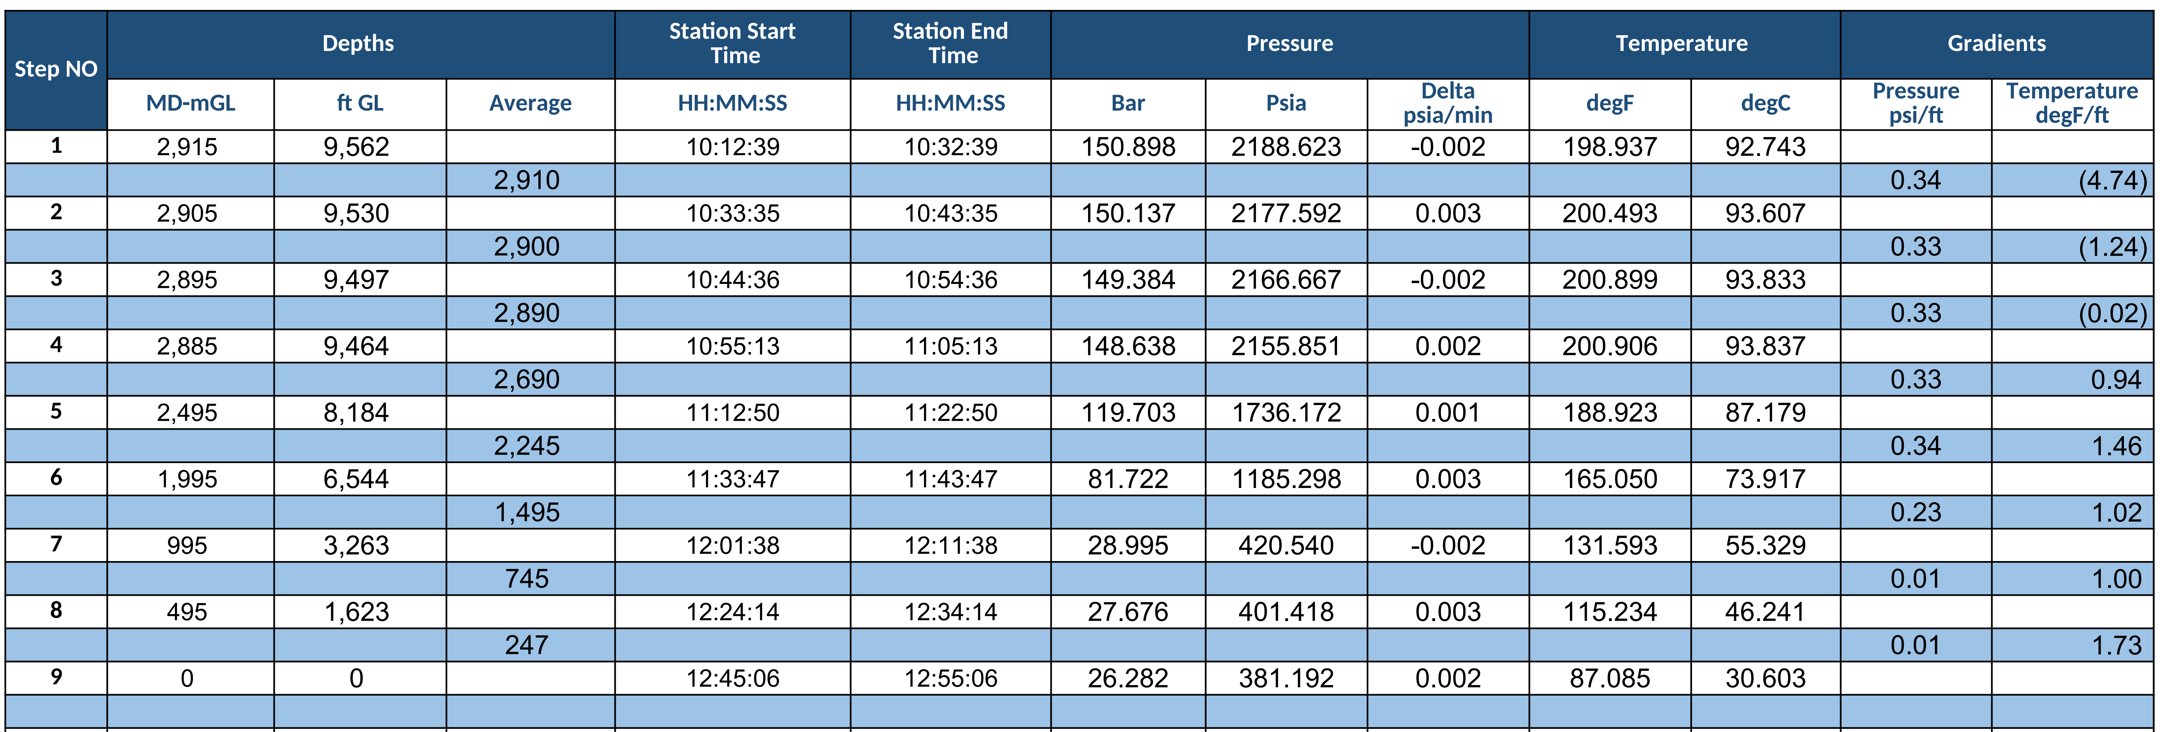

{{type}} Result Plots
Bottom gauge D-8700
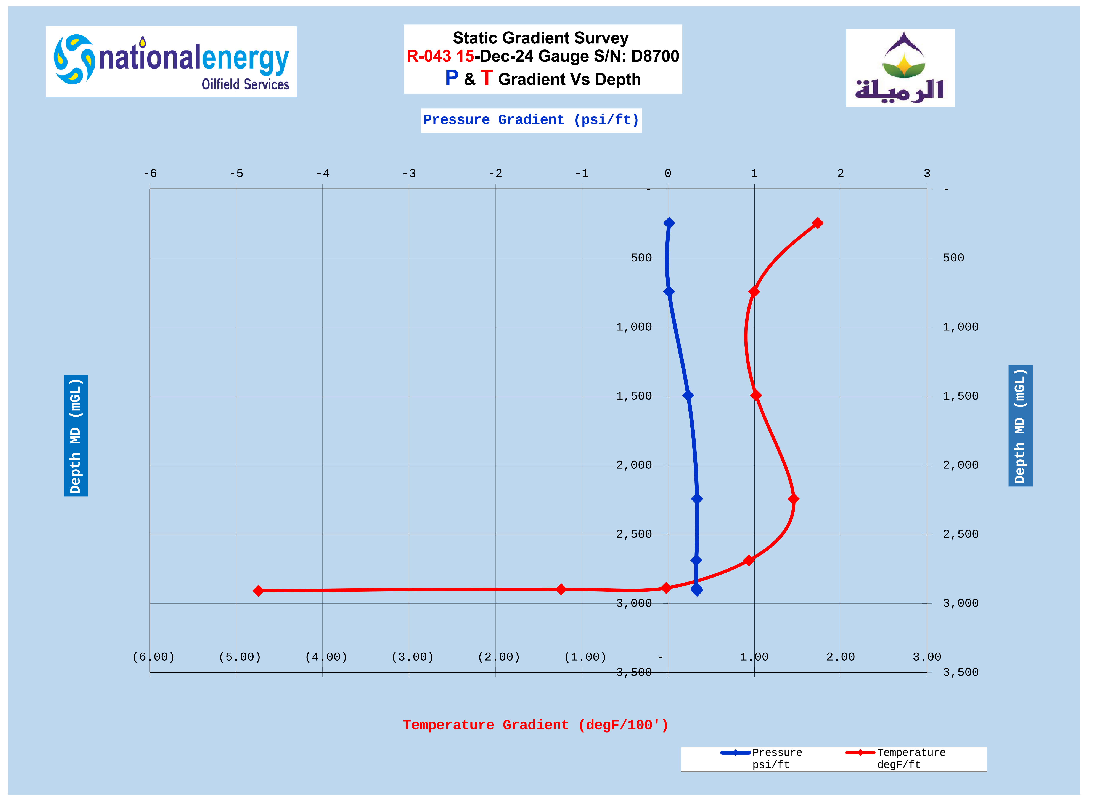
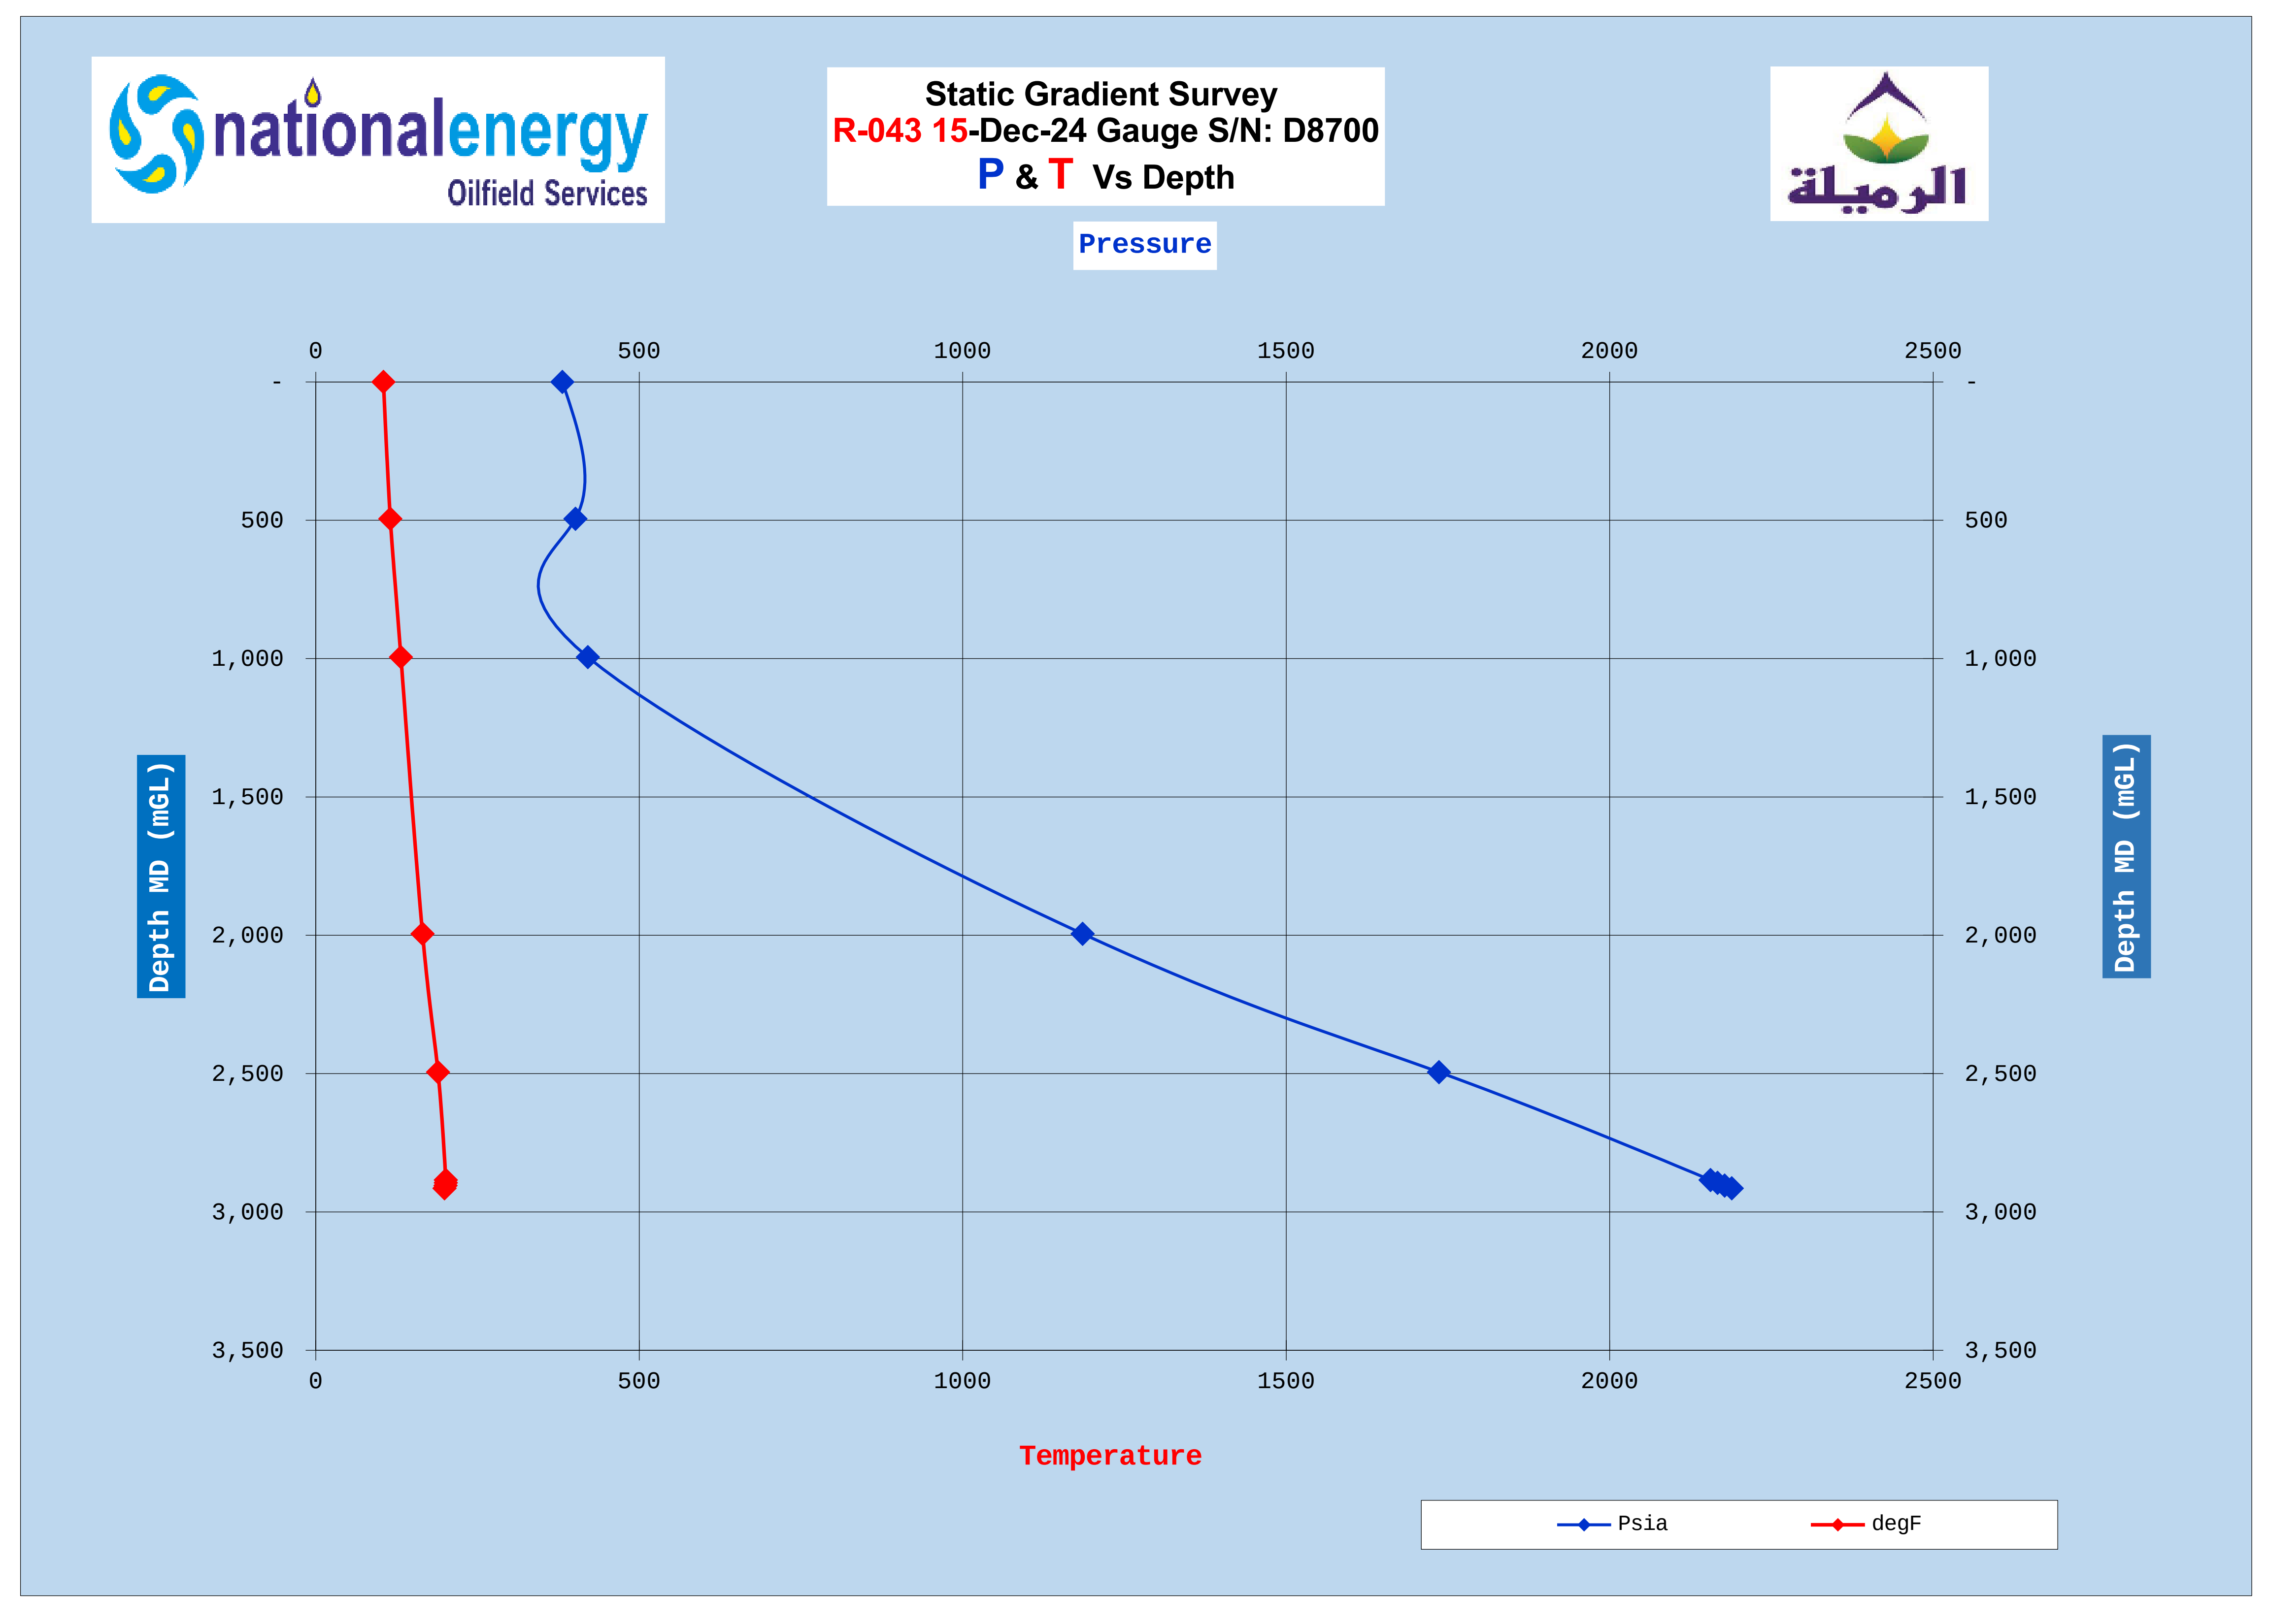

Overall Downhole Memory Gauge Plot
Bottom gauge D-8700

Down Hole Memory Gauges Overall Comparison
Bottom D8700, Top D8701

Well Completion Diagram

Wellhead Picture

Slickline Memory Gauges String Diagram

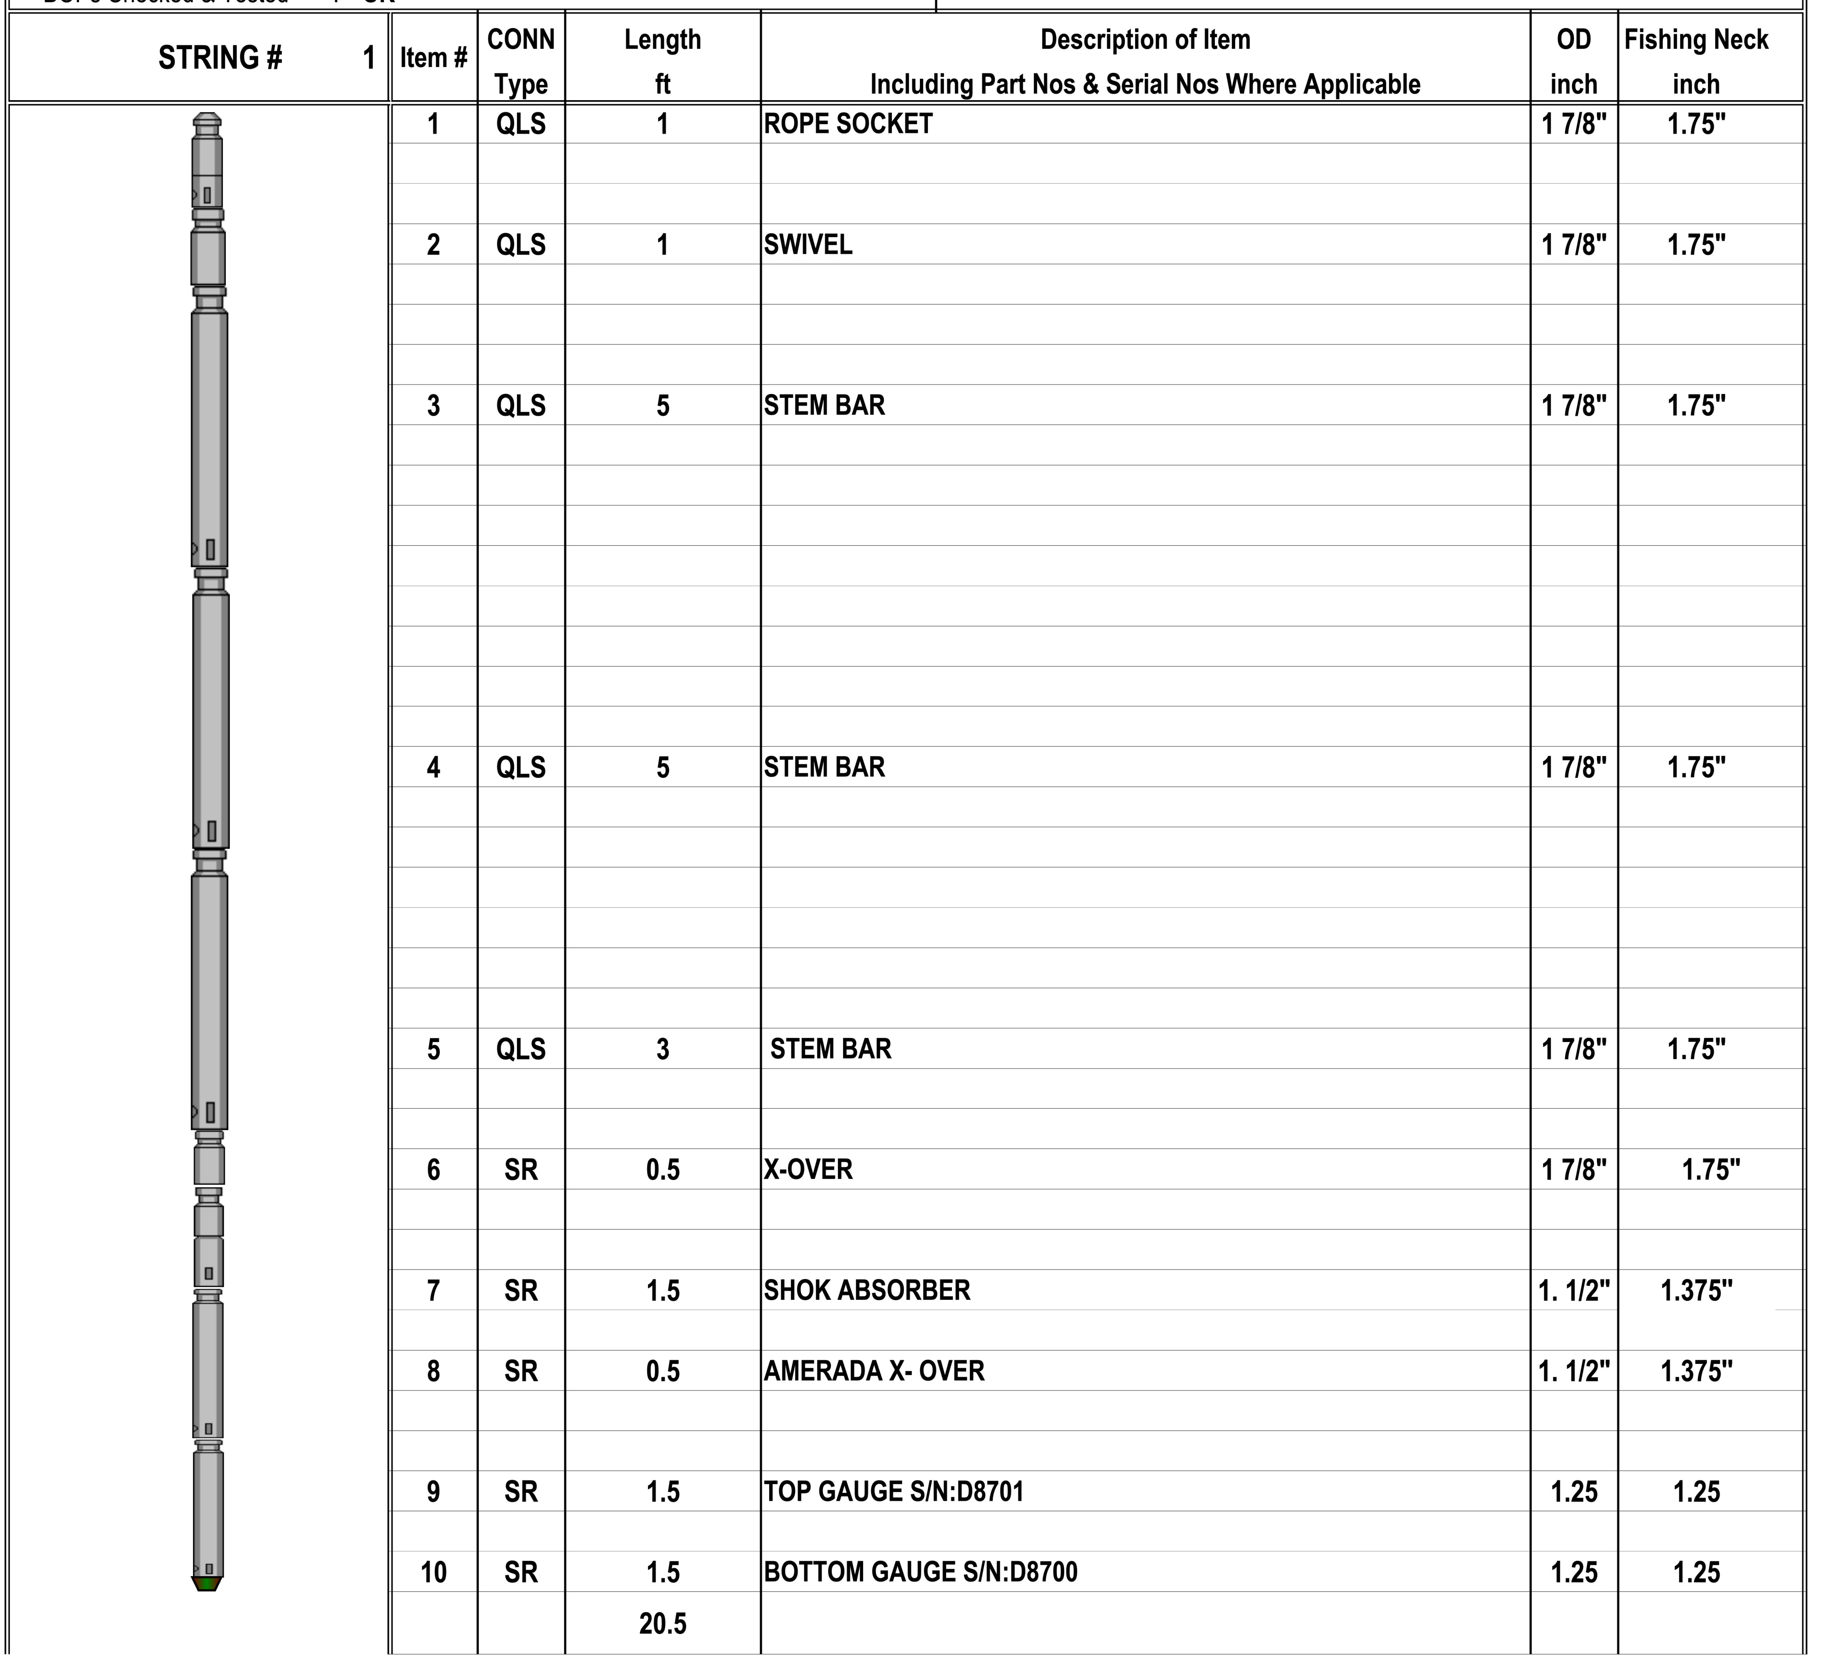

PCE Schematic
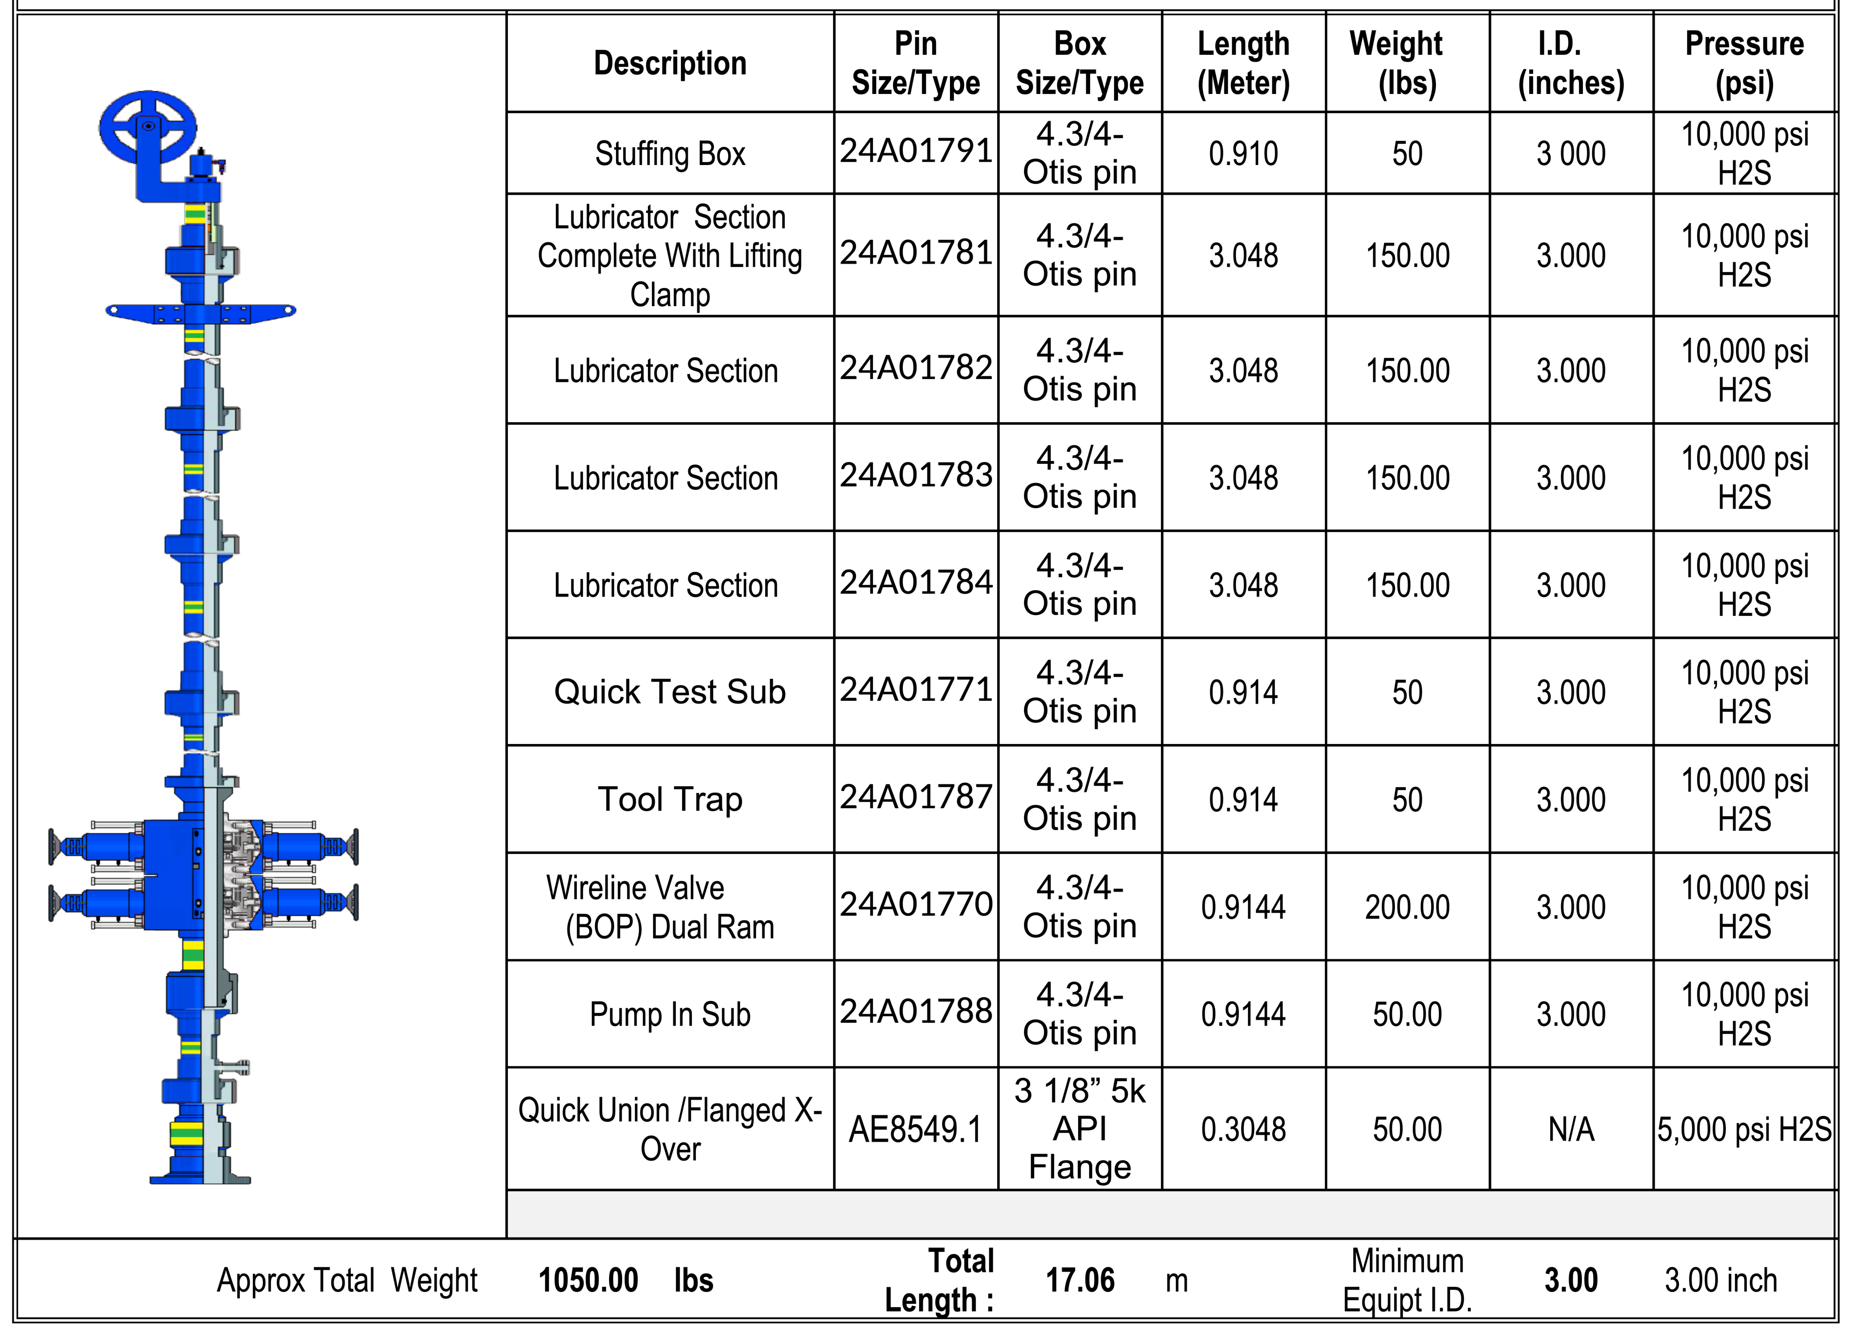

Calibration Top Gauge D8701
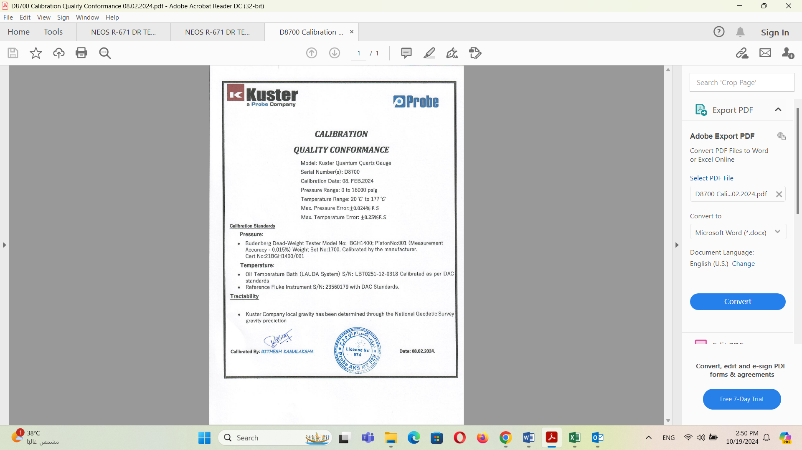

Calibration Bottom Gauge D8700

