FINAL REPORT
STATIC GRADIENT SURVEY

Well: {{well_name}}
Field: {{field}}
Date: {{date}}



Table of Contents
SURVEY OBJECTIVES 3
BASIC WELL INFORMATION 4
SEQUENCE OF EVENTS 5
STATIC GRADIENT SURVEY RESULTS TABLE 5
STATIC GRADIENT SURVEY RESULT PLOTS 6
OVERALL DOWNHOLE MEMORY GAUGE PLOT 7
DOWN HOLE MEMORY GAUGES OVERALL COMPARISON 8
WELL COMPLETION DIAGRAM 9
WELLHEAD PICTURE 10
SLICKLINE MEMORY GAUGES STRING DIAGRAM 11
PCE SCHEMATIC 12
CALIBRATION TOP GAUGE D8701 13
CALIBRATION BOTTOM GAUGE D8700 14

SURVEY OBJECTIVES

A Pressure Survey was carried out on {{date}} in well {{well_name}} of {{field}} field to perform {{type}} to evaluate the bottom hole pressure and temperature

BASIC WELL INFORMATION

GENERAL INFORMATION
Company : TotalEnegies Ratawi Hub

Field : {{field}}

Well : {{well_name}}

DGS/CPS :

Test : {{type}}

Rig : RIGLESS

Country/City : IRAQ- BASRA

Depth Reference : GL (Ground Level)

Unit System : Field System

OPERATION DETAILS:
Date of test : {{date}}

Co. Representative : Coordinator

NEOS Representative : {{spv}}

WELL DATA:

States before test : Producer oil

Well type : {{welltype}}

Fluid type : {{fluid}}

Completion type : {{packer}}

Well status : Producer

Min restriction : {{min-res}}

Casing size : 9 5/8 in, 47 lb/ft, L-80

Tubing size : {{tubing}}

Liner size : 7”, 2.9#, L-80

Test interval : {{interval}}

SEQUENCE OF EVENTS

Start | End | Total | Operation Description
06:00 | 07:00 | 01:00 | NEOS slickline crew left from the base to RT-50.
07:00 | 09:30 | 02:30 | Got PTW.
09:30 | 09:40 | 00:10 | Gas test was done (O2=20.9, Flammables =0% of LEL,H2S=0 PPM) Permit was signed off to PA.
09:40 | 10:00 | 00:20 | Review JSA and held tool box meeting with slickline crew Job Risk Assessment discussion JRA.
10:00 | 10:30 | 00:30 | Perform DROPs check list, offload equipment from transport truck and Scaffolding.
10:30 | 10:45 | 00:15 | Pressure test against Aux valves,WHP 200 psi. test OK
10:45 | 11:45 | 01:00 | Started R/U slickline equipment.
11:45 | 12:00 | 00:15 | Remove wireline valve from frame and connect hydraulic hoses.  1. Function test wireline valve rams with hydraulic supply (close 10 sec, open 9 sec).  2. Hydraulic accumulator testing:  a. Accumulator pre-charge pressure: 1500psi  b. Accumulator pressurized to 3000 psi  c. Function testing each rams with accumulator (close 7 sec, open 7 sec, close 8 sec, open 7 sec).  d. Residual accumulator pressure: 2300 psi.  e. Bleed off hydraulic and accumulator pressure.
12:00 | 12:30 | 00:30 | Pressure test Hose & Low torque Valve & PCE up to 250 psi /5min and 2700 psi /10 min test Ok.
12:30 | 15:00 | 02:30 | Opened Swab RIH with GC 2.8" tagged HUD@ 3307 mGL inform TEEPERH SPDT and POOH.
15:00 | 15:15 | 00:15 | Slickline tools at surface, Bleed off LUB & Prepare for next run.
15:15 | 15:30 | 00:15 | Pressure testing for Quick test sub 2700 psi /10 min.
15:30 | 17:15 | 01:45 | Opened Swab valve RIH with TEL 3 1/2" & 2.8" GC located EOT @ 3084.7 mGL inform TEEPERH SPDT and POOH.
17:15 | 17:30 | 00:15 | Slickline tools at surface, Bleed off LUB & Prepare for next run.
17:30 | 18:17 | 00:47 | RIH two memory pressure /Temperature gauges Top SN: D8701, Bottom SN: D8700 and Stop at measuring depth 3303 mGL for 20 min. Night shift crew arrive at location and handover with day shift.
18:17 | 21:07 | 02:50 | POOH gauges with 10 stations 10 min each (3293, 3283, 3273, 3092, 2990,1990,1490, 990, 490, 0) mGL as per Client instruction.
21:07 | 21:15 | 00:08 | Slickline tools at surface, Bleed off LUB, disconnect memory gauges and download the data, inform TEEPERH SPDT and start R/D.
21:15 | 22:30 | 01:15 | Finished rig down and housekeeping .
22:30 | 22:45 | 00:15 | Pressure test wellhead flange with 250 psi for 5 minutes and 2700 psi for 10 minutes, test Ok .
22:45 | 23:59 | 01:14 | Close PTW and waiting Day shift.

STATIC GRADIENT SURVEY RESULTS TABLE
Bottom Gauge D-8700

STATIC GRADIENT SURVEY RESULT PLOTS
Bottom gauge D-8700

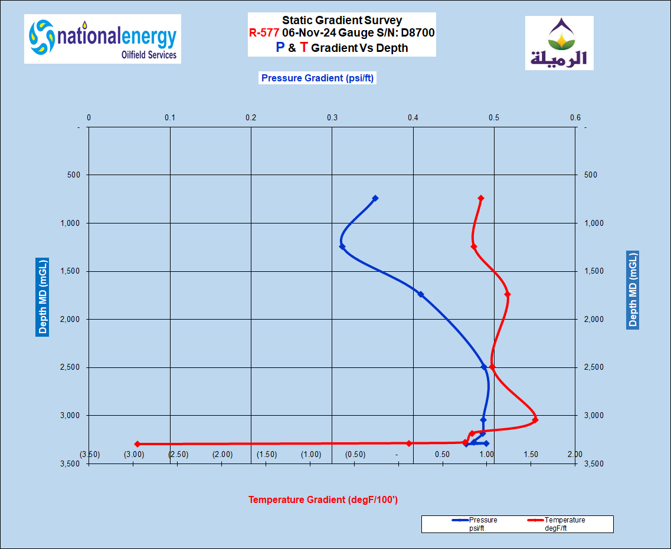
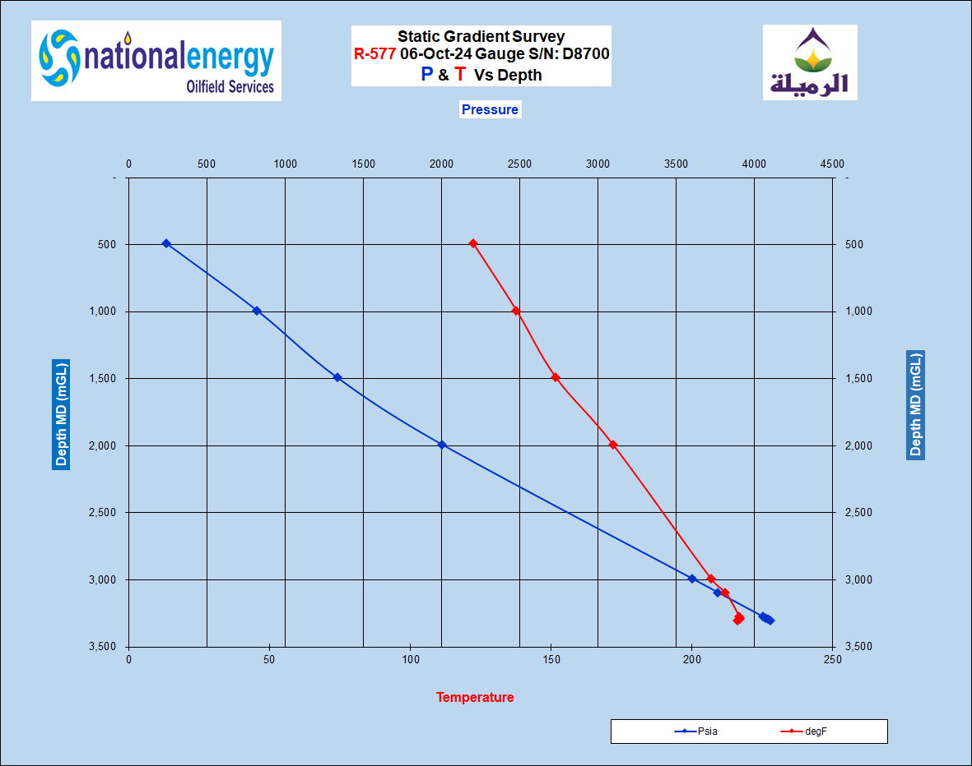



OVERALL DOWNHOLE MEMORY GAUGE PLOT
Bottom gauge D-8700

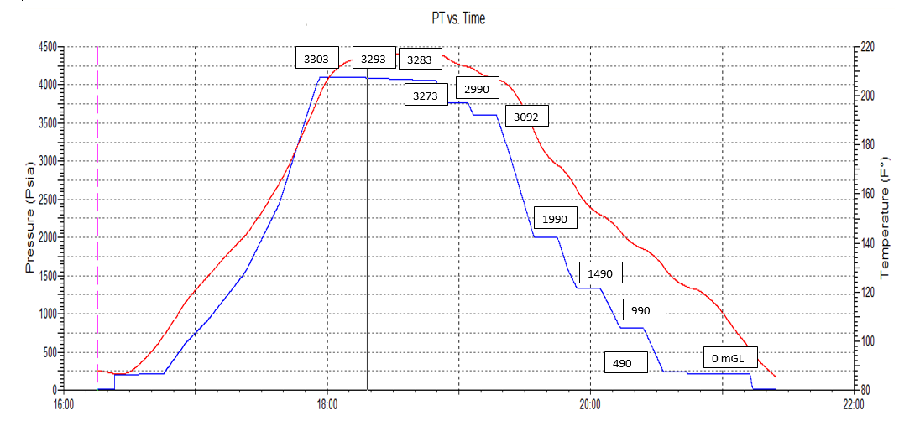

DOWN HOLE MEMORY GAUGES OVERALL COMPARISON
Bottom D8700, Top D8701
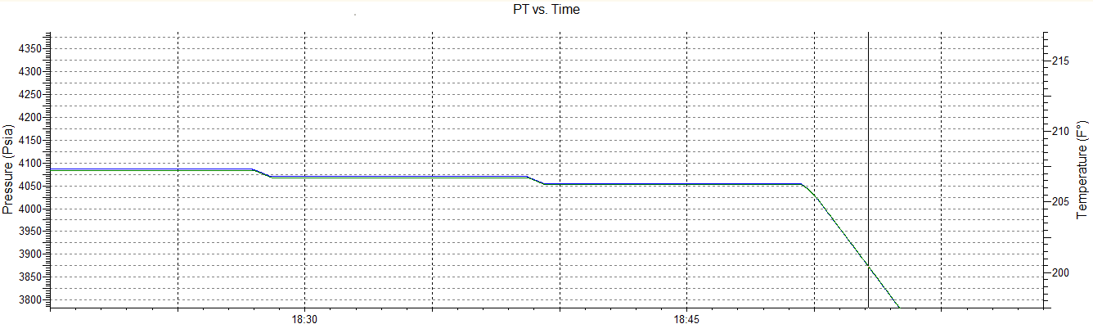

WELL COMPLETION DIAGRAM

WELLHEAD PICTURE

SLICKLINE MEMORY GAUGES STRING DIAGRAM
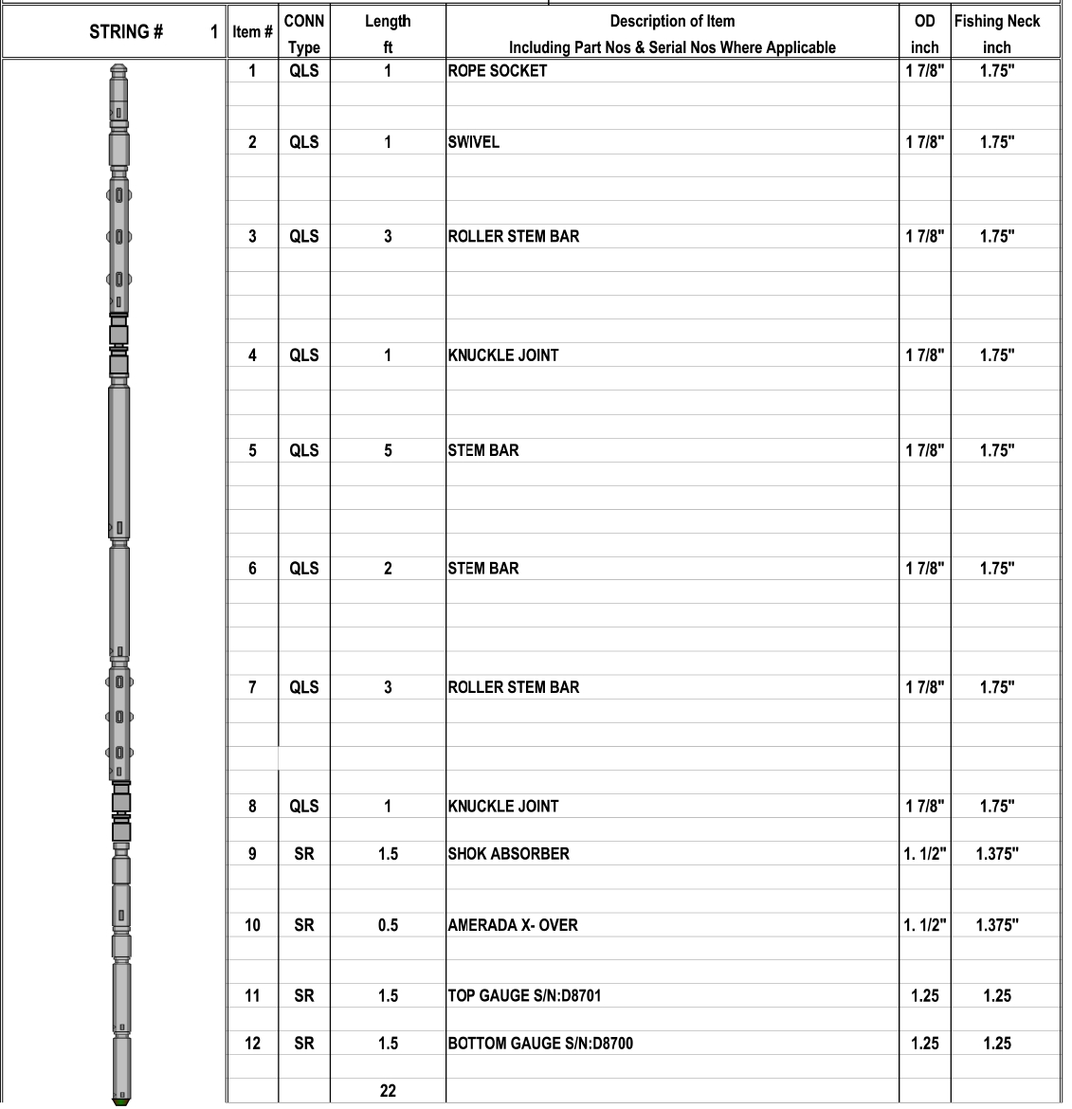

PCE SCHEMATIC

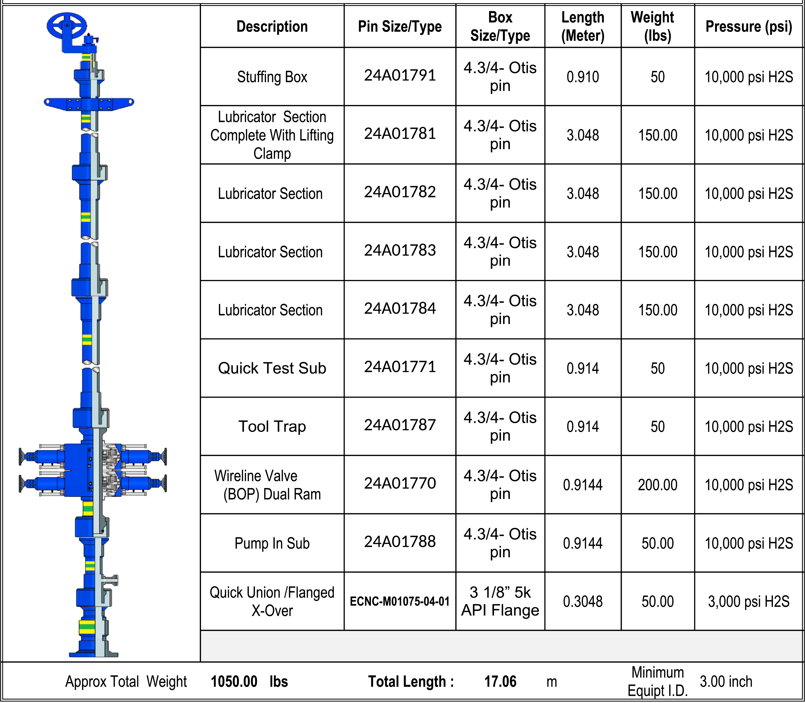
Example only

CALIBRATION TOP GAUGE D8701
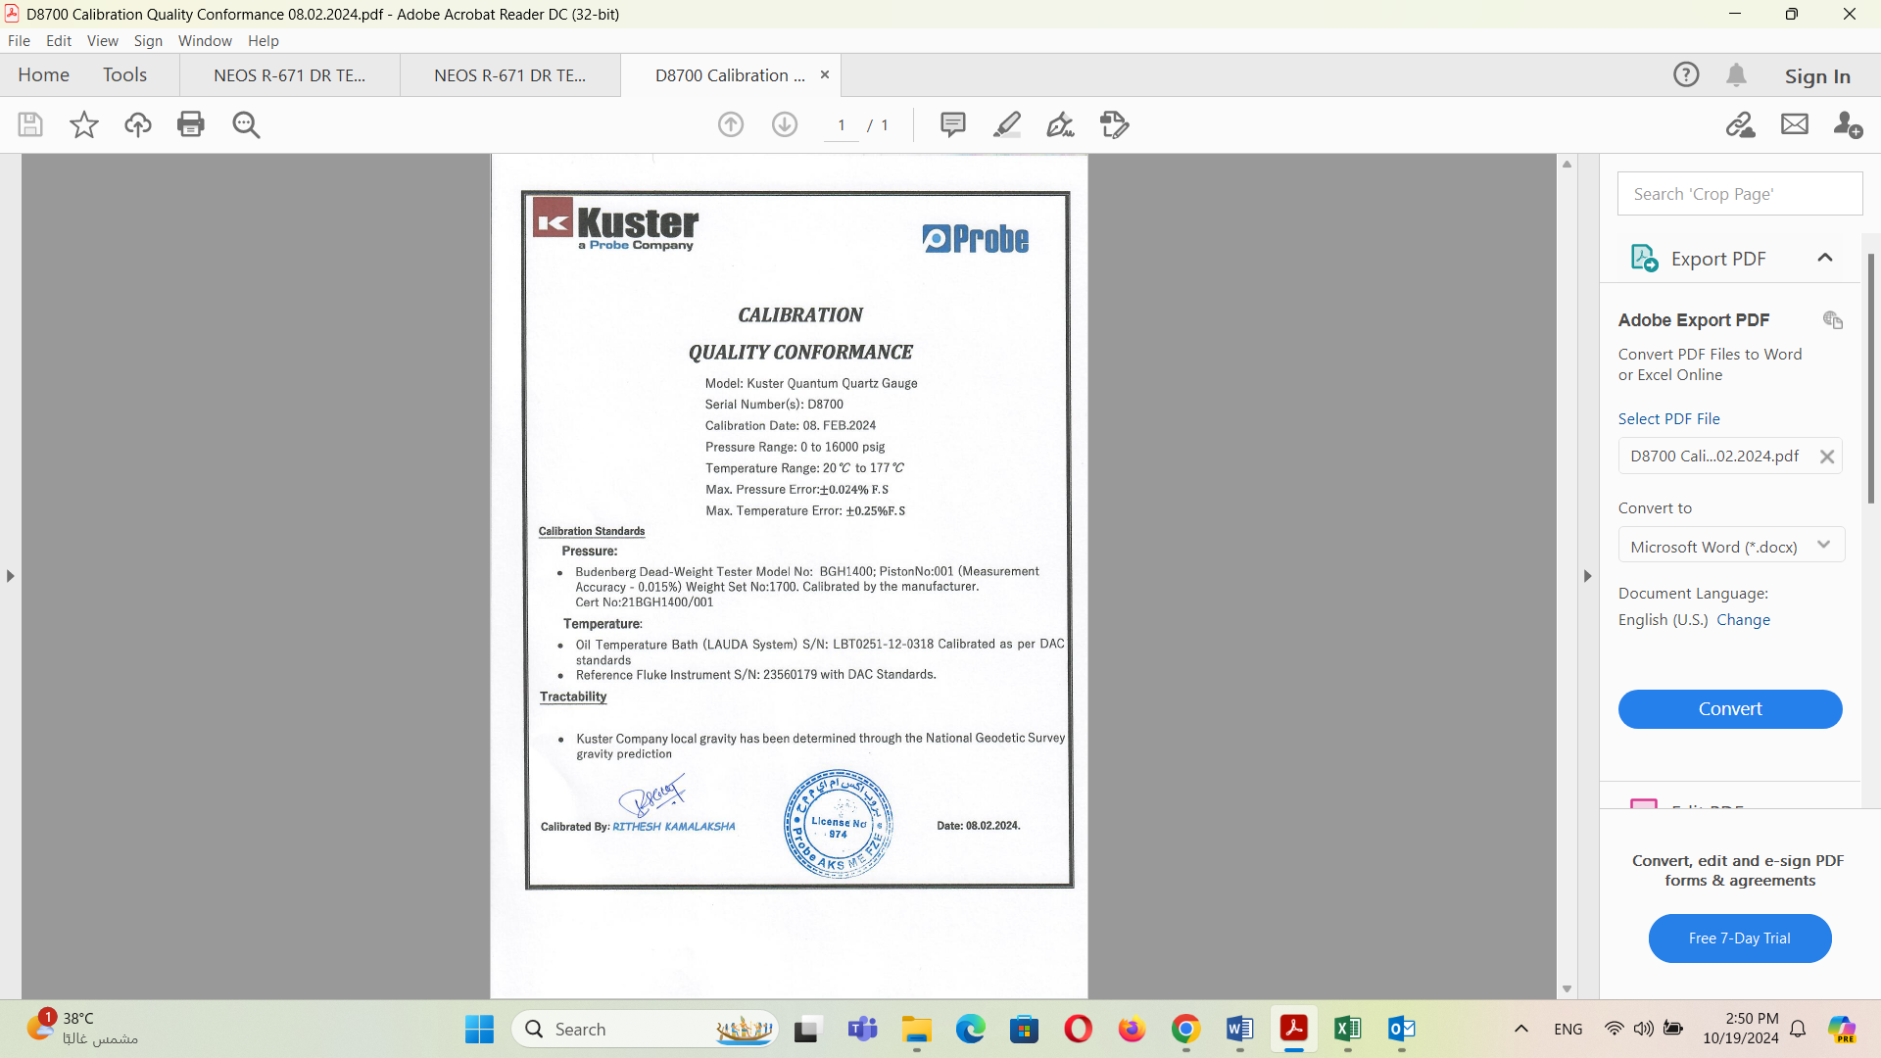

CALIBRATION BOTTOM GAUGE D8700

