COMP 340 – Additional Requirements – Project Phase 2
Windows Server 2016 - configuring local storage and File and Share Access

A. Configuring Local Storage [_____/6]

Storage Spaces is a disk virtualization technology that enables a server to concatenate storage space from individual physical disks and allocate that space to create virtual disks of any size. Storage Spaces uses unallocated disk space on server drives to create storage pools. A storage pool can span multiple drives invisibly, and by using the space in the pool, one can create virtual disks of any size. A virtual disk behaves much like a physical disk except that the actual bits might be stored on any number of physical drives in the system. Virtual disk can also provide fault tolerance by using physical disks in storage pool to hold mirrored or parity data.

Disk mirroring writes same data to identical volumes on two different disks and is one of the simplest forms of fault tolerance to implement and manage, but it is also one of the more expensive solutions.

On one of the machines, do the followings.
1. Shrink a Volume
In Server Manager window, click Tools > Computer management > Disk Management. Right click on C:\ and shrink the C: drive by reducing its space by 20 GB. Leave the rest of the drive as unallocated.

2. Creating Storage Pool and Virtual Disk
- Using Server Manager > File and Storage Services > Storage Pools, TASKS, select Rescan Storage, right click on the primordial space to create a new storage pool called pool1. Select one disk into the storage pool and set Allocation as Automatic.

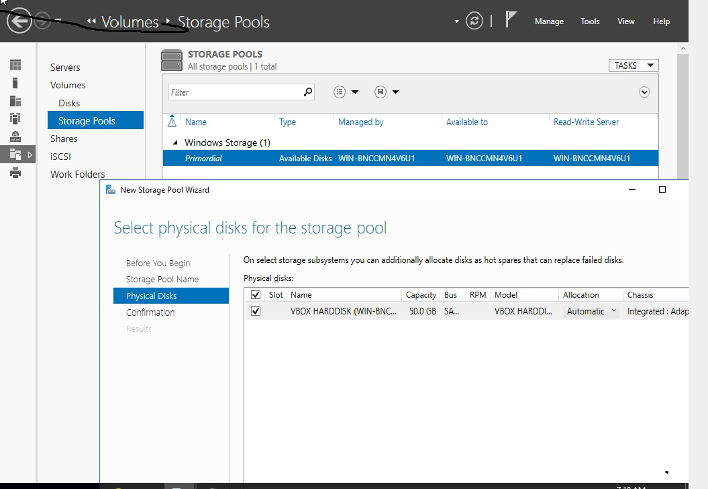

What is the Total selected capacity? ________________ click Next, click Create

- Create a new simple volume, select pool1, VIRTUAL DISKS -> TASKS select New Virtual Disk, virtual1, by using the maximum available capacity. Using NTFS as the file system.

What is the available capacity? _______________

- Use Disk Management to check the number of disk and disk space available on the system. Also use file manager to see if you have the two volumes created.

Drive letter ______________ Size____________

Drive letter ______________ Size____________

B. File and Share Access [_____/6]

Server-based file shares provide users with a simplified data storage solution that they can use to store their files, share files with other users, and easily locate the files shared by their colleagues. Server-based storage tools can be used to protect everyone’s files, regulate access to sensitive data, and prevent users from abusing their storage privileges.

- Folder sharing using File Explorer
a. Use File Explorer to create a folder Test under the user Administrator.
b. Share the folder Test with everyone with Read permission by right click on the folder, select Share with > Specific people, and from the pop-up window, click the down arrow on right of the box at the center, select Everyone and click Add. You will see Everyone has been added with Read as the default permission. Click Share at the bottom of the pop-up window.
c. Create a subfolder test1 under the folder Test.
d. Using Ctrl-Alt-Del, switch to user student1. Can you access the folders Test and test1? _________
e. Can you create a folder under test1 without the admin password? _____________
f. Sign out from student1 and switch back to the Administrator account.
- Install the Server for NFS role service
- From the Server Manager, click Manage > Add Role and Features.
- At Server Roles, click the drop-down arrow of File and Storage Services > File and iSCSI Services, then check the Server for NFS. Click Add features when prompted.
- Take the defaults for the rest and click install.
- Wait for the installation to complete.

- Create a folder students under C:
- Create a Folder Share
- Click Server Manager > File and Storage Services > Shares. Select Tasks > New Share.
- From the New Share Wizard window, look at the descriptions for SMB Share – Quick and NFS Share - Quick by clicking on them. What is the main difference between SMB and NFS share?

Note that Server Message Blocks (SMB) is the file-sharing protocol used by all versions of Windows.

- Select SMB Share – Quick and click Next.
- Use C:\Shares as the Share location, and students as the Share name.
- Select Enable access-based enumeration and Allow caching of share.
- Take the defaults for the rest and click Create.
- Close the pop-up window when the share was successfully created.
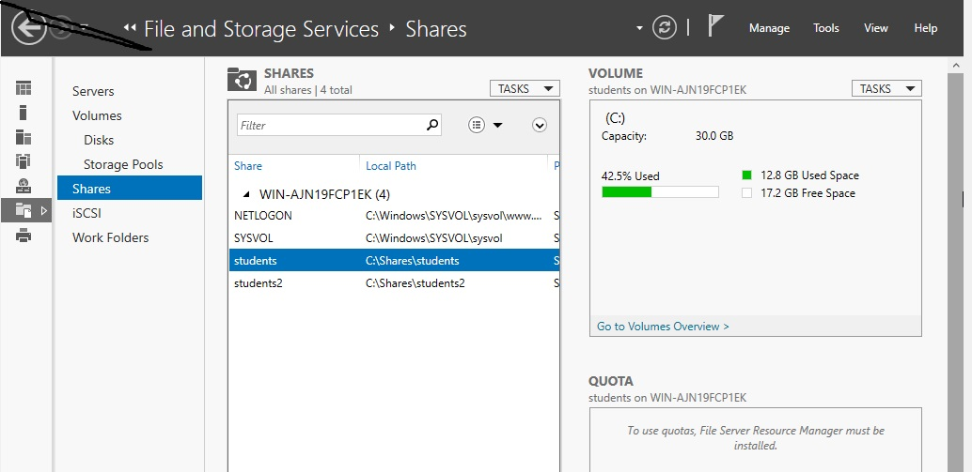

C. Assigning Permissions [_____/8]
1. Assigning Read/Write permission of the folder students to user student1.
- Click Server Manager > File and Storage Services > Shares. Select students in Shares. Right click, then select Properties.
- Click Permissions > Customize permissions … > Add > Select a principal >Advanced
- Set Object Types as Users, click Find Now, and select student1 and click OK.
What are the default permissions shown?

- Click Show advanced permissions on the right.
What are the default permissions shown?

- Go back to Basic permissions and add in Write permission by checking the box on the left. Click Show advanced permissions.
What are the addition permissions shown?

Is Delete subfolders and files allowed?

- Close the Permission Entry for students pop-up window by clicking OK.
2. Removing Special Access
- From the Advanced Security Settings for students window > Permissions, select the entry for Users with Special Access. Click view and Show advanced permissions. What are the permissions given?

- Close the Permission pop-up window. From the Advanced Security Settings window, try to remove the Special Access. What is the message displayed on the screen?

- Click Disable inheritance and convert inherited permissions into explicit permissions. Try to remove the Special Access. Is the removal successful?

Close all the pop-up windows.
3. Use the file explorer to add a subfolder Adminsub1 under folder students.

- Allow log on locally for student1 and student2 [added November 9, 2023]

- Open the Local Group Policy Editor (gpedit.msc);
- Go to Computer Configuration -> Windows Settings -> Security Settings -> Local Policies -> User Rights Assignment;
- 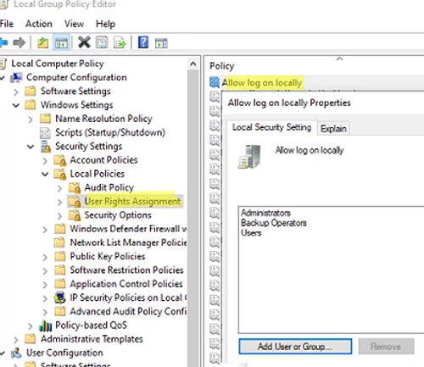

- Find Allow log on locally in the list of policies;
- The policy contains the list of groups and users allowed to sign in to the computer locally.
Select Users, Click Add User or Group, add User Student1 and Student2
Depending on the operating system and computer role, the list of groups allowed to sign-in locally may vary. For example, local sign-in is allowed for the following user groups on workstations running Windows 10 and servers running Windows Server 2022,2019,2016:
  - Administrators
  - Backup Operators
  - Users

Switch to user student1.

- Can you delete the subfolder Adminsub1 without the admin password? ___________

- Under folder students, create a subfolder sub1.
- Switch to user student2. Can you create a subfolder sub2 under folder students without the admin password? _________________

- Can you delete the subfolder sub1? ________________

- Sign out from student2 and switch back to user student1. Can you delete the subfolder sub1? ________________

Do screen prints and include in Project Phase2

