William Craycroft
CS 134 – Project 03
3/25/2019

Application Design:

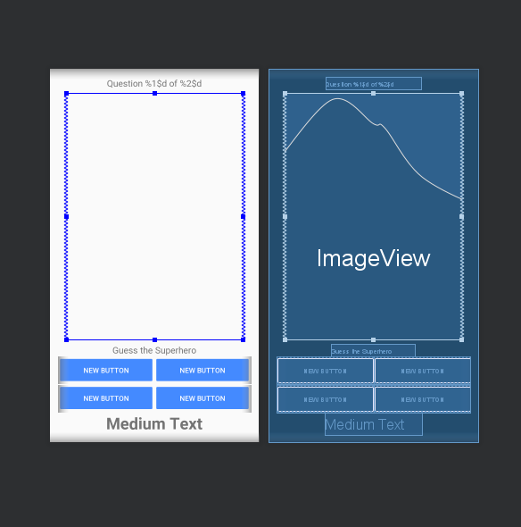

Component Tree:

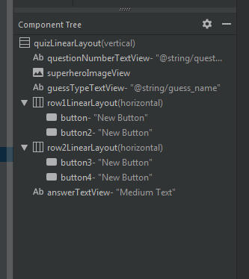

App Running (Name):

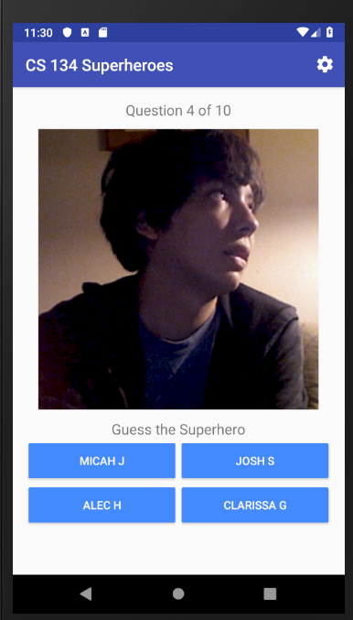

App Running (Superpower):

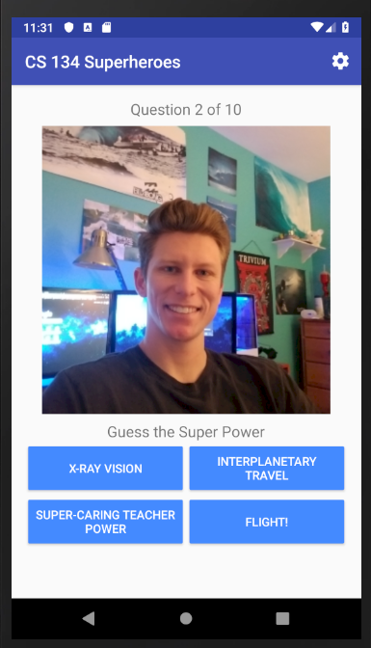

App Running (One Thing):

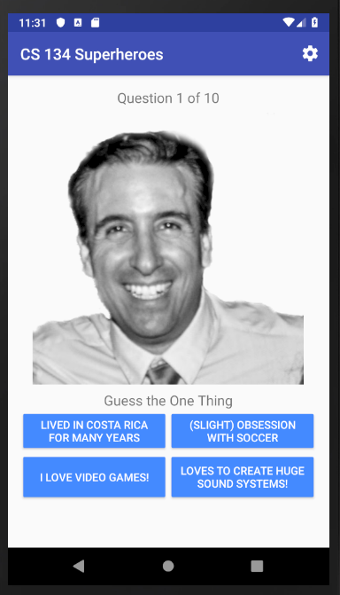

QuizActivity.java:

package edu.miracostacollege.cs134.cs134superheroes;
import android.content.DialogInterface;
import android.content.Intent;
import android.content.SharedPreferences;
import android.content.res.AssetManager;
import android.graphics.drawable.Drawable;
import android.media.MediaPlayer;
import android.os.Bundle;
import android.os.Handler;
import android.preference.PreferenceManager;
import android.support.v7.app.AlertDialog;
import android.support.v7.app.AppCompatActivity;
import android.util.Log;
import android.view.Menu;
import android.view.MenuItem;
import android.view.View;
import android.widget.Button;
import android.widget.ImageView;
import android.widget.TextView;
import android.widget.Toast;
import java.io.IOException;
import java.io.InputStream;
import java.security.SecureRandom;
import java.util.ArrayList;
import java.util.Collections;
import java.util.List;
import edu.miracostacollege.cs134.cs134superheroes.model.Superhero;
import edu.miracostacollege.cs134.cs134superheroes.model.JSONLoader;
/**
* This controller class handles the behavior of the Quiz Activity, which encompasses the entire
* life-cycle of the Superhero Quiz. Gets Superhero data from the JSONLoader and creates a randomized
* quiz. Tracks user input (guesses) as well as the end and restarting of the quiz.
*
* @author William Craycroft
* @version 1.0
*/
public class QuizActivity extends AppCompatActivity {
public static final String TAG = "CS 134 Superheroes";
private static final String TYPE_KEY = "pref_type"; // Pref key for quiz type
private static final int SUPERHEROES_IN_QUIZ = 10; // The number of quiz questions
private String mQuizType; // the quiz type (name, superpower or oneThing)
private Button[] mButtons = new Button[4]; // array of all 4 button objects
private List<Superhero> mAllSuperheroesList; // all the Superheroes loaded from JSON
private List<Superhero> mQuizSuperheroesList; // Superheroes in current quiz
private Superhero mCorrectSuperhero; // correct Superhero for the current question
private int mTotalGuesses; // number of total guesses made
private int mCorrectGuesses; // number of correct guesses
private SecureRandom rng; // used to randomize the quiz
private Handler handler; // used to delay loading next Superhero
private TextView mQuestionNumberTextView; // shows current question #
private ImageView mSuperheroImageView; // displays the image of a Superhero
private TextView mAnswerTextView; // displays correct answer or "Incorrect guess"
private TextView mGuessTypeTextView; // displays what information the user is guessing
// Preference listener object
private SharedPreferences.OnSharedPreferenceChangeListener mSharedPreferenceChangeListener =
new SharedPreferences.OnSharedPreferenceChangeListener() {
@Override
public void onSharedPreferenceChanged(SharedPreferences sharedPreferences, String key) {
Log.i(TAG, "key: " + key);
mQuizType = sharedPreferences.getString(TYPE_KEY,
getString(R.string.default_quiz_type));
resetQuiz();
Toast.makeText(QuizActivity.this, R.string.restarting_quiz,
Toast.LENGTH_SHORT).show();
}
};
/**
* Inflates the activity_quiz layout, links views, and instantiates any resources needed when
* the application is first launched.
*
* @param savedInstanceState - Bundle of data saved from previous state (unused)
*/
@Override
protected void onCreate(Bundle savedInstanceState) {
super.onCreate(savedInstanceState);
setContentView(R.layout.activity_quiz);
// Instantiate list and helper objects
mQuizSuperheroesList = new ArrayList<>(SUPERHEROES_IN_QUIZ);
rng = new SecureRandom();
handler = new Handler();
// Store quiz type value from saved preferences (name, superheroes or oneThing)
try {
mQuizType = PreferenceManager.getDefaultSharedPreferences(this).getString(TYPE_KEY,
getString(R.string.default_quiz_type));
} catch (NullPointerException e) {
Log.e(TAG, e.getMessage());
}
// Log quiz type for debugging purposes
Log.i(TAG, "Quiz type set to " + mQuizType);
// Get references to GUI components (TextViews and ImageView)
mQuestionNumberTextView = findViewById(R.id.questionNumberTextView);
mSuperheroImageView = findViewById(R.id.superheroImageView);
mAnswerTextView = findViewById(R.id.answerTextView);
mGuessTypeTextView = findViewById(R.id.guessTypeTextView);
// Link all 4 buttons to the mButtons array
mButtons[0] = findViewById(R.id.button);
mButtons[1] = findViewById(R.id.button2);
mButtons[2] = findViewById(R.id.button3);
mButtons[3] = findViewById(R.id.button4);
// Set mQuestionNumberTextView's text to the appropriate strings.xml resource
mQuestionNumberTextView.setText(getString(R.string.question, 1, SUPERHEROES_IN_QUIZ));
// Load all the Superheroes from the JSON file using the JSONLoader
try {
mAllSuperheroesList = JSONLoader.loadJSONFromAsset(this);
} catch (IOException e) {
Log.e(TAG, e.getMessage());
}
// Attach preference listener
PreferenceManager.getDefaultSharedPreferences(this)
.registerOnSharedPreferenceChangeListener(mSharedPreferenceChangeListener);
// Call the method resetQuiz() to start the quiz.
resetQuiz();
}
/**
* Generates a new set of randomized Superheroes and starts a new quiz.
*/
public void resetQuiz() {
// Reset the number of correct guesses made
mCorrectGuesses = 0;
// Reset the total number of guesses the user made
mTotalGuesses = 0;
// Clear list of quiz Superheroes (for prior games played)
mQuizSuperheroesList.clear();
// Randomly add SUPERHEROES_IN_QUIZ (10) superheroes from the mAllSuperheroesList into the mQuizSuperheroesList
int size = mAllSuperheroesList.size();
int randomPosition;
Superhero randomSuperhero;
while (mQuizSuperheroesList.size() <= SUPERHEROES_IN_QUIZ) {
randomPosition = rng.nextInt(size);
randomSuperhero = mAllSuperheroesList.get(randomPosition);
// Ensure no duplicate superheroes (e.g. don't add a superhero if it's already in mQuizSuperheroesList)
// Check for duplicates (!contains) before adding to quiz
if (!mQuizSuperheroesList.contains(randomSuperhero)) {
mQuizSuperheroesList.add(randomSuperhero);
}
}
// Set the text of guessTypeTextView based on quiz type
switch(mQuizType) {
case ("name"):
mGuessTypeTextView.setText(R.string.guess_name);
break;
case("superpower"):
mGuessTypeTextView.setText(R.string.guess_superpower);
break;
case("oneThing"):
mGuessTypeTextView.setText(R.string.guess_one_thing);
break;
}
// Start the quiz by calling loadNextSuperhero
loadNextSuperhero();
}
/**
* Method initiates the process of loading the next Superhero for the quiz, showing
* the Superhero's image and then 4 buttons, one of which contains the correct answer.
*/
private void loadNextSuperhero() {
// Initialize the mCorrectSuperhero by removing the item at position 0 in the mQuizSuperheroesList
mCorrectSuperhero = mQuizSuperheroesList.get(0);
mQuizSuperheroesList.remove(0);
// Clear the mAnswerTextView so that it doesn't show text from the previous question
mAnswerTextView.setText("");
// Display current question number in the mQuestionNumberTextView
mQuestionNumberTextView.setText(getString(R.string.question, mCorrectGuesses + 1, SUPERHEROES_IN_QUIZ));
// Use AssetManager to load next image from assets folder
AssetManager am = getAssets();
// Set the image drawable to the correct Superhero image.
try {
InputStream stream = am.open(mCorrectSuperhero.getFileName());
Drawable image = Drawable.createFromStream(stream, mCorrectSuperhero.getName());
mSuperheroImageView.setImageDrawable(image);
} catch (IOException e) {
Log.e(TAG, e.getMessage());
}
// Shuffle the order of all the superheroes (use Collections.shuffle)
do {
Collections.shuffle(mAllSuperheroesList);
}
// If first entry is correct superhero, reshuffle
while (mAllSuperheroesList.subList(0, mButtons.length).contains(mCorrectSuperhero));
// Loop through 4 buttons to be enabled, enable them and set them to the first 4 superheroes
for (int i = 0; i < mButtons.length; i++) {
mButtons[i].setEnabled(true);
// Display info based on quiz type using custom getter in model
mButtons[i].setText(mAllSuperheroesList.get(i).getInfo(mQuizType));
}
// After the loop, randomly replace one of the active buttons with the correct Superhero
mButtons[rng.nextInt(mButtons.length)].setText(mCorrectSuperhero.getInfo(mQuizType));
}
/**
* Handles the click event of one of the 4 buttons indicating the guess of a Superhero's name,
* superpower, or one thing to match the image displayed. If the guess is correct, the correct
* answer is show in green and a success sounds if played, followed by a slight delay of 2 seconds,
* then the next Superhero image will be loaded. Otherwise, the word "Incorrect Guess" will be
* shown in RED, an failure sound will be played and the button will be disabled.
*
* @param v - The view calling this method (should always be a Button object)
*/
public void makeGuess(View v) {
// Instantiate MediaPlayer for success/failure sound files
final MediaPlayer successMP = MediaPlayer.create(this, R.raw.success);
final MediaPlayer failedMP = MediaPlayer.create(this, R.raw.failed);
mTotalGuesses++;
// Downcast the View v into a Button (since it's one of the 4 buttons)
Button clickedButton = (Button) v;
// Get the guessed information from the text of the button
String guessedInfo = clickedButton.getText().toString();
// If the guess matches the correct superhero info...
if (guessedInfo.equalsIgnoreCase(mCorrectSuperhero.getInfo(mQuizType))) {
// Increment the number of correct guesses
mCorrectGuesses++;
// Play correct guess sound
successMP.start();
// If quiz is not over...
if (mCorrectGuesses < SUPERHEROES_IN_QUIZ) {
// Change answer text to correct answer and set text color to green
mAnswerTextView.setText(mCorrectSuperhero.getInfo(mQuizType));
mAnswerTextView.setTextColor(getResources().getColor(R.color.correct_answer));
// Disable all 4 buttons (can't keep guessing once it's correct)
for (int i = 0; i < mButtons.length; i++) {
mButtons[i].setEnabled(false);
}
// Pause before going to next Superhero
handler.postDelayed(new Runnable() {
@Override
public void run() {
loadNextSuperhero();
}
}, 2000);
}
// If quiz is over...
else {
// Create AlertDialog with text and button to reset quiz
AlertDialog.Builder builder = new AlertDialog.Builder(this);
double percentage = (double) mCorrectGuesses / mTotalGuesses * 100.0;
builder.setMessage(getString(R.string.results, mTotalGuesses, percentage));
builder.setPositiveButton(getString(R.string.reset_quiz), new DialogInterface.OnClickListener() {
@Override
public void onClick(DialogInterface dialog, int which) {
resetQuiz();
}
});
// Disable the cancel operation (can't cancel dialog)
builder.setCancelable(false);
builder.create();
builder.show();
}
}
// If answer is incorrect...
else {
// Display "Incorrect Guess!" in red
mAnswerTextView.setText(getString(R.string.incorrect_answer));
mAnswerTextView.setTextColor(getResources().getColor(R.color.incorrect_answer));
// Disable just the incorrect button.
clickedButton.setEnabled(false);
// Play incorrect guess sound
failedMP.start();
}
}
/**
* Inflates an Options Menu which displays a settings icon on the Quiz Activity title bar.
*
* @param menu - The options Menu object
*/
@Override
public boolean onCreateOptionsMenu(Menu menu) {
getMenuInflater().inflate(R.menu.menu_settings, menu);
return super.onCreateOptionsMenu(menu);
}
/**
* Handles the click event for the Options Menu. Creates an empty intent and sends the user to
* the SettingsActivity.
*
* @param item - the selected MenuItem
*/
@Override
public boolean onOptionsItemSelected(MenuItem item) {
Intent settingsIntent = new Intent(this, SettingsActivity.class);
startActivity(settingsIntent);
return super.onOptionsItemSelected(item);
}
}

SettingsActivity.java:

package edu.miracostacollege.cs134.cs134superheroes;
import android.preference.PreferenceFragment;
import android.support.v7.app.AppCompatActivity;
import android.os.Bundle;
/**
* This controller class inflates the Settings Activity and links it to the preferences layout.
* Allows the user to select the type of Superhero information the quiz will ask for.
*
* @author William Craycroft
* @version 1.0
*/
public class SettingsActivity extends AppCompatActivity {
/**
* Inflates the inner SettingsActivityFragment class using FragmentManager.
*
* @param savedInstanceState - Bundle of data saved from previous state (unused)
*/
@Override
protected void onCreate(Bundle savedInstanceState) {
super.onCreate(savedInstanceState);
getSupportActionBar().setDisplayHomeAsUpEnabled(true);
// Display the fragment as the main content
getFragmentManager().beginTransaction().replace(android.R.id.content,
new SettingsActivityFragment()).commit();
}
/**
* This inner class overrides the onCreate in PreferenceFragment in order to manually load
* the preferences XML.
*/
public static class SettingsActivityFragment extends PreferenceFragment {
@Override
public void onCreate(Bundle savedInstanceState) {
super.onCreate(savedInstanceState);
// Load preferences from an XML resource
addPreferencesFromResource(R.xml.preferences);
}
}
}

strings.xml:

<resources>
<string name="app_name">CS 134 Superheroes</string>
<string name="action_settings">Settings</string>
<string name="quiz_type">Quiz Type</string>
<string name="quiz_type_description">Choose superhero name, superpower or one thing about them</string>
<string name="guess_name">Guess the Superhero</string>
<string name="guess_superpower">Guess the Super Power</string>
<string name="guess_one_thing">Guess the One Thing</string>
<string name="results">%1$d guesses, %2$.01f%% correct</string>
<string name="incorrect_answer">Incorrect Guess!</string>
<string name="default_quiz_type_message">One quiz type must be selected. Setting Superhero Name as the default quiz.</string>
<string name="restarting_quiz">Quiz will restart with your new settings.</string>
<string name="question">Question %1$d of %2$d</string>
<string name="reset_quiz">Reset Quiz</string>
<string name="image_description">Image of the current Superhero in the quiz</string>
<string name="default_quiz_type">name</string>
<string name="title_activity_settings">Settings</string>
</resources>

activity_quiz.xml:

<?xml version="1.0" encoding="utf-8"?>
<LinearLayout xmlns:android="http://schemas.android.com/apk/res/android"
android:layout_width="match_parent"
android:layout_height="match_parent"
android:paddingLeft="@dimen/activity_horizontal_margin"
android:paddingRight="@dimen/activity_horizontal_margin"
android:paddingTop="@dimen/activity_vertical_margin"
android:paddingBottom="@dimen/activity_vertical_margin"
android:orientation="vertical"
android:id="@+id/quizLinearLayout">
<TextView
android:layout_width="wrap_content"
android:layout_height="wrap_content"
android:textAppearance="?android:attr/textAppearanceMedium"
android:text="@string/question"
android:id="@+id/questionNumberTextView"
android:layout_gravity="center_horizontal"
android:layout_marginBottom="@dimen/spacing"/>
<ImageView
android:layout_width="match_parent"
android:layout_height="0dp"
android:id="@+id/superheroImageView"
android:layout_gravity="center"
android:layout_marginBottom="@dimen/spacing"
android:layout_marginLeft="@dimen/activity_horizontal_margin"
android:layout_marginRight="@dimen/activity_horizontal_margin"
android:layout_weight="1"
android:adjustViewBounds="true"
android:contentDescription="@string/image_description"
android:scaleType="fitCenter"/>
<TextView
android:id="@+id/guessTypeTextView"
android:layout_width="wrap_content"
android:layout_height="wrap_content"
android:layout_gravity="center_horizontal"
android:text="@string/guess_name"
android:textAppearance="?android:attr/textAppearanceMedium" />
<LinearLayout
android:orientation="horizontal"
android:layout_width="match_parent"
android:layout_height="wrap_content"
android:id="@+id/row1LinearLayout">
<Button
android:id="@+id/button"
style="@style/Widget.AppCompat.Button.Colored"
android:layout_width="0dp"
android:layout_height="match_parent"
android:layout_weight="1"
android:lines="2"
android:onClick="makeGuess"
android:text="New Button" />
<Button
android:id="@+id/button2"
style="@style/Widget.AppCompat.Button.Colored"
android:layout_width="0dp"
android:layout_height="match_parent"
android:layout_weight="1"
android:lines="2"
android:onClick="makeGuess"
android:text="New Button" />
</LinearLayout>
<LinearLayout
android:orientation="horizontal"
android:layout_width="match_parent"
android:layout_height="wrap_content"
android:id="@+id/row2LinearLayout">
<Button
android:id="@+id/button3"
style="@style/Widget.AppCompat.Button.Colored"
android:layout_width="0dp"
android:layout_height="match_parent"
android:layout_weight="1"
android:lines="2"
android:onClick="makeGuess"
android:text="New Button" />
<Button
android:id="@+id/button4"
style="@style/Widget.AppCompat.Button.Colored"
android:layout_width="0dp"
android:layout_height="match_parent"
android:layout_weight="1"
android:lines="2"
android:onClick="makeGuess"
android:text="New Button" />
</LinearLayout>
<TextView
android:layout_width="wrap_content"
android:layout_height="wrap_content"
android:textAppearance="?android:attr/textAppearanceMedium"
android:text="Medium Text"
android:id="@+id/answerTextView"
android:layout_gravity="bottom|center_horizontal"
android:gravity="center_horizontal"
android:textSize="@dimen/answer_size"
android:textStyle="bold"/>
</LinearLayout>

activity_settings.xml:

<?xml version="1.0" encoding="utf-8"?>
<android.support.constraint.ConstraintLayout xmlns:android="http://schemas.android.com/apk/res/android"
xmlns:app="http://schemas.android.com/apk/res-auto"
xmlns:tools="http://schemas.android.com/tools"
android:layout_width="match_parent"
android:layout_height="match_parent"
tools:context=".SettingsActivity">
</android.support.constraint.ConstraintLayout>

