Earth Model Report
Table of contents

Dataset Description
Property | Value
Observations | 1486
Target variable(s) | sale_price, rent
Predictors used | sale_age, living_sqft, beds_total, baths_total, lot_size, area_id, age, latitude, longitude, garage_spaces, no_of_stories, style
Categorical predictors | area_id, no_of_stories, style

Model Specification
Parameter | Value
Degree | 2
Cross-validation | Yes (10-fold)
Number of terms | 22
Predictors in model | 7
Response variables | 2

Allowed Interactions
 | sale_age | living_sqft | beds_total | baths_total | lot_size | area_id | age | latitude | longitude | garage_spac… | no_of_stori… | style
sale_age |  | ✓ | ✓ | ✓ | ✓ | ✓ | — | — | — | ✓ | ✓ | ✓
living_sqft | ✓ |  | ✓ | ✓ | ✓ | ✓ | — | — | — | ✓ | — | —
beds_total | ✓ | ✓ |  | — | — | — | — | — | — | — | — | —
baths_total | ✓ | ✓ | — |  | — | — | — | — | — | — | — | —
lot_size | ✓ | ✓ | — | — |  | — | — | — | — | — | — | —
area_id | ✓ | ✓ | — | — | — |  | — | — | — | — | — | —
age | — | — | — | — | — | — |  | — | — | — | — | —
latitude | — | — | — | — | — | — | — |  | ✓ | — | — | —
longitude | — | — | — | — | — | — | — | ✓ |  | — | — | —
garage_spac… | ✓ | ✓ | — | — | — | — | — | — | — |  | — | —
no_of_stori… | ✓ | — | — | — | — | — | — | — | — | — |  | —
style | ✓ | — | — | — | — | — | — | — | — | — | —

Coefficients & Basis Functions
term | sale_price | rent
(Intercept) | 3589507.3606 | 9106.5850
h(living_sqft-2970) | 416.5580 | 0.9898
h(2970-living_sqft) | -920.5400 | -2.2481
h(living_sqft-2970)*area_id460 | 1411.8135 | 3.9102
h(5983-lot_size) | -193.3221 | -0.5093
h(age-38) | 9244.5644 | 17.9031
h(38-age) | 24370.0317 | 54.7924
h(sale_age-1398) | -1086.4486 | -2.5275
h(1398-sale_age) | -267.6022 | -0.4855
h(1161-sale_age)*h(living_sqft-2970) | 0.6328 | 0.0008
h(living_sqft-2970)*area_id466 | 819.0668 | 2.2042
h(sale_age-1017)*h(2970-living_sqft) | 0.2839 | 0.0006
h(1017-sale_age)*h(2970-living_sqft) | 0.3490 | 0.0007
h(sale_age-1976) | 755.1171 | 1.6611
h(living_sqft-2970)*h(7991-lot_size) | -0.3694 | -0.0008
h(living_sqft-2970)*h(4-beds_total) | -2914.2532 | -7.2606
h(beds_total-5) | -353907.6691 | -1066.2921
h(5-beds_total) | -54920.1762 | -139.9260
area_id466 | 390663.5043 | 886.0832
area_id460 | 237283.3111 | 545.8780
h(age-68) | -13051.3944 | -27.6536
h(2970-living_sqft)*area_id466 | -225.2542 | -0.5091

Variable Importance
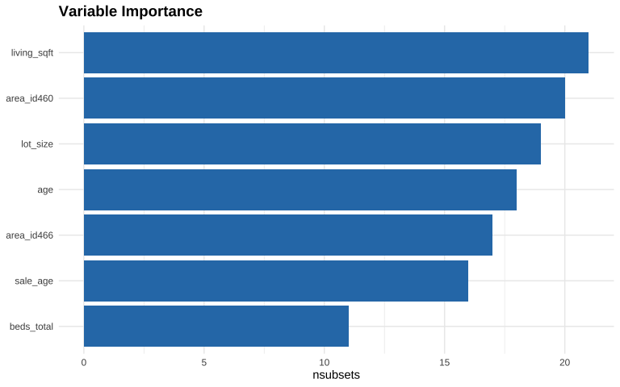
variable | nsubsets | gcv | rss
living_sqft | 21 | 100.0000 | 100.0000
area_id460 | 20 | 53.3092 | 53.7312
lot_size | 19 | 40.7195 | 41.3224
age | 18 | 32.3420 | 33.1207
area_id466 | 17 | 27.1425 | 28.0508
sale_age | 16 | 22.9018 | 23.9454
beds_total | 11 | 12.3538 | 13.7288

Correlation Matrix
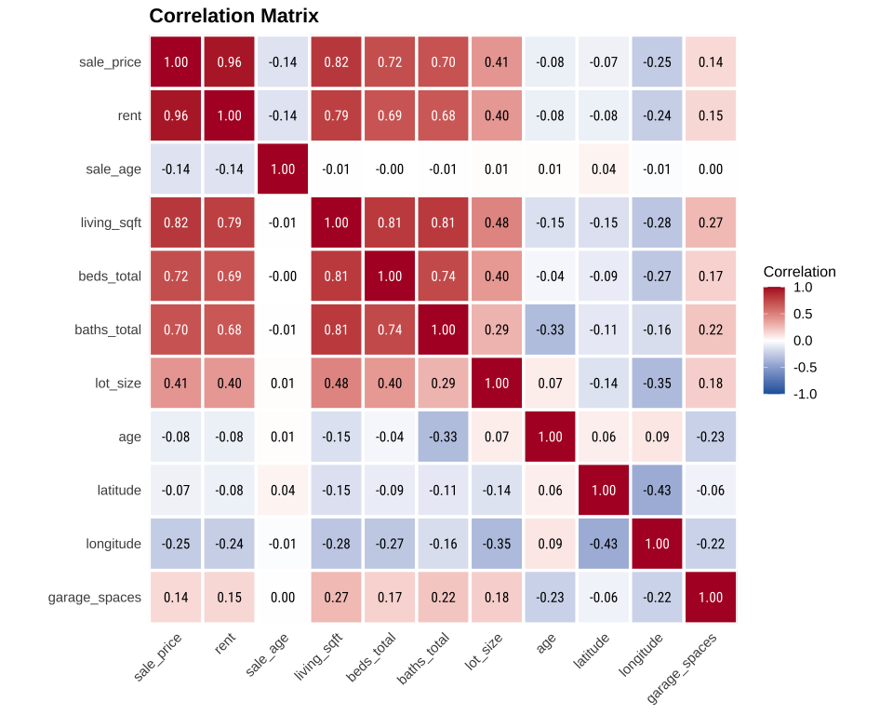

Response: sale_price

Summary
Metric | Value
R² | 0.8820
GRSq | 0.8750
GCV | 164427258682.5426
RSS | 230402755696141.06
CV R² | 0.8398

Model Equation
$$\begin{matrix}\text{Basis} & ​^{0}g_{1}^{0} = & 3589507 \\ \text{living_sqft} & ​^{0}g_{1}^{1} = & 416.558⋅max\left(0,\text{living_sqft}−2970\right) \\ & & −920.54⋅max\left(0,2970−\text{living_sqft}\right) \\ \text{lot_size} & ​^{0}g_{2}^{1} = & −193.3221⋅max\left(0,5983−\text{lot_size}\right) \\ \text{age} & ​^{0}g_{3}^{1} = & 9244.564⋅max\left(0,\text{age}−38\right) \\ & & +24370.03⋅max\left(0,38−\text{age}\right) \\ & & −13051.39⋅max\left(0,\text{age}−68\right) \\ \text{sale_age} & ​^{0}g_{4}^{1} = & −1086.449⋅max\left(0,\text{sale_age}−1398\right) \\ & & −267.6022⋅max\left(0,1398−\text{sale_age}\right) \\ & & +755.1171⋅max\left(0,\text{sale_age}−1976\right) \\ \text{beds_total} & ​^{0}g_{5}^{1} = & −353907.7⋅max\left(0,\text{beds_total}−5\right) \\ & & −54920.18⋅max\left(0,5−\text{beds_total}\right) \\ \text{area_id} & ​^{1}g_{6}^{1} = & 390663.5⋅I\{\text{area_id}=\text{466}\} \\ & & +237283.3⋅I\{\text{area_id}=\text{460}\} \\ \{\text{area_id}, \text{living_sqft}\} & ​^{1}g_{1}^{2} = & 1411.813⋅max\left(0,\text{living_sqft}−2970\right)⋅I\{\text{area_id}=\text{460}\} \\ & & +819.0668⋅max\left(0,\text{living_sqft}−2970\right)⋅I\{\text{area_id}=\text{466}\} \\ & & −225.2542⋅max\left(0,2970−\text{living_sqft}\right)⋅I\{\text{area_id}=\text{466}\} \\ \{\text{living_sqft}, \text{sale_age}\} & ​^{0}g_{2}^{2} = & 0.6327595⋅max\left(0,1161−\text{sale_age}\right)⋅max\left(0,\text{living_sqft}−2970\right) \\ & & +0.2838743⋅max\left(0,\text{sale_age}−1017\right)⋅max\left(0,2970−\text{living_sqft}\right) \\ & & +0.3489544⋅max\left(0,1017−\text{sale_age}\right)⋅max\left(0,2970−\text{living_sqft}\right) \\ \{\text{living_sqft}, \text{lot_size}\} & ​^{0}g_{3}^{2} = & −0.3694047⋅max\left(0,\text{living_sqft}−2970\right)⋅max\left(0,7991−\text{lot_size}\right) \\ \{\text{beds_total}, \text{living_sqft}\} & ​^{0}g_{4}^{2} = & −2914.253⋅max\left(0,\text{living_sqft}−2970\right)⋅max\left(0,4−\text{beds_total}\right)\end{matrix}$$

g-Function Contributions

living_sqft
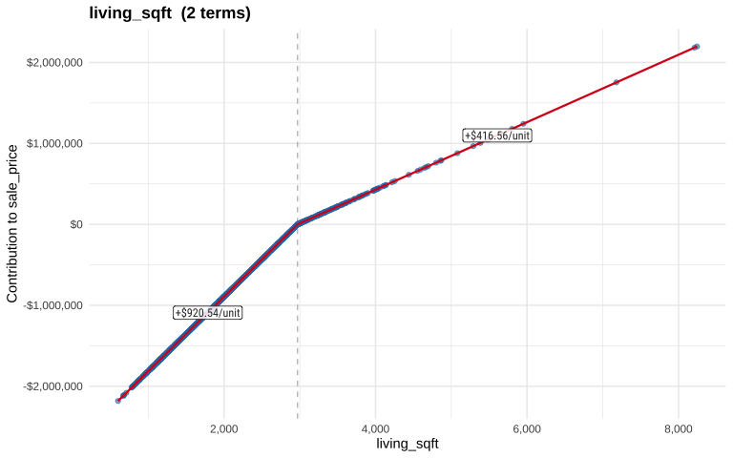

lot_size
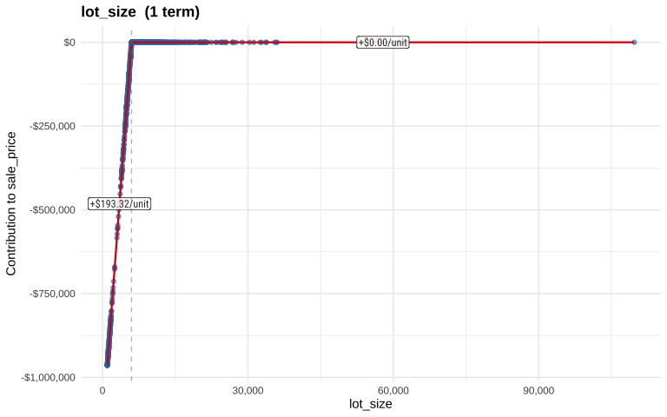

age
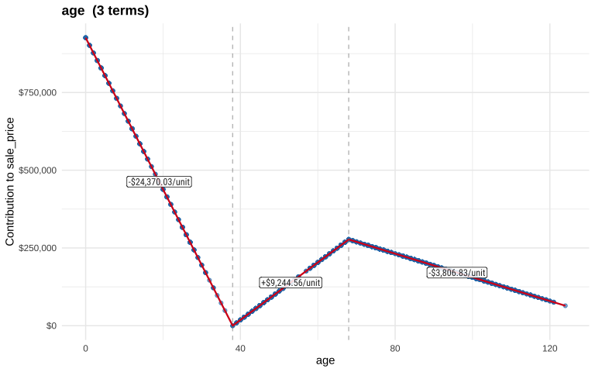

sale_age
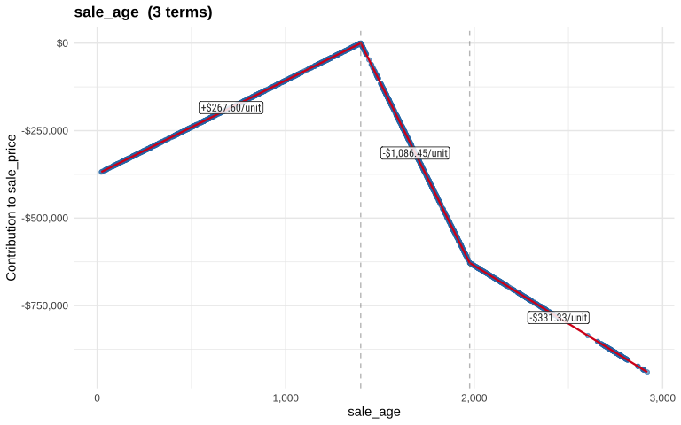

beds_total
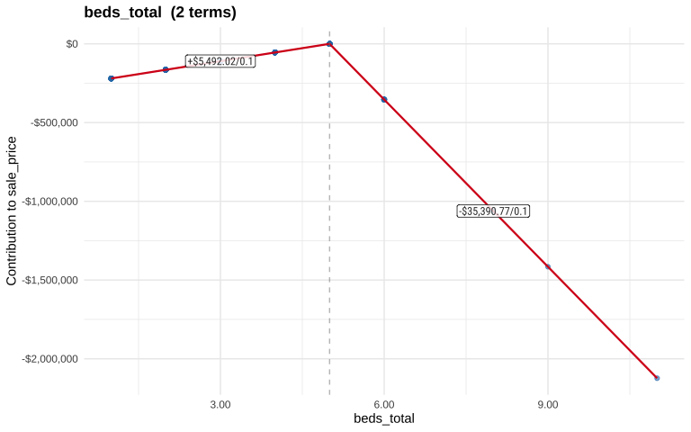

area_id
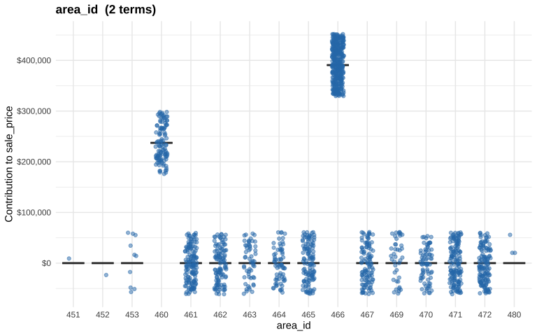

area_id living_sqft
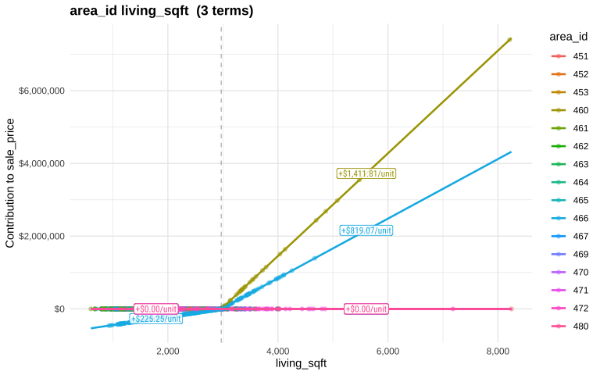

living_sqft × sale_age
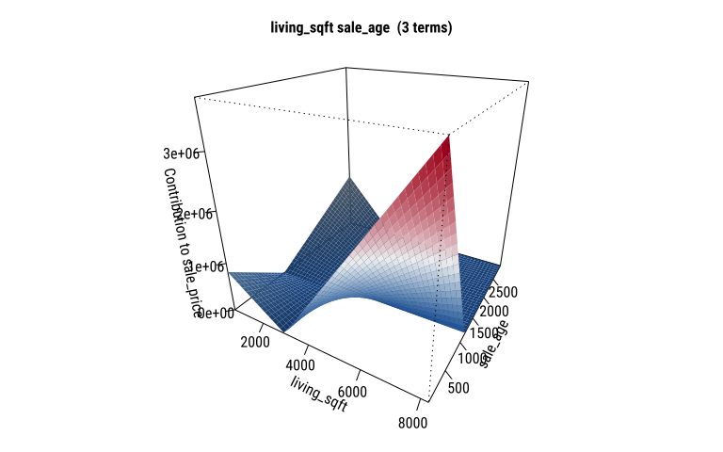
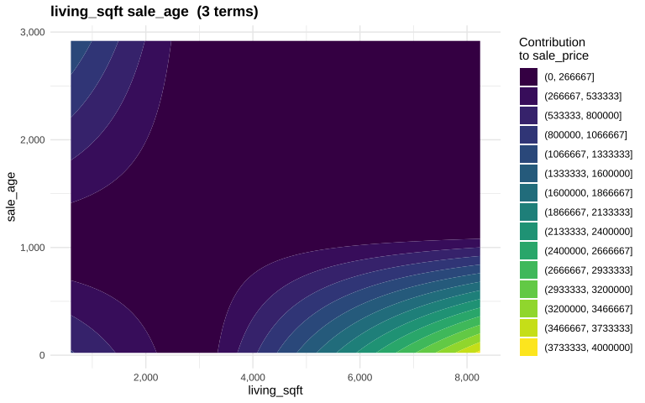

living_sqft × lot_size
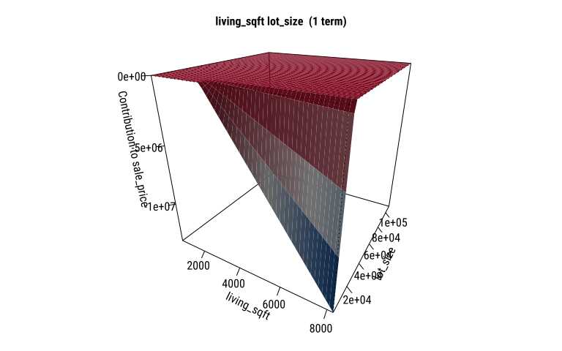
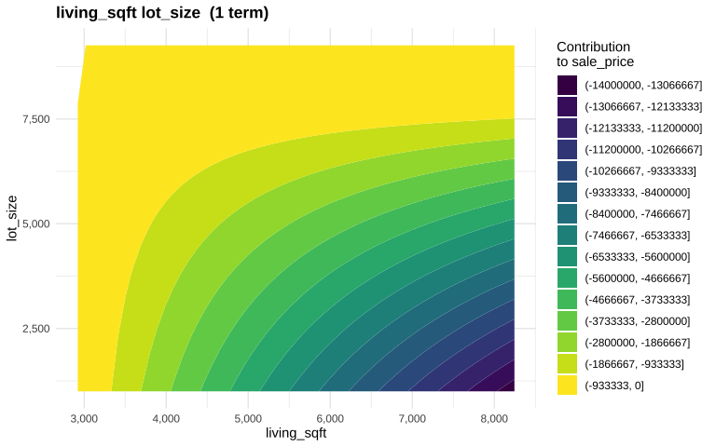

beds_total × living_sqft
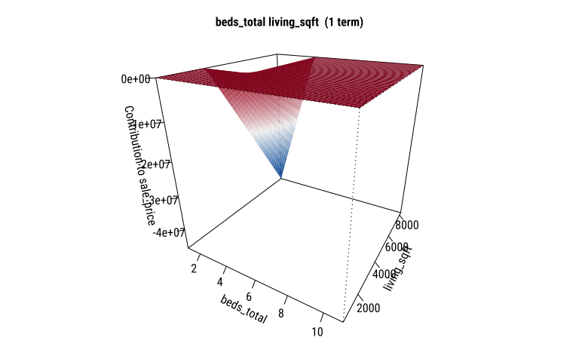
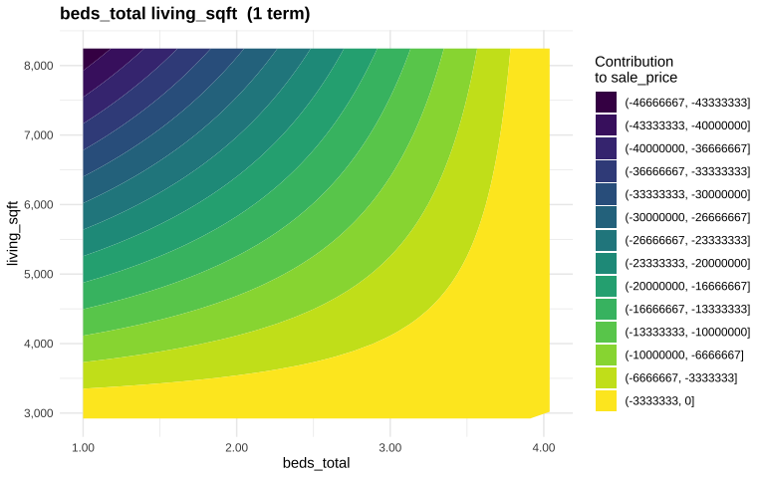

Diagnostics

Residuals vs Fitted
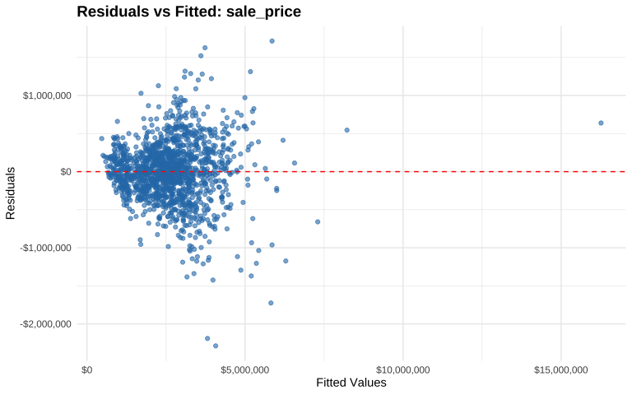

Normal Q-Q Plot
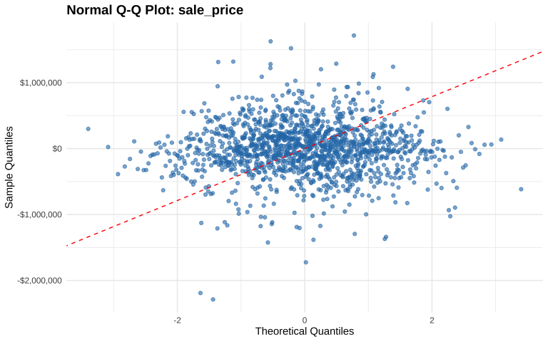

Actual vs Predicted
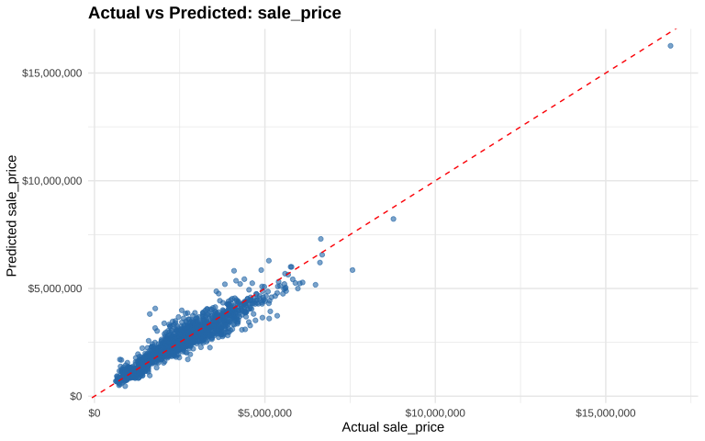

Response: rent

Summary
Metric | Value
R² | 0.8142
GRSq | 0.8033
GCV | 1722822.1770
RSS | 2414094720.86
CV R² | 0.7674

Model Equation
$$\begin{matrix}\text{Basis} & ​^{0}g_{1}^{0} = & 9106.585 \\ \text{living_sqft} & ​^{0}g_{1}^{1} = & 0.9898426⋅max\left(0,\text{living_sqft}−2970\right) \\ & & −2.248148⋅max\left(0,2970−\text{living_sqft}\right) \\ \text{lot_size} & ​^{0}g_{2}^{1} = & −0.5093145⋅max\left(0,5983−\text{lot_size}\right) \\ \text{age} & ​^{0}g_{3}^{1} = & 17.90314⋅max\left(0,\text{age}−38\right) \\ & & +54.79245⋅max\left(0,38−\text{age}\right) \\ & & −27.65357⋅max\left(0,\text{age}−68\right) \\ \text{sale_age} & ​^{0}g_{4}^{1} = & −2.527498⋅max\left(0,\text{sale_age}−1398\right) \\ & & −0.4854587⋅max\left(0,1398−\text{sale_age}\right) \\ & & +1.661082⋅max\left(0,\text{sale_age}−1976\right) \\ \text{beds_total} & ​^{0}g_{5}^{1} = & −1066.292⋅max\left(0,\text{beds_total}−5\right) \\ & & −139.926⋅max\left(0,5−\text{beds_total}\right) \\ \text{area_id} & ​^{1}g_{6}^{1} = & 886.0832⋅I\{\text{area_id}=\text{466}\} \\ & & +545.878⋅I\{\text{area_id}=\text{460}\} \\ \{\text{area_id}, \text{living_sqft}\} & ​^{1}g_{1}^{2} = & 3.910167⋅max\left(0,\text{living_sqft}−2970\right)⋅I\{\text{area_id}=\text{460}\} \\ & & +2.204193⋅max\left(0,\text{living_sqft}−2970\right)⋅I\{\text{area_id}=\text{466}\} \\ & & −0.5091287⋅max\left(0,2970−\text{living_sqft}\right)⋅I\{\text{area_id}=\text{466}\} \\ \{\text{living_sqft}, \text{sale_age}\} & ​^{0}g_{2}^{2} = & 0.0008298394⋅max\left(0,1161−\text{sale_age}\right)⋅max\left(0,\text{living_sqft}−2970\right) \\ & & +0.0006479528⋅max\left(0,\text{sale_age}−1017\right)⋅max\left(0,2970−\text{living_sqft}\right) \\ & & +0.0006919883⋅max\left(0,1017−\text{sale_age}\right)⋅max\left(0,2970−\text{living_sqft}\right) \\ \{\text{living_sqft}, \text{lot_size}\} & ​^{0}g_{3}^{2} = & −0.0008038014⋅max\left(0,\text{living_sqft}−2970\right)⋅max\left(0,7991−\text{lot_size}\right) \\ \{\text{beds_total}, \text{living_sqft}\} & ​^{0}g_{4}^{2} = & −7.260569⋅max\left(0,\text{living_sqft}−2970\right)⋅max\left(0,4−\text{beds_total}\right)\end{matrix}$$

g-Function Contributions

living_sqft
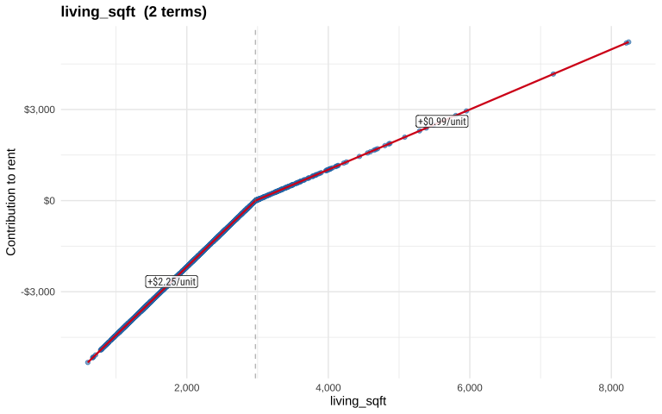

lot_size
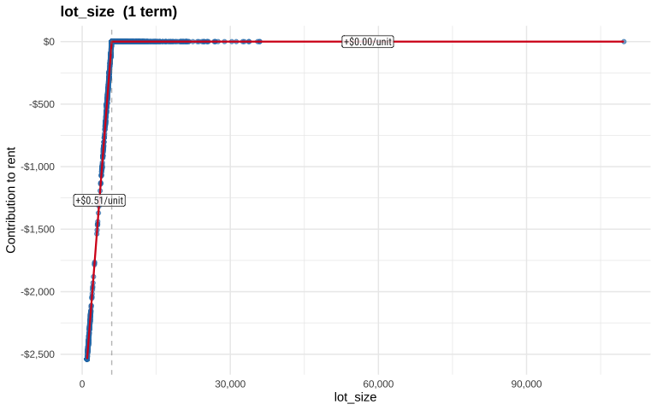

age
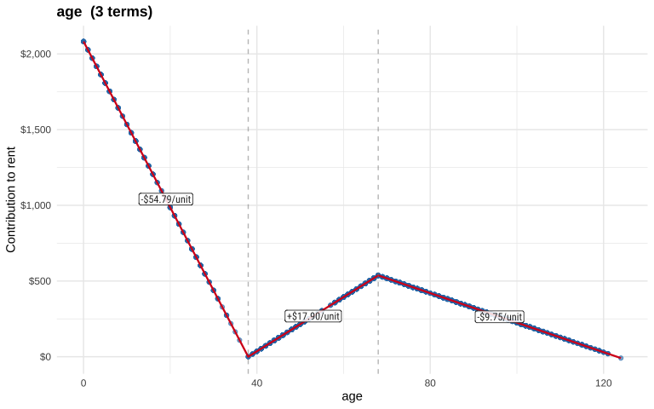

sale_age
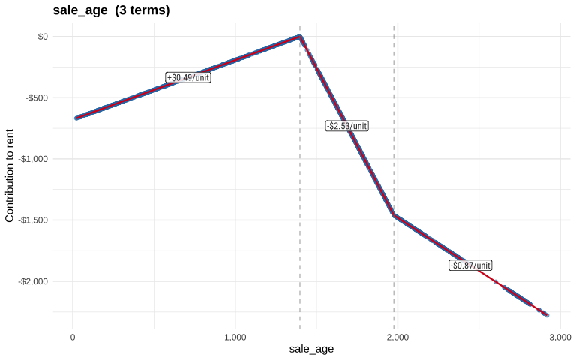

beds_total
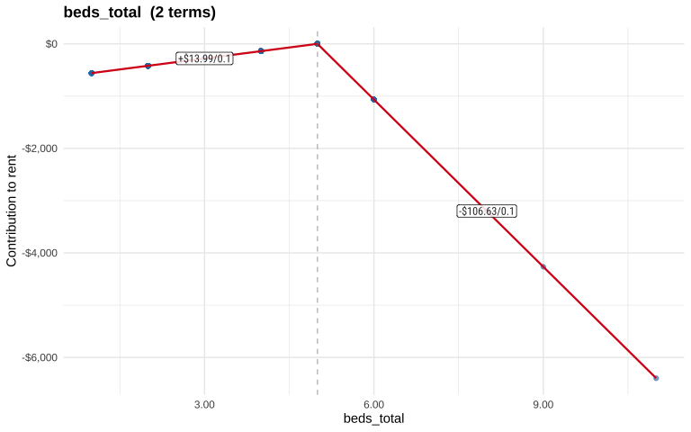

area_id
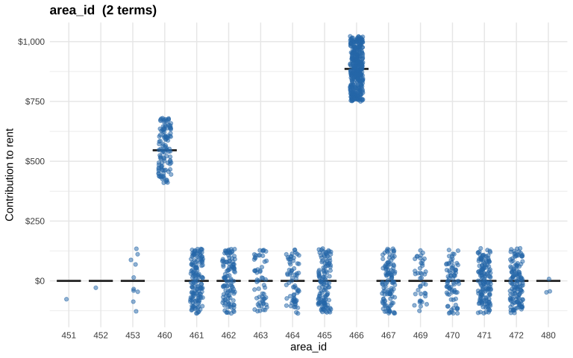

area_id living_sqft
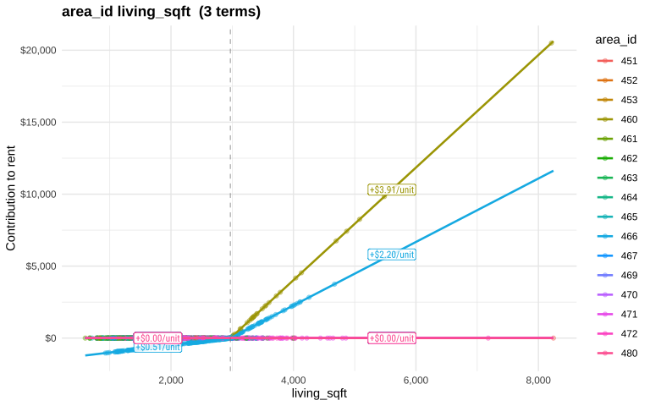

living_sqft × sale_age
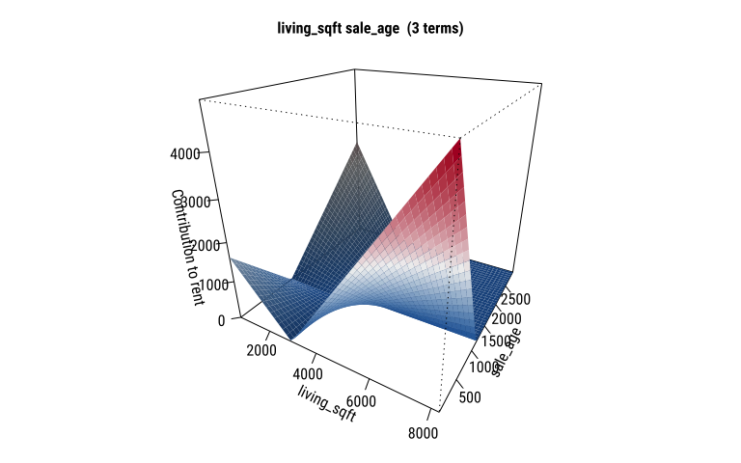
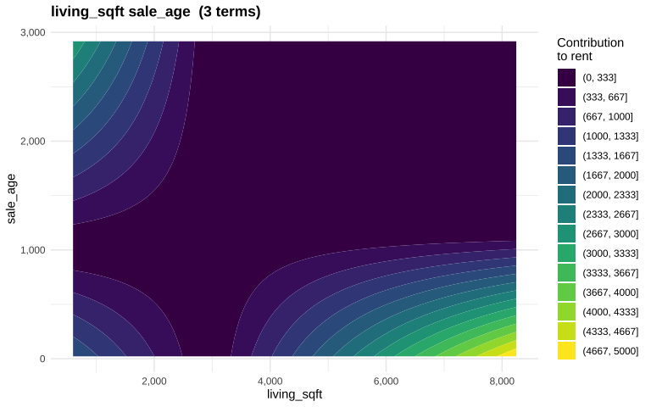

living_sqft × lot_size
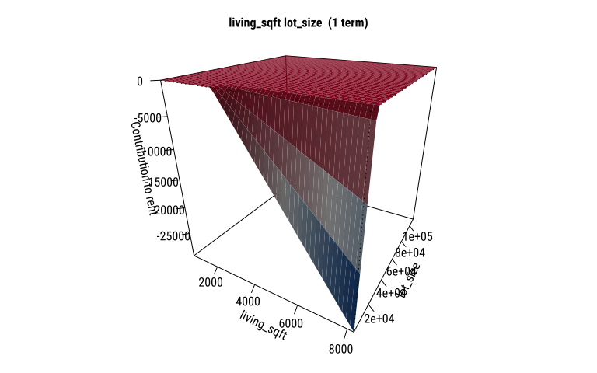
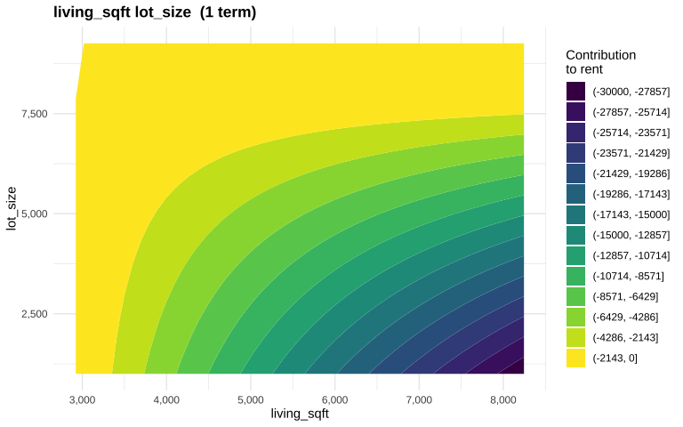

beds_total × living_sqft
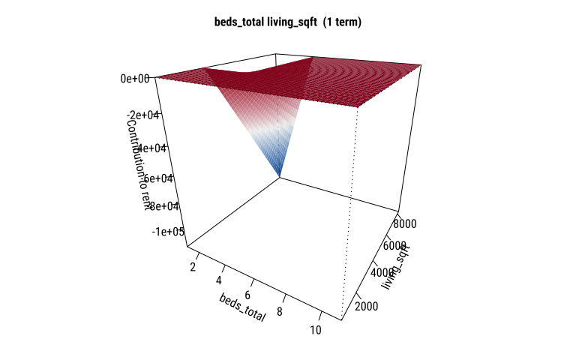
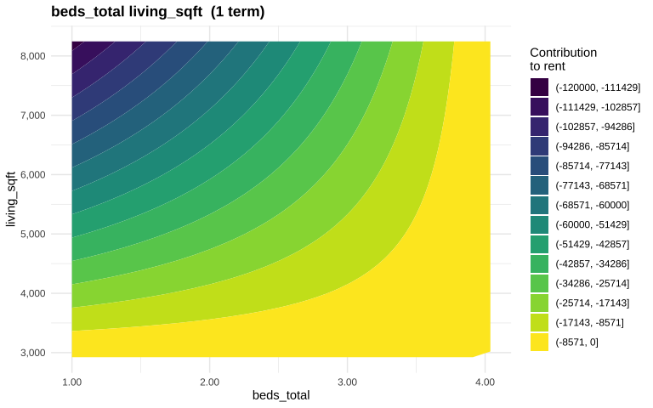

Diagnostics

Residuals vs Fitted
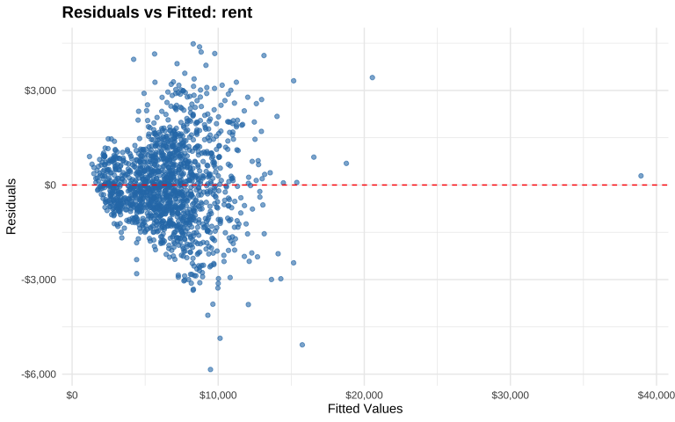

Normal Q-Q Plot
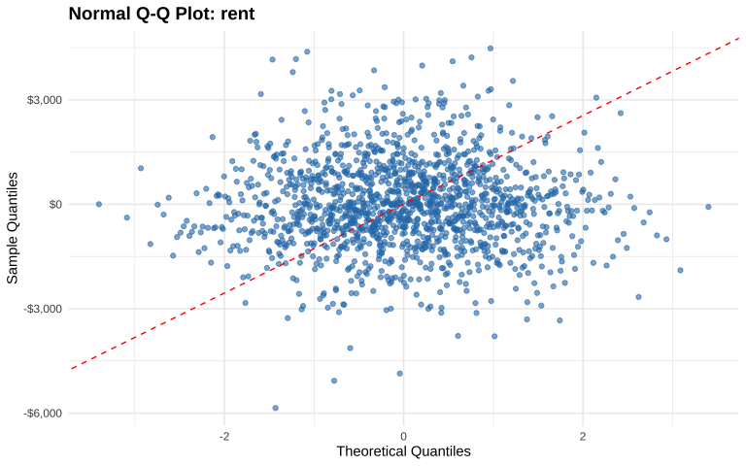

Actual vs Predicted
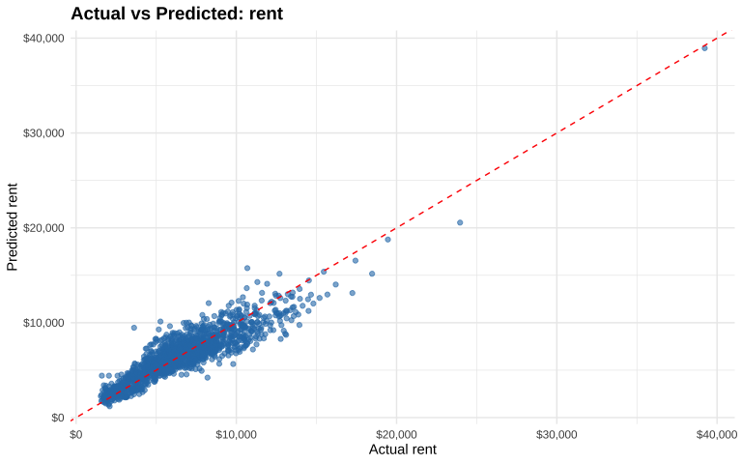

ANOVA Decomposition
term | description | variables | sale_price | rent
1 | (Intercept) |  | 3589507.3606 | 9106.5850
2 | h(living_sqft - 2970) | living_sqft | 416.5580 | 0.9898
3 | h(2970 - living_sqft) | living_sqft | -920.5400 | -2.2481
4 | h(living_sqft - 2970) * h(0 - area_id460) | living_sqft, area_id460 | 1411.8135 | 3.9102
5 | h(5983 - lot_size) | lot_size | -193.3221 | -0.5093
6 | h(age - 38) | age | 9244.5644 | 17.9031
7 | h(38 - age) | age | 24370.0317 | 54.7924
8 | h(sale_age - 1398) | sale_age | -1086.4486 | -2.5275
9 | h(1398 - sale_age) | sale_age | -267.6022 | -0.4855
10 | h(1161 - sale_age) * h(living_sqft - 2970) | sale_age, living_sqft | 0.6328 | 0.0008
11 | h(living_sqft - 2970) * h(0 - area_id466) | living_sqft, area_id466 | 819.0668 | 2.2042
12 | h(sale_age - 1017) * h(2970 - living_sqft) | sale_age, living_sqft | 0.2839 | 0.0006
13 | h(1017 - sale_age) * h(2970 - living_sqft) | sale_age, living_sqft | 0.3490 | 0.0007
14 | h(sale_age - 1976) | sale_age | 755.1171 | 1.6611
15 | h(living_sqft - 2970) * h(7991 - lot_size) | living_sqft, lot_size | -0.3694 | -0.0008
16 | h(living_sqft - 2970) * h(4 - beds_total) | living_sqft, beds_total | -2914.2532 | -7.2606
17 | h(beds_total - 5) | beds_total | -353907.6691 | -1066.2921
18 | h(5 - beds_total) | beds_total | -54920.1762 | -139.9260
19 | h(0 - area_id466) | area_id466 | 390663.5043 | 886.0832
20 | h(0 - area_id460) | area_id460 | 237283.3111 | 545.8780
21 | h(age - 68) | age | -13051.3944 | -27.6536
22 | h(2970 - living_sqft) * h(0 - area_id466) | living_sqft, area_id466 | -225.2542 | -0.5091

Earth Output
== Model ==
Selected 22 of 26 terms, and 7 of 108 predictors (nprune=60)
Termination condition: Reached nk 33
Importance: living_sqft, area_id460, lot_size, age, area_id466, sale_age, ...
Number of terms at each degree of interaction: 1 13 8
GCV RSS GRSq RSq CVRSq
sale_price 164427258683 2.304028e+14 0.8749910 0.8819622 0.8398118
rent 1722822 2.414095e+09 0.8032669 0.8142379 0.7673516
All 219237493458 3.072053e+14 0.8749908 0.8819620 0.8156584
== Summary ==
Call: earth(formula=cbind(sale_price,rent)~., data=data.frame[1486,14],
weights=c(1,1,1,1,1,1,1...), wp=c(2,1), pmethod="backward",
keepxy=TRUE, trace=1, degree=2, nprune=60, nfold=10, ncross=5,
stratify=TRUE, varmod.exponent=1, varmod.conv=1, varmod.clamp=0.1,
varmod.minspan=-3, Scale.y=FALSE, thresh=0.001, penalty=2,
minspan=9, endspan=12, fast.k=60, nk=33, newvar.penalty=2,
fast.beta=1, Adjust.endspan=2, Auto.linpreds=TRUE,
Force.weights=FALSE, Use.beta.cache=TRUE, Force.xtx.prune=FALSE,
Get.leverages=TRUE, Exhaustive.tol=1e-10, allowed=function.object)
sale_price rent
(Intercept) 3589507.4 9106.5850
area_id460 237283.3 545.8780
area_id466 390663.5 886.0832
h(1398-sale_age) -267.6 -0.4855
h(sale_age-1398) -1086.4 -2.5275
h(sale_age-1976) 755.1 1.6611
h(2970-living_sqft) -920.5 -2.2481
h(living_sqft-2970) 416.6 0.9898
h(5-beds_total) -54920.2 -139.9260
h(beds_total-5) -353907.7 -1066.2921
h(5983-lot_size) -193.3 -0.5093
h(38-age) 24370.0 54.7924
h(age-38) 9244.6 17.9031
h(age-68) -13051.4 -27.6536
h(living_sqft-2970) * area_id460 1411.8 3.9102
h(2970-living_sqft) * area_id466 -225.3 -0.5091
h(living_sqft-2970) * area_id466 819.1 2.2042
h(1017-sale_age) * h(2970-living_sqft) 0.3 0.0007
h(sale_age-1017) * h(2970-living_sqft) 0.3 0.0006
h(1161-sale_age) * h(living_sqft-2970) 0.6 0.0008
h(living_sqft-2970) * h(4-beds_total) -2914.3 -7.2606
h(living_sqft-2970) * h(7991-lot_size) -0.4 -0.0008
Selected 22 of 26 terms, and 7 of 108 predictors (nprune=60)
Termination condition: Reached nk 33
Importance: living_sqft, area_id460, lot_size, age, area_id466, sale_age, ...
Number of terms at each degree of interaction: 1 13 8
GCV RSS GRSq RSq CVRSq
sale_price 164427258683 2.304028e+14 0.8749910 0.8819622 0.8398118
rent 1722822 2.414095e+09 0.8032669 0.8142379 0.7673516
All 219237493458 3.072053e+14 0.8749908 0.8819620 0.8156584
Note: the cross-validation sd's below are standard deviations across folds
Cross validation: nterms 21.86 sd 1.46 nvars 7.48 sd 0.76
CVRSq sd MaxErr sd
sale_price 0.840 0.042 4280387 2271426
rent 0.767 0.053 -16908 6468
All 0.816 0.044 4280387 2271426

Report generated by earthUI on 2026-03-05 23:12:22.984012

