mgcvUI GAM Report
Date: 2026-03-28 01:27

Equation
Family: gaussian(link = "identity") Method: REML

log10(sale_price) = -31.2954 + f1(sale_age) + f2(living_sqft) + f3(beds_total) + f4(baths_total) + f5(age) + f6(garage_spaces) + f7(living_sqft, sale_age) + f8(beds_total, living_sqft) + f9(baths_total, living_sqft) + 0 * lot_size - 5e-04 * area_id - 0.1711 * latitude - 0.3652 * longitude

Smooth function definitions:
f1 -> s(sale_age) -- cubic regression spline, k = 6
f2 -> s(living_sqft) -- thin plate regression spline, k = 10
f3 -> s(beds_total) -- thin plate regression spline, k = 8
f4 -> s(baths_total) -- cubic regression spline, k = 4
f5 -> s(age) -- thin plate regression spline, k = 10
f6 -> s(garage_spaces) -- thin plate regression spline, k = 5
f7 -> ti(living_sqft,sale_age) -- tensor product smooth, k = 5 x 5
f8 -> ti(beds_total,living_sqft) -- tensor product smooth, k = 5 x 5
f9 -> ti(baths_total,living_sqft) -- tensor product smooth, k = 5 x 5

Smooth Function Definitions
Term | Variable | Type | Basis | k | Knots
s(sale_age, bs="cr", k=6) | sale_age | s | cr | 6 | 552, 757, 1163, 1393, 1883, 1932
s(living_sqft) | living_sqft | s | tp | default | 2970, 3100
s(beds_total, k=8) | beds_total | s | tp | 8 | 3, 4
s(baths_total, bs="cr", k=4) | baths_total | s | cr | 4 | 2, 3.5, 4, 5
lot_size | lot_size | linear | - | default | -
area_id | area_id | linear | - | default | -
s(age) | age | s | tp | default | 39, 79
latitude | latitude | linear | - | default | 37.724, 37.728
longitude | longitude | linear | - | default | -121.472, -121.447
s(garage_spaces, k=5) | garage_spaces | s | tp | 5 | 3
ti(living_sqft, sale_age) | living_sqft, sale_age | ti | tp | default | 2970, 3100
ti(beds_total, living_sqft) | beds_total, living_sqft | ti | tp | default | 3, 4
ti(baths_total, living_sqft) | baths_total, living_sqft | ti | tp | default | 2, 3.5, 4, 5

Model Summary
R-squared: 0.8591
Deviance explained: 86.3 %
AIC: -3464.9
n: 1488
CV R-squared: 0.8344
Family: gaussian
Method: REML

Smooth Terms
Term | EDF | Ref.df | F | p_value
s(sale_age) | 4.52 | 5 | 35.22 | < 2e-16
s(living_sqft) | 4.90 | 9 | 46.20 | < 2e-16
s(beds_total) | 2.07 | 7 | 2.75 | 4.95e-07
s(baths_total) | 0.00 | 3 | 0.00 | 0.918371
s(age) | 7.30 | 9 | 59.78 | < 2e-16
s(garage_spaces) | 2.42 | 4 | 3.59 | 0.000515
ti(living_sqft,sale_age) | 4.76 | 16 | 3.43 | < 2e-16
ti(beds_total,living_sqft) | 5.29 | 16 | 2.70 | < 2e-16
ti(baths_total,living_sqft) | 3.03 | 16 | 4.15 | < 2e-16

Parametric Terms
Term | Estimate | Std_Error | t_value | p_value
(Intercept) | -31.2954 | 17.8843 | -1.750 | 0.080350
lot_size | 0.0000 | 0.0000 | 3.746 | 0.000187
area_id | -0.0005 | 0.0009 | -0.577 | 0.563766
latitude | -0.1711 | 0.3440 | -0.497 | 0.618932
longitude | -0.3652 | 0.1899 | -1.923 | 0.054616

Variable Importance
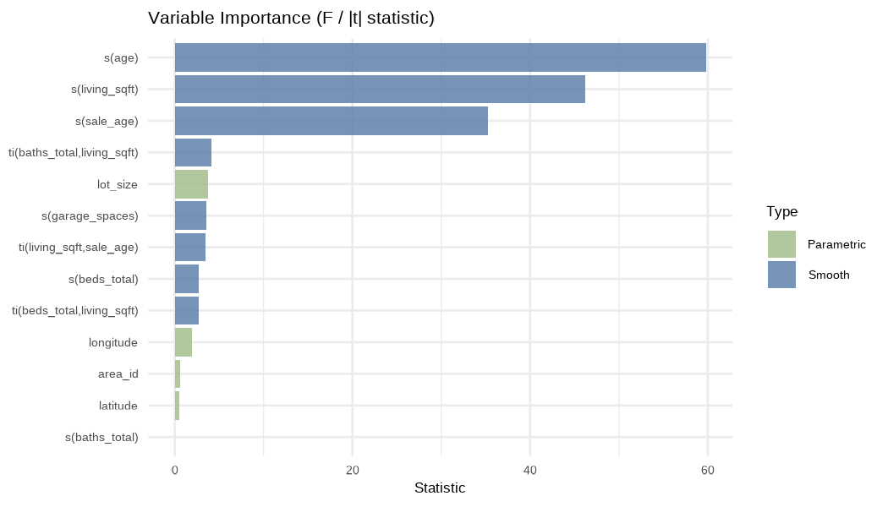

Contribution Plots
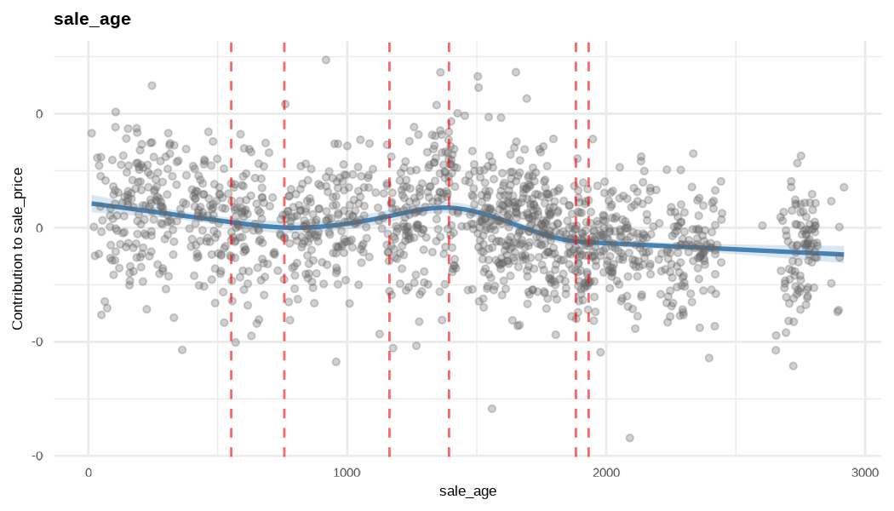

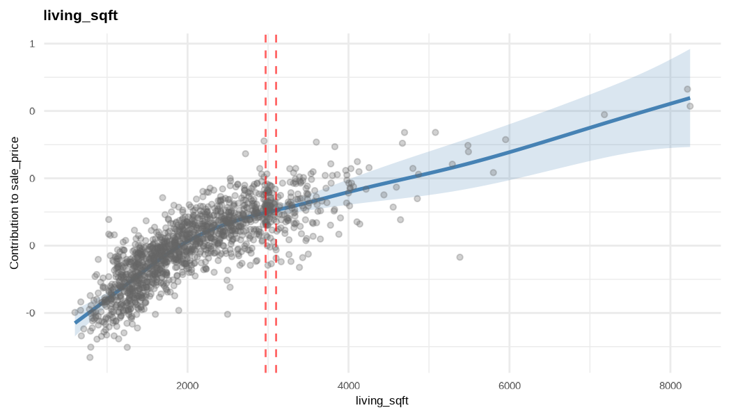

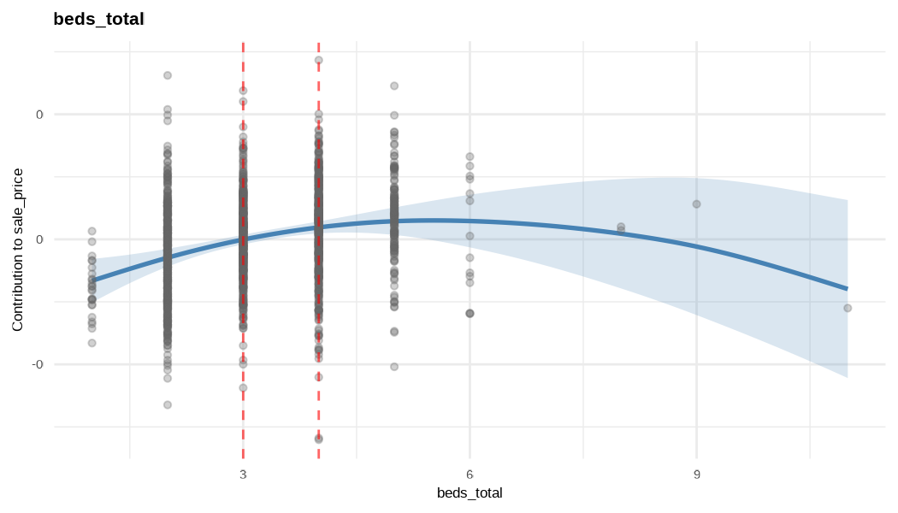

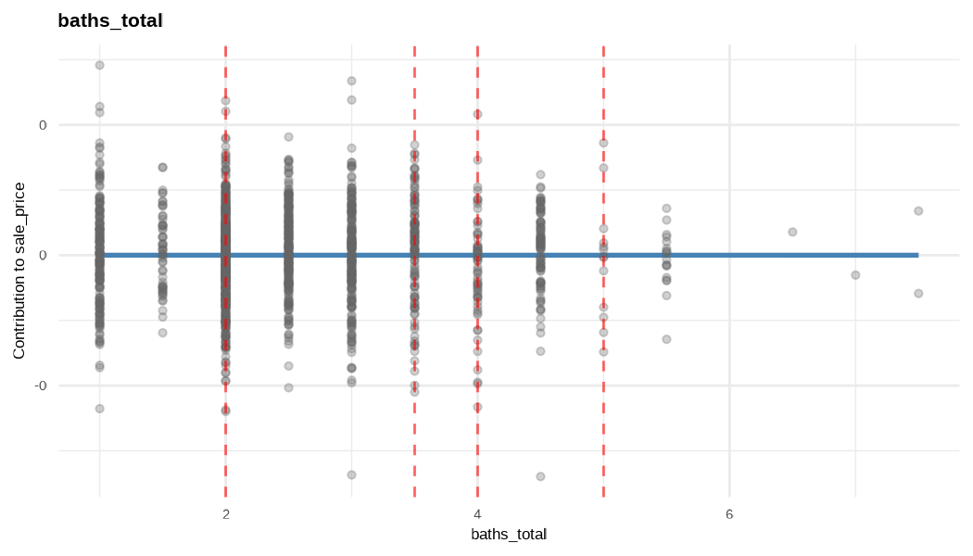

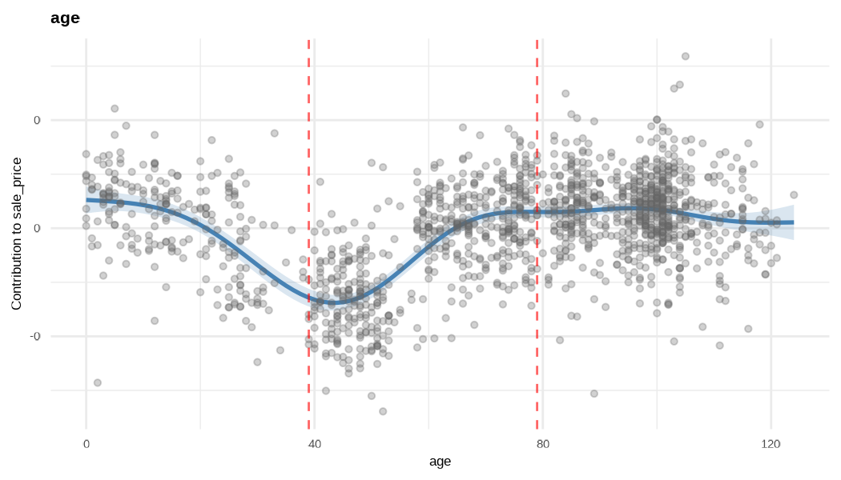

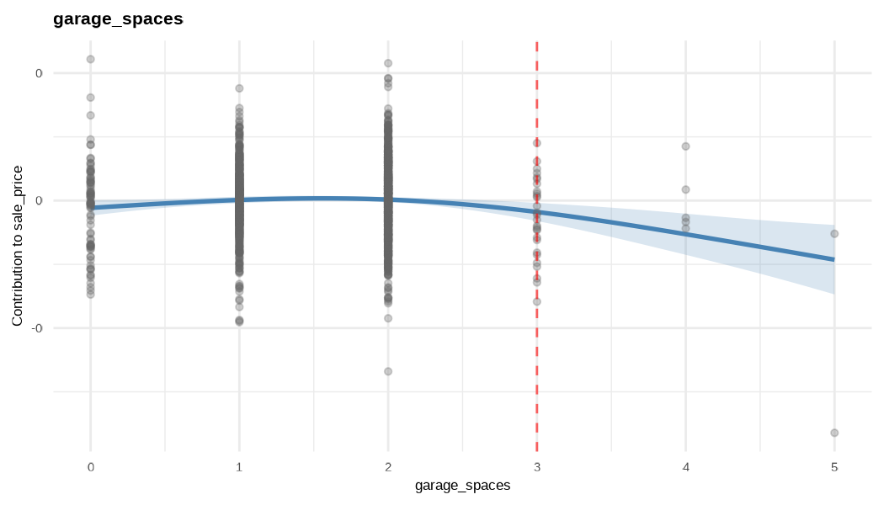

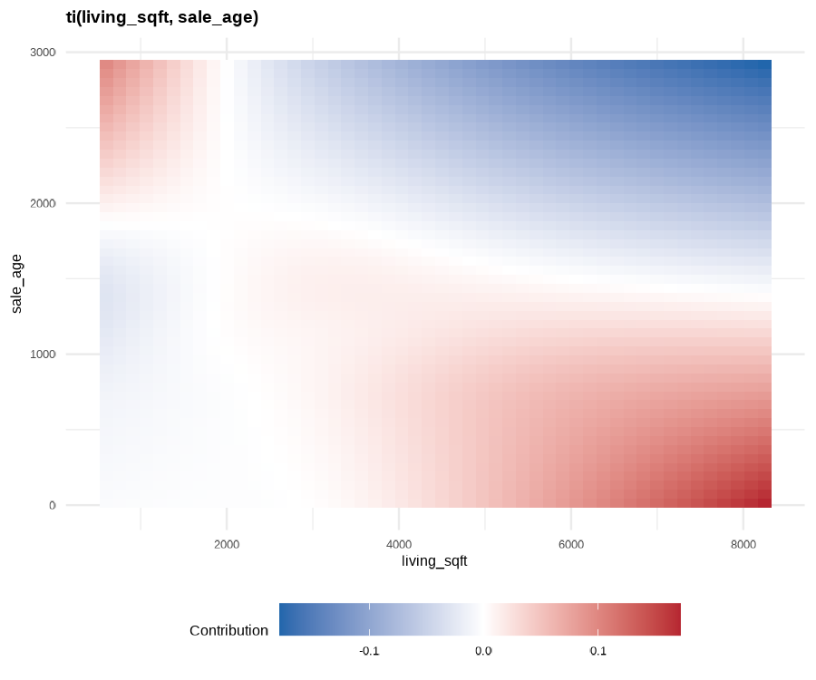

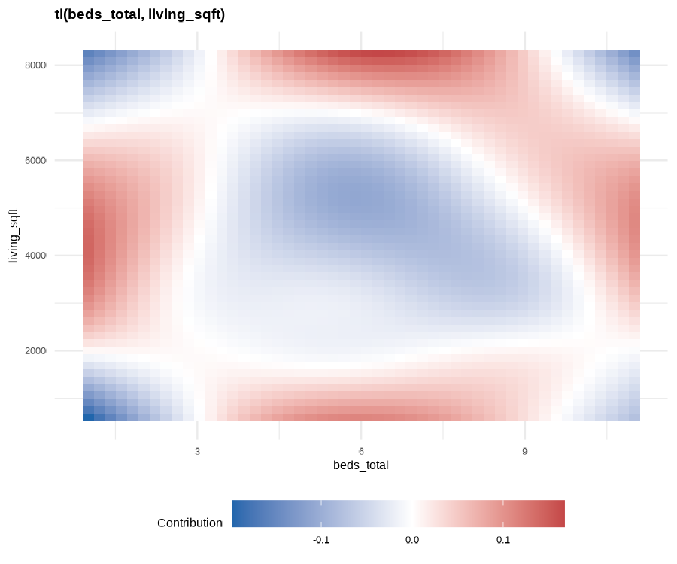

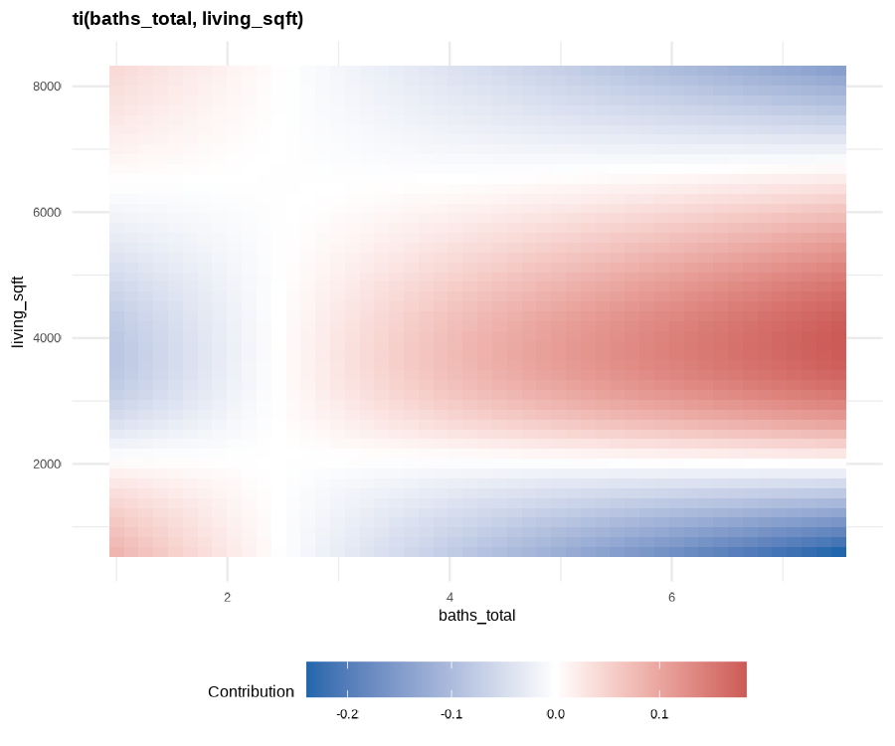

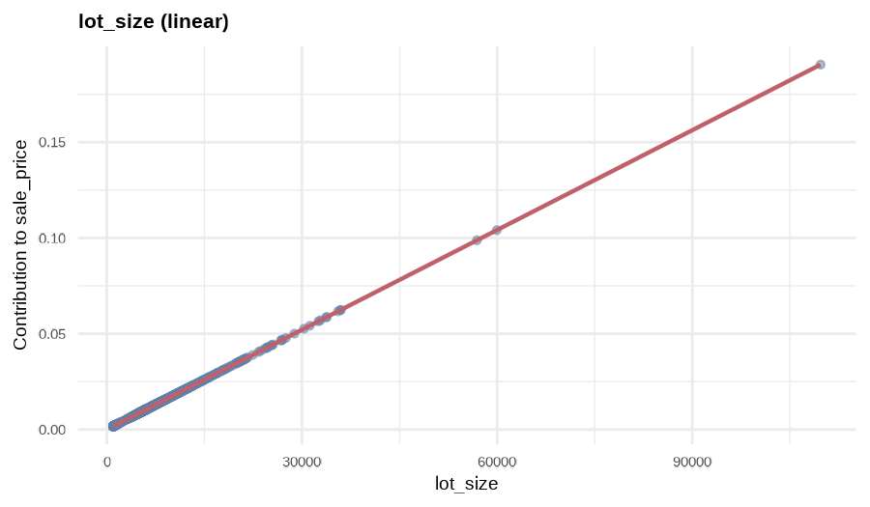

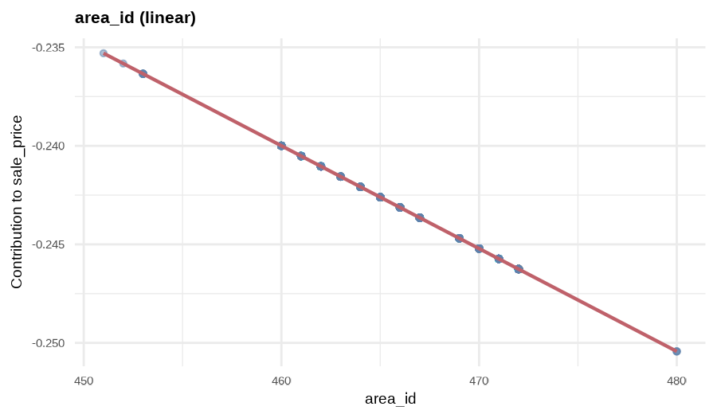

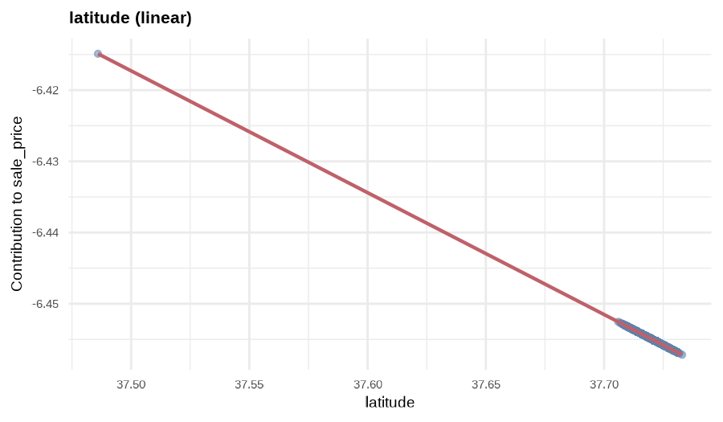

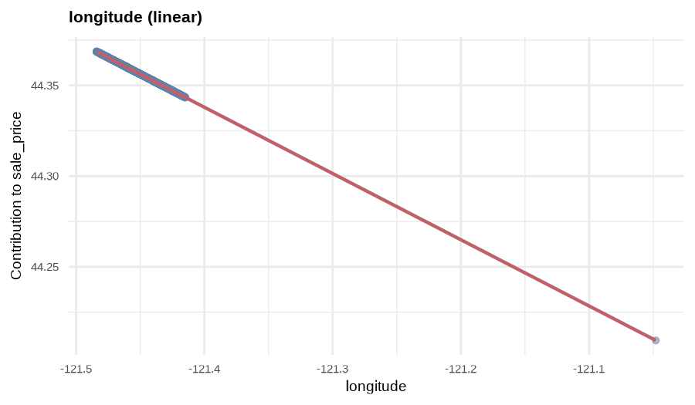

Correlation Matrix
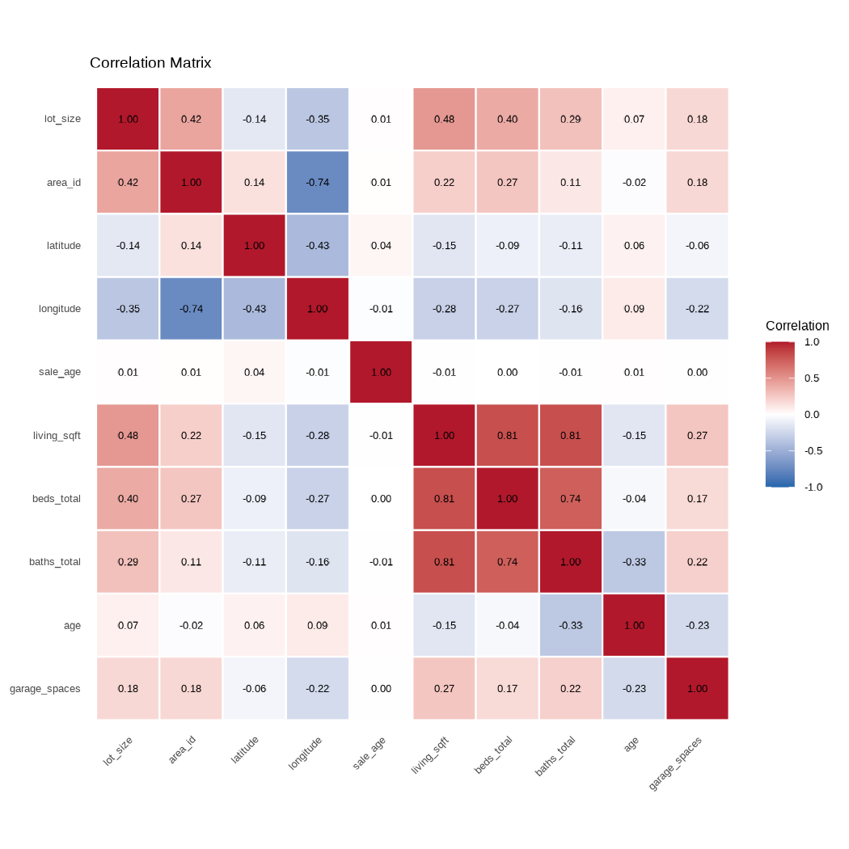

Diagnostics
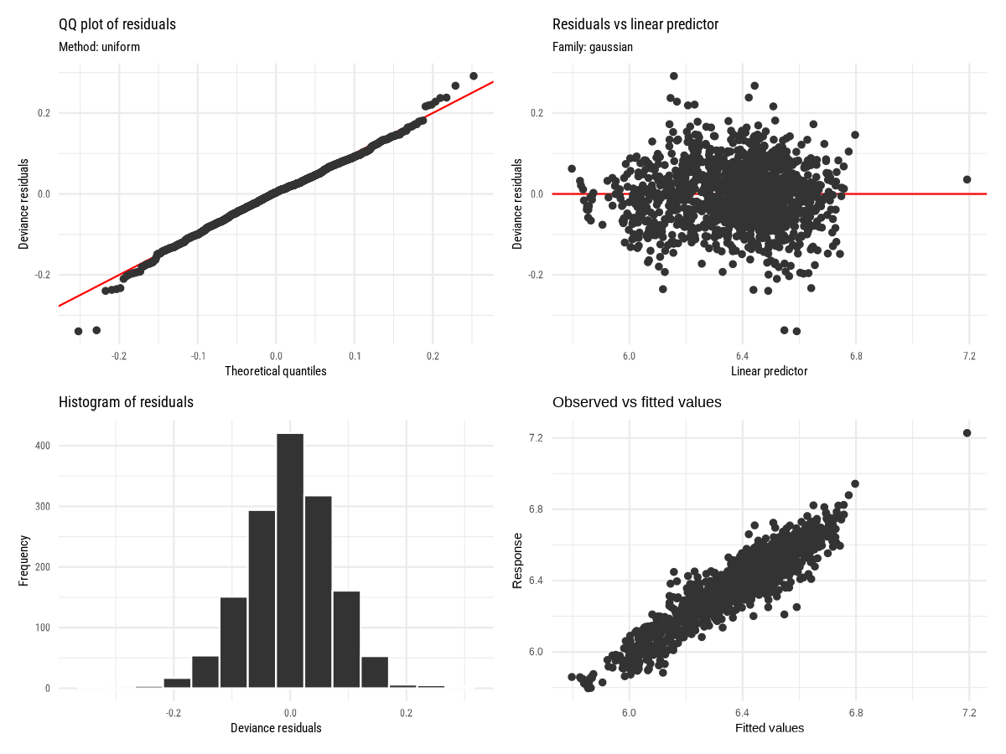

Actual vs Predicted
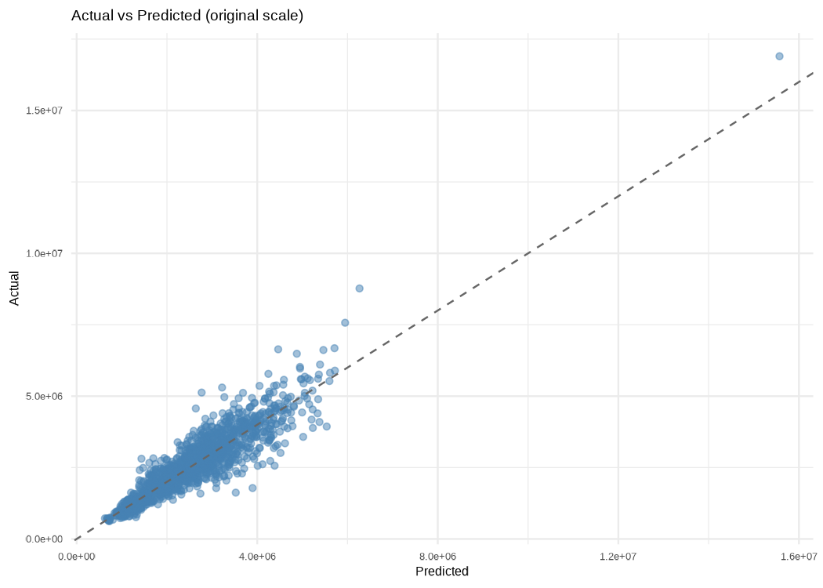

ANOVA
Term | Type | Estimate | Std. Error | t value | Pr(&gt;|t|) | edf | Ref.df | F | p-value
(Intercept) | parametric | -3.129539e+01 | 1.788425e+01 | -1.7498852 | 0.080350 | NA | NA | NA | NA
lot_size | parametric | 1.736204e-06 | 4.634554e-07 | 3.7462159 | 0.000187 | NA | NA | NA | NA
area_id | parametric | -5.217318e-04 | 9.036047e-04 | -0.5773894 | 0.563766 | NA | NA | NA | NA
latitude | parametric | -1.711277e-01 | 3.439949e-01 | -0.4974716 | 0.618932 | NA | NA | NA | NA
longitude | parametric | -3.652221e-01 | 1.898761e-01 | -1.9234761 | 0.054616 | NA | NA | NA | NA
s(sale_age) | smooth | NA | NA | NA | NA | 4.524618e+00 | 5 | 3.521688e+01 | < 2e-16
s(living_sqft) | smooth | NA | NA | NA | NA | 4.895054e+00 | 9 | 4.620176e+01 | < 2e-16
s(beds_total) | smooth | NA | NA | NA | NA | 2.066779e+00 | 7 | 2.745638e+00 | 4.95e-07
s(baths_total) | smooth | NA | NA | NA | NA | 8.508396e-05 | 3 | 1.970645e-06 | 0.918371
s(age) | smooth | NA | NA | NA | NA | 7.297068e+00 | 9 | 5.978320e+01 | < 2e-16
s(garage_spaces) | smooth | NA | NA | NA | NA | 2.421475e+00 | 4 | 3.592726e+00 | 0.000515
ti(living_sqft,sale_age) | smooth | NA | NA | NA | NA | 4.760240e+00 | 16 | 3.425616e+00 | < 2e-16
ti(beds_total,living_sqft) | smooth | NA | NA | NA | NA | 5.289953e+00 | 16 | 2.702266e+00 | < 2e-16
ti(baths_total,living_sqft) | smooth | NA | NA | NA | NA | 3.030834e+00 | 16 | 4.153160e+00 | < 2e-16

Link function: identity
Family: gaussian

Family:

-REML = -1169.7 Scale est. = 0.0054996 n = 1488
R-sq.(adj) = 0.859 Deviance explained = 86.3%

Signif. codes: 0 ‘***’ 0.001 ‘**’ 0.01 ‘*’ 0.05 ‘.’ 0.1 ‘ ’ 1
---
ti(baths_total,living_sqft) 3.031e+00 16 4.153 < 2e-16 ***
ti(beds_total,living_sqft) 5.290e+00 16 2.702 < 2e-16 ***
ti(living_sqft,sale_age) 4.760e+00 16 3.426 < 2e-16 ***
s(garage_spaces) 2.421e+00 4 3.593 0.000515 ***
s(age) 7.297e+00 9 59.783 < 2e-16 ***
s(baths_total) 8.508e-05 3 0.000 0.918371
s(beds_total) 2.067e+00 7 2.746 4.95e-07 ***
s(living_sqft) 4.895e+00 9 46.202 < 2e-16 ***
s(sale_age) 4.525e+00 5 35.217 < 2e-16 ***
edf Ref.df F p-value
Approximate significance of smooth terms:

Signif. codes: 0 ‘***’ 0.001 ‘**’ 0.01 ‘*’ 0.05 ‘.’ 0.1 ‘ ’ 1
---
longitude -3.652e-01 1.899e-01 -1.923 0.054616 .
latitude -1.711e-01 3.440e-01 -0.497 0.618932
area_id -5.217e-04 9.036e-04 -0.577 0.563766
lot_size 1.736e-06 4.635e-07 3.746 0.000187 ***
(Intercept) -3.130e+01 1.788e+01 -1.750 0.080350 .
Estimate Std. Error t value Pr(>|t|)
Parametric coefficients:

"tp"))
bs = c("tp", "tp")) + ti(baths_total, living_sqft, bs = c("tp",
sale_age, bs = c("tp", "tp")) + ti(beds_total, living_sqft,
longitude + s(garage_spaces, bs = "tp", k = 5) + ti(living_sqft,
k = 4) + lot_size + area_id + s(age, bs = "tp") + latitude +
s(beds_total, bs = "tp", k = 8) + s(baths_total, bs = "cr",
sale_price ~ s(sale_age, bs = "cr", k = 6) + s(living_sqft, bs = "tp") +
Formula:

Link function: identity
Family: gaussian

Summary:

<environment: 0x1609fedc8>
"tp"))
bs = c("tp", "tp")) + ti(baths_total, living_sqft, bs = c("tp",
sale_age, bs = c("tp", "tp")) + ti(beds_total, living_sqft,
longitude + s(garage_spaces, bs = "tp", k = 5) + ti(living_sqft,
k = 4) + lot_size + area_id + s(age, bs = "tp") + latitude +
s(beds_total, bs = "tp", k = 8) + s(baths_total, bs = "cr",
sale_price ~ s(sale_age, bs = "cr", k = 6) + s(living_sqft, bs = "tp") +
Formula:

Timing: 1.70 seconds

Mgcv Output
variable | earth_direction | gam_direction | consistent
sale_age | increasing | decreasing | FALSE
living_sqft | increasing | increasing | TRUE
beds_total | mixed | mixed | TRUE
baths_total | increasing | decreasing | FALSE
age | increasing | mixed | TRUE
latitude | increasing | mixed | TRUE
longitude | mixed | mixed | TRUE
garage_spaces | increasing | mixed | TRUE

Earth vs GAM Sign Consistency
para | s(sale_age) | s(living_sqft) | s(beds_total) | s(baths_total) | s(age) | s(garage_spaces) | ti(living_sqft,sale_age) | ti(beds_total,living_sqft) | ti(baths_total,living_sqft)
1.0000 | 0.0000 | 0.0000 | 0.0000 | 0.0000 | 0.0000 | 0.0000 | 0.0056 | 0.6970 | 0.5946
0.0000 | 1.0000 | 0.0129 | 0.0124 | 0.0052 | 0.0162 | 0.0061 | 0.0198 | 0.0182 | 0.0163
0.0000 | 0.0129 | 1.0000 | 0.7287 | 0.6946 | 0.1968 | 0.3327 | 0.9600 | 0.9993 | 0.9996
0.0000 | 0.0124 | 0.7287 | 1.0000 | 0.5762 | 0.2850 | 0.0970 | 0.9353 | 1.0000 | 0.9921
0.0000 | 0.0052 | 0.6946 | 0.5762 | 1.0000 | 0.2754 | 0.0631 | 0.2251 | 0.4987 | 0.9861
0.0000 | 0.0162 | 0.1968 | 0.2850 | 0.2754 | 1.0000 | 0.1740 | 0.0654 | 0.2103 | 0.3048
0.0000 | 0.0061 | 0.3327 | 0.0970 | 0.0631 | 0.1740 | 1.0000 | 0.2848 | 0.7090 | 0.4564
0.0056 | 0.0198 | 0.9600 | 0.9353 | 0.2251 | 0.0654 | 0.2848 | 1.0000 | 0.9782 | 0.9854
0.6970 | 0.0182 | 0.9993 | 1.0000 | 0.4987 | 0.2103 | 0.7090 | 0.9782 | 1.0000 | 0.9995
0.5946 | 0.0163 | 0.9996 | 0.9921 | 0.9861 | 0.3048 | 0.4564 | 0.9854 | 0.9995 | 1.0000

Concurvity (Pairwise Worst)
para | s(sale_age) | s(living_sqft) | s(beds_total) | s(baths_total) | s(age) | s(garage_spaces) | ti(living_sqft,sale_age) | ti(beds_total,living_sqft) | ti(baths_total,living_sqft)
1 | 0.5998 | 1.0000 | 1.0000 | 0.9993 | 0.5611 | 0.9451 | 0.9977 | 1.0000 | 1.0000
1 | 0.3636 | 0.9988 | 0.9970 | 0.9967 | 0.4807 | 0.5412 | 0.2362 | 0.9630 | 0.9532
1 | 0.4134 | 0.9807 | 0.9893 | 0.9838 | 0.4022 | 0.3041 | 0.0888 | 0.9108 | 0.8509

Concurvity (Overall)

