mgcvUI GAM Report
Date: 2026-03-09 04:14

Model Summary
R-squared: 0.8575
Deviance explained: 86.1 %
AIC: 42836
n: 1486
CV R-squared: 0.672
Family: gaussian
Method: REML
Formula: sale_price ~ s(sale_age, bs = "cr", k = 3) + s(living_sqft, bs = "tp") + s(beds_total, bs = "tp", k = 8) + s(baths_total, bs = "tp") + s(lot_size, bs = "cr", k = 3) + area_id + s(age, bs = "cr", k = 3) + s(latitude, bs = "tp") + s(longitude, bs = "tp") + s(garage_spaces, bs = "tp", k = 5)

Smooth Terms
Term | EDF | Ref.df | F | p_value
s(sale_age) | 1.957215 | 2 | 89.323630 | 0.000000e+00
s(living_sqft) | 8.837883 | 9 | 129.161499 | 0.000000e+00
s(beds_total) | 6.942211 | 7 | 60.511807 | 0.000000e+00
s(baths_total) | 2.584250 | 9 | 3.587445 | 0.000000e+00
s(lot_size) | 1.988736 | 2 | 199.902150 | 0.000000e+00
s(age) | 1.880757 | 2 | 44.444860 | 0.000000e+00
s(latitude) | 5.715220 | 9 | 3.619277 | 1.956413e-06
s(longitude) | 6.622083 | 9 | 7.612343 | 0.000000e+00
s(garage_spaces) | 2.839072 | 4 | 5.865720 | 1.245743e-05

Parametric Terms
Term | Estimate | Std_Error | t_value | p_value
(Intercept) | 14297141.47 | 3731595.907 | 3.831375 | 0.0001328933
area_id | -25042.52 | 8011.163 | -3.125953 | 0.0018076124

Smooth Plots
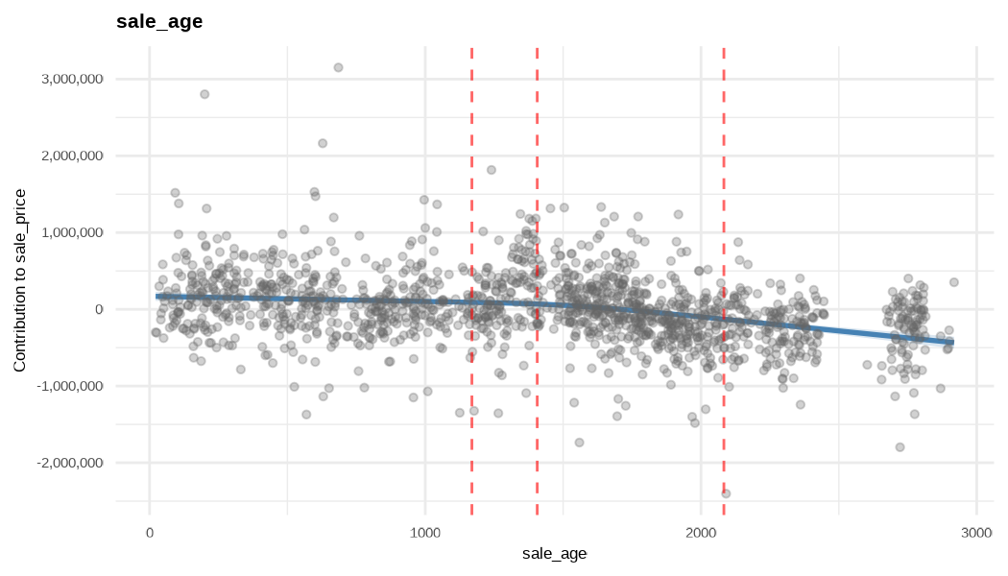

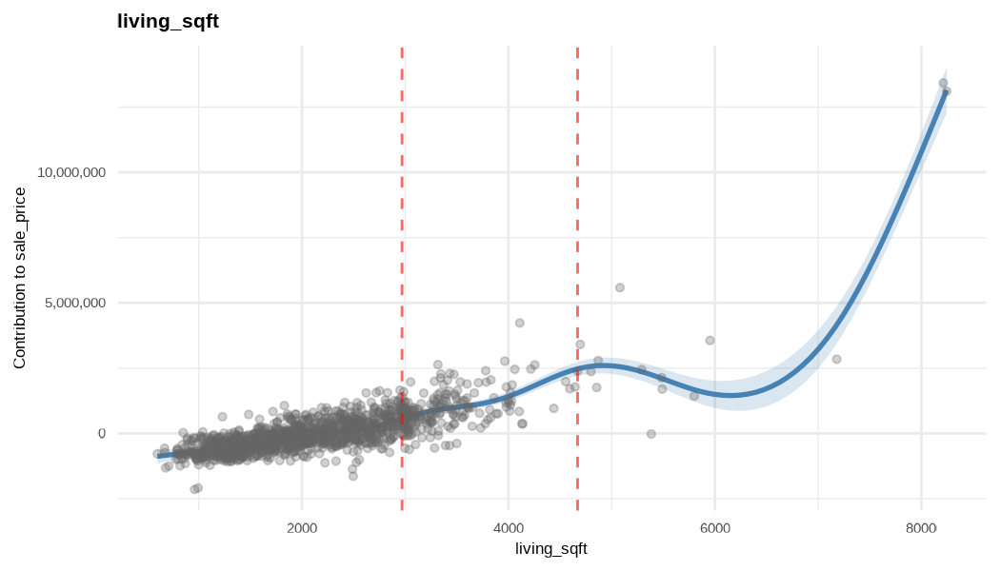

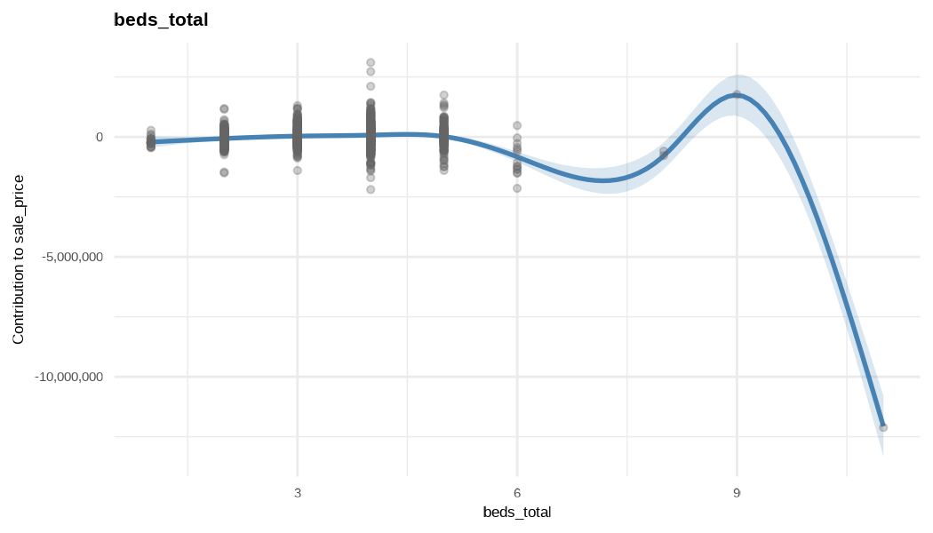

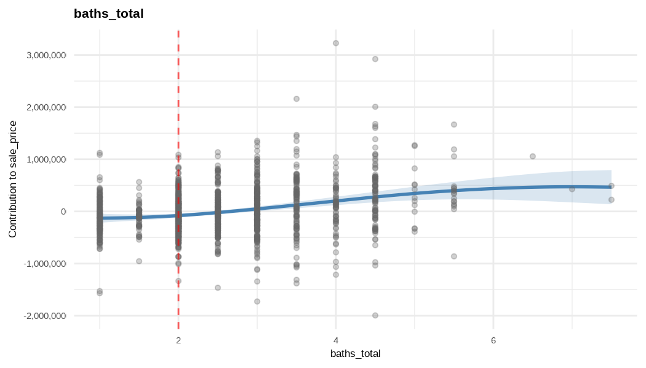

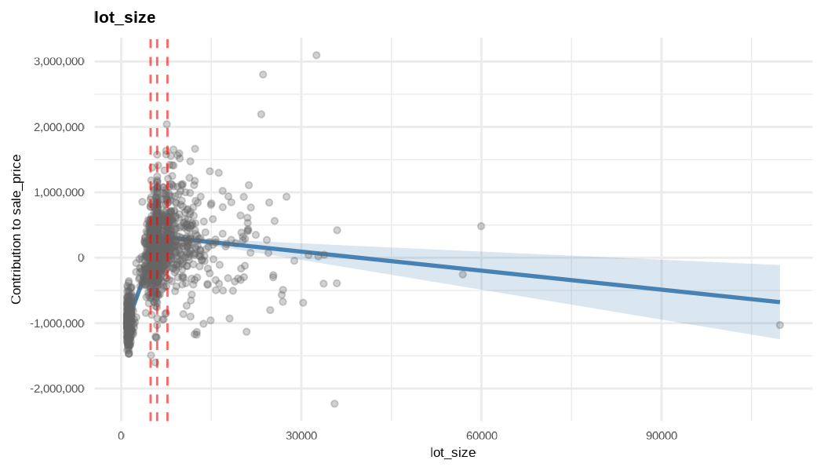

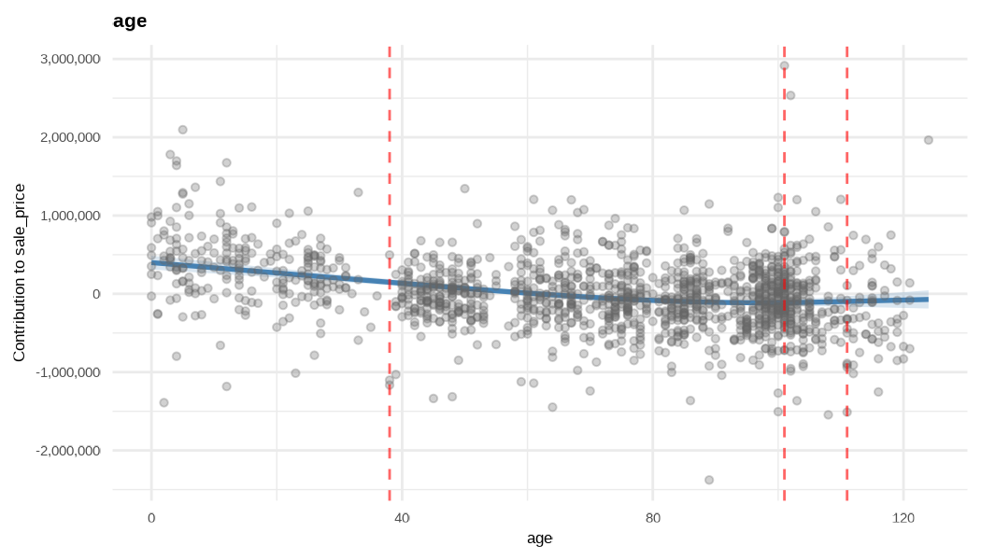

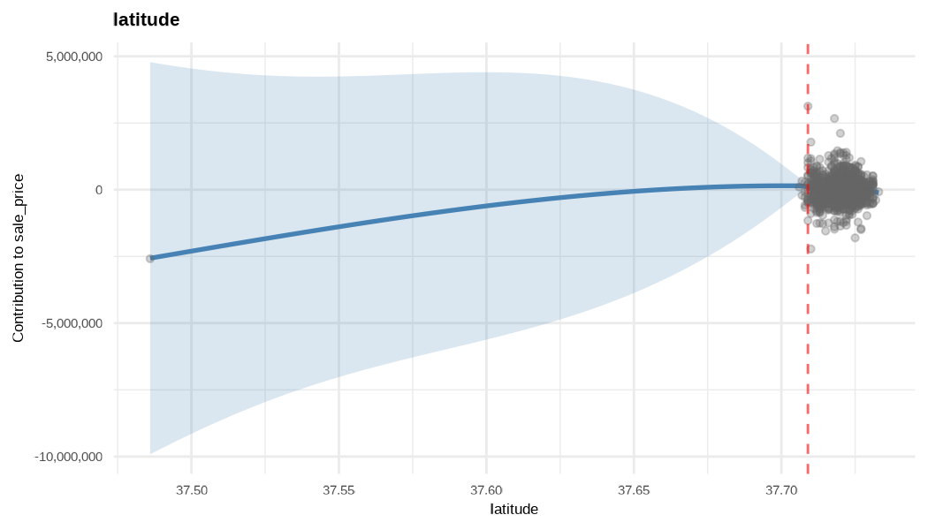

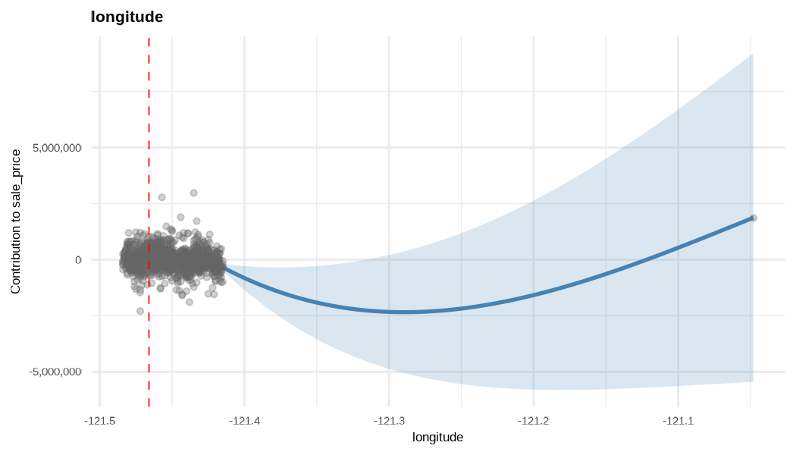

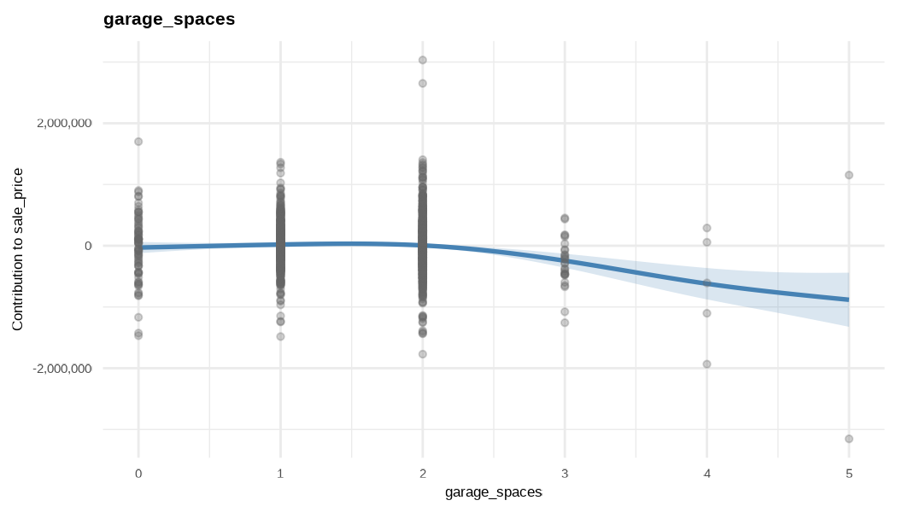

Diagnostics
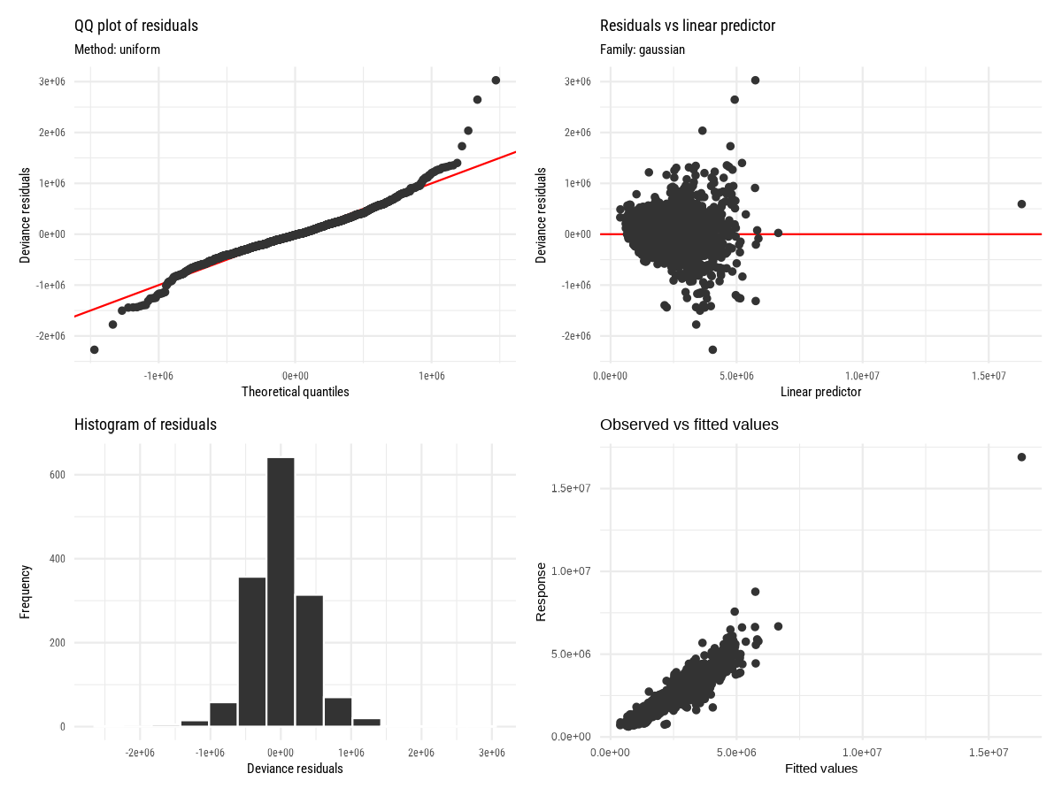

Actual vs Predicted
