# Creating atti06.pl to Compile Code

Note: The only thing that changed is on the atti06.pl file.

1. Download c code compiler. I used one from mingw.org. There is a download button on the left side of the screen under “navigation”
2. Perl can be downloaded at <https://www.perl.org/get.html>
3. Download EKF_c folder
4. Once downloaded, move atti06.pl file out of the att folder into the EKF_c file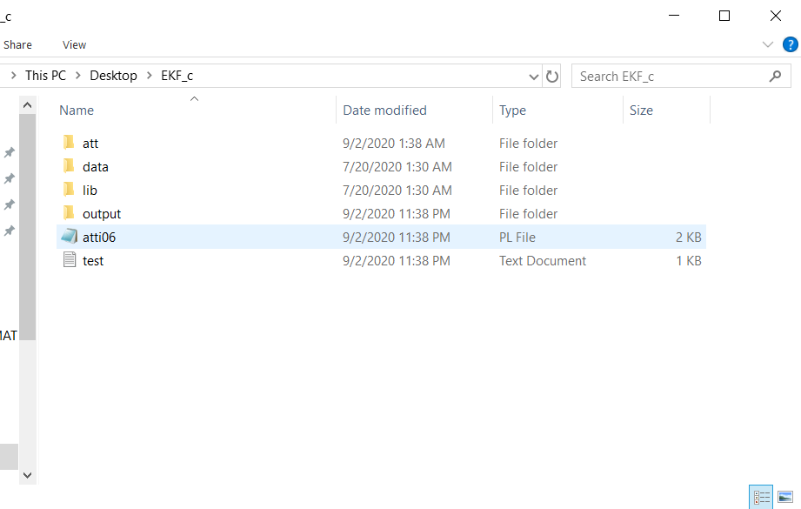
5. Change $DATA_DIR header of atti06.pl to match location of EKF_c file

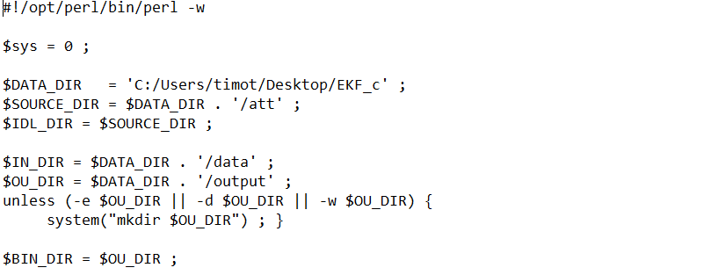

7. In order to run file, open up command prompt and access the EKF_C folder using the “cd” command

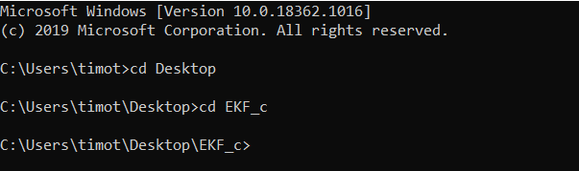

8. Type in “perl atti06.pl” in order to run file

9. This will produce all the output data, but will not produce the quat_true_six.png and the quat_true_quest.png graphs. The original code results in an error and no text file creation. By changing the code as shown below, a file is produced but I don’t know how to open it. 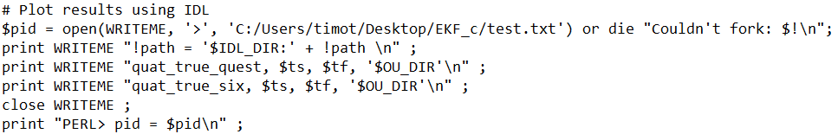

# Debugging

Charles Hingst

## Compiling the C Code

Follow the instructions above. Have the file atti06.pl one directory above the att, data, lib, and output folders:

>Code_Folder

atti06.pl

>att

>data

>output

Edit line 5 to match the path to the Code_Folder. My Code_Folder is named “Compile”



The forward and backslashes of the atti06.pl file may also have to be edited.

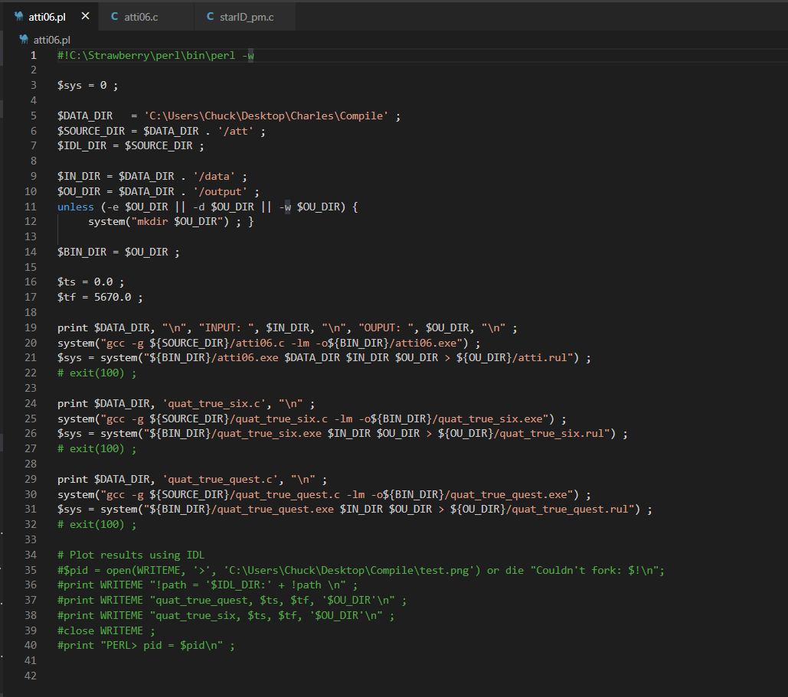

Comment out the bottom portion of atti06.pl. It is not needed for debugging purposes.

Lines of atti06.c must be fixed.

**You may get the following errors:**

C:\Users\Chuck\Desktop\Compile/att/atti06.c:747:10: error: 'fn_tmp' undeclared (first use in this function); did you mean 'fn_dir'?

strcpy(fn_tmp, fn_dir) ; strcat(fn_tmp, "/lib/scel525.dat") ;

^~~~~~

fn_dir

C:\Users\Chuck\Desktop\Compile/att/atti06.c:780:10: error: 'fn_tmp' undeclared (first use in this function); did you mean 'fn_dir'?

strcpy(fn_tmp, fn_dir) ; strcat(fn_tmp, "/lib/x525_tab.dat") ;

^~~~~~

fn_dir

C:\Users\Chuck\Desktop\Compile/att/atti06.c:813:10: error: 'fn_tmp' undeclared (first use in this function); did you mean 'fn_dir'?

strcpy(fn_tmp, fn_dir) ; strcat(fn_tmp, "/lib/sadj.dat") ;

^~~~~~

fn_dir

### 

### Fix Error in Subfunction starcell() of atti06.c

Original

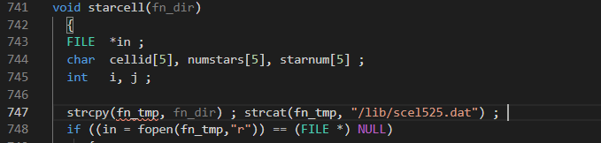

Error Fixed -> Add char fn_tmp[FNLEN]; to the variables of starcell()

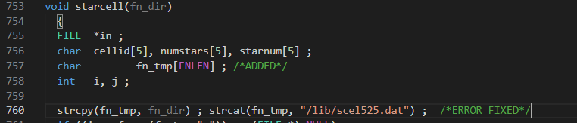

### Fix Error in Subfunction starcell2() of atti06.c

Original

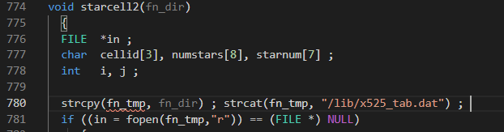

Error Fixed -> Add char fn_tmp[FNLEN]; to the variables of starcell2()

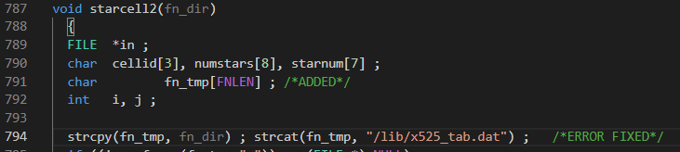

### Fix Error in Subfunction celladj() of atti06.c

Original

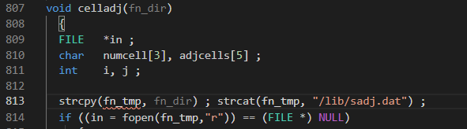

Error Fixed -> Add char fn_tmp[FNLEN]; to the variables of starcell2()

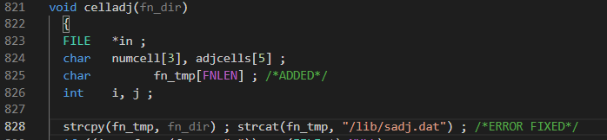

The code will now compile and run.

## Viewing C Code Variables

Viewing variables in the C code can be done by adding fprintf statements.

To print to the output terminal use the following default format:

fprintf(stderr, “ “);

stderr - print output to terminal

Here are some examples:

Print Statement

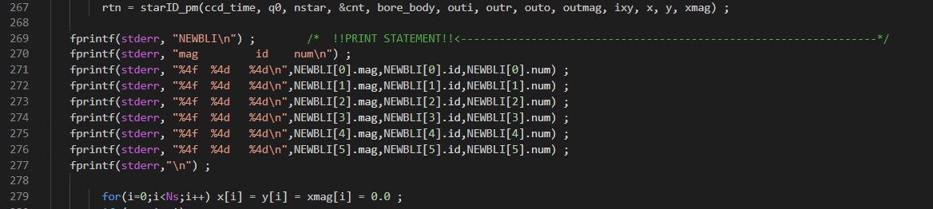

Output

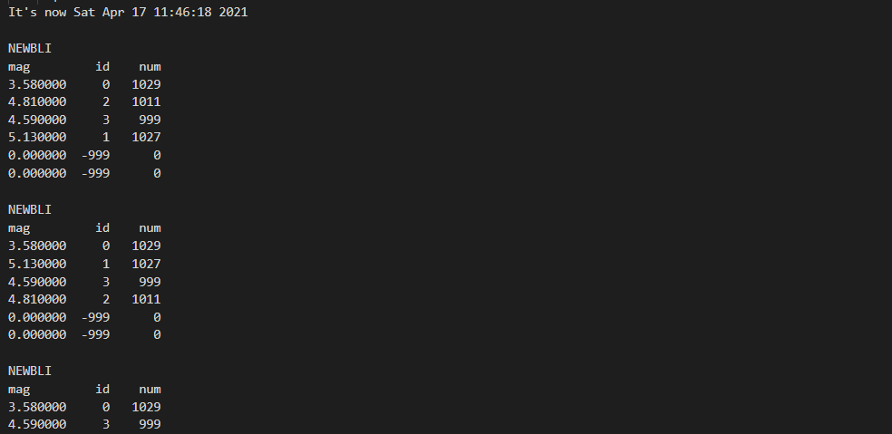

Place similar fprintf statements in your MATLAB code to compare variables.

## MATLAB and C Syntax Comparison

Note: C indexing starts at 0 and MATLAB indexing starts at 1

|  | **C** | **MATLAB** |
| --- | --- | --- |
| Struct | NEWBLI[0].L[1] | NEWBLI(1).L(2) |
| Struct | NEWBLI[0]->L[1] | NEWBLI(1).L(2) |
| Comment | /* ... */ | % |
| For loop | for(i=0;i<j;i++)  {  ...  } | for i=1:j  …  end |
| Matrix | matrix[1][2] | matrix(2,3) |
| Array | array[12] | array(13) |
| Does not equal | != | ~= |
|  |  |  |
|  |  |  |
|  |  |  |

## starID_pm() Subfunction MATLAB input and output

| [m_star, BLI, NEWBLI] | starID_pm | (t, q0, nstar, id_count, bore_body, outi, outr, outo, outmag, ixy, x, y, xmag, adjcell, scell, stars) |
| --- | --- | --- |
|  |  |  |
| Index | CellIndex | (az, el) |
| BLI | sort_BLI | (ij, BLI) |
| [NEWBLI, jj, esignal] | on6stars | (ij, m_star, BLI, NEWBLI) |
| [NEWBLI, jj, esignal] | on5stars | (ij, m_star, BLI, NEWBLI) |
| [NEWBLI, jj, esignal] | on4stars | (ij, esignal, m_star, BLI, NEWBLI) |
| [NEWBLI, jj, esignal] | on3stars | (ij, m_star, BLI, NEWBLI) |
| [NEWBLI, ii, jj, esignal] | compare0 | (n, m, ij, m_star, BLI, NEWBLI) |
| [NEWBLI, ii, jj, esignal] | compare1 | (n, m, ii, jj, ij, m_star, BLI, NEWBLI) |
| [jj, sign] | compare2 | (n, m, ij, tolerance, m_star, BLI, NEWBLI) |
| [NEWBLI, sign] | compare3 | (n, m, jj, tolerance, m_star, BLI, NEWBLI) |
| [jj, sign] | compare4 | (n, m, jj, ij, m_star, BLI, NEWBLI) |
| [NEWBLI, psignal] | mag_test | (n, m, i, j, m_star, BLI, NEWBLI) |
| L | cartesian | (alpha, delta) |
| [x, y, xmag, m_star] | obs_ang | (nstar, x, y, xmag, m_star) |
| [x, y, xmag, m_star] | rearrange | (nstar, x, y, xmag, m_star) |
| return_value | sym_test | (dist_tol, NEWBLI) |

# Code Structure

## atti06.c

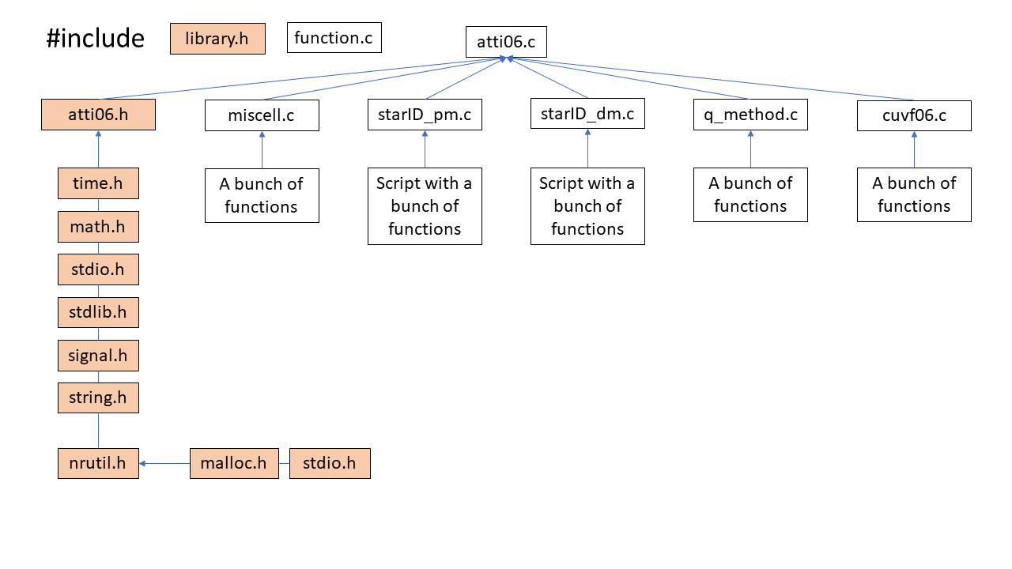

## starID_pm.c

