 | 

Undergraduate Project Report
2016/17

A Semantic Annotation System for Web of Things

Name: | Du Sicong
Programme: | Telecoms
Class: | 2013215108
QM Student No. | 130801256
BUPT Student No. | 2013213144

Date 2017/5/2

Table of Contents
Abstract 4
Chapter 1: Introduction 6
1.1 Motivation 6
1.2 Achievement 8
1.3 Technique context 8
1.4 Report Structure 9
Chapter 2: Background 10
2.1 Web of Things (WoT) 10
2.2 Semantic web 10
2.2.1 Resource Description Framework (RDF) 11
2.2.2 Web Ontology Language（OWL） 12
2.2.3 Simple Protocol and RDF Query Language (SPARQL) 13
2.3 Related work 13
2.3.1 Semantic Sensor Web (SSW) 13
2.3.2 Linked sensor middleware (LSM) 13
2.3.3 Knowledge Extraction and Knowledge Base Construction 14
Chapter 3: Design and Implementation 15
3.1 System framework description 15
3.2 Manual annotation tool 16
3.3 Automatic annotation tool 16
3.3.1 Candidate sets generation 16
3.3.2 Jointly Reasoning 19
3.4 Proof-of-concept Implementation 21
3.4.1 Tools and environmental setup 21
3.4.2 Use case description 21
Chapter 4: Results and Evaluation 23
4.1 Experiment results 23
4.1.1 Manual annotation tool 23
4.1.2 Automatic annotation tool 25
4.2 Evaluation 26
4.2.1 Re-rank phase 26
4.2.2 Semi-automatic annotation 26
4.2.3 Performance 26
Chapter 5: Conclusion and Further Work 27
5.1 Conclusion 27
5.2 Future work 27
References 28
Acknowledgement 29
Appendix 30
Risk Assessment 36
Environmental Impact Assessment 37

Abstract

Integrating Web of Things (WoT) with semantic technologies facilitates the construction of a large-scale networked knowledge infrastructure which can provide many smart applications with a strong knowledge base. However, current WoT applications work with a manual mechanism to define the data model and device annotations. This leads to the emergence of many domain-specific applications which results in the problem that many knowledge resources are isolated from each other. This paper proposes and implements a semi-automatic semantic annotation system to link domain-specific entities to a domain independent knowledge base to improve the usability and the usefulness of WoT knowledge resources. Some use cases for tests are also considered.

Key words: Web of Things (WoT), semantic annotation, entity linking, message passing, jointly reasoning

摘要 (Chinese translation of the Abstract)

将语义技术与物联网相结合，有助于构建一个大型的网络知识基础设施，为许多智能应用提供强大的知识库。然而，当前的物联网应用程序使用手动机制来定义数据模型和设备标注。在这种情况下出现了许多特定领域的物联网应用，导致了许多知识资源彼此隔离。本文提出并实现了一个半自动语义标注系统，将特定领域的实体链接到一个与领域无关的知识库，以提高物联网知识资源的可用性和有用性。一些用于测试的用例也被考虑了进来。

Introduction

Motivation
Internet of Things (IoT) connects many physical devices into the cyber world of World Wide Web through Uniform Resource Identifier (URI) as unique IDs for the devices. Web of Things (WoT) focus on reusing web patterns and protocols to enhance the concept of IoT. “Web Servient” is proposed to improve the abstract model of the devices. Each device is not only a client but also a server which facilitates the construction of cyber-physical systems with higher data and resource usability.

Under the spread of the concept of WoT, many WoT platforms emerge to provide developers with convenient data service and various solution templates. BaiduTianGong, Yeelink and Amazon web service are some of the available platform resources on the web. Developers open these platforms and invoke the APIs to define the business dependent device data model and web service interfaces to develop WoT applications. Obviously, the openness of the web technologies makes the development of IoT applications more easy. Devices in the real world can be more conveniently mashed up with both web services and other devices through cyber-physical systems. However, this results in many heterogeneous and isolated data and resources. Because the data models are defined by individuals without unified standard or linking method. Thus, this is a waste of usable information resources.

The data and services of WoT applications can be regarded as web resources. The introduction of semantic technologies aims to improve the usability and usefulness of WoT resources by bridging heterogeneous data from different domain dependent data sources with the help of global domain independent knowledge base. Accordingly, the semantic annotation technology facilitates the construction of a networked knowledge infrastructure with more interoperable structural data sources.

There are already some efforts to adopt semantic web technologies in WoT applications including Semantic Sensor Web, SENSEI and SPITFIRE. By annotating the physical devices with computer comprehensible vocabulary such as Semantic Sensor Network (SSN) ontology model, it is possible to share data and knowledge with other applications and platforms. However, these efforts still have limitations. The computer understandable vocabularies such as RDF linked ontology are based on domain-specific knowledge. The semantics extraction from raw data needs domain experts to accomplish in manual way. This lowers the interoperability of data and knowledge sharing among different systems in different domains. They do not consider the possibility of a growing knowledge base linked to global domain independent Linked Open Data (LOD), for example, DBpedia, Yago, FOAF and etc. Since Key-Value pairs is a common form to annotate the attributes of the WoT devices, I take the format of JSON in an example to explain a possible concrete situation in which the data interoperability is lowered. In Figure 1, there are two schema from two different domains in JSON format. In schema 1, the developer annotates the type “location” with “location”. However, in schema 2, another developer annotates the type “location” with “deploy”. Computer does not know the two annotations refer to the same type. Thus, by linking domestic entities to the entities in domain independent knowledge base such as DBpedia, computer can understand the relations among different data sources among different domains which supports further semantic searching and integration.
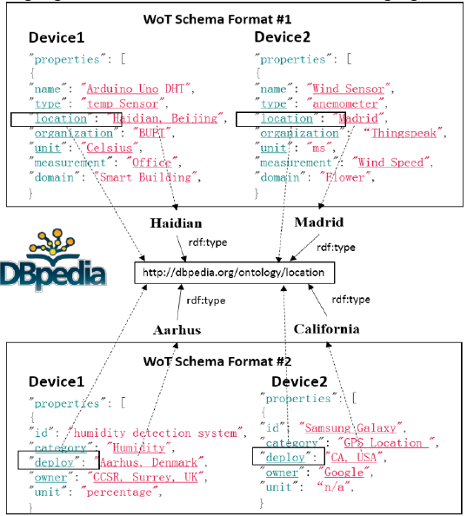
Figure 1 Linked WoT data with semantic annotations of keys, values and relations

Achievement
A manual annotation tool is implemented for user to manually construct the local knowledge graph. The construction of the local knowledge base is subject to a predefined ontology model. The output after manual annotation is a domain specific knowledge graph.

This paper proposes a factor graphic model to link the domain-specific WoT metadata to a domain independent knowledge base (KB). And an entity linking algorithm based on message passing is also proposed to disambiguate the domestic metadata. These techniques are used to implement the automatic annotation tool.

Some possible use cases for test and application are studied. These use cases are about the usage of the knowledge graph generated after manual and automatic annotation.

Technique context
The web application is implemented based on JSP techniques. The framework of Spring + Spring-MVC + Mybatis is adopted. Because these Java-based techniques have the following advantages:
•Java is an object oriented language. Object oriented is a natural abstraction of the real world entity model. Any entity in the physical world can be seen as an object. These objects can interact through messages. In addition, any entity in the physical world can be attached to a class of things. An object is an instance of a class. An object-oriented programming language is object-centred and message-driven. Object-oriented programming language can be regarded in a perspective that program is object plus message. Hence, it is easy to model the entities in the real world to the classes in programmes.
• Java is a platform-independent language. Applications written in Java can run on different hardware and software platforms without modification. Java mainly relies on the Java Virtual Machine (JVM) at the target code level to achieve platform independence. JVM is an abstract machine attached to the specific operating system. JVM has a set of virtual machine instructions with its own stacks and register groups. But the JVM is usually implemented on software rather than on hardware. Platform independence of Java has greatly accelerated and promoted the development of software products.
•Java supports multi-thread programming. Java supports multithreading in two ways. On the one hand, the Java environment itself is multithreaded. Several system threads are responsible for the useless cells recycling, system maintenance and other system-level operations. On the other hand, Java language built-in multi-threaded controlling can greatly simplify the development of multi-threaded applications. Java provides a class Thread, which is responsible for starting to run, terminating the thread, and checking the thread status. Java threads also include a set of synchronization primitives. These primitives are responsible for concurrency control of threads. Using Java's multi-thread programming interfaces, developers can easily develop the applications supporting multi-thread, improving program executing efficiency.

The storage methods in the implementation are as follows:
•Jena-tdb. This is a file storage system with the query language SPARQL. The input and the output of this module are both in OWL format. The data is RDF linked in Jena-tdb. Jena-tdb has built-in tools to support semantic reasoning.
•Mysql. Mysql is a relational database system based on table forms or schemas. We can conveniently apply the factor graphic model with the help of Mysql.

•Neo4j. Meo4j is a graph database which can visibly display the structure of the RDF linked data with labels and relations in a vivid graph form.

Report Structure
The rest of this paper is arranged in this way. Chapter 2 focuses on some background knowledge of semantic Web of Things. The detailed description of the annotation system and all the involved algorithms are illustrated in Chapter 3 as well as the details about the application implementation. Chapter 4 is about the experiment results and performance evaluation from various aspects of the annotation system. And Chapter 5 concludes the whole paper and predicts some possible subsequent future work after the efforts of this paper.

Background

Web of Things (WoT)
The Web of Things (WoT) allows objects in the real world to connect to the cyber world, such as World Wide Web. It can be adopted to refer to relevant software architectural styles, programming patterns and approaches. Just as what Web (lies at Application layer) is to the Internet (lies at Network layer), the Web of Things serves as an Application Layer approach to simplify the development of Internet of Things (IoT) applications.

Instead of proposing a brand new standard, Web of Things reuses widely spread Web standards used in
•programmable Web, e.g. REST, HTTP, JSON
•semantic Web, e.g. JSON-LD, Microdata
•real-time Web, e.g. Websocket
•social Web, e.g. OAuth, social networks

Semantic web
The Semantic Web is an extension of the Web following the standards by the World Wide Web Consortium (W3C). It is an imagination towards the future network. Now, the semantic web behaves as one of the features of the age of Web 3.0. In short, semantic web is a type of intelligent web. It can interpret not only words and concepts, but also the logic relationship among them which can make communications more efficient and valuable.

The core of semantic web is to add machine comprehensible semantic metadata to the documents in the web such as HTML and XML. Thus, the whole Internet becomes a common medium for information exchange.

The evolution history of semantic web is depicted in Figure 2 with comparison to the timeline of XML world.
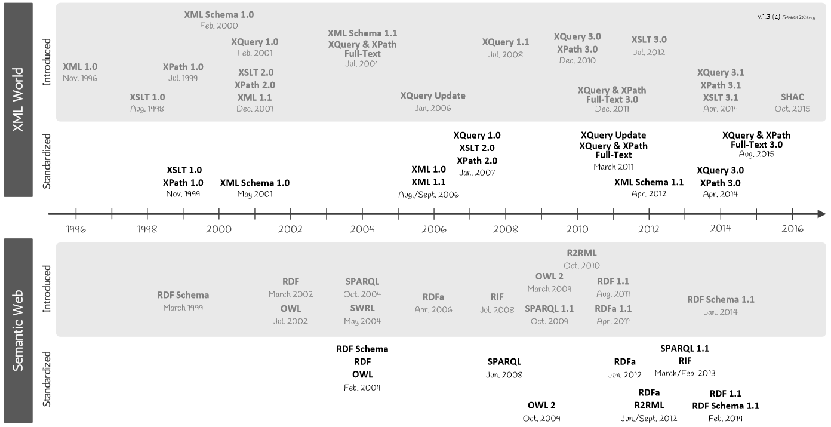
Figure 2 Evolution history of XML and semantic web standards

http://www.dblab.ntua.gr/~bikakis/XML%20and%20Semantic%20Web%20W3C%20Standards%20Timeline-History.pdf

Resource Description Framework (RDF)
RDF is a W3C standard used to describe cyber resources on the Web such as title, author, updated date, content and copyright of webpages. RDF is written based on XML techniques which is called RDF/XML. With the use of XML, RDF information can easily be exchanged among machines with different operating systems and application languages. And Resource Description Framework also provides models and grammars with respect to data. It serves as a general method to describe data so that it can be read and understood by computers. Thus, individual teams can use it and exchange information.

Accordingly, RDF is designed to be an important part of semantic web activities which facilitates the interactions among computers rather than presentations to persons in webpages. The purposes of Semantic Web Vision proposed by W3C are:
• Information on the Web has accurate meanings
• Web information can be understood and processed by computers
• Computers can integrate information from Web

Moreover, RDF is a directed, labeled graph data format for representing information in the web. It is often used to represent personal information, social networks, metadata about digital artifacts among other things, as well as to provide a method to integrate many different sources of information.

Web Ontology Language（OWL）
The term “ontology” comes from philosophy. The theory of ontology aims at studying various entities in the universe and how they are connected. When it comes to Web, ontology is an accurate description about web information and the relations among web information.

OWL is a kind of language used to process information on the web which is also a W3C standards. It is constructed on top of RDF using XML. The same as RDF, OWL is designed to be interpreted by computers rather than read by persons. And OWL is also an important component of “Semantic Web Vision”. OWL consists of sub-languages:
• OWL Lite
• OWL DL (Description Logic, including OWL Lite)
• OWL Full (including OWL DL)

OWL has many similar aspects with RDF. However, compared to RDF, OWL has a stronger ability of machine interpretation. It possesses larger vocabulary than RDF does.

Simple Protocol and RDF Query Language (SPARQL)
SPARQL is a data access protocol and a query language developed and defined for RDF data model. It can be used for any information resources which can be represented by RDF. It is now a W3C recommended standard. As a protocol, SPARQL is a way of communication between parties that run SPARQL queries. It defines a way of invoking the service and bindings of a transport protocol for that goal. And it is also a standard query language and data access language in the form of expressive query against the RDF data model. Especially, SPARQL is compatible with the graph patterns when conducting queries.

To be short, SPARQL connects two web technologies together, Web 2.0 and semantic web. It is very promising to be the major network database query language and data access standard in the future.

Related work
This section is about some state of the art on using semantic technology to annotate sensory data and link entities for WoT applications. Some methods implement the annotation by linked data and ontological knowledge engineering and some others adopts machine learning methods to extract knowledge from existing data sources.

Semantic Sensor Web (SSW)
The semantic sensor web (SSW) proposes a method to annotate sensory data using three dimensions which are spatial, temporal and thematic semantic metadata. This method reuses specifications proposed by Open Geospatial Consortium (OGC) and Sensor Web Enablement (SWE) and tries to extend the specifications using semantic technologies to construct an enhanced framework to describe and access the sensory data.

Linked sensor middleware (LSM)
Linked sensor middleware (LSM) implements many functionality modules, for instances,
•wrappers to collect and publish real-time data
•a web interface for data annotation and visualization
•a Simple Protocol and RDF Query Language (SPARQL) for operation on entities and ontology

It facilitates the integration among different data sources. And with the help of LSM, the modularization of WoT applications can be improved in a great extent.

Knowledge Extraction and Knowledge Base Construction
Wang et al. uses a novel pattern-based Hidden Markov model (pHMM) to model time series which tries to reveal a global picture of the system dynamics that generates the time series data. Ganz et al. proposes an approach to automatically acquire the semantic knowledge from sensor data. They apply an enhanced k-means clustering method and a statistic model to extract and link relevant concepts in the form of a topical ontology. The City Pulse framework aims at pattern discovery in real-time cases and analysis involving prediction. It facilitates the construction of business services and use application in the background of smart city. It aggregates, interprets and extracts meaningful knowledge from large amount of heterogeneous data streams and provides real-time adaptive urban reasoning services.

Some other studies are not directly applied to IoT knowledge base construction. But, the methods they proposed can be used to semantic annotation and extraction on structural metadata of devices. For examples, Limaye et al. and Mulwad et al. both used probabilistic graphical model. And they both took a thought called message passing into consideration into their algorithm.

Design and Implementation

System framework description
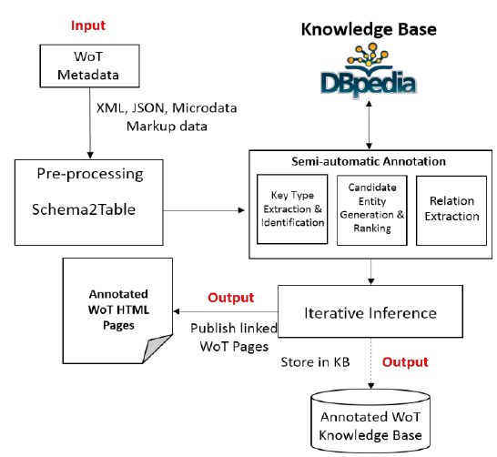
Figure 3 Annotation System on WoT metadata based on entity ranking and message passing
Figure 3 shows the overall structure of my annotation system based on entity linking algorithm and the massage passing model. The system consists of two main parts which are manual annotating and automatic annotating respectively. The manual parts aim at collecting WoT metadata from web front end with HTML and transfers them into tables and constructs the domestic domain-specific knowledge base. The automatic annotation part focus on linking the domain-specific knowledge base to the global domain independent knowledge base and providing a functionality of disambiguation based on entity linking algorithm and message passing model. In this implementation, DBpedia is chosen to be the global domain independent knowledge base.

When the local knowledge graph is constructed according to the user inputs through HTML, the entity linking module begins to work. First the Candidate Generation module queries from DBpedia and gets a candidate set returned from DBpedia for each entity or cell value in the table. And then svm-ranking which is a third party supporting module will re-rank the candidate sets for each entity. The candidate sets for classes and relations between classes can be generated from the candidates of cell values and their corresponding types in DBpedia.

Manual annotation tool
Manual annotation tool aims at transferring the user input into tables and RDF linked data. User input annotations for his devices through web front end (HTML). And the manual annotation system will store them into MySQL as tables and into Jena-tdb as RDF linked data.

Automatic annotation tool
Automatic annotation tool aims at linking the local knowledge graph to the global domain independent knowledge base. This operation is actually to link a local entity to a global entity to help computers to interpret what exactly the local entity means. All the modules are illustrated as follows.

Candidate sets generation
This part of candidate generation consists of Query and Re-rank phase for each cell values and a process for generation for candidates for column headers (classes) and relations between types.

Query for entity candidates
For each cell value, the query module generates a ranked list of possible assignments from DBpedia. The ranking criterion adopted by DBpedia is entity popularity score. DBpedia provides web online query service, so we can get the service at its URL. The sqarql query commands for a cell text is shown in Figure 4.
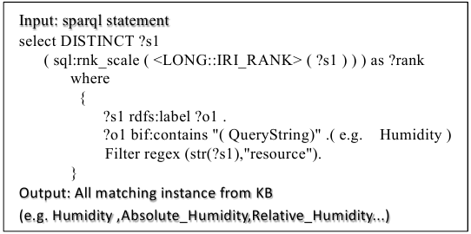
Figure 4 sparql query commands to DBpedia
The cell value which corresponds to an entity is used as the query string. And then DBpedia will return a ranked list subject to the query conditions. The query string should be fuzzily matched under the relation “rdfs:label” and the candidate entity should be of the type “resource”.

Re-Ranking phase
We expect the candidate set to be listed according to the possibility in which what the actual content in the cell could be. But the ranking result does not fully meet our requirement. For example, I take “eu” as the query string. In the result list, the first is “http://dbpedia.org/resource/Euroscepticism” and the second is “http://dbpedia.org/resource/Unitary_patent”. http://dbpedia.org/resource/EU_(European_Union) which is the actual target we want is out of the top 100.

To improve the confidence of the ranking score, I use a SVM ranking classifier to re-rank the list returned by DBpedia. The SVM ranking uses string similarity and entity popularity as metrics to evaluate how possible an entity is what we want. The explanation of the two concepts are shown as follows.

•String similarity
The SVM ranking classifier compares the syntactic features between the query string and the entities in the candidate sets. Several metrics are considered in its ranking mechanism:
• Levenshtein Distance
• string length
• Dice score
Several 0-1 checks are also adopted by the SVM ranking module to see whether the entity equals to the query string or fully contains the query string. The SVM ranking tool checks whether all words in the query string are matched in the original order in the candidate entities, too.

•Entity popularity
Entity popularity is a kind of prior probability feature. It has already been integrated in DBpedia. The score of entity popularity is listed along with the candidate entities returned from DBpedia. It can be helpful when entities have similar names. This score is generated according to how frequently the target entity is referenced by other entities. That is, the more references to this entity, the higher the score is.

Candidates generation for types and relations
In principle, the candidate set of types and relations are generated from the corresponding entity sets. The candidate set for type is exactly the union of all the candidate sets of type for corresponding candidate entity. And the candidate sets of the relations between each pair of types can also be returned from DBpedia.

For each candidate entity, I sent a new query to DBpedia and DBpedia can return a set of possible types. This query takes the entity as the subject and “rdf:type” as the predicate. The objects returned are of our interest. As for the relations between types or keys, I did another query to DBpedia which takes one type as subject and another type as object. DBpedia can return a set of possible predicates for the pair of types. The predicates are exactly the relations we want.

Jointly Reasoning

Principle
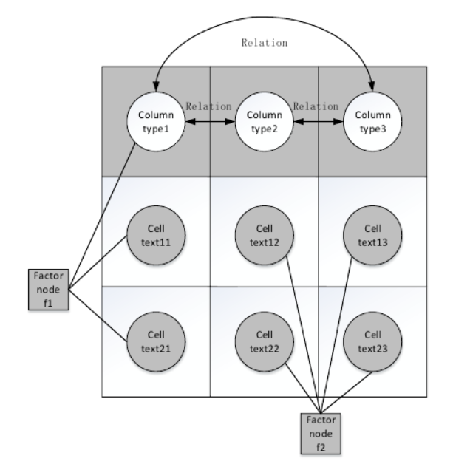
Figure 5 factor graph of a given table
In the stage of jointly reasoning, this paper first maps the input table into a factor graph model which is a kind of probability graph model. The factor graph for a given table is shown in Figure 5. The circular grey nodes are entity nodes who holds attribute values corresponding to every fields. Each row can be regarded as a device instance. The circular white nodes represent the types of all entities in corresponding columns. The schema keys or attribute names are mapped to the values of these type nodes as column headers. These two kinds of nodes of column headers and cell values are variable nodes for the following iterative message passing algorithm. And the square grey nodes are factor nodes in the message passing algorithm. Factor node f1 works as functions of every variable nodes in each column to generate the most possible column type. Factor node f2 works as functions of every pair of cell values in each row to genetate the most possible relation between column types.

The iterative message passing algorithm is illustrated as Algorithm 1 in Error: Reference source not found. The algorithm takes the top candidate value from the list output by re-ranking module as the initial value for each cell entity. In each iteration, variable nodes transfer their values to the factor nodes they connected firstly which means that values of the variable nodes are the paragrams of the connected factor nodes. And then, factor nodes f1 and f2 run to generate the most possible value for each column type and relation between each pair of column types respectively. After that, the factor nodes will pass the result to every variable nodes they connect with an “change” or “unchange” message. The variable nodes will reassign their values accoding to the messages they received. This process will iterate until no change happens or the upper limitation is for the whole iteration is reached. And the details of how factor nodes f1 and f2 work are illustrated in the following two sections.

To draw a short conclusion, the values of column types and relations between each pair of column types are generated from the assignments of all the cell entities. And column types and the relations between columns also work as constraints to disambiguate the values of cell entity. The iterative constraints finally link the domain-specific knowledge base to the global domain independent knowledge base. Therefore, in this way, we can know that some different description of keys in different schemas refer to the same entity in the domain independent knowledge base. Thus, the ambiguation disappears and some further operations such as semantic search or integration among different systems can be possible.

Function for types reasoning
For each current assignment of the entity in one column, I set a query to DBpedia as mentioned in section 3.2.3. And then, the factor node f1 will count, in the column, how many times each type appears as the score of this candidate type. The top one with the highest score is exactly what we want. When two candidates have the same score, this algorithm considers the granularity as the second metric. This is to see how many instances belong to the target type. The less instances a type has, the more specific the type is. Of course, want the one with a minimum granularity.

There is a problem here worth mentioning. The type with the top score may not be actually the one we want. It just seems to be the most possible one according to reasoning. So, setting a threshold is a better choice. When the top score is under the threshold, treat it as with a low confidence, and do not annotate the column with this type.

When variable nodes receive the message from the factor nodes. It will reassign its value according to the guide in the received message. If changed, actually, it will connect to a new class coming from the domain independent knowledge base.

Function for relations reasoning
The algorithm for relations reasoning is similar to that for type reasoning. One difference is that the factor node f2 takes the current assignments of two different cell entities in the same row. And then the message should be returned to both variable nodes. Another difference is that the relation between two columns can be bi-directional which means one can be the subject with the other to be the object and vice versa.

Other details of the implementation
The implementation is a web application technically. This web application uses DBpedia to be the domain independent knowledge base. The tool for the re-ranking phase is an open source SVM ranking classifier. And, the whole web application is based on Java language with Spring + Spring MVC + Mybatis framework. And the application uses Jena-tdb to store the RDF linked data and Mysql to store mapped tables from user inputs.

Relevant use cases
A typical use case of the annotation system is smart building. Many sensors and actuators are deployed in the building in advance. User needs to manually annotate all the devices complying with a predefined ontology model through front end (HTML). The web application then can run entity linking algorithm to link local knowledge base to DBpedia. In the use case of smart building, anomaly diagnosis from sensory data and automatic controlling to change the environment can also be integrated into the annotation system based on annotations reasoning.

Results and Use cases study

Experiment results
In this section, the results after annotation are shown as knowledge graph with the help of Neo4j.

Manual annotation tool
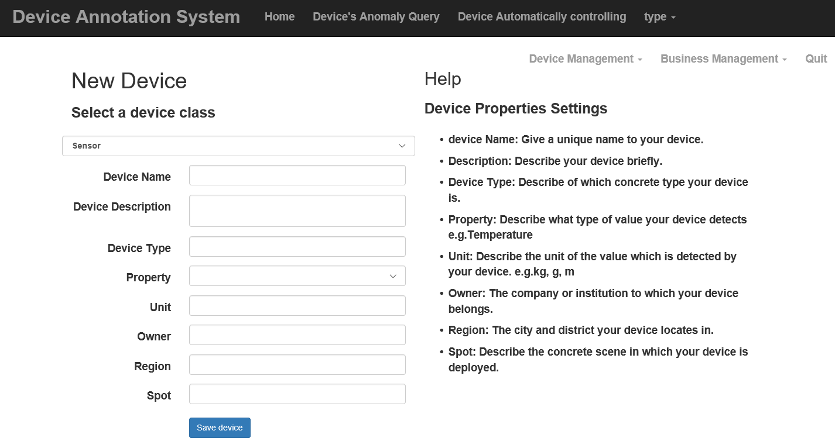
Figure 6 manual annotation input page
The input page for manual annotation subsystem is shown in Figure 6. User inputs various annotations into the boxes. And the application will store the information into the storage system. The initial local knowledge base is shown in Figure 7. The initial knowledge graph is constructed according to the predifined ontology model. After manual annotation, the domestic knowledge base is shown in Figure 8.
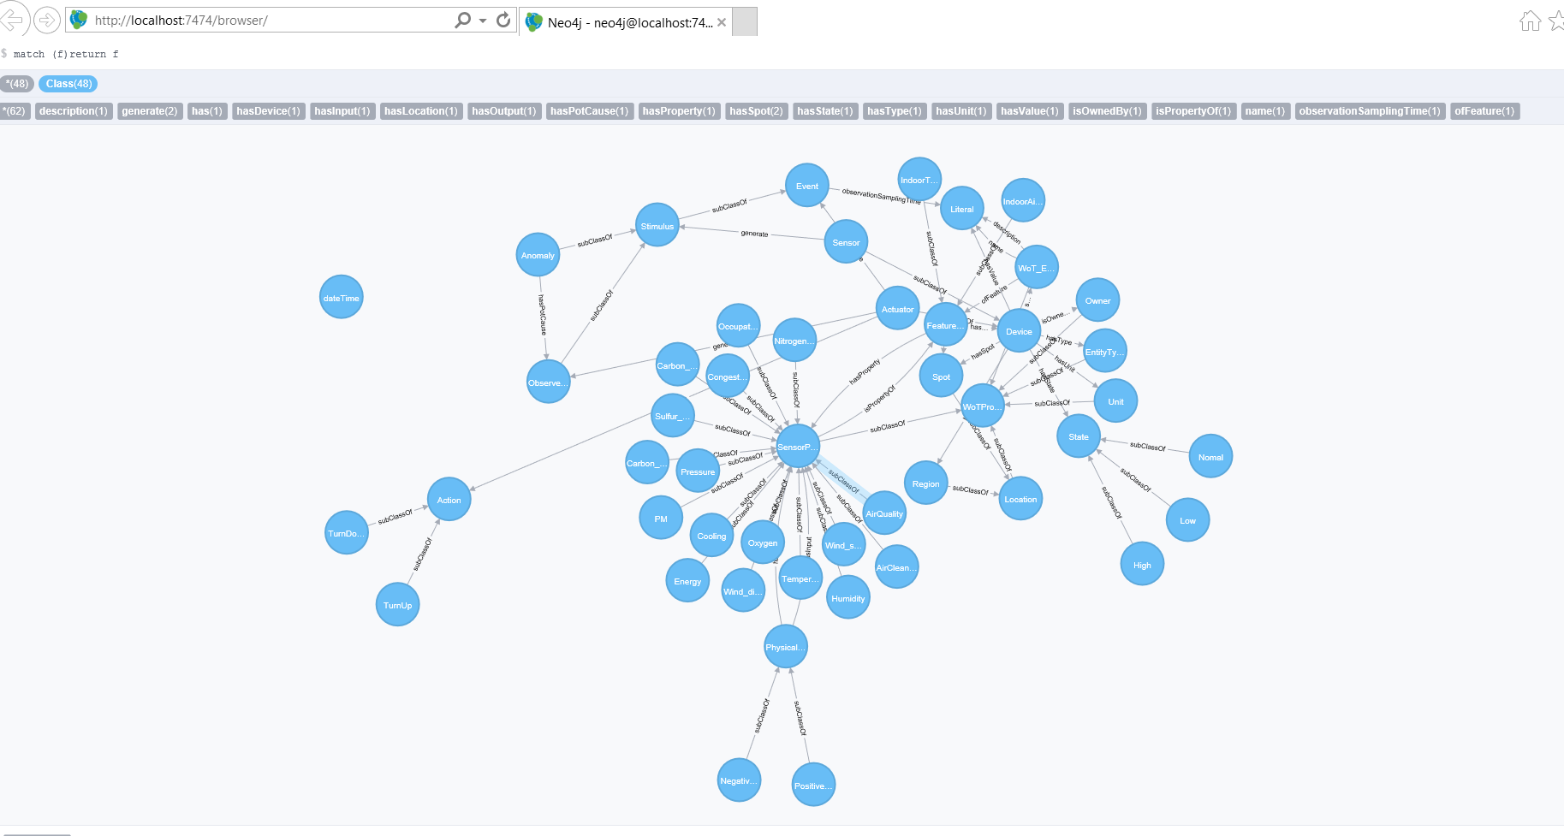
Figure 7 initial local knowledge base

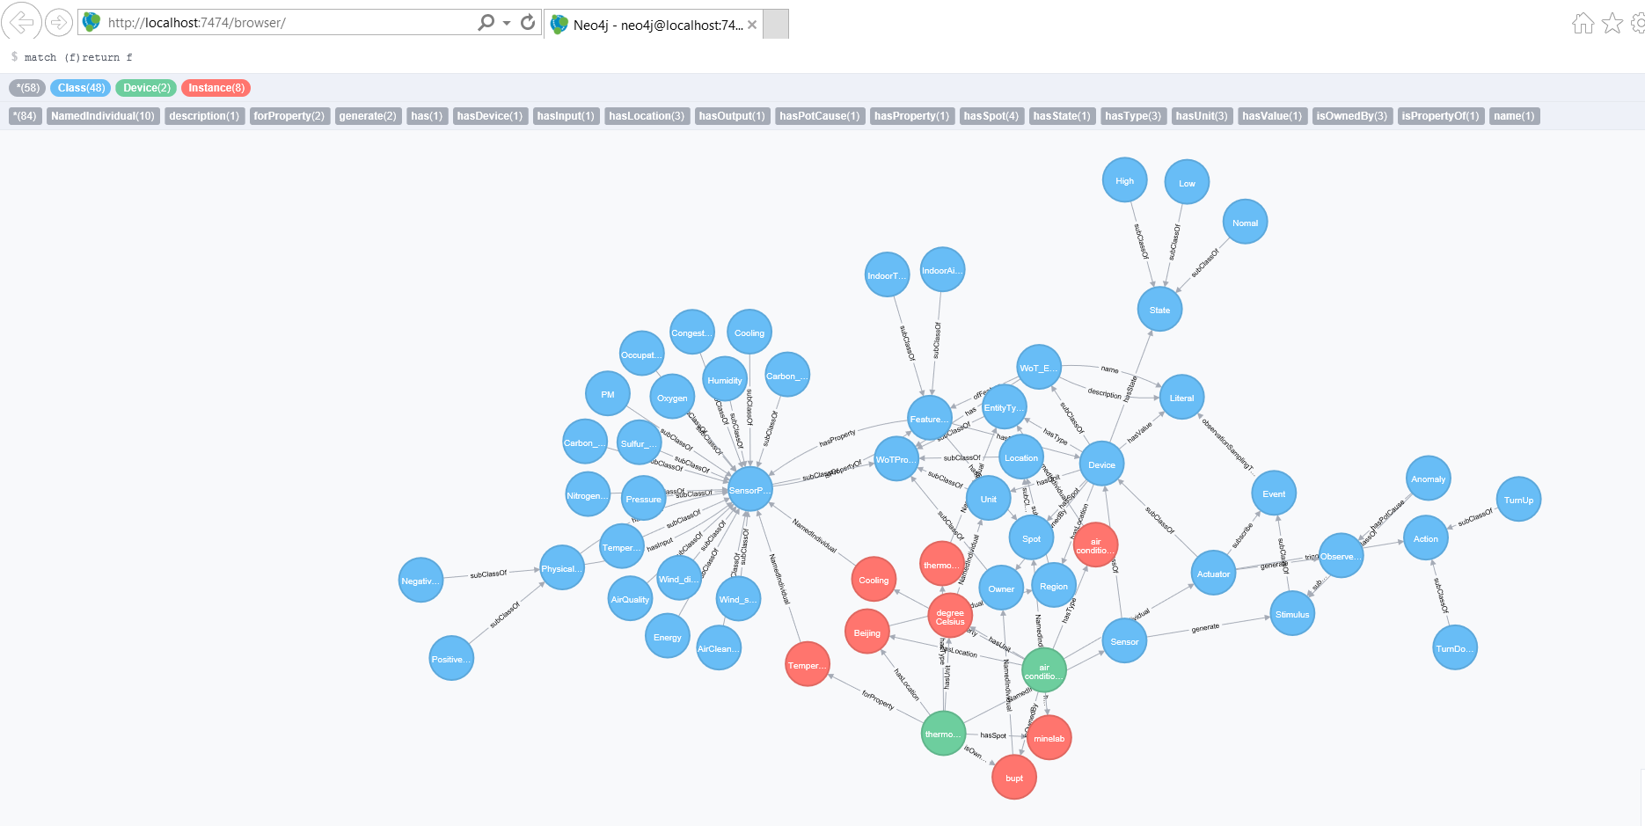
Figure 8 local knowledge base after manual annotation

Automatic annotation tool
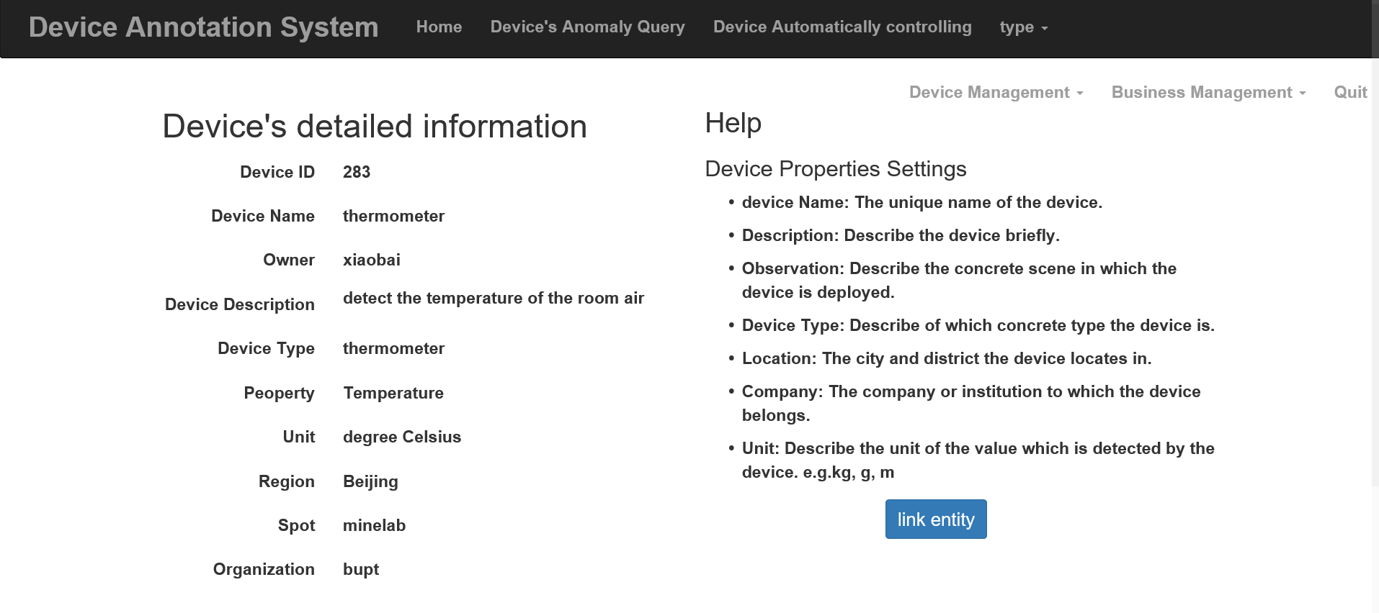
Figure 9 entrance point page for automatic annotation

The entrance point for the automatic annotation is shown in Figure 9. After entering the details of target device, click the “link entity” button. And then the web application will run the entity linking module. The results are shown in Figure 10. The blue nodes are the initial classes constructed according to the predefined ontology model. The green nodes are devices input by the user. The red nodes are the annotations for the devices added manually. The pink nodes are the entities from DBpedia which have connections with local entities. In another way, the local knowledge graph is extended by the entity linking algorithm with the help of DBpedia.
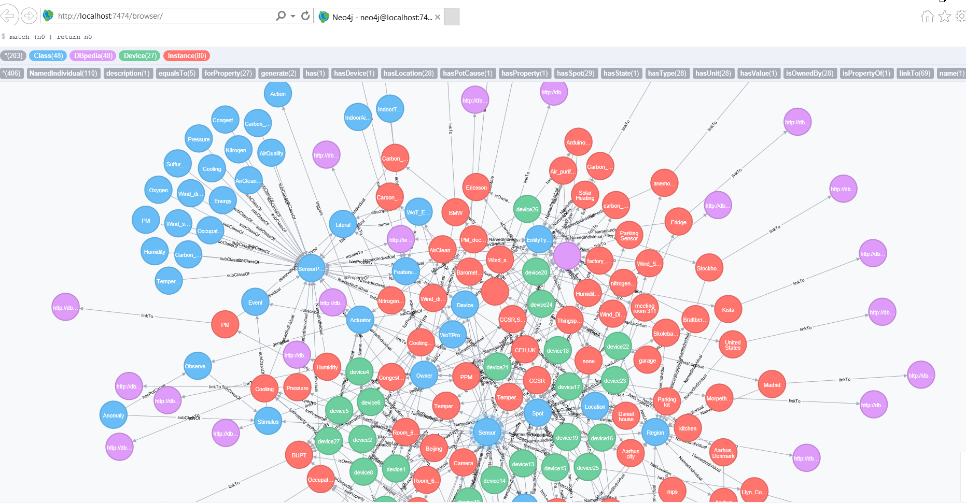
Figure 10 local knowledge base after automatic annotation

Performance
There is a notable phenomenon worth paying some attention. The iteration of the iterative message passing converges very quickly. After the first two iterations, there is no variable node to be changed. Two reasons may account for it. One is the contribution of the re-rank module. The re-rank module tries to move the target assignment to the top of the list with higher accuracy. The other reason is that the number of the relations between columns may be little. The more relations there exist, the more constraints upon one variable node need to be considered. Thus, less relations may result in less iterations.

And another thing is that the time consumed for each annotation table varies considerably with respect to the number of the rows and the columns in that table. It is reasonable that more time is needed if there are more rows and columns since more nodes and messages need to be processed.

Use cases study

The final output of the whole annotation system is a RDF linked knowledge graph taking a domain independent knowledge base into consideration. The usage of this knowledge graph is of great importance. In this section, I will propose several use cases for the purpose of guidance for the usage of the knowledge graph. The use cases are illustrated in the form of the story board.

Conclusion and Further Work

Conclusion
This paper proposes an entity linking (EL) algorithm based on iterative message passing using factor graph model. The EL algorithm adopts semantic techniques for WoT applications to bridge the domestic domain specific knowledge base to the global domain independent knowledge base. Then, ambiguities among different schemas towards the same type disappear since different local annotations are linked to the same type in the global domain independent knowledge base. Thus, a growing networked knowledge infrastructure can be achieved. And I also achieve a web application as a proof of concept implementation to verify the feasibility of the whole annotation system. The web application contains both the manual and automatic annotation tools.

Future work
Based on the knowledge graph base generated by the annotation system, some further functions can be integrated into the web application such as anomaly diagnosis, automatic controlling and semantic searching. Anomaly diagnosis aims at finding the anomaly occurs in the application scene by reasoning based on the sensory data and predefined rules. The application scene can be smart building, industrial monitoring, system maintenance and etc. Automatic controlling is the action responding to the observed anomaly. The target is to remove the anomaly due to the requirement of concrete application scenes. Semantic searching refers to do some reasoning work based on semantic annotations which can make computer more intelligent.
References
Everything you cite from other sources should be properly referenced. APA (The American Psychological Association) format should be used for referencing. You can find the full details on the reference from http://www.learningdevelopment.qmul.ac.uk/sources-referencing, and a few examples are provided below:
Books:
Pitts, J. M., & Schormans, J. A. (2000). Introduction to IP and ATM design and performance: with applications and analysis software. New York: John Wiley. (047149187X)
Journals:
Chiau, C.C., Chen, X., & Parini, C. (2003). Multiperiod EBG structure for wide stopband circuits. IEE Proceedings-Microwaves Antennas & Propagation, 150, no.6, 489-92.
Conference papers:
Papadopoulos, S., & Parini, C. G. (1998). FDTD scattering by a dielectric strut in large geodesic space-frame radomes. In International Symposium on Electromagnetic Theory. Proceedings. 25-28 May, 1998 (Vol.2, pp. 721-3). Thessaloniki: Aristotle University.
Online sources:
Abbott, K. (2004, May). Finding information for Electronic Engineering, Engineering, Materials and the IRC in Biomedical Materials. Retrieved May 27, 2004, from Queen Mary, University of London Library Web site: http://www.library.qmul.ac.uk/

Acknowledgement
I would like to give my gratitude here to my supervisor and a senior fellow apprentice in my laboratory who are really nice persons. They give much help and guidance to me when I meet problems. I learned a lot from them with this project.
Appendix
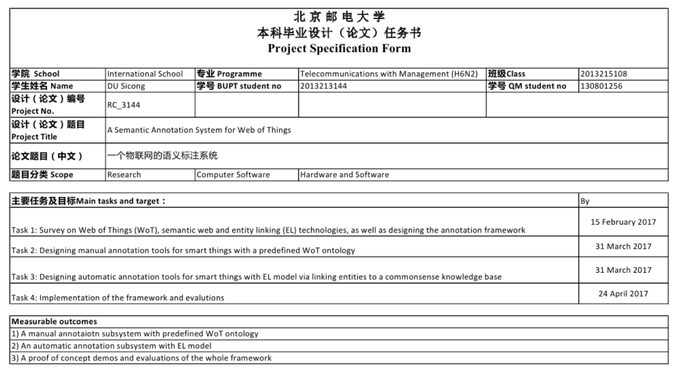
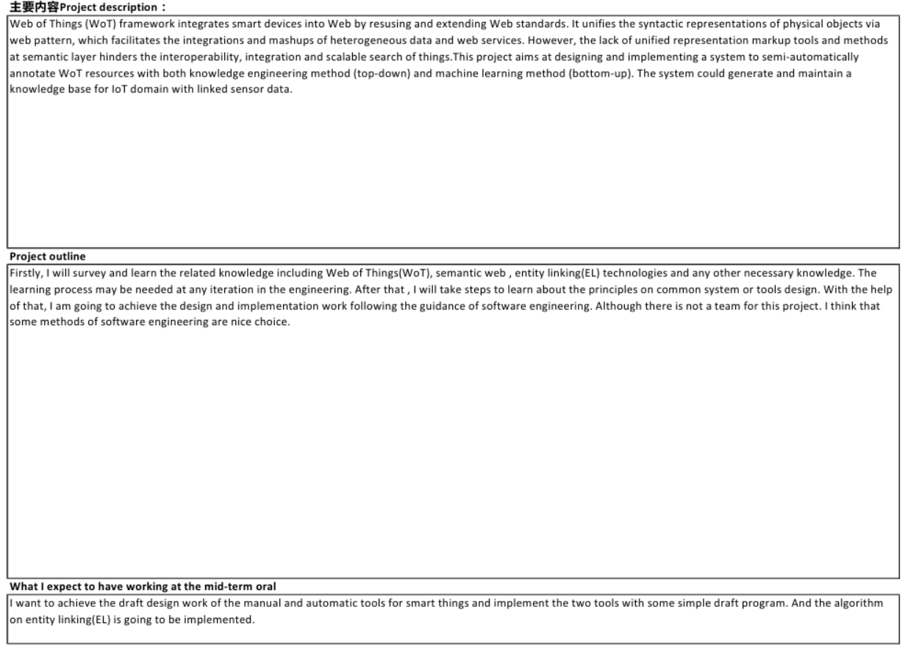
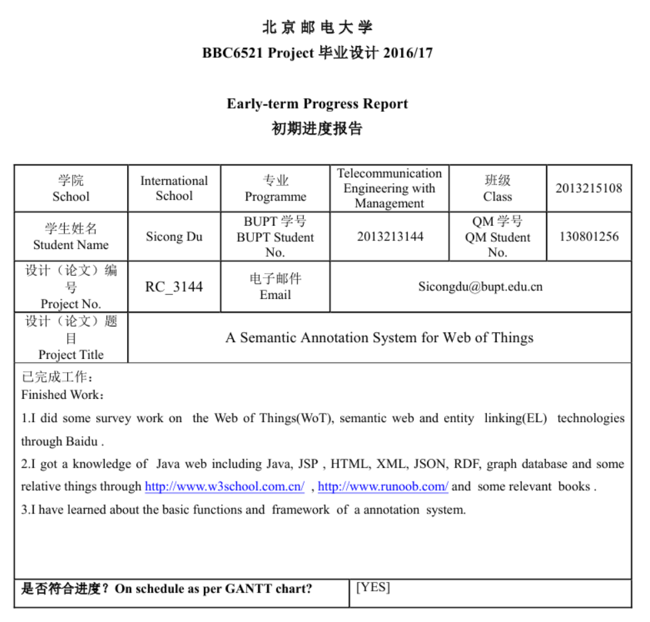
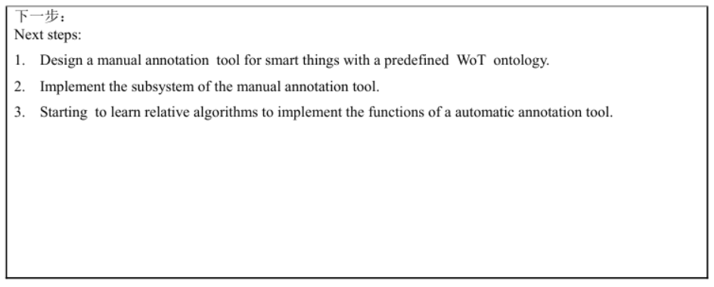

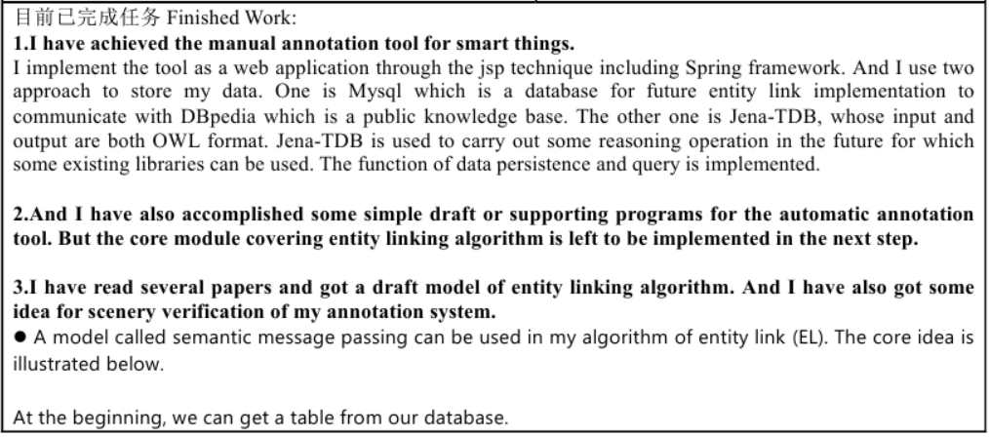
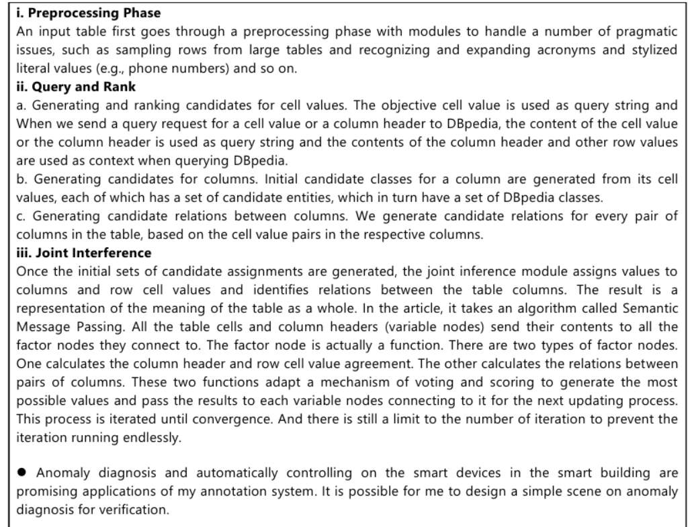
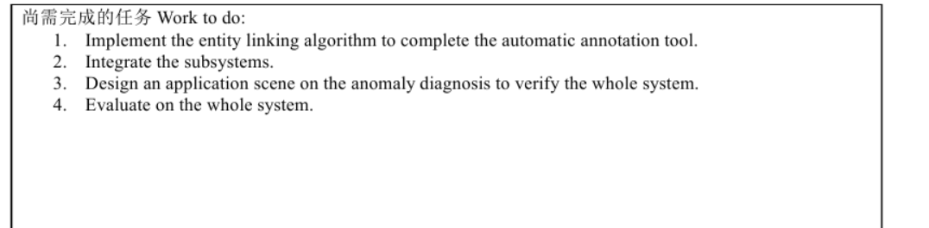
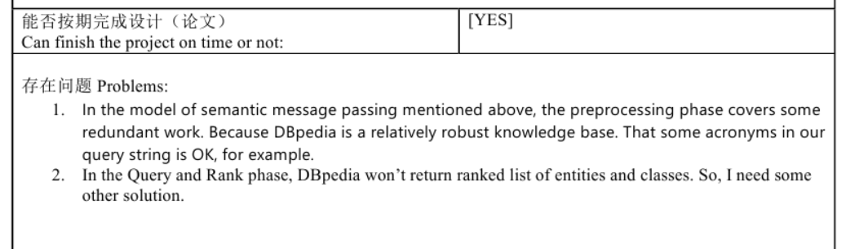
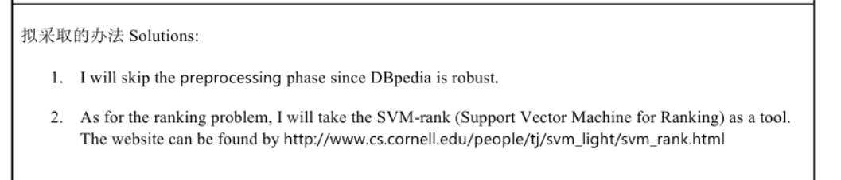
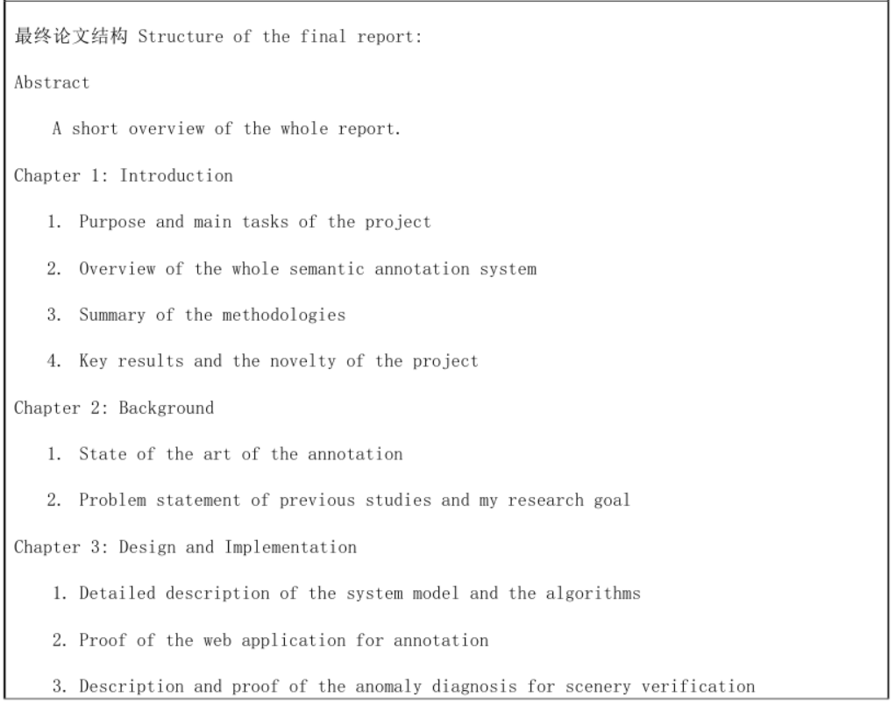
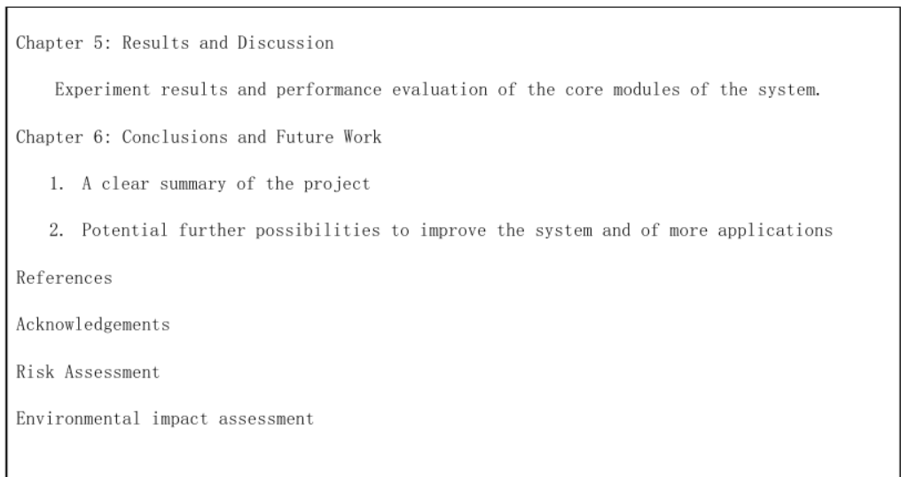

Risk Assessment

Environmental Impact Assessment

