 | 

Undergraduate Project Report
2016/17

A Semantic Annotation System for Web of Things

Name: | Du Sicong
Programme: | Telecoms
Class: | 2013215108
QM Student No. | 130801256
BUPT Student No. | 2013213144

Date 2017/5/2

Table of Contents
Abstract 3
Chapter 1: Introduction 5
1.1 Format 5
1.1.1 Format for headings 5
1.1.2 Format for body text 5
1.1.3 Format for equations 5
1.1.4 Format for figures 6
1.1.5 Format for Tables 6
1.2 Format 7
1.3 Format 7
1.4 Format 7
1.5 Format 7
Chapter 2: Background 8
Chapter 3: Design and Implementation 9
Chapter 4: Results and Discussion 10
Chapter 5: Conclusion and Further Work 11
References 12
Acknowledgement 13
Appendix 14
Risk Assessment 15
Environmental Impact Assessment 16

Abstract

The abstract should be a short overview of the whole report (200-300 words maximum). It should give the reader enough information about your whole project to know what you have tried to do and whether you were successful.

Integrating Web of Things (WoT) with semantic technologies facilitates the construction of a large-scale networked knowledge infrastructure which can provide many smart applications with a strong knowledge base. However, current WoT applications work with a manual mechanism to define the data model and device annotations. This leads to the emergence of many domain-specific applications which results in the problem that many knowledge resources are isolated from each other. This paper proposes a semi-automatic semantic annotation system to link domain-specific entities to a domain independent knowledge base to improve the usability and the usefulness of WoT knowledge resources. An implementation is carried on to prove the feasibility of the semantic annotation system which takes a use case of anormaly diagnosis and automatic controlling into consideration. And a quantitative evaluation towards the whole system is also included.

Key words: Web of Things (WoT), semantic annotation, entity linking, message passing, jointly reasoning

摘要 (Chinese translation of the Abstract)
将语义技术与物联网相结合，有助于构建一个大型的网络知识基础设施，为许多智能应用提供强大的知识库。然而，当前的物联网应用程序使用手动机制来定义数据模型和设备标注。在这种情况下出现了许多特定领域的物联网应用，导致了许多知识资源彼此隔离。本文提出了一个半自动语义标注系统，将特定领域的实体链接到一个与领域无关的知识库，以提高物联网知识资源的可用性和有用性。通过完成一个实现来验证这个语义标注系统的可行性。该实现考虑了一个异常诊断和自动控制的用例场景，包括了对整个系统的一个定量评估。

Introduction
The Introduction is one of the most important parts of your report as it gives a brief overview that will make the reader understand (i) what you set out to do and (ii) what you achieved. Many readers will read the Introduction first and then the Conclusions to get an overview before reading the detail – so it is important that both sections are very carefully written.
It is very important that Introduction introduces the report and the project – it is not there to introduce the subject in general.
There are no rules on how to write an introduction, but it should include what the project is about, give a very short description of the technical context in which the project is carried out and explain the motivation for the work. If you are doing an implementation project it must explain what functionality the system realises, and if you are doing a research project what is the novelty of the approach used.
Very importantly, it should clearly indicate what you have done for the project.
A good introduction should be no more than 4 pages.

Format

Format for headings
Format for level 1, 2 and 3 headings is given in this template; just choose the relevant style from the format list.

Format for body text
Font size should be 12pt, 1.5 line spacing in and justified. Do not indent the first line.

Format for equations
Equations should be centred with a numbered caption on the right; an example is below:
 | 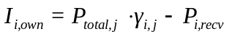 | ()

Format for figures
Figures should be centred and followed by captions. Captions should be centred, 10pt font Times New Roman Bold. Use automatic numbering without chapter number for captions. Select “Caption” from Styles and Formatting to format captions.
Whenever you include a figure in your document you must reference it in the text e.g. this is a reference to Figure 1 using an MS Word cross-reference for the figure number.
When presenting graphs, make sure you label the axes and include units where applicable. Also include a legend (i.e. key) where appropriate.
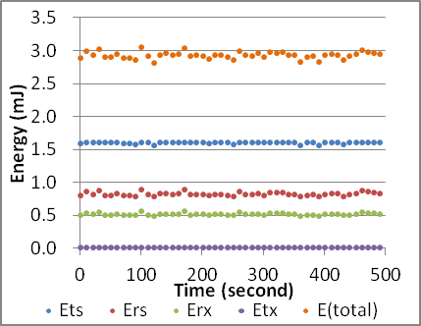
Figure 1 Comparison of energy components

Format for Tables
Unlike figures, the caption for a table should be before the table; Table 1 shows an example of the correct layout.
Table 1: Example Table

Motivation
Internet of Things (IoT) connects many physical devices into the cyber world of World Wide Web through Uniform Resource Identifier (URI) as unique IDs for the devices. Web of Things (WoT) focus on reusing web patterns and protocols to enhance the concept of IoT. “Web Servient” is proposed to improve the abstract model of the devices. Each device is not only a client but also a server which facilitates the construction of cyber-physical systems with higher data and resource usability.

Under the spread of the concept of WoT, many WoT platforms emerge to provide developers with convenient data service and various solution templates. BaiduTianGong, Yeelink and Amazon web service are some of the available platform resources on the web. Developers open these platforms and invoke the APIs to define their own device data model and web service APIs to develop WoT applications. Obviously, the openness of the web technologies makes the development of IoT applications more easy. Devices in the real world can be more conveniently mashed up with both web services and other devices through cyber-physical systems. However, this results in many heterogeneous and isolated data and resources. Because the data models are defined by individuals without unified standard or linking method. Thus, this is a waste of usable information resources.

The data and services of WoT applications can be regarded as web resources. The introduction of semantic technologies aims to improve the usability and usefulness of WoT resources by bridging heterogeneous data from different domain-specific data sources. Accordingly, the semantic technology facilitates the construction of a networked knowledge infrastructure with more interoperable data sources from both cyber and physical worlds.

There are several efforts to integrate semantic web with WoT platforms including Semantic Sensor Web, SENSEI and SPITFIRE. By annotating the physical devices with machine understandable vocabulary such as Semantic Sensor Network (SSN) ontology, it is possible to share data and knowledge with other applications and platforms. However, these efforts still have limitations. The computer understandable vocabularies such as RDF linked ontology are based on domain-specific knowledge. The semantics extraction from raw data needs domain experts to accomplish in manual way. This lowers the interoperability of data and knowledge sharing among different systems in different domains. They do not consider the possibility of a growing knowledge base linked to global domain independent Linked Open Data (LOD), for example, DBpedia, Yago, FOAF and etc. Since Key-Value pairs is a common form to annotate the attributes of the WoT devices, I take the format of JSON in an example to explain a possible concrete situation in which the data interoperability is lowered. In Figure 2, there are two schema from two different domains in JSON format. In schema 1, the developer annotates the type “location” with “location”. However, in schema 2, another developer annotates the type “location” with “deploy”. Computer does not know the two annotations refer to the same type. Thus, by linking domestic entities to the entities in domain independent knowledge base such as DBpedia, computer can understand the relations among different data sources among different domains which supports further semantic searching and integration.
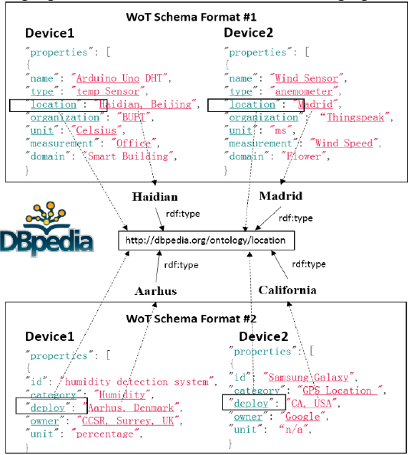
Figure 2 Linked WoT data with semantic annotations of keys, values and relations

Achievement
This paper designs an ontology model subject to the NeOn methodology to annotate all the devices involved in a use case of smart building. NeOn methodology guarantees the extensibility and the reusability of the ontology. The use case includes the issues of anormaly diagnosis and automatic controlling.

This paper proposes a factor graphic model to link the domain-specific WoT metadata to a domain independent knowledge base (KB). And an entity linking algorithm based on message passing is also proposed to disambiguate the domestic metadata.

A web application is implemented to test the feasibility of the whole method for semantic annotation. The use case is about temperature self-adaption in the smart building automation. The performance of the whole system is evaluated with quantitative evidence.

Technique context
The web application is implemented based on JSP techniques. The framework of Spring + Spring-MVC + Mybatis is adopted. Because these Java-based techniques have the following advantages:
•Java is an object-oriented language. Object-oriented is a natural extension of the real-world model. Any entity in the real world can be seen as an object. Objects interact through messages. In addition, any entity in the real world can be attached to a class of things. Any object is an instance of a class of things. The object-oriented programming language is object-centered and message-driven. Object-oriented programming language can be regarded in a perspective that program is object plus message. Hence, it is easy to model the entities in the real world to the classes in programmes.
• Java is a platform-independent language. Applications written in Java can run on different hardware and software platforms without modification. Java mainly relies on the Java Virtual Machine (JVM) at the target code level to achieve platform independence. JVM is an abstract machine attached to the specific operating system. JVM has a set of virtual machine instructions with its own stacks and register groups. But the JVM is usually implemented on software rather than on hardware. Platform independence of Java has greatly accelerated and promoted the development of software products.
•Java supports multi-thread programming. Java supports multithreading in two ways. On the one hand, the Java environment itself is multithreaded. Several system threads are responsible for the useless cells recycling, system maintenance and other system-level operations. On the other hand, Java language built-in multi-threaded controlling can greatly simplify the development of multi-threaded applications. Java provides a class Thread, which is responsible for starting to run, terminating the thread, and checking the thread status. Java threads also include a set of synchronization primitives. These primitives are responsible for concurrency control of threads. Using Java's multi-thread programming interfaces, developers can easily develop the applications supporting multi-thread, improving program executing efficiency.

The storage methods in the implementation are as follows:
•Jena-tdb. This is a file storage system with the query language SPARQL. The input and the output of this module are both in OWL format. The data is RDF linked in Jena-tdb. Jena-tdb has built-in tools to support semantic reasoning.
•Mysql. Mysql is a relational database system based on table forms or schemas. We can conveniently apply the factor graphic model with the help of Mysql.

•Neo4j. Meo4j is a graph database which can visibly display the structure of the RDF linked data with labels and relations in a vivid graph form.

Report Structure
The rest of this paper is arranged in this way. Chapter 2 focuses on some background knowledge of semantic Web of Things. The detailed description of the annotation system and all the involved algorithms are illustrated in Chapter 3 as well as the details about the application implementation. Chapter 4 is about the experiment results and performance evaluation from various aspects of the annotation system. And Chapter 5 concludes the whole paper and predicts some possible subsequent future work after the efforts of this paper.

Background
In this part of the report, you should give all the relevant background information about your project. Remember that your reader will not necessarily know the background technology you are using, so it is worthwhile to let them know.
Also if your project is a research project, this is a good place to put down the related work or state of the art in the area – what the others have done? And why your research is novel?
But don’t make the background 20 pages long with every detail. It should be relevant to your project, with all the necessary information, written nicely and crisply.

Web of Things (WoT)
The Web of Things (WoT) allows objects in the real world to be part of the World Wide Web. It can be used to describe relevant software architectural styles, programming patterns and approaches. Just as what Web (Application layer) is to the Internet (Network layer), the Web of Things provides an Application Layer approach to simplify the development of Internet of Things (IoT) applications.

Rather than propose a brand new standard, Web of Things reuses widely spread Web standards used in
•programmable Web, e.g. REST, HTTP, JSON
•semantic Web, e.g. JSON-LD, Microdata
•real-time Web, e.g. Websocket
•social Web, e.g. OAuth, social networks

Semantic web
The Semantic Web is an extension of the Web following the standards by the World Wide Web Consortium (W3C). It is an imagination towards the future network. Now, the semantic web behaves as one of the features of the age of Web 3.0. In short, semantic web is a type of intelligent web. It can interpret not only words and concepts, but also the logic relationship among them which can make communications more efficient and valuable.

The core of semantic web is to add machine comprehensible semantic metadata to the documents in the web such as HTML and XML. Thus, the whole Internet becomes a common medium for information exchange.

The evolution history of semantic web is depicted in Figure 3 with comparison to the timeline of XML world.
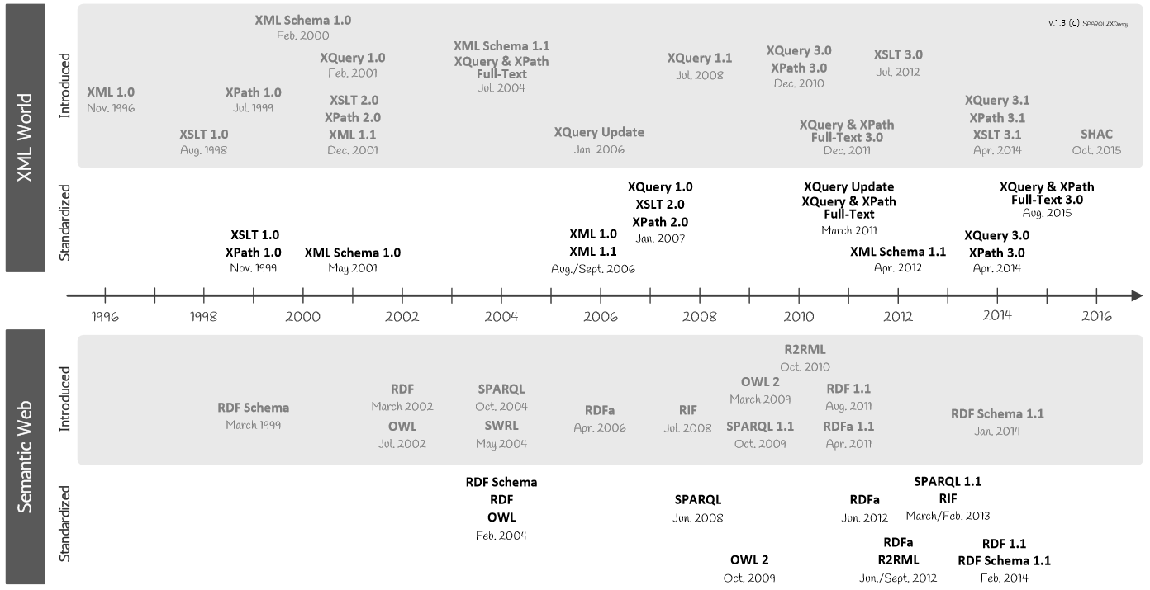
Figure 3 XML and semantic web standards timeline

http://www.dblab.ntua.gr/~bikakis/XML%20and%20Semantic%20Web%20W3C%20Standards%20Timeline-History.pdf

Resource Description Framework (RDF)
RDF is a W3C standard used to describe cyber resources on the Web such as title, author, updated date, content and copyright of webpages. RDF is written based on XML techniques which is called RDF/XML. With the use of XML, RDF information can easily be exchanged among computers using different operating systems and application languages. RDF provides models and grammars with respect to data. It is a general method to describe information so that it can be read and understood by computers. Thus, individual teams can use it and exchange information.

Accordingly, RDF is designed to be an important part of semantic web activities which facilitates the interactions among computers rather than presentations to persons in webpages. The purposes of Semantic Web Vision proposed by W3C are:
• Information on the Web has accurate meanings
• Web information can be understood and processed by computers
• Computers can integrate information from Web

Moreover, RDF is a directed, labeled graph data format for representing information in the web. RDF is often used to represent, among other things, personal information, social networks, metadata about digital artifacts, as well as to provide a means of integration over disparate sources of information.

Web Ontology Language（OWL）
The term “ontology” comes from philosophy. The theory of ontology aims at studying various entities in the universe and how they are connected. When it comes to Web, ontology is an accurate description about web information and the relations among web information.

OWL is a kind of language used to process information on the web which is also a W3C standards. It is constructed on top of RDF using XML. The same as RDF, OWL is designed to be interpreted by computers rather than read by persons. And OWL is also an important part of “Semantic Web Vision”. OWL has three sub-language:
• OWL Lite
• OWL DL (Description Logic, including OWL Lite)
• OWL Full (including OWL DL)

OWL has many similar aspects with RDF. However, compared to RDF, OWL has a stronger ability of machine interpretation. It possesses larger vocabulary than RDF does.

Simple Protocol and RDF Query Language (SPARQL)
SPARQL is a data access protocol and a query language developed and defined for RDF data model. It can be used for any information resources which can be represented by RDF. It is now a W3C recommended standard. As a protocol, SPARQL is a way of communication between parties that run SPARQL queries. It defines a way of invoking the service and bindings of a transport protocol for that goal. And it is also a standard query language and data access language in the form of expressive query against the RDF data model. Especially, SPARQL is compatible with the graph patterns when conducting queries.

To be short, SPARQL connects two web technologies together, Web 2.0 and semantic web. It is very promising to be the major network database query language and data access standard in the future.

Related work
This section is about some state of the art on using semantic technology to annotate sensory data and link entities for WoT applications. Some methods implement the annotation by linked data and ontological knowledge engineering and some others adopts machine learning models to extract knowledge from existing data sources.

Semantic Sensor Web (SSW)
The semantic sensor web (SSW) proposes a method to annotate sensory data using three dimensions which are spatial, temporal and thematic semantic metadata. This method reuses specifications proposed by Open Geospatial Consortium (OGC) and Sensor Web Enablement (SWE) and tries to extend the specifications using semantic technologies to construct an enhanced framework to describe and access the sensory data.

Linked sensor middleware (LSM)
Linked sensor middleware (LSM) provides many functionalities, for instances,
•wrappers real-time data collecting and publishing
•a web interface for data annotation and visualization
•a Simple Protocol and RDF Query Language (SPARQL) for operating on entities and ontology

It facilitates the integration among different data sources. And with the help of LSM, the modularization of WoT applications can be improved in a great extent.

Knowledge Extraction and Knowledge Base Construction
Wang et al. uses a novel pattern-based Hidden Markov model (pHMM) to model time series which tries to reveal a global picture of the system dynamics that generates the time series data. Ganz et al. proposes an approach to automatically acquire the semantic knowledge from sensor data. They apply an enhanced k-means clustering method and a statistic model to extract and link relevant concepts in the form of a topical ontology. The City Pulse framework aims at pattern discovery in real-time cases and analysis involving prediction. It facilitates the construction of business services and use application in the background of smart city. It aggregates, interprets and extracts meaningful knowledge from large amount of heterogeneous data streams and provides real-time adaptive urban reasoning services.

Some other studies are not directly applied to IoT knowledge base construction. But, the methods they proposed can be used to semantic annotation and extraction on structural metadata of devices. For examples, Limaye et al. and Mulwad et al. both used probabilistic graphical model. And they both took a thought called message passing into consideration into their algorithm.

Design and Implementation
Normally there will be a part about the design and implementation of the system, especially for an implementation project. However, every project has its unique phases so you should talk to your supervisor about it.

System framework description

Candidate sets generation

Query for entity candidates

Re-Ranking phase

Candidates generation for classes and relations

Jointly Reasoning

Principle

Function for types reasoning

Function for relations reasoning

Proof-of-concept Implementation

Tools and environmental setup

Use case description

Corresponding simulation

Results and Discussion
Again, most projects will have results, especially for a research project. But again you should talk to your supervisor about it.

Experiment results

Evaluation

Experiment setup

Re-rank phase

Semi-automatic annotation

Performance

Conclusion and Further Work
The conclusion is an important part of the report, as it states what you have done for the project. It also concludes the findings of your research or the outcome of implementing a system.
A good conclusion will NOT repeat what you have done, but set out the achievements very crisply (2 pages should be sufficient).
Further work can be the next step of your research, or some functionality that can be added to the implementation to make it more practical.

NOTE: The maximum length of the report up to here is 50 pages.

Conclusion

Future work
References
Everything you cite from other sources should be properly referenced. APA (The American Psychological Association) format should be used for referencing. You can find the full details on the reference from http://www.learningdevelopment.qmul.ac.uk/sources-referencing, and a few examples are provided below:
Books:
Pitts, J. M., & Schormans, J. A. (2000). Introduction to IP and ATM design and performance: with applications and analysis software. New York: John Wiley. (047149187X)
Journals:
Chiau, C.C., Chen, X., & Parini, C. (2003). Multiperiod EBG structure for wide stopband circuits. IEE Proceedings-Microwaves Antennas & Propagation, 150, no.6, 489-92.
Conference papers:
Papadopoulos, S., & Parini, C. G. (1998). FDTD scattering by a dielectric strut in large geodesic space-frame radomes. In International Symposium on Electromagnetic Theory. Proceedings. 25-28 May, 1998 (Vol.2, pp. 721-3). Thessaloniki: Aristotle University.
Online sources:
Abbott, K. (2004, May). Finding information for Electronic Engineering, Engineering, Materials and the IRC in Biomedical Materials. Retrieved May 27, 2004, from Queen Mary, University of London Library Web site: http://www.library.qmul.ac.uk/

Acknowledgement
Give your acknowledgement to people who helped you during the project here. Maximum length of this section is 1 page. DO NOT MENTION YOUR SUPERVISOR’S NAME HERE.
Appendix
You must include the following here:
- Specification
- Early-term Progress Report
- Mid-term Check Report
NOTE: all of the above must be the final PDF versions downloaded from QMPlus.
Risk Assessment

Environmental Impact Assessment

