**Stochastic Processes**

Coursework Project Report

Spring 2020

Name: Xin Yi (易鑫)

Student ID: 1950271009

Name: Cheng Wen (文成)

Student ID: 1950271008

1. **Introduction**

In the first section, explain the background, the assignment, and which research scenario you have chosen and why (max. two pages).

In radio channel or optical channel, noise can cause transmission errors, that can be modeled as a stochastic process. However, real-life experiments show that bit errors often appear in bursts. The Gilbert–Elliott model [1] is a simple channel model introduced by Edgar Gilbert and E. O. Elliott widely used for describing burst error patterns in transmission channels, that enables simulations of the digital error performance of communications links.

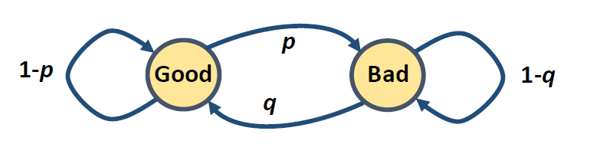 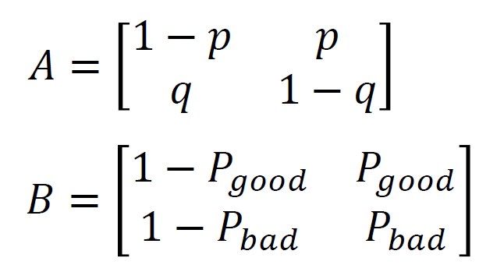

Figure 1. General Illustration of Gilbert-Elliot Model

In our research scenario, we aim to answer two research question.

**Research Question 1**: Given the bit error sequence, how to find out the most likely parameters for this Gilbert-Elliot model?

Transmission error in a radio channel appears when a transmitted symbol is received incorrectly. Digital information is usually processed and transmitted as bits; therefore, we can say that there is a bit error, if transmitted bit 0 is received as 1, or if transmitted bit 1 is received as 0. It has been observed that when digital information is transmitted over a radio channel, transmission errors usually appear in bursts, rather than isolated from each other. Therefore, bit errors are often simulated by using Gilbert-Elliot model [1]. A general illustration of Gilbert-Elliot model is shown in Figure 1. More specifically, the Gilbert–Elliott model is based on a Markov chain with two with two states Good (for good or gap) and Bad (for bad or burst). In Good state, bit error probability is low; in Bad state, bit error probability is high. We can define that the observed state is 0 if there is no bit error, and the observed state is 1, if there is a bit error. Transition between Good state and Bad state can be expressed by parameters *p* and *q*, using the transition matrix A in Figure 1. In the first part of the project, our research question is to find the most likely parameters λ = {p, q, , } for Gilbert-Elliot model producing the bit error sequence included in text file “*biterrors.txt*”, which is in the form of "00000000...1...00000..."

**Research Question 2**: How to perform simulation of bit errors by using Gilbert-Elliot model?

In the second part of the project, our research question is to implement a radio channel simulator, using a Gilbert-Elliot model to simulate bit errors. We use the scenario illustrated in Figure 2 as an inspiration for our study. We generate a sequence of bits randomly, apply simulated bit errors to the bitstream, and then compare the transmitted and received bitstreams to compute bit error rate , defined as a ratio of erroneously received bits , and the total number of bits : .

Using the channel simulator, we have conducted a small-scale research study, analyzing the impact of Gilbert-Elliot model parameters for transmission performance. We ran the simulation with different Gilbert-Elliot model parameters and compare the experimentally achieved bit error rate results against analytically derived results for the respective parameters. We also implement forward error correcting code (FEC) and study the impact of error correction on the residual bit error rate.

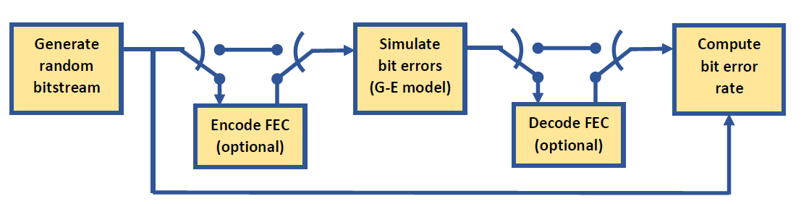

Figure 2. Example Bit Error Simulation Scenario

In summary, this article makes the following significances:

* + We summarized both EM algorithm and Baum-Wilch algorithm and try to use these two methods to find out the most likely parameters in Gilbert-Elliot model for the given bit error sequence.
  + We have designed a channel simulator with and without the error-correcting code. We conducted a small-scale research study on the impact of error correction on the residual bit error rate.
  + We implement the prototype codes (in python and matlab), of which source code are available via a publicly accessible repository: <https://github.com/wcventure/StochasticCoursework>.
  + We provide compelling results and the analysis for each experiment.

The remainder of this paper is organized as follows. We describe the detail of our methodology in Section 2, followed by the experimental results and analysis in Section 3. Section 4 declares the contribution of each author. Section 5 concludes the paper.

1. **Methods**

In the second section, you explain what you have done, how you implemented the system, and possibly your own ideas how you have differentiated your study from those published already (max. two pages if written by one student, three pages if written by two students).

1. **Experimental Results and Analysis**

In the third section, you explain the experimental results and analysis, including numerical results, graphs and discussion (max. three pages if written by one student, four pages if written by two students, excluding figures). It is highly recommended to use illustrations and tables (see Fig. 1 and Table I as examples).

**Figure 1.** Example figure caption.

**Table I.** Example table caption.

|  |  |  |  |
| --- | --- | --- | --- |
|  | Parameter set I | Parameter set II | Parameter set III |
| Method A |  |  |  |
| Method B |  |  |  |
| Method C |  |  |  |

1. **Contributions**

Student Cheng Wen and Student Xin Yi discuss to overcome technical difficulties, and design our solution together. Student Cheng Wen implemented functions *baum-welch.py*, *em.py*, and mainly wrote Section 2.2 and 3.2. Student Xin Yi implemented *gilbert-elliot.m*, *encode-decode.m*, and mainly wrote Section 2.3 and 3.3. The other parts were written jointly by both students.

1. **Conclusion**

In this article, we …

1. **References**

Use references to acknowledge the sources of your information, as well as source code, if you use source code from external sources.

[1] E. O. Elliot, “Estimates of Error Rates for Codes on Burst-Noise Channels.” *Bell System Technical Journal*, 42: 5, pp 1977-1997, September 1963.