----**Model Number**----

**\*\*Image of Model Summary\*\***

**Model Number**-**Fit Number**)

**\*\*Python Fit Code\*\***

**\*\*Image of Fit Accuracy\*\***

**…**

----1----

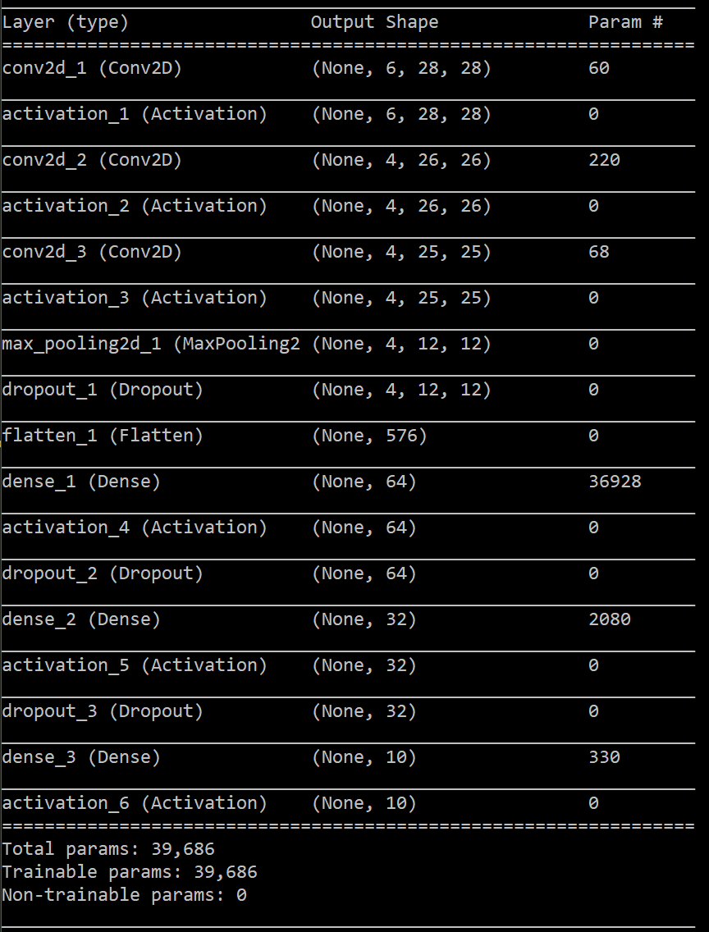

1-1)

for i in range(0, 5, 1):

model = trainModel(model, (i+1), 20*pow(2, i), x, y_train)

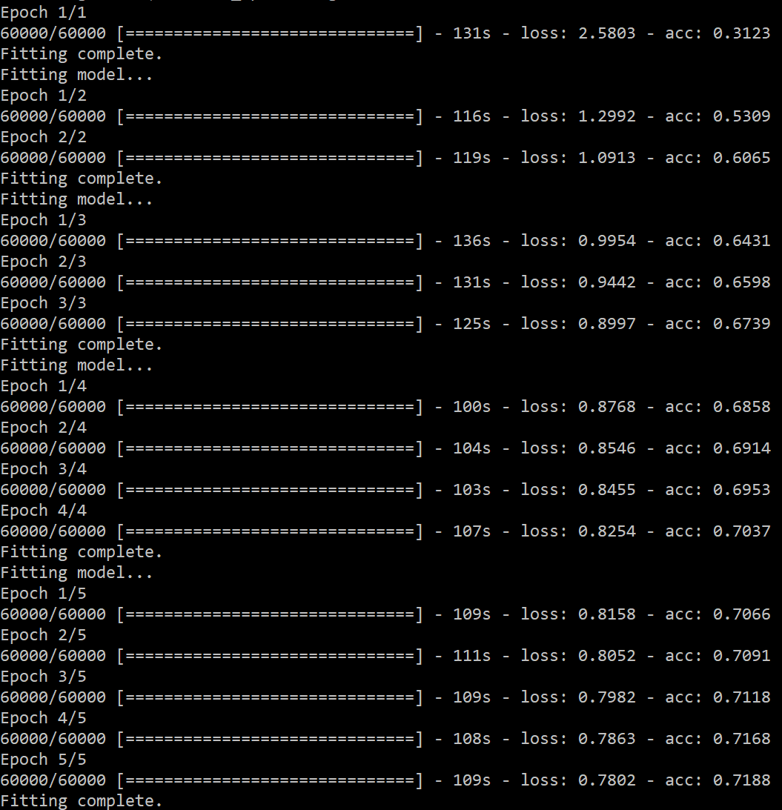

1-2)

for i in range(4, -1, -1):

model = trainModel(model, (i+1), 20*pow(2, i), x, y_train)

----2----

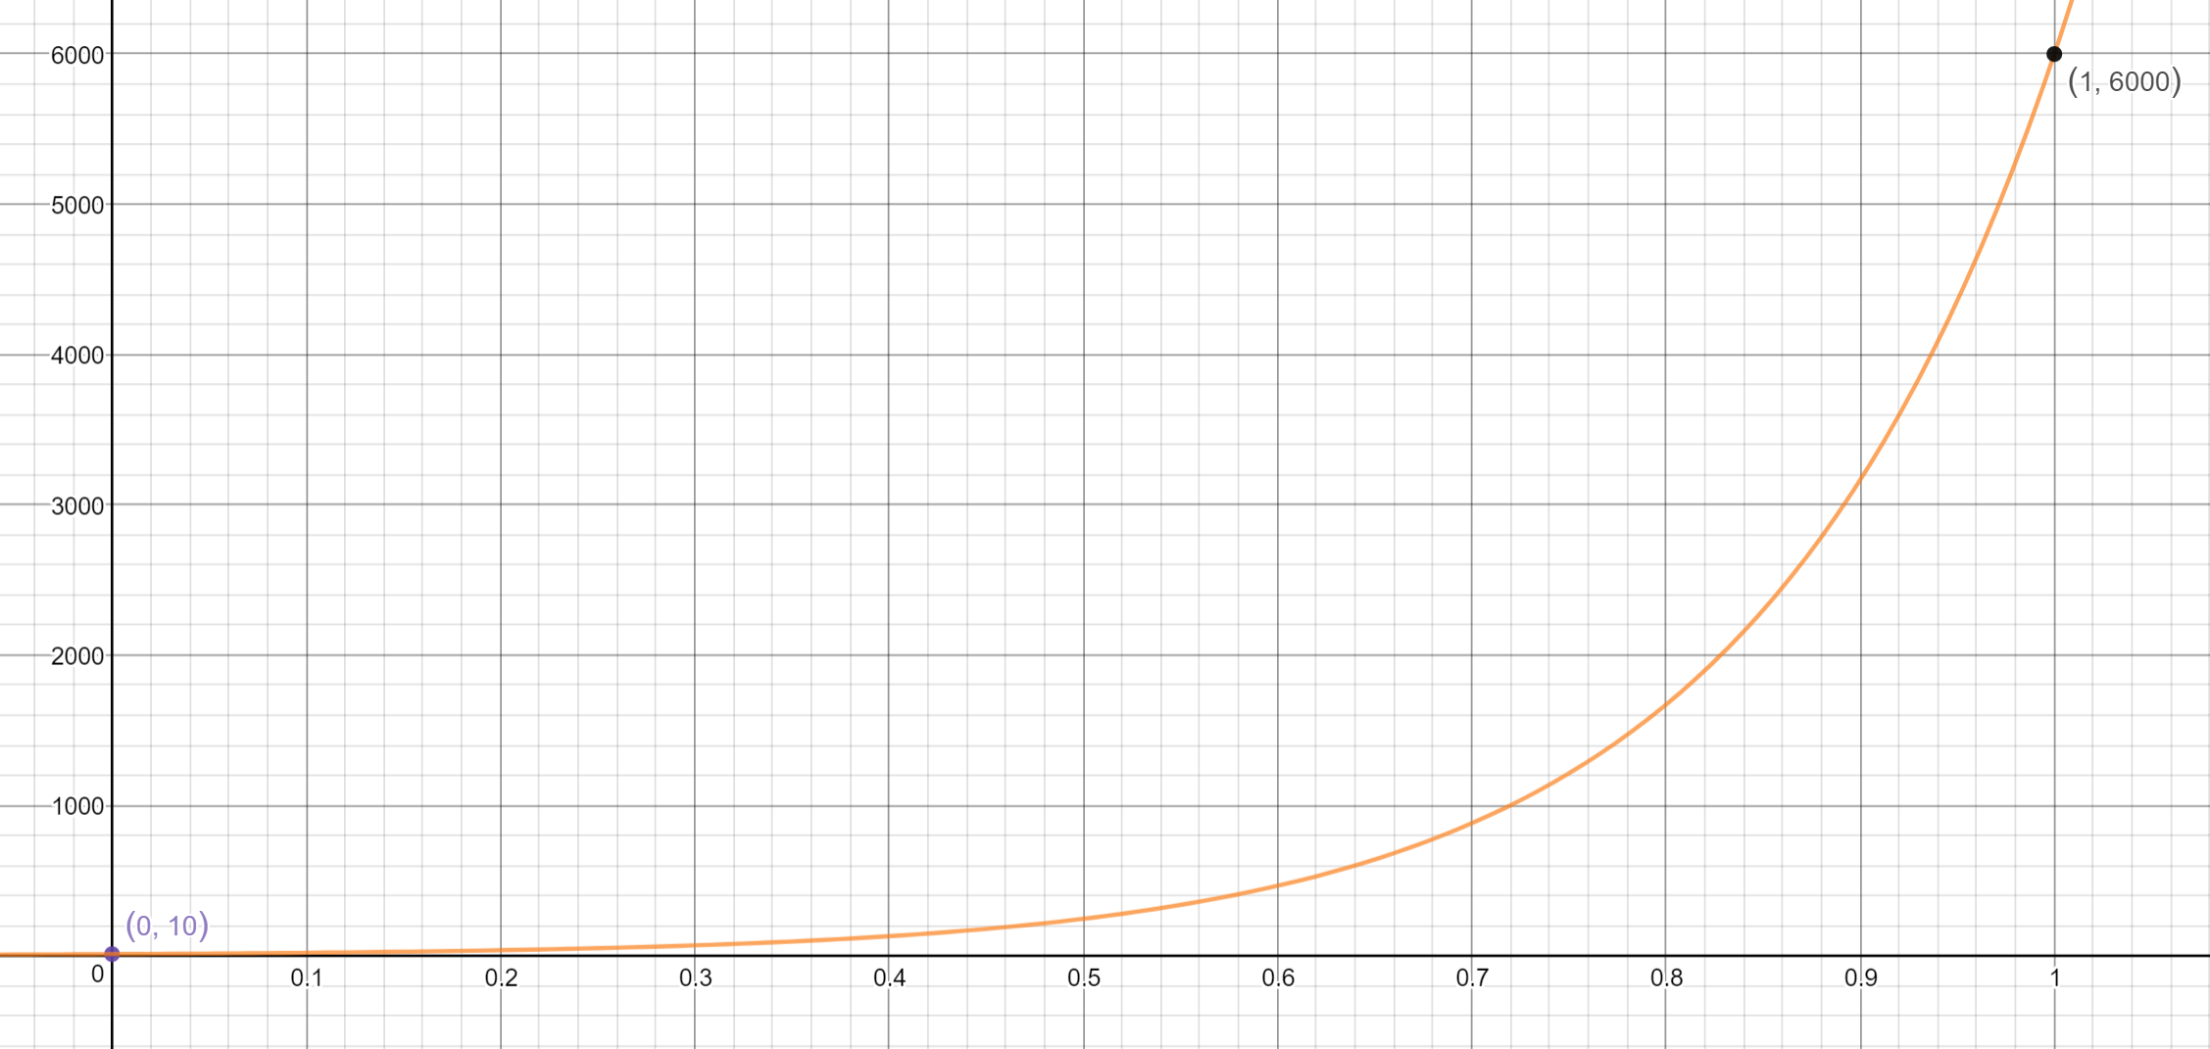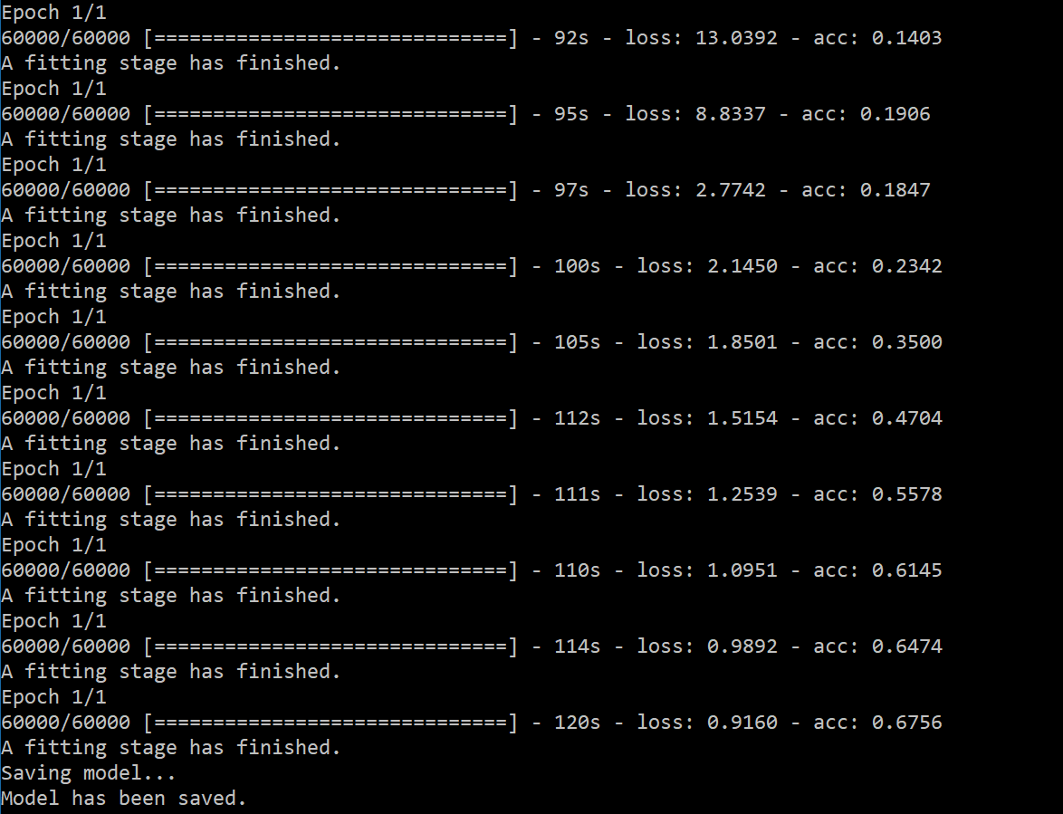

----Model3----