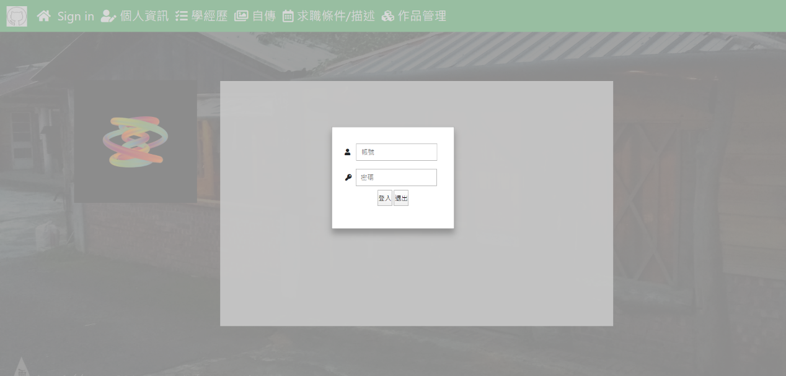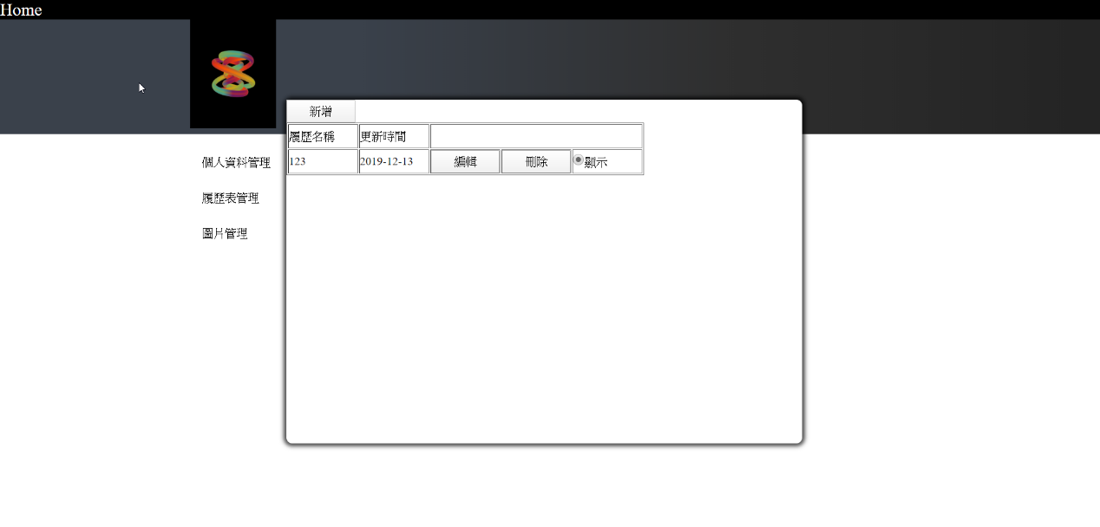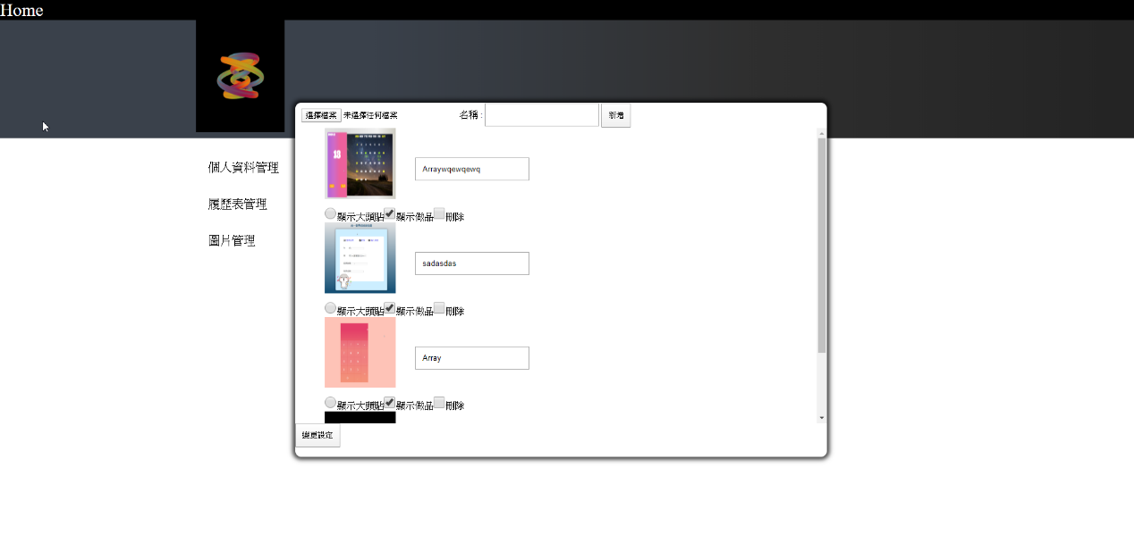

cakeresume

https://www.cakeresume.com/s--PLn8_iLSOsGtqbV7jFUqJQ--/andrew103321