Nodemon

Nodemon is a utility that will monitor for any changes in your source and automatically restart your server

Just use nodemon instead of node to run your code, and now your process will automatically restart when your code changes

<https://nodemon.io/>

npm install nodemon

ref

<https://medium.com/@blonded/understanding-handlebars-js-cabe7c92a154>

<https://ghost.org/docs/api/v3/handlebars-themes/structure/>

<http://derpturkey.com/multiple-views-directories-with-express-hbs/>

<https://scotch.io/tutorials/build-simple-authentication-in-express-in-15-minutes>

<https://developer.mozilla.org/en-US/docs/Learn/Server-side/Express_Nodejs/forms>

<https://webapplog.com/handlebars/>

<https://hackersandslackers.com/handlebars-templates-expressjs/>

<https://www.youtube.com/watch?v=HxJzZ7fmUDQ>

<https://www.youtube.com/watch?v=1srD3Mdvf50>

<https://learningnode.wordpress.com/2015/11/21/express-handlebars/>

<https://github.com/Blonded/Satiable-Soiree/blob/master/server.js>

<https://blog.fossasia.org/using-partials-in-handlebars-and-reusing-code/>

<https://github.com/ericf/express-handlebars/blob/master/examples/advanced/server.js>

<https://stackoverflow.com/questions/16385173/node-js-express-handlebars-js-partial-views>

<https://www.npmjs.com/package/hbs>

<https://github.com/pillarjs/hbs/blob/master/examples/partial/app.js>

<https://blog.teamtreehouse.com/handlebars-js-part-2-partials-and-helpers>

<https://handlebarsjs.com/guide/partials.html#basic-partials>

<https://www.youtube.com/watch?v=eQ3ItSF61Dg&list=PLurIMwd6GdCi3ssXNAcjZ2l5mYaTfYPhf&index=9>

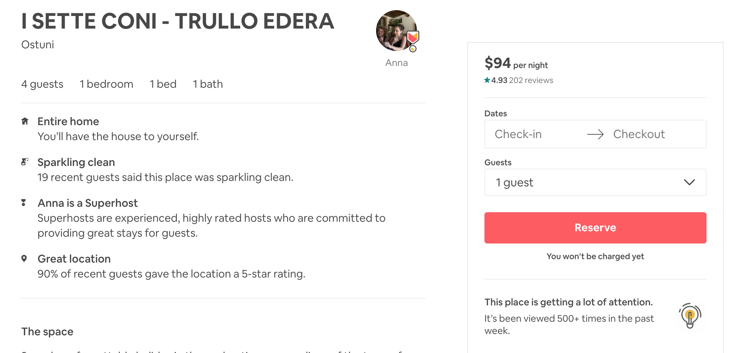

<https://www.airbnb.ca/rooms/432044?source_impression_id=p3_1579817807_fGS9hJxo%2B1uwwWm0>

<https://www.airbnb.ca/rooms/530250?source_impression_id=p3_1579818064_1RFPYEvaYSkZ%2FTc9>

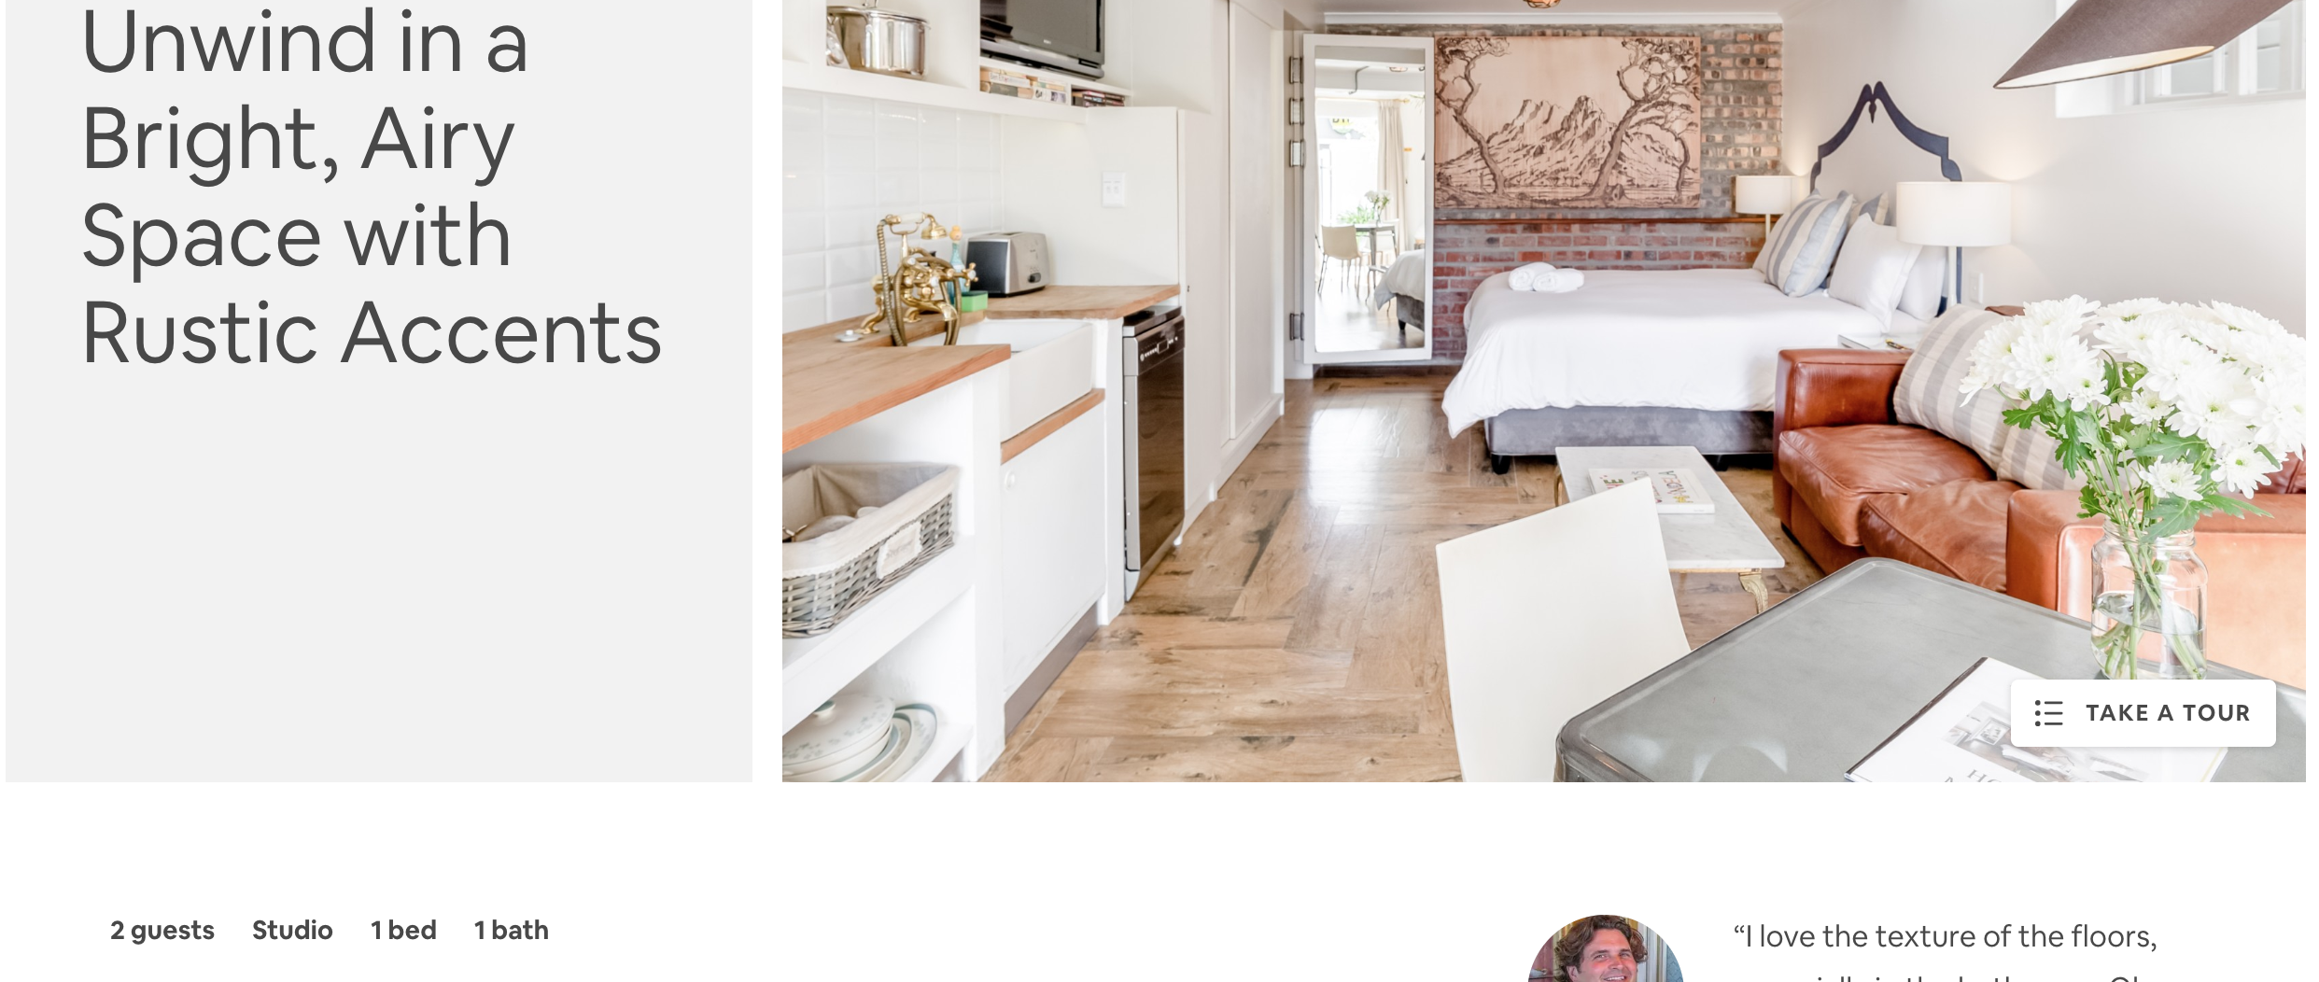

<https://www.airbnb.ca/rooms/plus/4646142?source_impression_id=p3_1579818216_SBAGeb3hgLDl7xN0>

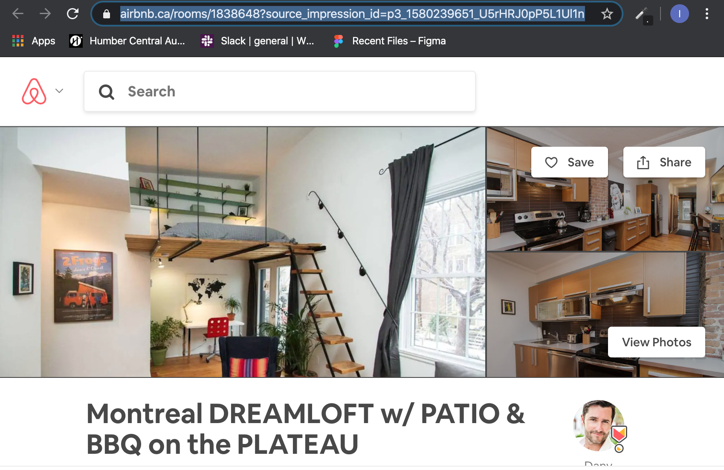

<https://www.airbnb.ca/rooms/1838648?source_impression_id=p3_1580239651_U5rHRJ0pP5L1Ul1n>